Abstract

Health is one of the most important aspects of everyone's day to day life. But we recently have seen the devastating effects of Ebola (in east Africa) or MERS (in the Middle East). Furthermore we have seen new types of drug resistant diseases emerging (Drug resistant TB) due to overuse or interruption of treatments. Being computer science students we chose to solve this problem using concepts we learned throughout our four year undergraduate program at HiLCoE.

We proposed and implemented a technology solution that provides decision support to doctors and government officials for the prevention and control of the aforementioned diseases. Our system also provides patients with various services that will help them follow and complete their treatments on schedule. Our system is Server-Client based, with a web interface for doctors and a mobile application for patients.

This document describes the design and architecture of our system by providing standard OOP diagrams, source-code and UI design wire frames. This document also describes the steps we took to consolidate the security and availability of the system, deployment instructions and our recommended deployment hardware and O.S. Specifications.

Implementation

- Web Application

We have used a python framework called Django 1.8 for the Web application, all the logic of our system is written in python. The web interface is fully responsive, we have adopted a mobile first approach in the design process.

  - The doctor is presented with the homepage
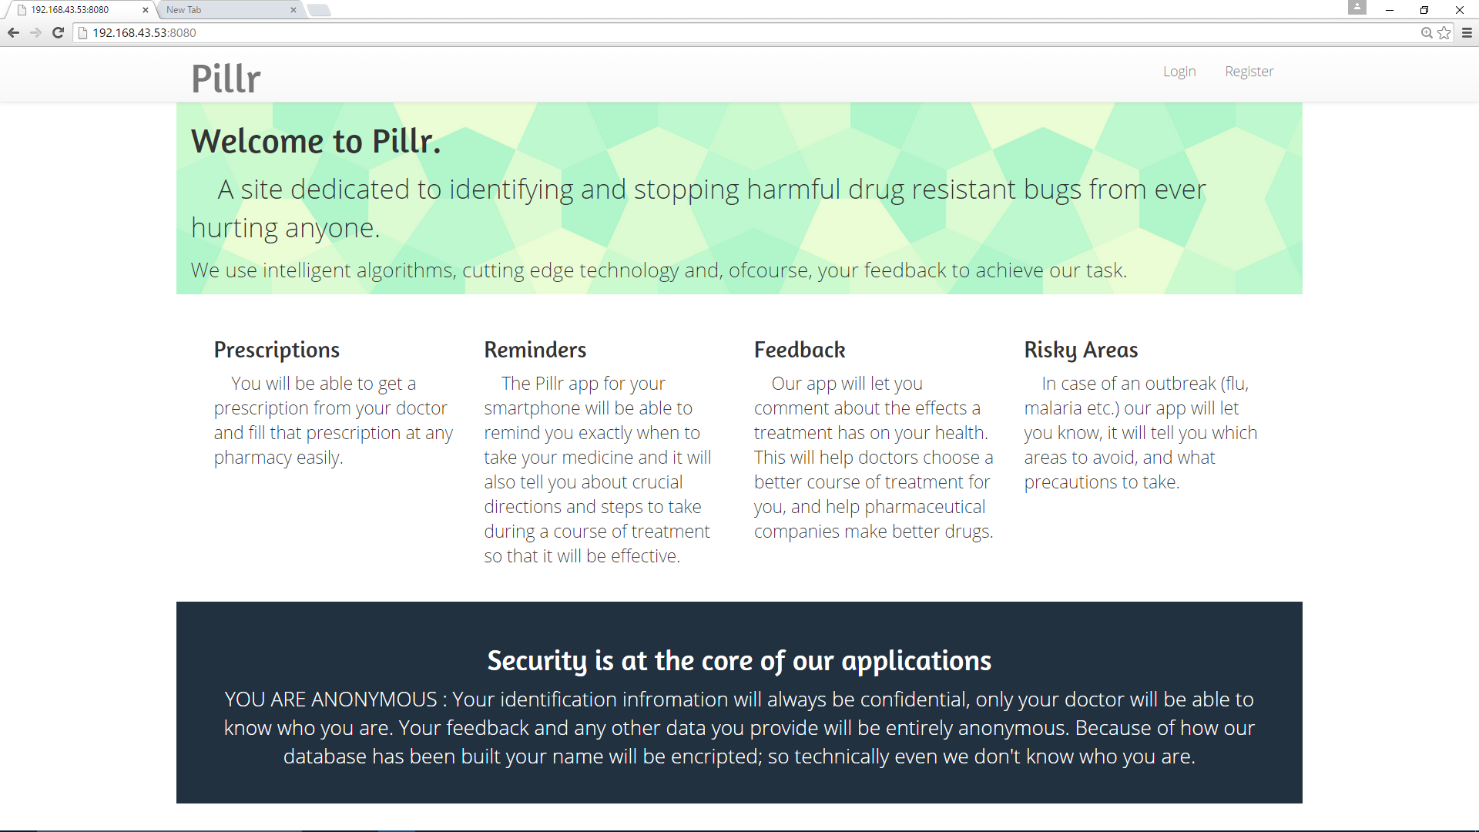

  - The Doctor can log in using the login page

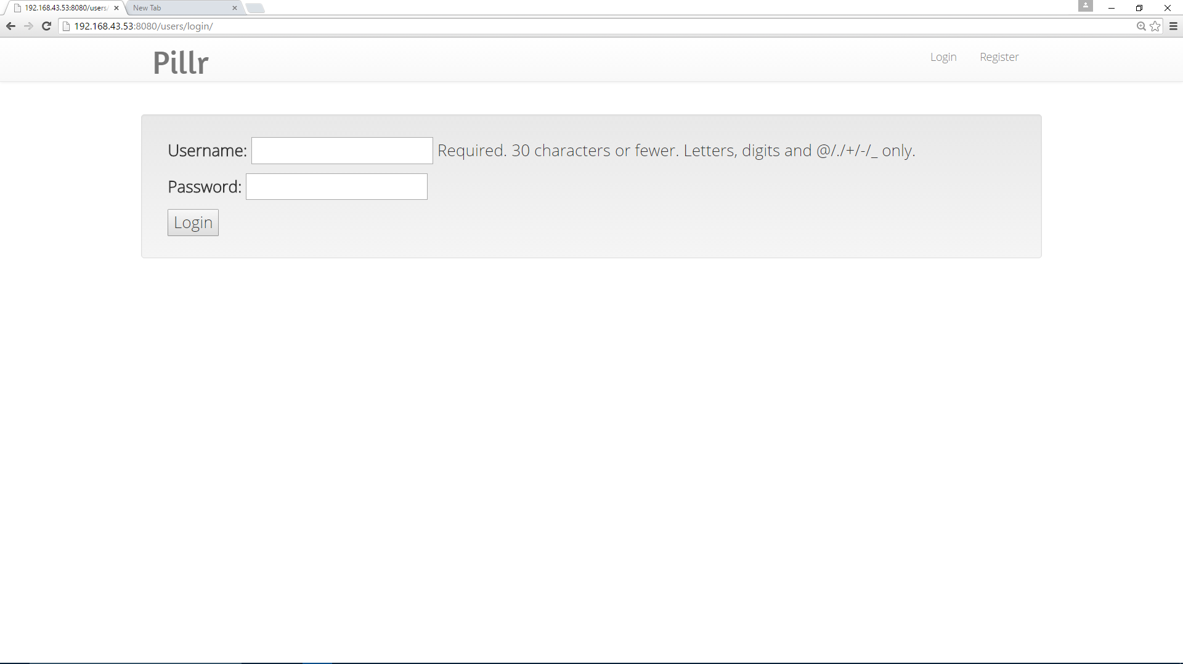
  - After login the doctor is presented with two options : Prescribe and View Patient analytics.

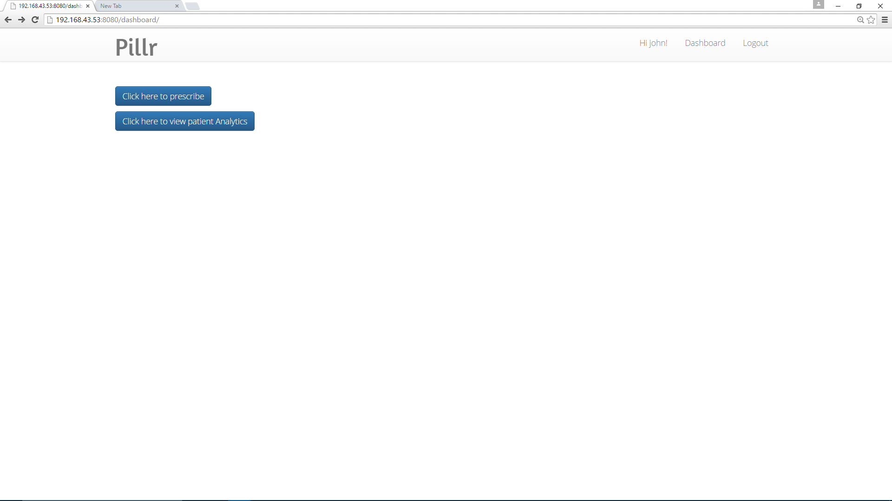

  - If the doctor wishes to prescribe medication than he is presented with the prescribe form and after completing the form and clicking prescribe he is redirected to the previous page:

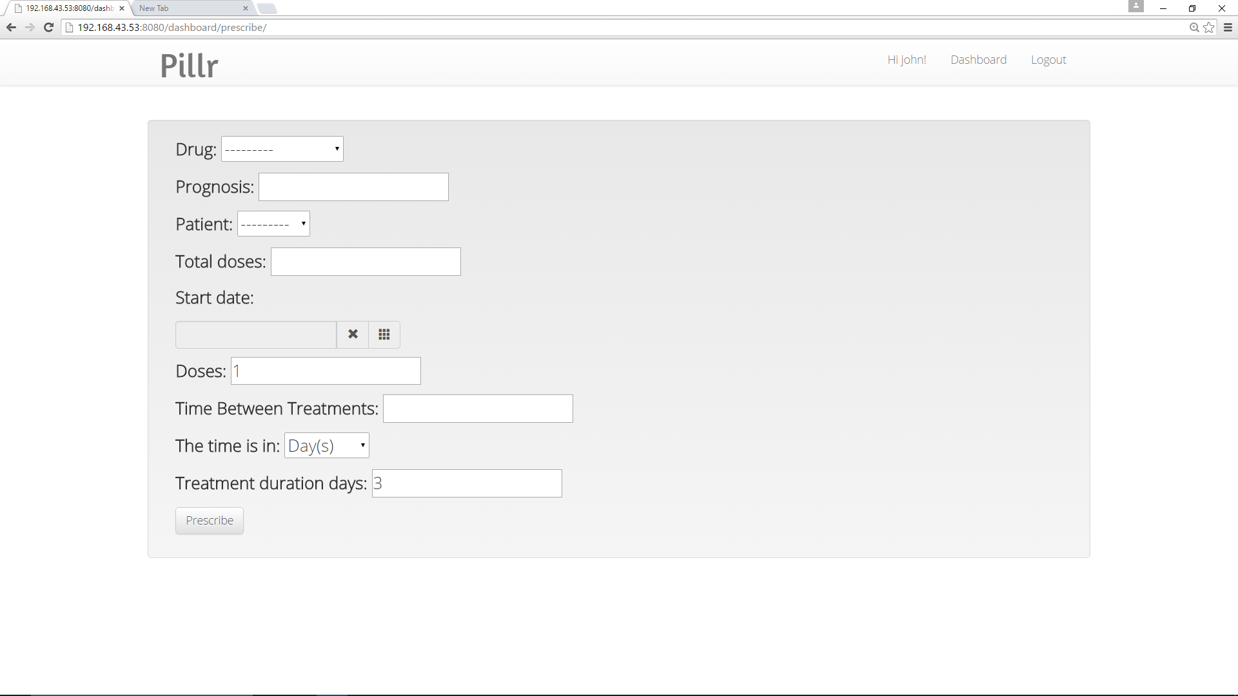

  - If the doctor wishes to view patient analytics he will be presented with the dss page where he can monitor his patients and how effective his prescriptions are:

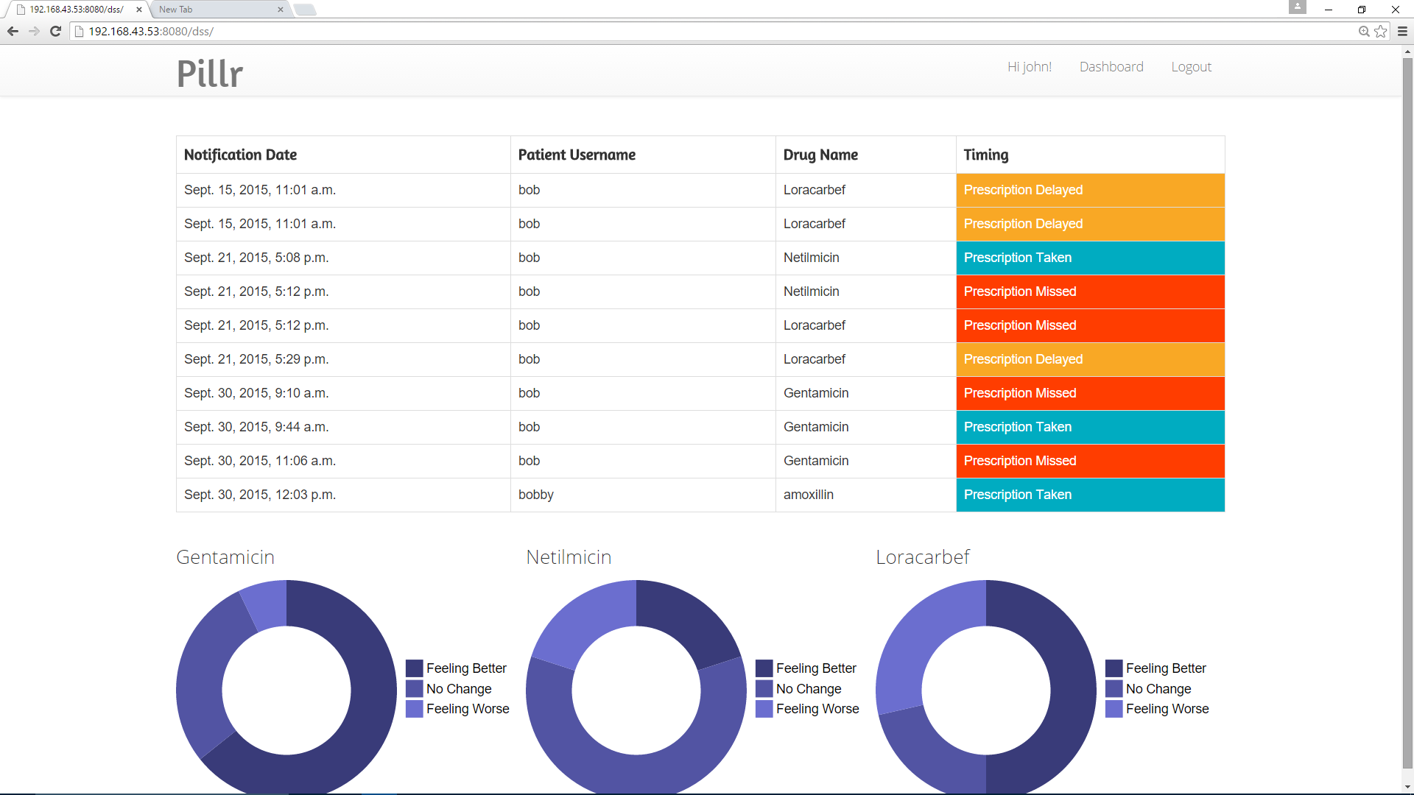

- The mobile application interface (used by patients) is built using java and the android sdk.

  - When opening the app the patient is presented with the login interface.

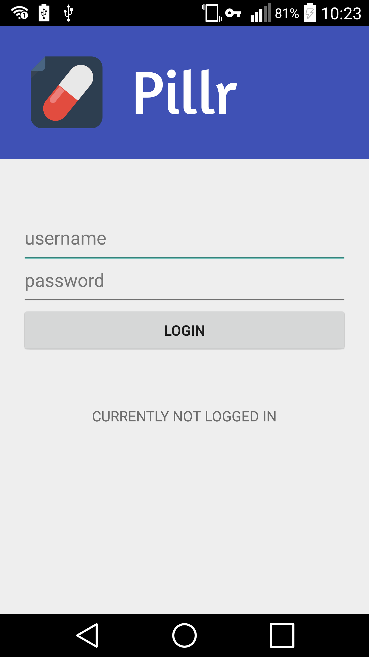

2.2 After login the patient is presented with the menu

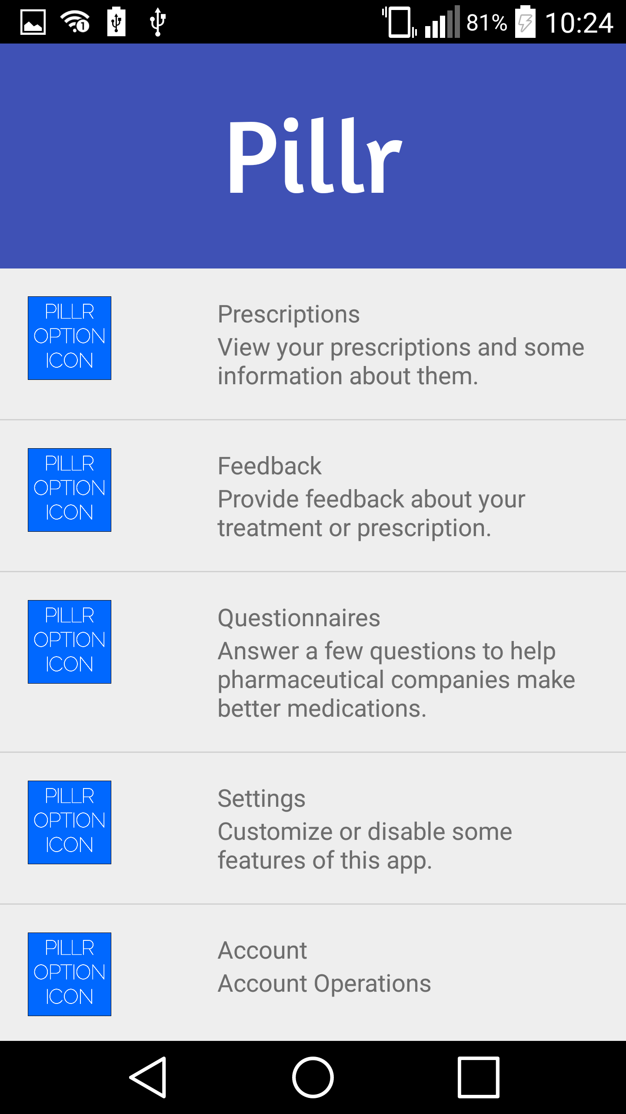

  - If the patient wishes to see his/her prescription schedule he/she can tap on the prescription menu item and the patient will be presented with the list of medications and their directions for use:
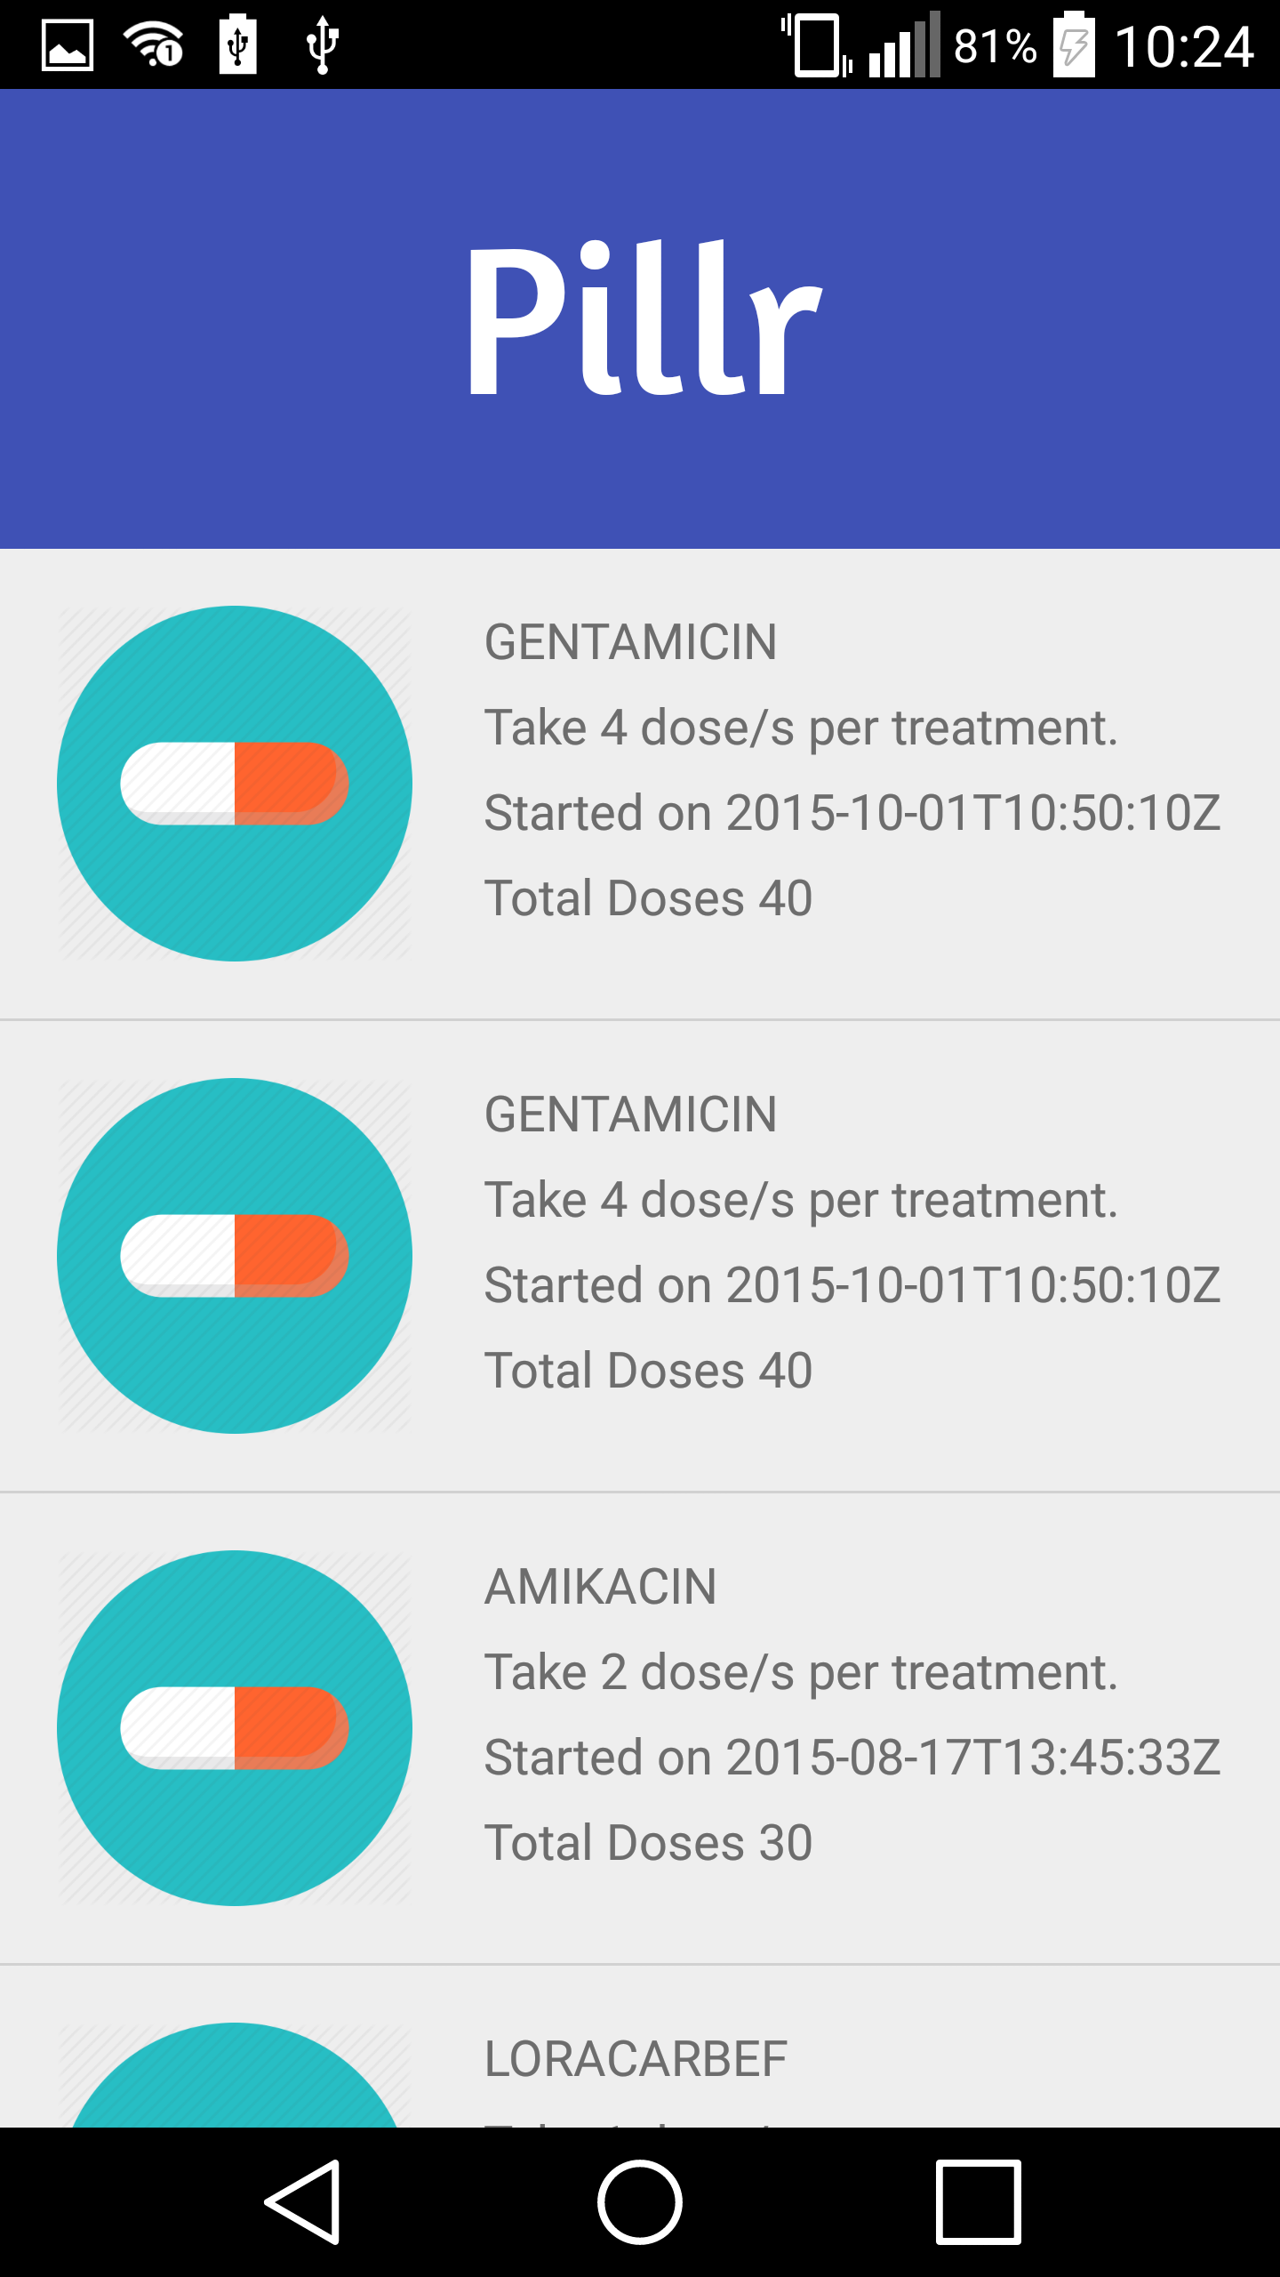

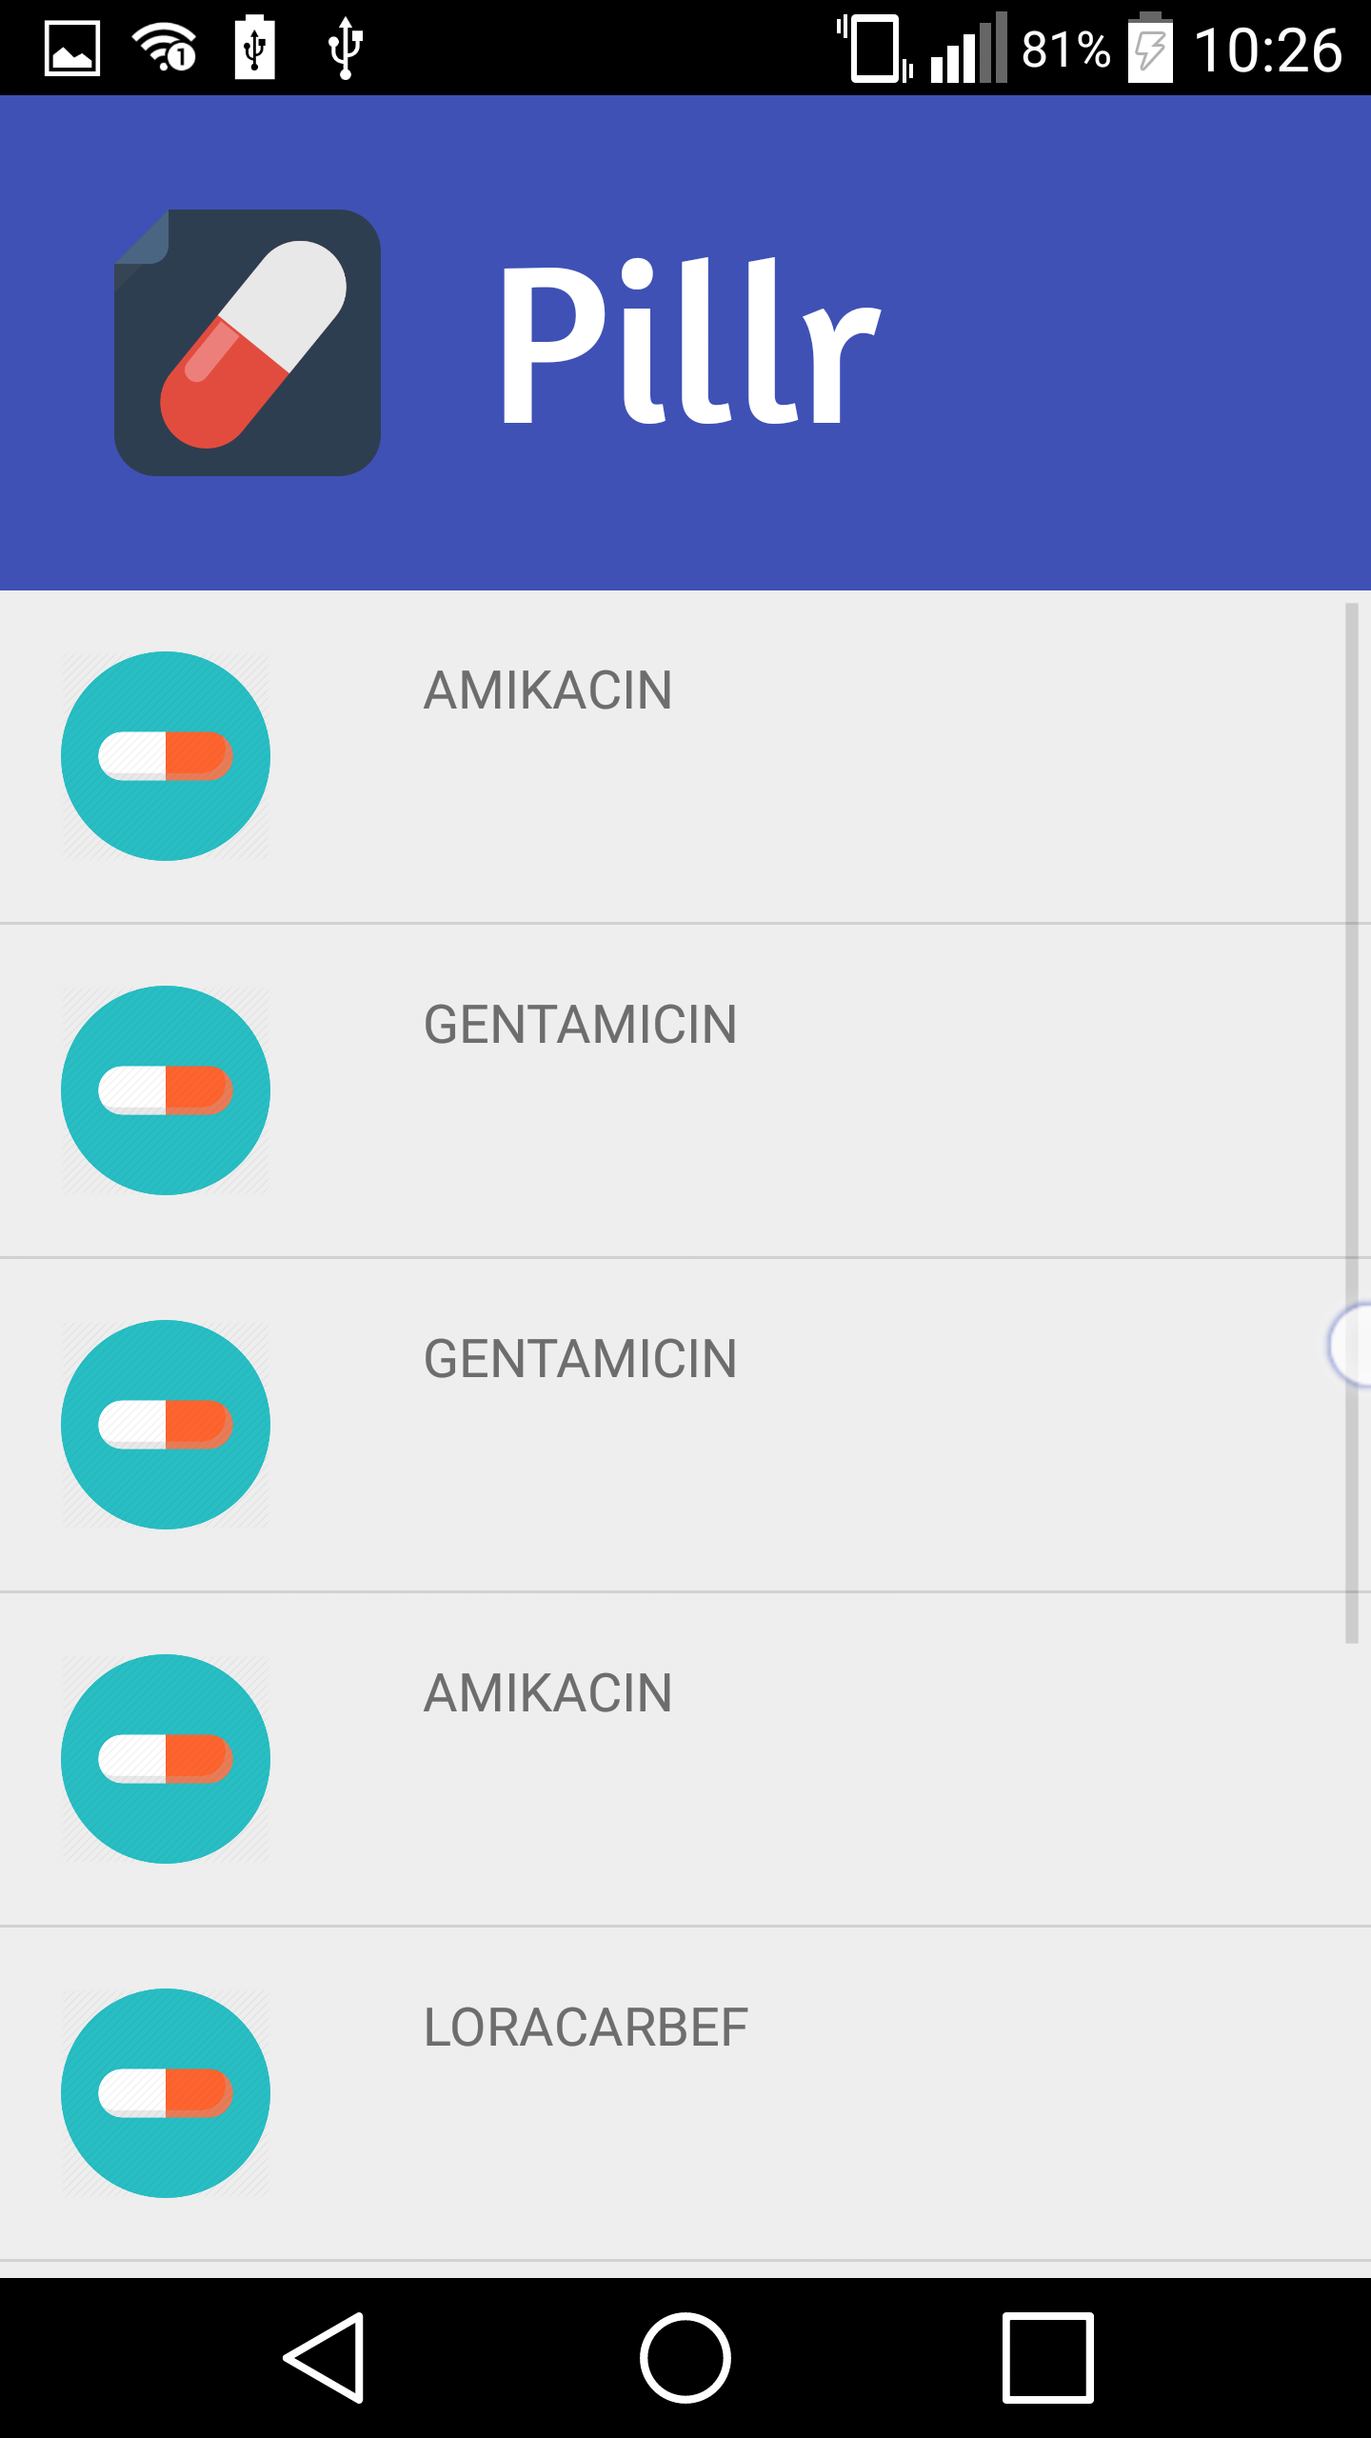
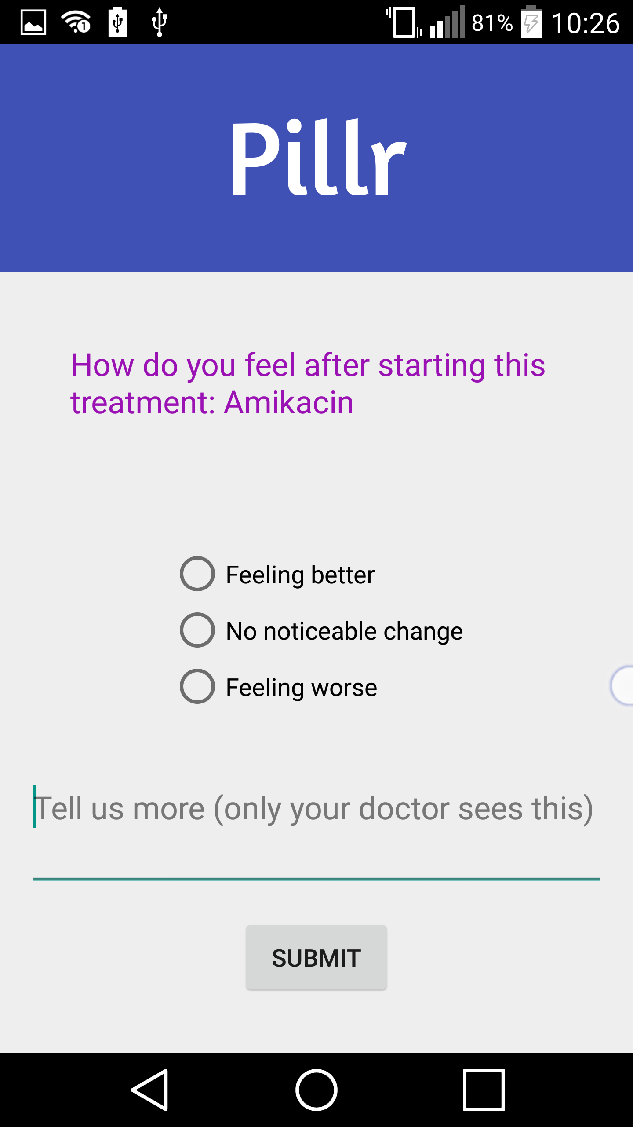
2.4 If the patient wants to rate or comment about a treatment he/she can tap on feedback and will be presented with a list of medications and after choosing one the patient will be presented with a form

