1. Access <https://start.spring.io/> to create a project

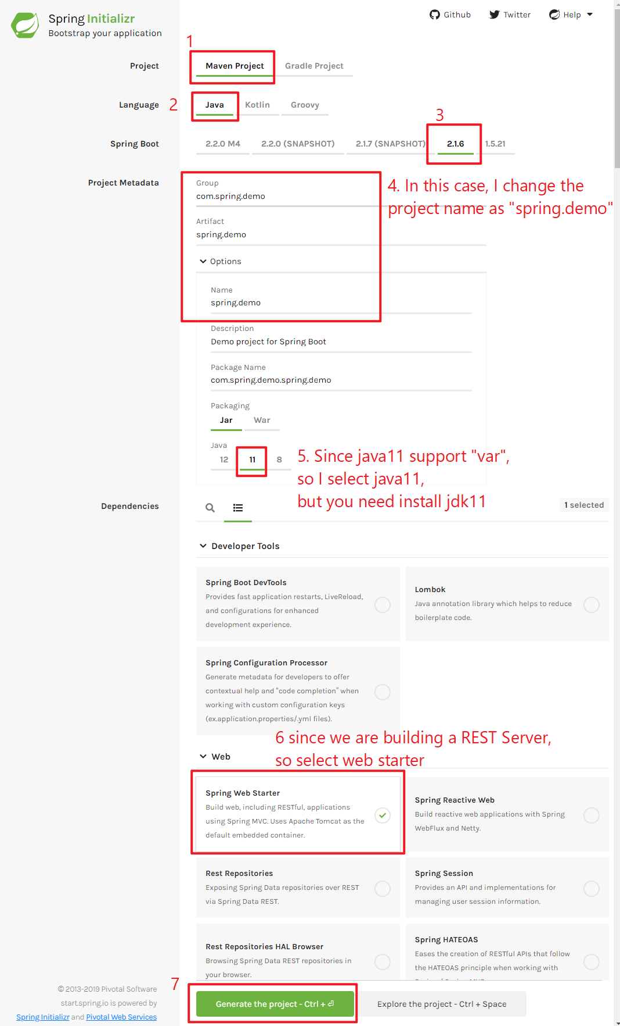

1. Download the project and extract.
2. Open the project in IDEA

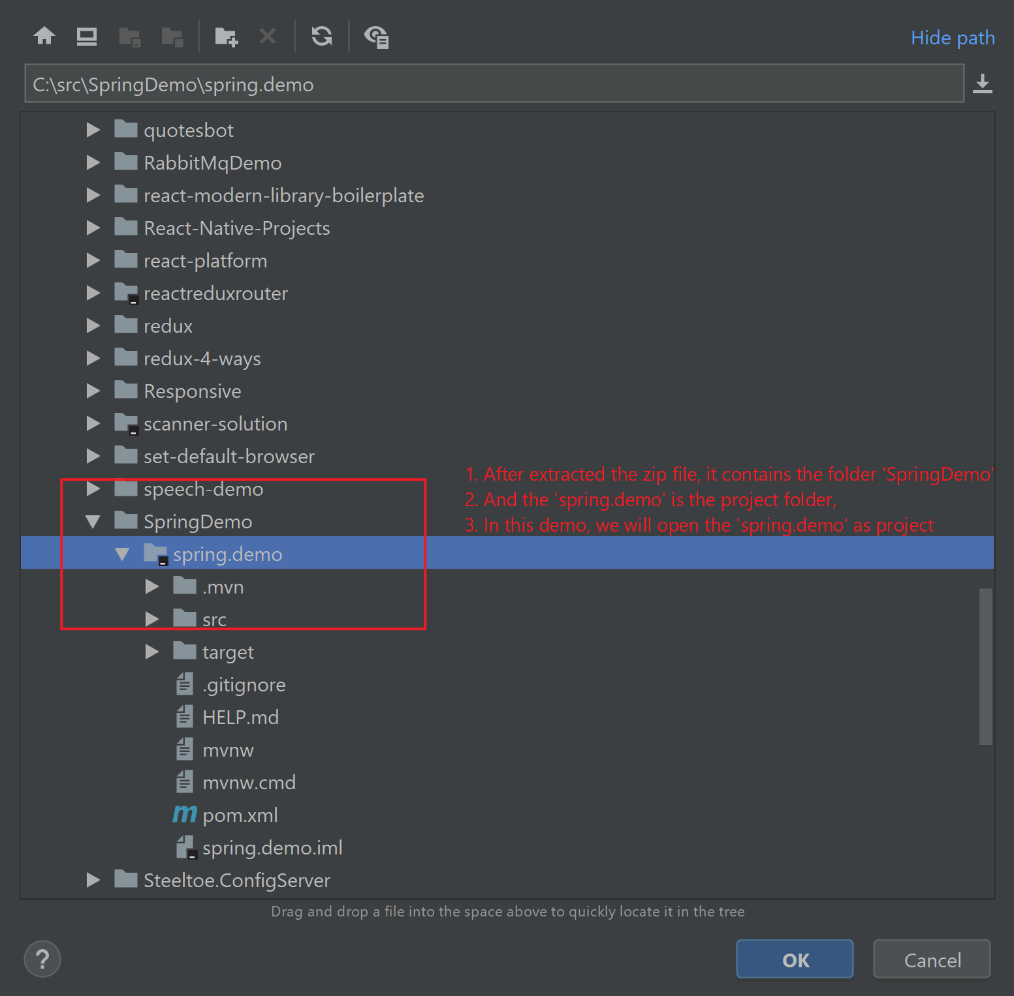

1. Click "File→Project Structure→Modules" to import our spring-boot project

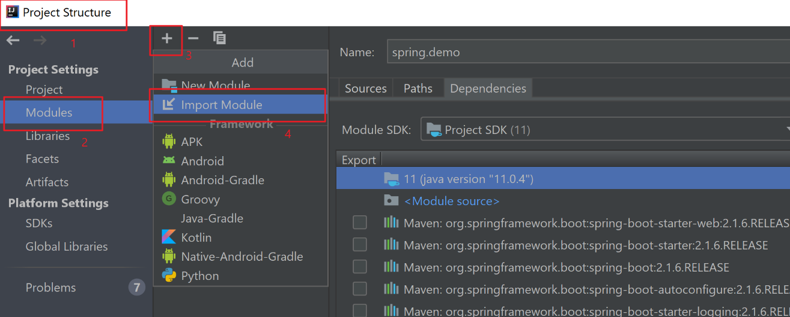

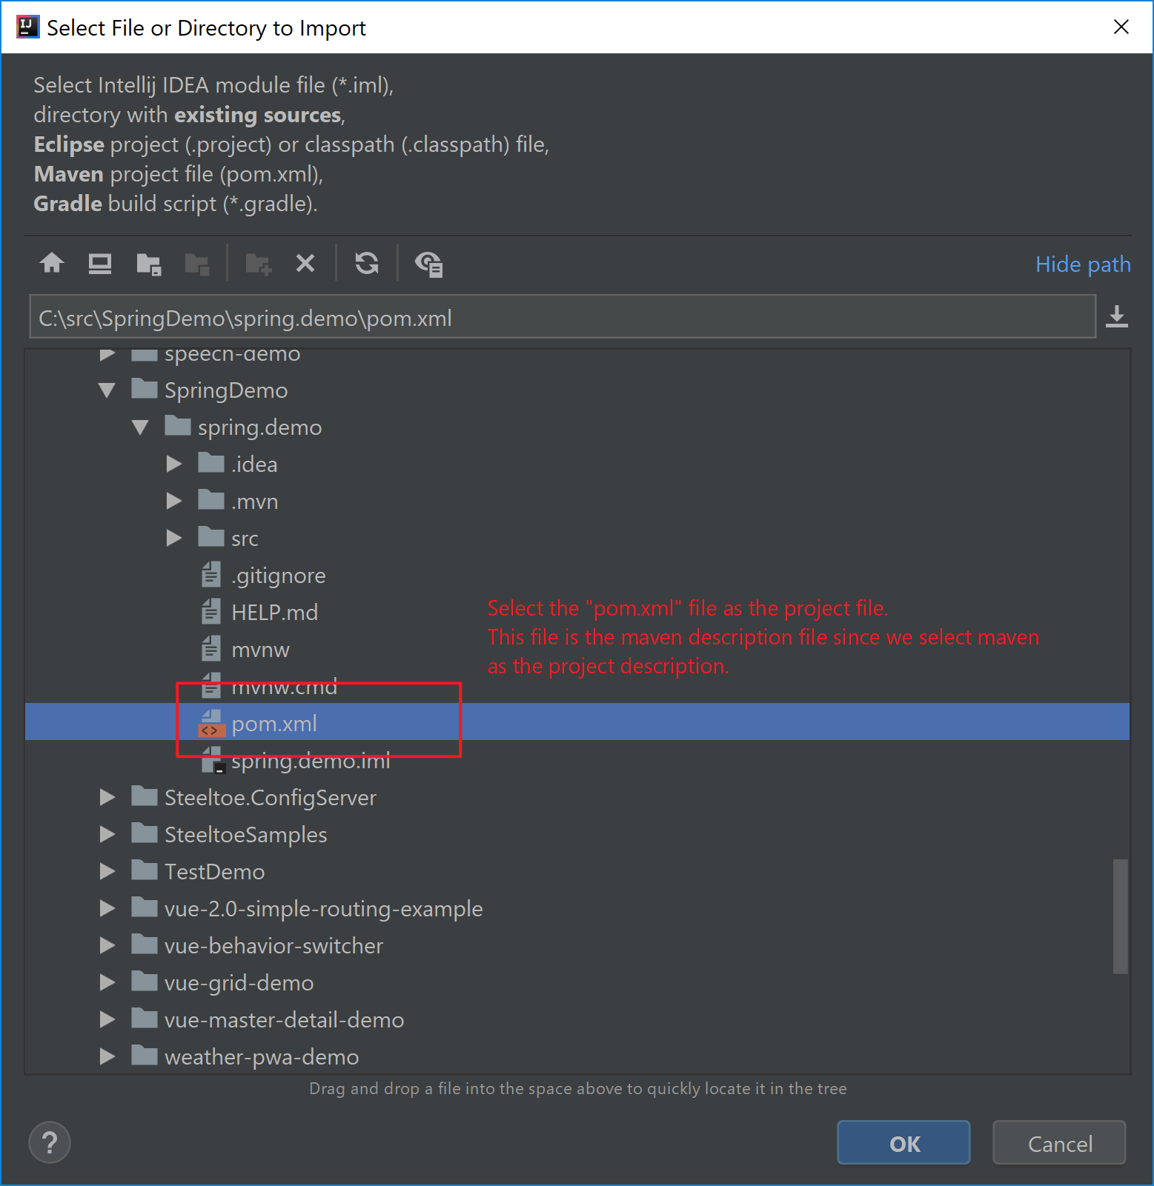

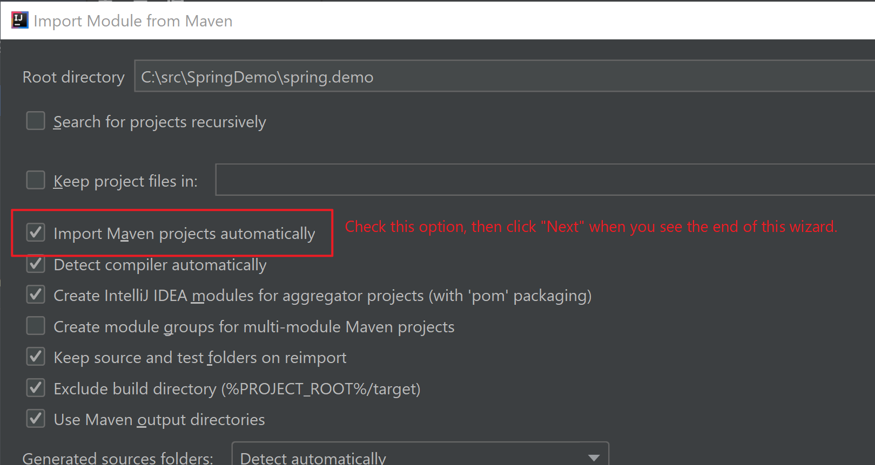

1. Click "Add Configuration" at the navigation bar

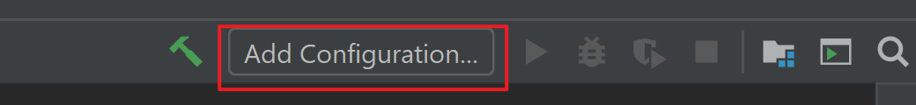

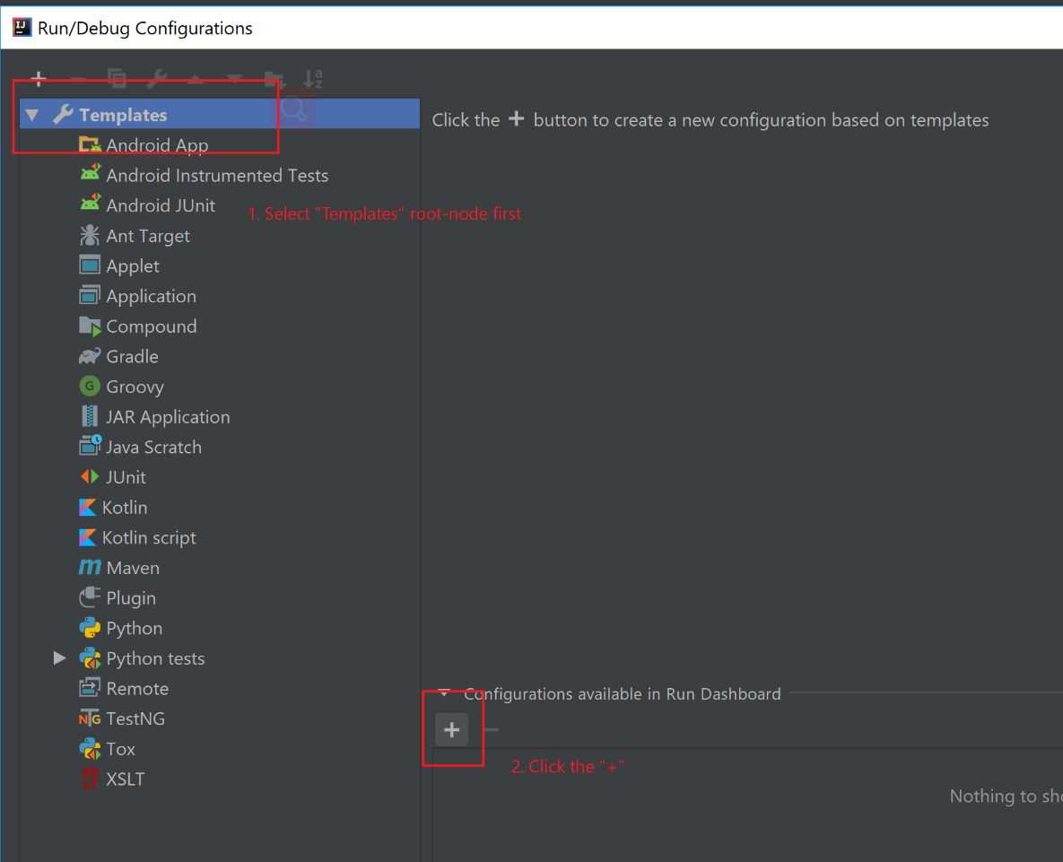

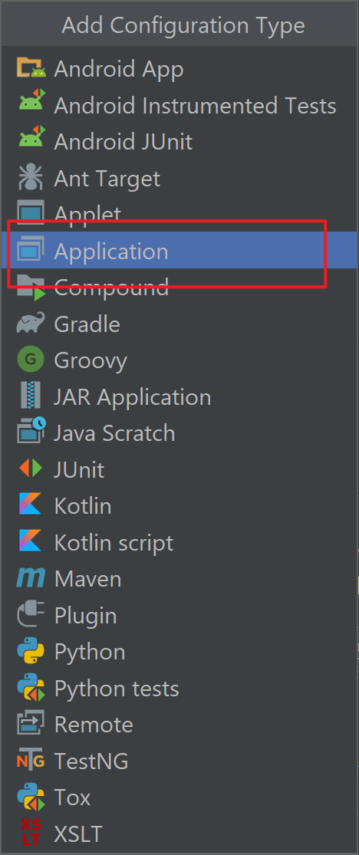

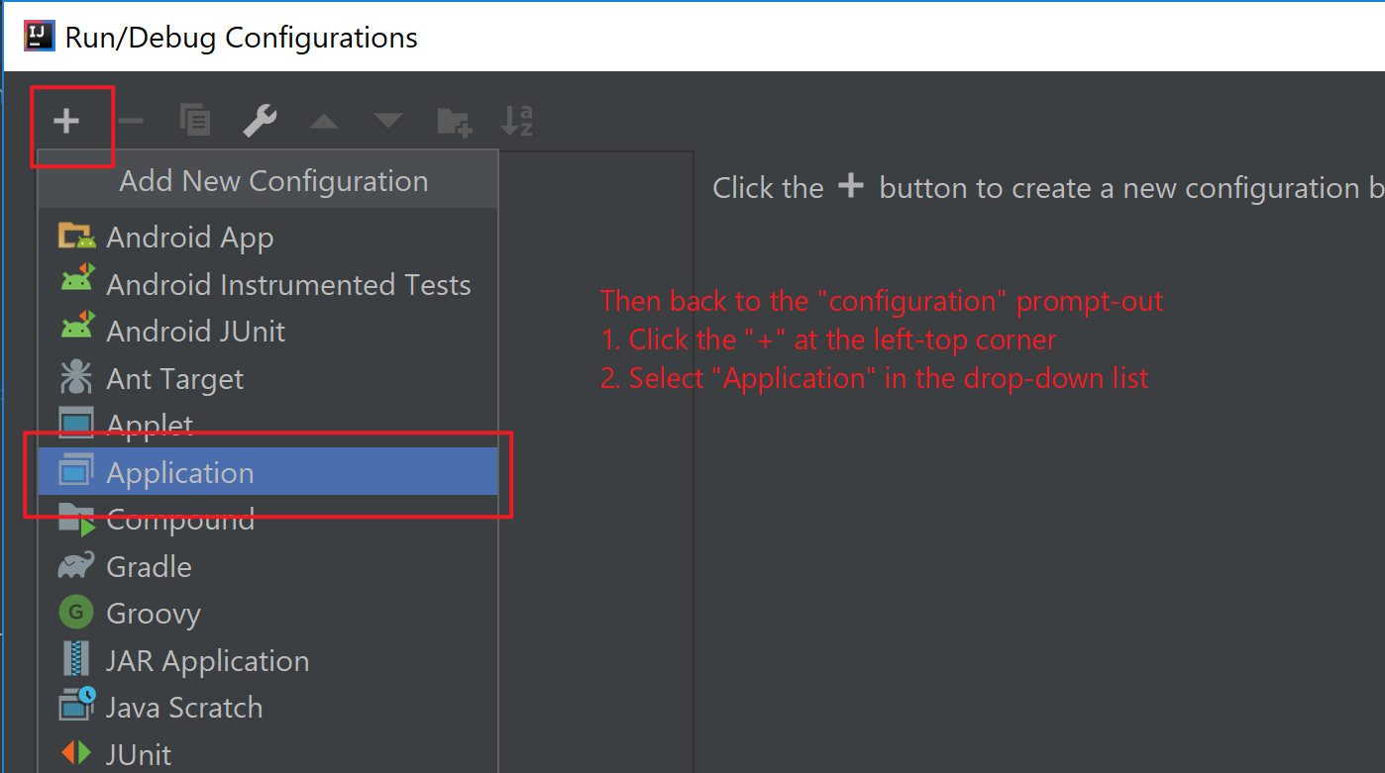

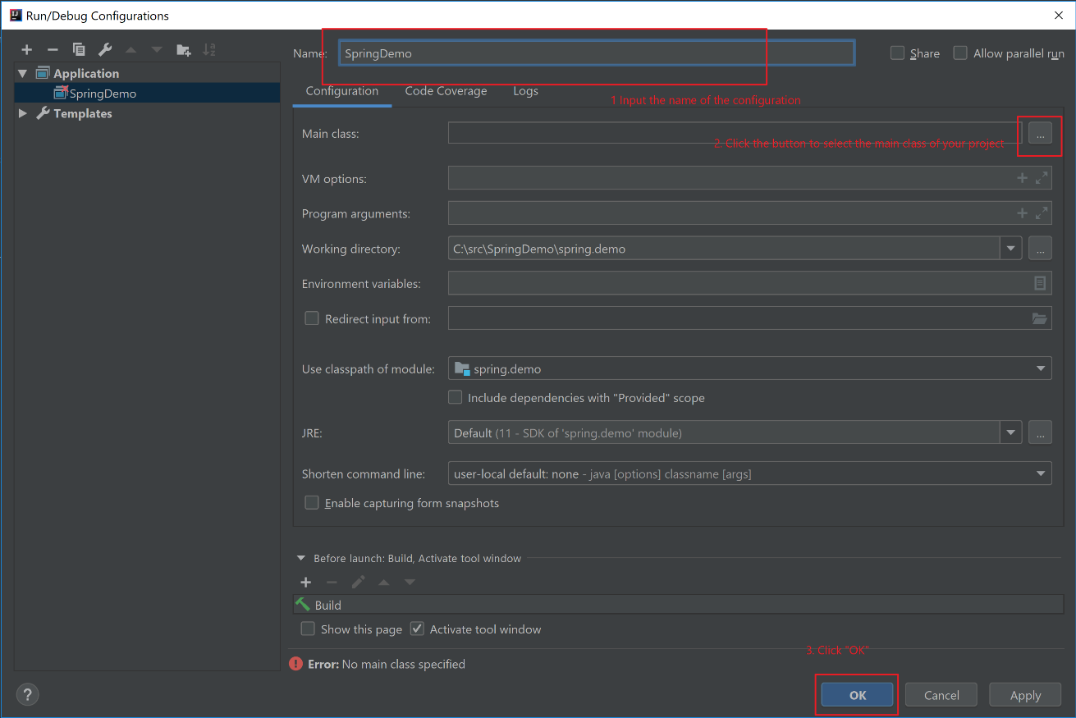

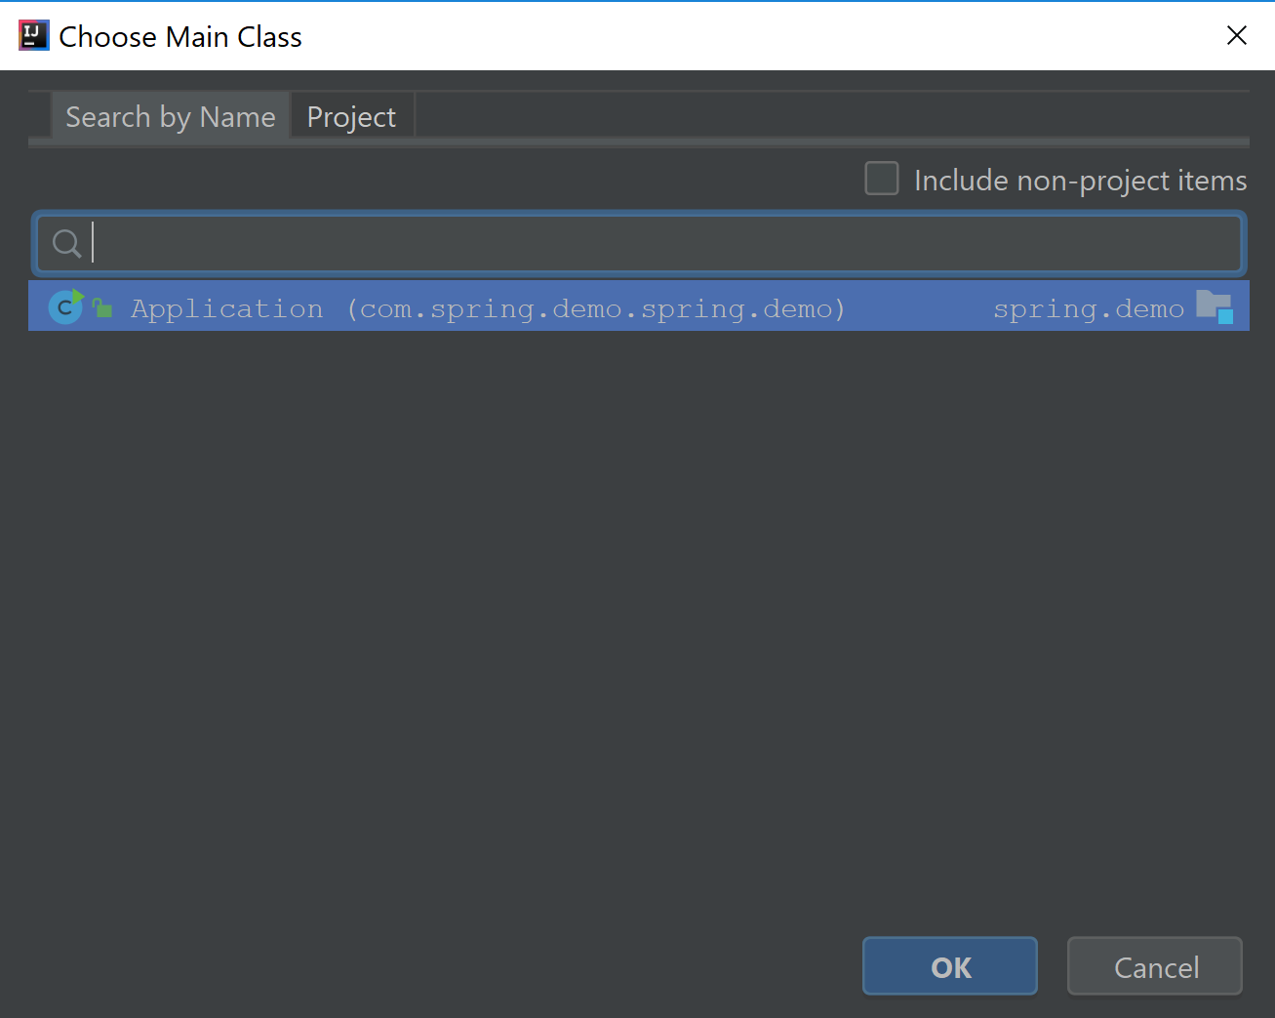

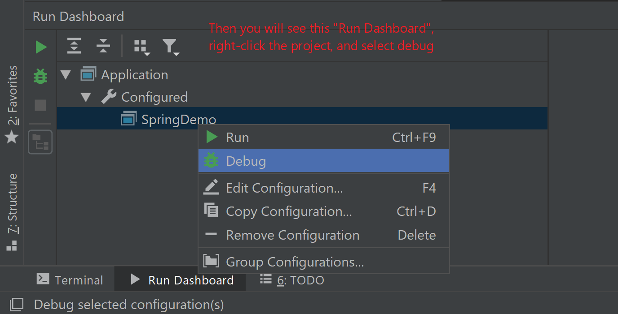

1. Fix the package issue
   1. In my case, when I click "debug", there is some test-package issue in my environment.
   2. If you didn't have this issue, please ignore below steps. Hope you will jump to next step.
   3. Open "ApplicationTest.java"
   4. Move your cursor on to the error, then you will see the tip, then click it, select "Add Maven Dependency"

