**Q. What is Database?**

**Ans:** A **database** is a structured place to **store, manage, and retrieve** data easily using a software system like MySQL, SQL Server, or Oracle

**DML (Data Manipulation Language)**

Used to **modify data** in the database.

* INSERT – Adds new records.
* UPDATE – Modifies existing records.
* DELETE – Removes records.
* MERGE – (Optional) Combines INSERT, UPDATE, DELETE logic.

### ****DQL (Data Query Language)****

Used to **query the database**.

* SELECT – Retrieves data from one or more tables.

### ****DDL (Data Definition Language)****

Used to **define and manage table structures**.

* CREATE – Creates database objects (tables, views, etc.).
* ALTER – Modifies structure of existing objects.
* DROP – Deletes database objects.
* TRUNCATE – Removes all rows from a table (faster than DELETE, no rollback in many DataBaes)

DDL statements are auto-committed in most databases (cannot be rolled back)

### ****DCL (Data Control Language)****

Used to **control access/permissions**.

* GRANT – Gives privileges to users.
* REVOKE – Removes granted privileges.

### ****TCL (Transaction Control Language)****

Used to **manage transactions**.

* COMMIT – Saves changes made by DML statements.
* ROLLBACK – Undoes changes made by DML before a commit.
* SAVEPOINT – Sets a point to which a transaction can be rolled back.

Q. What is Star Schema?

**Ans: Star schema is a centralized data model** where a single **fact table** is at the center and it is directly connected to multiple **dimension tables**.

In the **fact table**, you mostly find **foreign keys (FKs)** that reference the primary keys (PKs) of the dimension tables.

In the **dimension tables**, the **primary key (PK)** uniquely identifies each record and connects back to the fact table through the foreign key.

Q. What is Snowflake schema?

Ans: **Snowflake schema** is an extension of the **star schema**, where **dimension tables are normalized** — meaning they are broken down into **multiple related sub-tables**.

In this structure:

* One **dimension table** is split into **multiple related tables** using **primary keys (PK)** and **foreign keys (FK)**.
* This reduces data redundancy and improves storage efficiency, but increases complexity and the number of joins.

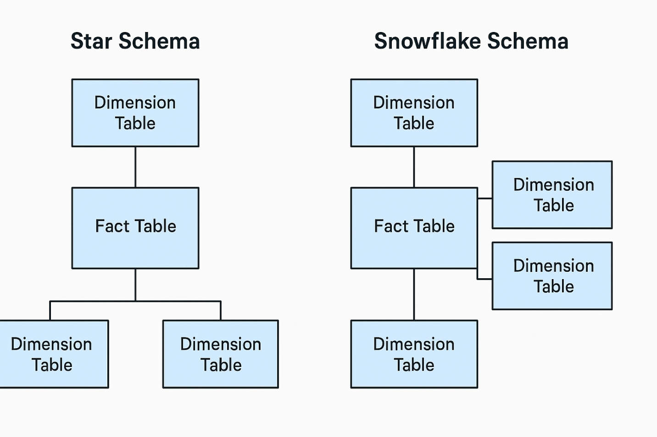

### Star vs Snowflake Summary:

| **Feature** | **Star Schema** | **Snowflake Schema** |
| --- | --- | --- |
| Structure | Flat | Normalized (multi-level) |
| Query Performance | Fast | Slower (more joins) |
| Storage | More (duplicate values) | Less (normalized data) |
| Complexity | Simple | Complex |
| Use Case | Dashboards, quick queries | Complex warehousing, cost-saving |
|  |  |  |

**OLTP (Online Transaction Processing):** is a type of database system used to handle **real-time transactions**, such as placing orders, processing payments, or updating customer information.

It is mainly used in sectors like **e-commerce**, **banking**, **retail**, and **telecommunications**, where fast, reliable, and consistent data operations are required.

**Data Engineers** often work with OLTP systems as a **source of raw data**, especially from order and product sale systems.

**OLAP (Online Analytical Processing):** is mainly used for **data analysis and reporting**. It helps create dashboards and reports in tools like **Power BI**, **Tableau**, or **Excel**, showing insights such as **sales performance**, **revenue trends**, and **customer behavior**.

It is designed for **complex queries** over large amounts of historical data, making it ideal for **business intelligence (BI)**.

**How to create table in database software?**

Ans: EX:

CREATE TABLE table_name (

column1 datatype constraint,

column2 datatype constraint,

...

);

**How to insert the values into tables?**

Ans: EX:

INSERT INTO TableName (Column1, Column2)

VALUES ('Value1', 'Value2');

**How to update the column in table?**

Ans: EX:

UPDATE table_name

SET column1 = value1,

column2 = value2

WHERE condition_column = condition_value;

**How to delete value in the table?**

Ans: EX

DELETE FROM table_name

WHERE column_name = value;

**How to add a new column in the table?**

Ans: Ex

ALTER TABLE table_name

ADD column_name datatype;

**Modify column datatype:**

ALTER TABLE table_name

MODIFY column_name new_datatype;

**Rename a column**

ALTER TABLE table_name

RENAME COLUMN old_name TO new_name;

OR

EXEC sp_rename ‘tblname.oldcol’,’newcol’,’column’

**Drop (delete) a column:**

ALTER TABLE table_name

DROP COLUMN column_name;

**How to create a user in the database software using Sql query?**

Ans:EX

Create login name with password = ‘pass’

Create user name for login name