**CSD326 SOFTWARE ENGINEERING**

**PRACTICAL 5**

**NAME – YAGAY KHATRI ROLL NO - 2110110605**

GitHub Link: <https://github.com/yagaykhatri19/2110110605_Lab05>

1. ACTIVITY DIAGRAM FOR UPLOAD PICTURE ACTIVITY.

Link: <https://online.visual-paradigm.com/community/share/yagay-2110110605-vpd-1nrmd5f3hd>

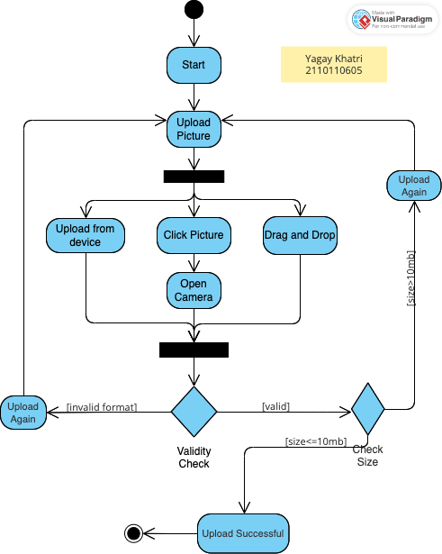

Description: The user initiates the process by selecting the "Start" button, followed by choosing the "Upload Picture" option. Upon selection, the user is presented with three alternatives: 1. Uploading from the device, 2. Click a Picture, or 3. Dragging and dropping an image. Opting for the "Click Picture" option opens the camera interface, allowing the user to capture an image. After the picture is uploaded, it undergoes a validation process to determine its format. If the format is invalid, the user is prompted to upload the picture again; otherwise, it proceeds to a size check. If the picture's size is 10MB or less, it is successfully uploaded; otherwise, the user is instructed to retry the upload.

2. ACTIVITY DIAGRAM FOR UPDATE PROFILE PASSWORD ACTIVITY.

Link: <https://online.visual-paradigm.com/community/share/yagay-2110110605-vpd-1ntjybouhb>

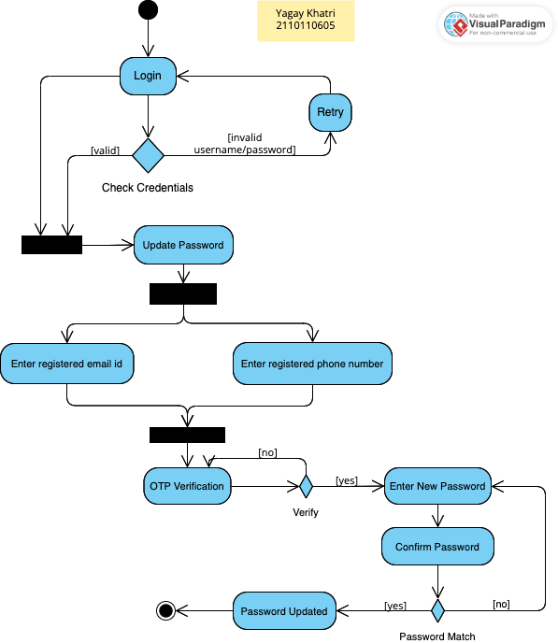

Description: The process begins with the user logging into their account. If the login is successful or if they encounter login issues, they are given the option to reset their password. This can be done either through their registered email or phone number. Subsequently, an OTP verification step is initiated. Once the OTP is verified, the user is prompted to enter and confirm their new password. Upon successful matching of both passwords, the new password is updated, and the process concludes.