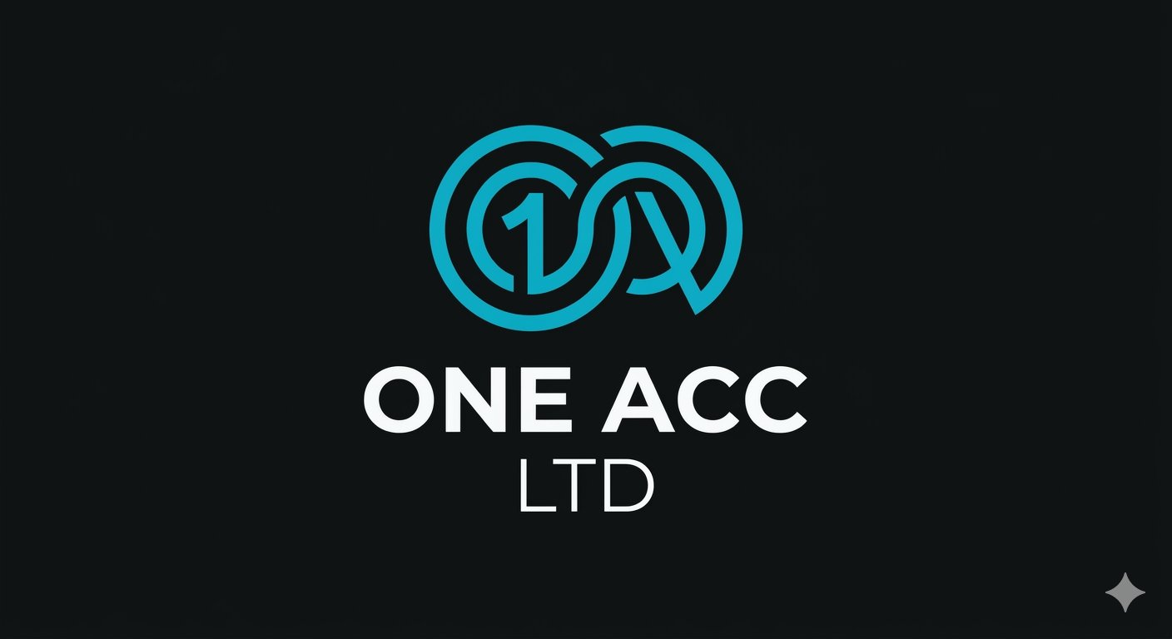
Technical Interview Assessment
Mobile Bill Scanner & Invoice Engine
Full-Stack Engineering Candidate Assessment

⚠ Disclaimer
This assignment is strictly an interview evaluation mechanism to assess architectural orchestration, engineering polish, and AI tool fluency. Your source code, proprietary logic, and deployed infrastructure remain entirely your own intellectual property and will not be used, distributed, or repurposed by us under any circumstances.

Overview
You are required to build and fully deploy a prototype of an end-to-end bill management ecosystem. The goal of the system is to allow users to create an account, scan a physical bill using a mobile application, view the parsed transaction data directly within the app interface, and permanently store the invoice. The saved invoices must then be accessible via an authenticated web dashboard.

The primary goal of this assessment is to deliver a simple but polished app that successfully executes a slightly complicated cross-platform workflow. You are highly encouraged to leverage AI tools (e.g. Cursor, Claude, ChatGPT, Copilot) for 100% of the development process — from writing boilerplate and generating architectures to creating design assets and deployment configurations.

We expect you to utilise AI to build at 10x speed rather than writing raw code by hand; however, your ability to debug, audit architectural decisions, and deeply understand how the pieces connect remains critical to a successful submission.

This system should not look like raw, unfinished AI output. It must be presented as a polished, cohesive, fully live product with its own distinct identity (including a product name and logo). You are also required to engineer one creative, well-scoped extra feature of your own choosing to showcase your product thinking.

You have full creative and architectural freedom over how you handle data flow, data extraction methodologies, state management, deployment hosting providers, and file storage.

Tech Stack Requirements
Layer | Technology
Mobile App | React Native
Backend API | C# (.NET / .NET Core Web API)
Web Dashboard | Next.js (App Router)
Database | Any relational database (SQL Server, PostgreSQL, or MySQL)

High-Level System Scope

1. Product Polish & Brand Identity
- Establish a distinct name and logo/branding for your application.
- Ensure both the mobile and web interfaces are clean, cohesive, well-styled, and presented as a ready-to-use product.

2. Authentication & Identity Layer
- The ecosystem must support standard email/password registration (Signup) and Login.
- The system must support Google Authentication (OAuth2) across both the mobile and web clients.

3. The Mobile Application (React Native)
- Provides user signup, traditional login, and Google Auth onboarding flows.
- Features a capability to scan/capture a physical bill.
- Displays the extracted bill data back to the user within the interface for review.
- Triggers the final save and sync pipeline to the production cloud database.

4. The Backend API (C#)
- Manages user account registration, traditional password verification, and Google OAuth token validation.
- Receives incoming requests from the mobile client to process and persist the invoice data and associated assets.
- Serves data to both the mobile and web clients safely scoped to the authenticated user.

5. The Web Dashboard (Next.js)
- Provides user authentication (Signup, Login, and Google Auth).
- Responsiveness: Responsiveness: The web portal must be highly mobile-friendly, fully reactive, and fluid across all screen sizes.
- Interactivity: Interactivity: Users must be able to view their historical invoices in a clean data table and actively perform actions on them (e.g. view details, delete, edit, or filter).

6. Creative Feature (Your Choice)
Design and implement one extra, well-scoped feature that delivers clear value to an expense-tracking or bill-scanning workflow. Examples include:
- Spending analytics & visualisation
- Automated bill categorisation
- Threshold / budget alerts
- Multi-currency conversion
- CSV / PDF export
…or any other feature that demonstrates strong product thinking.

Key Performance Indicators & Assessment Criteria
Your submission will be evaluated rigorously against the following performance indicators. Because you are encouraged to use AI, we expect an exceptionally high level of finish and execution precision.

KPI | Expectation
Deployment & Cloud Architecture | Web app, backend API, and database must be fully deployed to the cloud and seamlessly communicate in a live environment. Local-only submissions will not be accepted.
Instruction Following | Strict adherence to all explicitly stated tech stack requirements, authentication workflows, and system boundaries.
Product Polish & Attention to Detail | No unclickable placeholder buttons, no broken links, zero visible raw error stack traces in the UI, and complete error-handling across loading and failure states.
UI/UX Fluidity & Responsiveness | Smooth transitions in the React Native app. The Next.js web application must be fully responsive (mobile-first) and reactive to state changes without unnecessary page refreshes.
Engineering & Data Integrity | Clean separation of concerns, proper data modelling, and secure multi-tenant user scoping — users should only ever see their own data.

Deliverables
Your final submission must include all of the following components.

1. Live Production Links
- Web Dashboard URL — a link to the live, fully functional Next.js web application.
- Backend API Base URL — the live URL where your C# .NET API is hosted and accepting traffic.
- Mobile App Binary/Access — a downloadable Android APK, an Expo Go share URL, or a clear public testing channel link.

2. Source Code
- A link to a public GitHub repository hosting your organised, production-ready codebase (frontend, backend, and database configuration).

3. Documentation
A clear README.md file detailing:
- Live links and deployment details.
- Environment variables required (provide a template — do not commit raw keys).
- Brief instructions for running the ecosystem locally if troubleshooting is required.
- A short section explaining your chosen creative feature and the rationale behind it.

One Acc Ltd · oneacc.co.uk · Confidential — Interview Use Only

