Project Proposal for ESC 491 and ESC 492

Project Information
Does this project involve: Yes ☒ No ☐
(1) Human Subjects ☐ ☒
(2) Animal Subjects, Recombinant DNA ☐ ☒
(3) Radiological Materials ☐ ☒
(4) Hazardous Materials ☐ ☒
(5) Increased Need for Space/Utilities ☒ ☐
(6) Commercial Organization/Foundation ☐ ☒
(7) Intellectual property ☐ ☒

General information
Project
Title: | UAV Threat Map and Decision Support System
Project Supervisors: | - Meryem Erbilek (CNG)  - To be determined (EEE)
Programs Involved: | CNG, EEE
Number of Students Required/Program:
  Department Name | Number of Students
  - CNG | 4
  - EEE | 1

Project Description
Small, low-cost unmanned aerial vehicles (UAVs) have become one of the most pressing security challenges of recent years. Commercial drones and their modified variants are increasingly used for reconnaissance, disruption and attack, and in 2026 NATO approved a multi-year, multi-billion-dollar counter-drone initiative to address this threat [1]. Unauthorised drone activity is not limited to conflict zones: the U.S. Federal Aviation Administration alone has collected more than 20,000 UAV sighting reports since 2014 [2]. Detecting such UAVs is difficult, since small drones have radar cross-sections well below 0 dBsm and are therefore hard to track with radar alone [3]. Detection, however, is only half of the problem: once a UAV is detected, an operator must decide within seconds how dangerous it is, which assets and routes are exposed, and which response procedure applies.

Existing counter-UAS solutions, including those developed by the Turkish defence industry, concentrate mainly on the sensor and effector side: radar, radio-frequency (RF), electro-optical and acoustic detection, and jamming, spoofing or kinetic neutralisation. To the best of our knowledge, their publicly documented command-and-control software focuses on track fusion and effector assignment rather than on explaining why a track is dangerous in relation to the terrain, the protected assets and published doctrine. On the civil side, Türkiye's national UAV traffic management platform İHATTYS, introduced with the SHT-İHA instruction in 2026, manages registered, cooperative drones [4]; non-cooperative drones are by definition outside its scope. Recent advances in retrieval-augmented generation (RAG) [5], edge-AI hardware and openly available geospatial and sensor datasets now make it possible to build an explainable decision-support layer on top of UAV detection.

This project aims to design and implement a UAV Threat Map and Decision Support System that turns UAV detections into a live, explainable threat picture for the protection of a critical site, such as a campus area or a facility. The system will (i) detect and track UAVs using distributed edge sensor nodes that combine camera-based deep-learning detection with Wi-Fi/RF control-link detection, (ii) place every track on a real terrain and infrastructure model of the site and propagate its risk over a geospatial grid, taking line of sight and terrain masking into account, (iii) retrieve the relevant counter-UAS procedures from a knowledge base of unclassified doctrine documents using a locally running language model, and (iv) present the result to the operator on a map using standard military symbology (MIL-STD-2525/APP-6) [6], together with a recommended response and safe routes. Every recommendation will cite the document and page it is based on, so that the operator can verify it. Figure 1 depicts the considered scenario and the main system components.

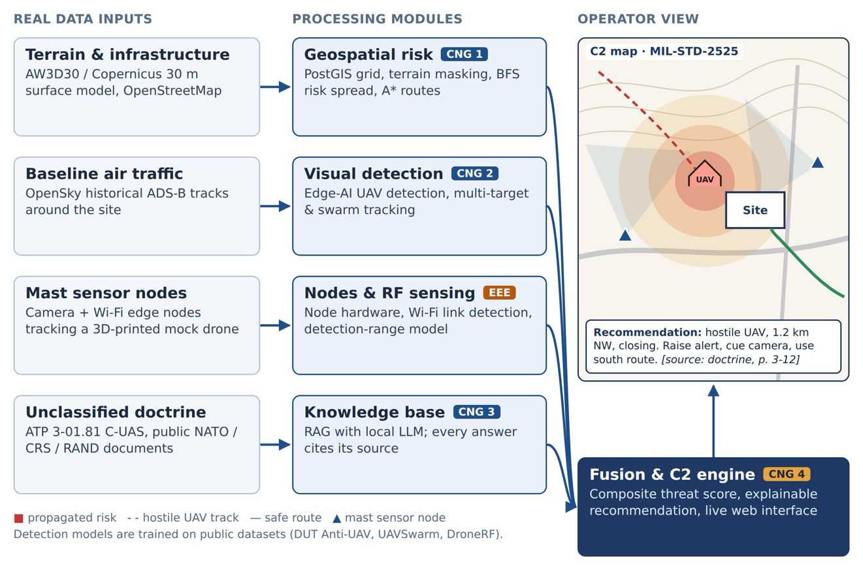
Figure 1 The scenario considered and the main system components

A key design principle of the project is that it is built on real, citable and openly accessible data rather than on synthetic assumptions. Terrain is taken from the ALOS World 3D 30 m surface model [7] and OpenStreetMap, the baseline of normal air traffic from the OpenSky Network [8], and the detection models are trained and evaluated on public benchmark datasets such as DUT Anti-UAV [9], UAVSwarm [10], the Halmstad multi-sensor drone dataset [11] and DroneRF [12]. Public sighting records [2] are used to validate the risk model. The curated catalogue of all sources, with their access status and licences, is maintained in the project's public repository [13].

The system will be demonstrated physically. Edge sensor nodes (e.g. Jetson or Raspberry Pi boards with cameras and Wi-Fi receivers) will be mounted on masts around a selected test area, and a 3D-printed drone mock-up carrying a Wi-Fi transmitter will be moved through the monitored area to emulate an approaching UAV. The nodes will detect it both visually and through its radio link, and the detections will be fused, mapped and explained on the operator interface in real time.

System components and student distribution are given below:

- EEE student to design and implement signal of the system.
- CNG Students will design a detection system for UAV.

CNG students will be supervised by Dr. Meryem Erbilek; the EEE supervisor will be determined.

Technical Requirements:

- EEE Student: interest in embedded systems, RF and wireless communication, sensors and signal processing, and hands-on hardware prototyping.
- CNG Students: skills in machine learning and computer vision, spatial databases and GIS, natural language processing and LLMs, graph algorithms, web development and software architecture.

Hardware Requirements
- Jetson Nano Developer Kits and Raspberry Pi 4/5 boards for the edge sensor nodes (from department inventory, if available)
- USB/CSI cameras and Wi-Fi adapters with monitor-mode support (or ESP32 modules)
- Masts or tripods for mounting the sensor nodes, and access to a 3D printer for the drone mock-up
- A workstation with a CUDA-capable GPU for model training and local LLM inference
Software Requirements
- Python, PyTorch, OpenCV, Ultralytics YOLO and TensorRT for edge inference
- PostgreSQL/PostGIS, GDAL and osm2pgsql for geospatial data
- FAISS or Qdrant, sentence-transformers and Ollama for the knowledge base
- FastAPI, React, Leaflet or CesiumJS, milsymbol.js and Docker for the C2 interface

8. RefReferences
- Army Recognition, “NATO approves $40 billion counter-drone initiative to defeat low-cost UAV threats,” 2026. [Online]. Available: https://www.armyrecognition.com/news/aerospace-news/2026/nato-approves-40-billion-counter-drone-initiative-to-defeat-low-cost-uav-threats
- Federal Aviation Administration, “UAS Sightings Report.” [Online]. Available: https://www.faa.gov/uas/resources/public_records/uas_sightings_report
- V. Semkin et al., “Analyzing radar cross section signatures of diverse drone models at mmWave frequencies,” IEEE Access, vol. 8, 2020.
- SAVX, “İHATTYS — İHA Takip ve Trafik Yönetim Sistemi (Türkiye’s national UTM platform, SHT-İHA Article 21),” 2026. [Online]. Available: https://www.savx.com.tr/uttms
- P. Lewis et al., “Retrieval-augmented generation for knowledge-intensive NLP tasks,” in Proc. Advances in Neural Information Processing Systems (NeurIPS), 2020.
- U.S. Department of Defense, “Joint Military Symbology,” MIL-STD-2525D, 2014.
- T. Tadono et al., “Precise global DEM generation by ALOS PRISM,” ISPRS Annals of the Photogrammetry, Remote Sensing and Spatial Information Sciences, vol. II-4, pp. 71–76, 2014.
- M. Schäfer, M. Strohmeier, V. Lenders, I. Martinovic and M. Wilhelm, “Bringing up OpenSky: A large-scale ADS-B sensor network for research,” in Proc. 13th Int. Symp. on Information Processing in Sensor Networks (IPSN), 2014.
- J. Zhao, J. Zhang, D. Li and D. Wang, “Vision-based anti-UAV detection and tracking,” IEEE Transactions on Intelligent Transportation Systems, vol. 23, 2022.
- C. Wang et al., “UAVSwarm dataset: An unmanned aerial vehicle swarm dataset for multiple object tracking,” Remote Sensing, vol. 14, no. 11, p. 2601, 2022.
- F. Svanström, F. Alonso-Fernandez and C. Englund, “A dataset for multi-sensor drone detection,” Data in Brief, vol. 39, 2021.
- M. S. Allahham, M. F. Al-Sa’d, A. Al-Ali, A. Mohamed, T. Khattab and A. Erbad, “DroneRF dataset: A dataset of drones for RF-based detection, classification and identification,” Data in Brief, vol. 26, 2019.
- Y. Akkaya et al., “uav-cuas-datasets: Real data sources for UAV threat mapping,” GitHub repository, 2026. [Online]. Available: https://github.com/yagizakkaya01/uav-cuas-datasets
- Headquarters, Department of the Army, “Counter-Unmanned Aircraft System (C-UAS),” ATP 3-01.81, 2023.

