**CONTENT**

LIST OF SIGNS AND ABBREVIATIONS 4

INTRODUCTION 5

1 OVERVIEW OF THE PROBLEM OF USING CHATBOTS IN HUMAN-MACHINE INTERACTION 7

1.1 Chatbots. Basic concepts and definitions 8

1.2 Using chatbots in the context of human resource 10

1.3 Overview of the process of human resource support requests set in natural language 12

1.4 Overview of existing software for query analysis in natural language 13

2 SELECTING TOOLS AND CREATING A CHATBOT FOR HUMAN RESOURCE 16

2.1 Formation of functional and non-functional requirements 16

2.2 Applied Techniques for Chatbot 18

2.2.1 Natural Language Processing 19

2.2.2 Pattern Recognition (Matching, Mapping) 21

2.2.3 Semantic web: 22

2.2.4 Data Mining 23

2.3 Architecture of Chatbot 24

2.4 Choosing a chatbot development platform 25

3 DESIGN AND IMPLEMENTATION OF AI CHATBOT 27

3.1 Design of AI chatbot 28

3.2 Software implementation of AI chatbot 33

3.3 Chat Bot Interface 36

4. EXPERIMENTAL RESULTS 38

4.1 Analysis of changes in the work processes of the human resource service after the implementation of the chatbot 39

4.2 Analyze the labor and time required to develop and implement a chatbot: 43

4.3 Chat Bot Testing 44

5 ECONOMIC ANALYSIS 48

5.1 Building the Canvas business model of the project 48

5.2 Calculation of the cost of software development 49

5.3 Calculation of operating costs 52

CONCLUSIONS 54

LIST OF INFORMATION SOURCES 56

# LIST OF SIGNS AND ABBREVIATIONS

AI - Artificial Intelligence.

NLP - Natural language processing

NLG - Natural language generation

NLU - Natural language understanding

NTLK - Natural Language Toolkit

# INTRODUCTION

In today's rapidly evolving technological landscape, organizations are constantly exploring innovative ways to streamline their operations and enhance communication with their stakeholders. One area that has seen significant advancements is the field of Human Resources (HR), which plays a crucial role in managing a company's most valuable asset—its people. With the advent of artificial intelligence (AI) and natural language processing (NLP), the concept of chatbots has emerged as a promising solution to improve HR processes and transform the way employees interact with HR systems.

This diploma thesis focuses on the design and implementation of a chatbot specifically tailored for Human Resources. By leveraging AI and NLP technologies, the chatbot aims to provide a more efficient and personalized HR experience for employees while reducing the administrative burden on HR professionals. The primary objective of this thesis is to develop a robust and intelligent chatbot that can understand and respond to a wide range of HR-related queries, ultimately enhancing employee engagement and satisfaction within the organization.

To achieve this objective, the thesis will delve into several key aspects. Firstly, it will explore the existing literature on chatbot design principles, AI, and NLP techniques relevant to HR applications. This review will lay the foundation for understanding the theoretical underpinnings and best practices in creating an effective HR chatbot.

Next, the thesis will discuss the requirements gathering and system analysis phase, wherein the specific needs and challenges of HR processes will be identified. By collaborating closely with HR professionals, their insights and expertise will be incorporated to ensure the chatbot addresses their pain points and fulfills their requirements effectively.

Subsequently, the thesis will present the design and architecture of the HR chatbot, outlining the system components, data flow, and integration with existing HR systems.

Emphasis will be placed on creating a user-friendly interface and designing conversational flows that prioritize clarity, accuracy, and ease of use.

The implementation phase will involve developing the chatbot using state-of-the-art AI and NLP frameworks. The thesis will explore various technologies and tools, such as machine learning algorithms, natural language understanding models, and dialogue management systems, to build an intelligent chatbot capable of understanding and responding to complex HR inquiries.

Finally, the thesis will evaluate the performance and effectiveness of the HR chatbot through user testing and feedback analysis. Metrics such as response accuracy, user satisfaction, and system efficiency will be measured to assess the chatbot's impact on HR processes and employee experience.

By the end of this diploma thesis, it is expected that a functional HR chatbot will be developed and demonstrated, showcasing its potential to revolutionize HR operations and improve employee engagement. The findings and insights from this research will contribute to the growing body of knowledge in the field of HR technology and pave the way for future advancements in chatbot design and implementation for HR.

Overall, this diploma thesis endeavors to bridge the gap between cutting-edge AI technology and HR processes, presenting a comprehensive framework for designing and implementing a chatbot tailored specifically to the needs of Human Resources..

# 1 OVERVIEW OF THE PROBLEM OF USING CHATBOTS IN HUMAN-MACHINE INTERACTION

There are several challenges and potential problems when using chatbots in human-machine interaction.

Limited understanding: Chatbots are limited in their understanding of language and context, so they may not be able to accurately interpret or respond to certain types of input. This can lead to misunderstandings and frustration for users.

Lack of empathy: Chatbots are not capable of experiencing emotions, so they may not be able to effectively communicate empathy or respond appropriately to emotional cues. This can make them feel less human and less able to provide a satisfying customer experience.

Inflexibility: Chatbots are often designed to follow a specific set of rules or scripts, which can make them inflexible and unable to handle unexpected input or situations. This can make them feel rigid and difficult to use.

Privacy concerns: Chatbots may collect and store user data, which can raise privacy concerns if the data is not properly secured or if it is used for purposes other than those for which it was intended.

Misuse: Chatbots may be used for malicious purposes, such as spamming or phishing, or to spread misinformation or propaganda.

Despite these challenges, chatbots can still be useful tools for human-machine interaction, particularly when they are carefully designed and used in appropriate contexts. You can see simple function of the chatbot in (Figure 1.1)

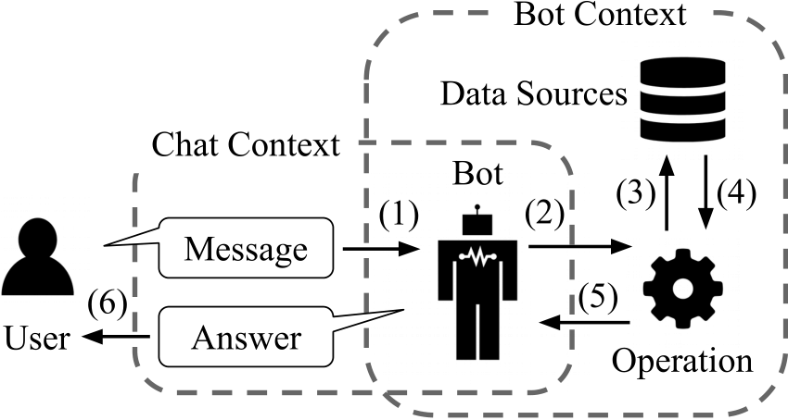

Figure 1.1 - The simple function of the chatbot

One of the struggles of simple chatbot technology is the inability to complete backend processes. Instead, they rely on the end-user to take further actions themselves.

Part of the reason for that is in many cases, contact centre agents use between 5 and 8 different systems to resolve inbound queries.

The result is that the customer is frustrated because they either have to specifically request a human agent or give up.

## 1.1 Chatbots. Basic concepts and definitions

Chatbots are chatbots that users communicate with as if they are writing to a human through messaging in the digital environment and that they use for various purposes such as getting information about a subject and taking action. Using a chatbot, it is possible to order pizza, buy movie tickets, check-in for flight, find out account balance.

There are 2 Types of Chatbots

1-Basic Chatbot:

In simple chats, the chatbot works based on pre-written keywords. Each of these given commands must be written separately by the developer using regular expressions or other forms of string analysis.

If the user has asked a question without using a single keyword, the robot cannot understand it and, as a rule, responds with messages such as "sorry, I don't understand".

2-Artificial Intelligence Powered Chatbot:

Intelligent chatbot relies on artificial intelligence when communicating with users. Instead of pre-prepared answers, the robot gives satisfactory answers on the topic. Also, all words spoken by users are saved for further processing.

Intelligent chatbot relies on artificial intelligence when communicating with users. Instead of pre-prepared answers, the robot gives satisfactory answers on the topic. Also, all words spoken by users are saved for further processing.

Figure 1.2 - Representative image of chatbot

However, the report published by the US-based Forrester institution indicates that artificial intelligence is not magic and is not yet ready to produce amazing experiences for users. On the contrary, a lot of work is required:

“Chat developers and designers need to guide conversations with soft fixes. These designers also need to encourage or even force clients to keep up with the sub-core experiences throughout the process. Because learning is really slow.”

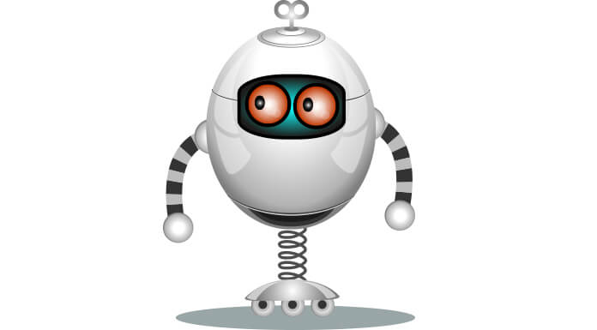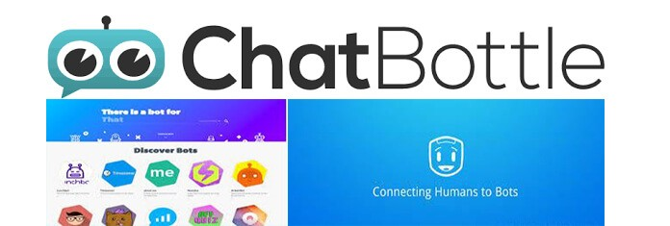

Figure 1.3 - ChatBottle company logo

There are several search engines for bots such as Chatbottle, Botlist, and There is a bot for that: for example, it helps developers notify users about the launch of new conversation bots.

## 1.2 Using chatbots in the context of human resource

The World Wide Web is becoming too crowded with various information where it is getting harder for the user to find information that they need. Usually employee or people needs to go through a long list of question and answers in a website support page in order to find out about solutions to problems that they are facing. The answers are fixed and the user might not be able to understand it. The next step that the user will take is to email the company’s human resource department or any other relevant department to ask about the problems or doubts that they are facing. This can be a hassle to the user as well as the respondent because in most cases it is a repetitive task where the user asks the same question over and over again. This can be a great amount of wasteful resources and time.

In order to increase the ease of the user and the support team, the interactionwith any sort of system, human or artificial intelligence (AI) is required. With theadvancement of intelligent systems, machines have started to impersonate differenthuman traits. In this modern age of intelligent machines, the advancement of AI has started to be even used in conversational applications. Chatbots are currently been gaining a lot of popularity especially in business sector where it is seen as a tool that can make a lot of profit. Businesses are looking to automate their interaction with humans. A chatbot can be considered as a question and answer system. This is to reduce the human effort required to do the job. Chatbots are the next stage in search evolution. The key players in search have a common and clear goal that is to better understand the meaning of a query and to return more or the most relevant results. It is not just machines that understand humans but chatbots that can do repetitively answer queries. It is a feature of natural conversation. Chatbots have the capacity to replicate this to make the search process more intuitive.

A chatbot (conversational agent, dialogue system) is a computer system that operates as an interface between human users and a software application, using spoken or written natural language as the primary means of communication. Chatbots Dialogue systems interact with users, relying on connected natural language dialogues, where the use of language goes way beyond a limited set of predefined commands. It is claimed that spoken conversation with chatbots in a manner similar to that of human- human dialogues allows for a natural, intuitive, robust, and efficient means to get knowledge or to request a transaction. Chatbots are typically useful in assisting users.

According to Chatbot Survey 2017, major information technology companies such as Facebook, Google, Microsoft and Amazon have been pushing chatbot releases along with companies like Slack, WeChat and Kik which are the new entries to chatbot. The advancements in Natural Language Processing (NLP) and Artificial Intelligence (AI) of voice and text have helped to boost chatbots to a whole new level.

Аccording to Diane Bedat from the Chatbot Survey 2017, more and more businesses see the benefit of having a chatbot to help them deal with customer service. Chatbots can take over smaller and time-consuming tasks in order for humans to dedicate their time to bigger and more important tasks. The awareness of chatbots have been increasing. According to the Chatbot Survey 2017, before 2015, only 15% of companies are aware of chatbots. These number increased to 25% in 2015 and to 60% in 2016.

Due to the success of chatbot experience, small business owners are also moving to use AI technologies to improve their daily operations, interaction withemployee and customers as well as to increase business profits. Integration fromdifferent areas with the help of bots have allow companies to introduce their software technology to better serve the company’s needs. 76% of business believe that resources to build a chatbot are easily available. 67% of businesses believe that chatbots will outperform mobile apps in the next five years.

However, there are a few disadvantages of chatbot. The first one is the inability to understand question asked by user. Chatbots are not as how conversations are made with humans. Besides that, the chatbot will have zero decision making which make it inefficient in making any sort of decision. Chatbots have a poor memory. It is not able to memorize the past conversations which forces the user to type or ask the same questions over again and again.

The use of chatbot for HR is very important and in this context, chatbot development directly affects HR. As I explained in the previous sections, it can answer any simple question (if it is registered in the chatbot's database), but the use of artificial intelligence and chatbot directly affects HR and maybe in the future HR staff can be replaced by chatbots.

## 1.3 Overview of the process of human resource support requests set in natural language

In the world where competition is increasing rapidly with the development of technology, HR managers; collection of accurate data on personnel and work process, personnel training and recruitment, orientation process, and performance appraisal etc. They use artificial intelligence technologies to facilitate difficult functions.

Artificial intelligence enables HR Managers to do their jobs faster and more efficiently. Artificial intelligence is also used in various departments such as human resources department, finance department, marketing and production department.

This study deals with human resource management in a historical perspective. The main purpose of the study is to examine the role of artificial intelligence in human resource management.

However, it tries to address how AI supports Human Resources functions such as recruitment, screening and interview process, training and talent management. As a result of the study, ideas about the intersection of artificial intelligence and human resource management cases, and some institutional and academic suggestions for the future are included.

## 1.4 Overview of existing software for query analysis in natural language

NLP Technology Overview. Machine learning models for NLP: We mentioned earlier that modern NLP is heavily based on an approach to artificial intelligence called machine learning. Machine learning makes predictions by generalizing samples from a dataset. This dataset is called training data, and machine learning algorithms are trained on this training data to create a machine learning model that performs a target task.

For example, sentiment analysis training data consists of sentences containing emotion (for example, positive, negative, or neutral emotion). A machine learning algorithm reads this dataset and generates a model that takes sentences as input and returns emotions. Such models, which take sentences or documents as input and introduce a label for that input, are called document classification models. Document classifiers can also be used to classify documents based on the topics they cover (for example, as sports, finance, politics, etc.).

Another model is used to recognize and classify entities in documents. For each word in the document, the model predicts whether the word is an entity expression and, if so, what type of entity is being referred to. For example, in the sentence "Share of Company XYZ traded for $28 yesterday," "Company XYZ" is a company asset, "$28" is a currency amount, and "yesterday" is a date. Training data for entity recognition is a collection of text where each word is labeled as it relates to whatever type of entity. Such patterns that generate a tag for each word in the input are called string tagging patterns.

Series-to-series models are one of the newest members of the model family used in NLP. The string-to-array (or seq2seq) model takes an entire sentence or document as input (just like a document classifier) but produces a sentence or other sequence (for example, a computer program) as output. (The document classifier, on the other hand, produces only a single symbol as output.) Examples of Seq2seq models include machine translation, document summarization (the output is a summary of the input), and semantic parsing (the input is a summary of the input) that takes an English sentence as input and returns a French sentence. is a query or request, and the output is a computer program that implements the request).

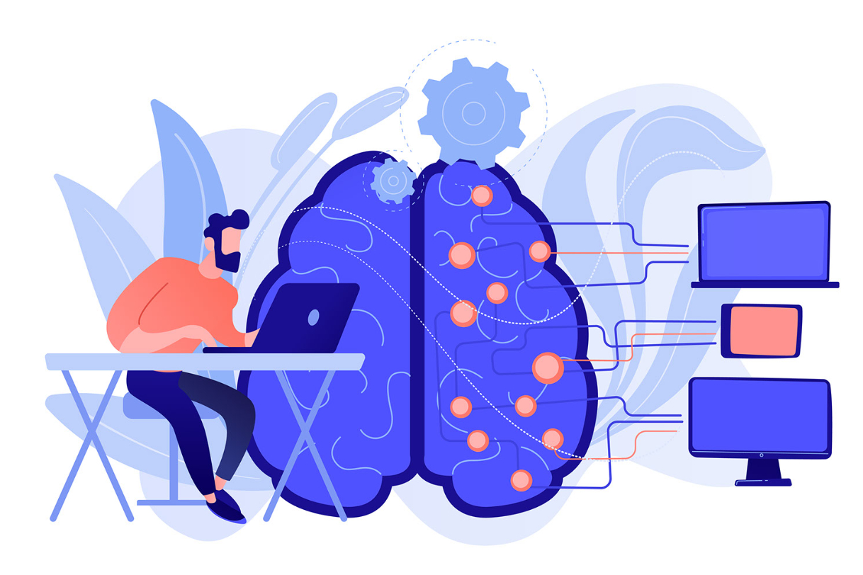

Figure1.4 - NLP icon

Deep learning, pre-trained models and transfer learning: Deep learning is the most widely used type of machine learning in NLP. In the 1980s, researchers developed neural networks. In these neural networks, multiple primitive machine learning models converge into a single network. Similar to the brain, simple machine learning models are sometimes referred to as "neurons." These neurons are arranged in layers, and the deep neural network contains many layers. Deep learning is machine learning that uses deep neural network models.

Because of their complexity, training a deep neural network requires a lot of data, and processing this data requires a lot of computing power and time. Modern deep neural network NLP models are trained from a variety of sources such as Wikipedia and data from the web. Training data can be 10 GB or larger and may require a week or longer to train the deep neural network on a high-performance cluster. (Researchers have found that training even deeper models from even larger datasets performs better. So there is a race to train even larger models from larger datasets.)

The extensive data and computing requirements of Deep Neural Networks may seem to severely limit their usefulness. However, transfer learning enables a trained deep neural network to be more trained to perform a new task with much less training data and computing effort. The simplest type of transfer learning is called fine tuning. It basically means first training the model on a large general dataset (e.g. Wikipedia) and then training ("tweaking") the model on a much smaller task-specific dataset with the actual target task tag. Surprisingly, fine-tuning datasets can be extremely small, consisting of only hundreds or even dozens of training samples, and fine-tuning training can be performed in minutes on a single CPU. Transfer learning facilitates company-wide deployment of deep learning models.

There is now an extensive ecosystem of providers offering pre-trained deep learning models trained in different combinations of languages, datasets, and pretraining tasks. These pre-trained models can be downloaded and fine-tuned for a wide range of target tasks.

# 2 SELECTING TOOLS AND CREATING A CHATBOT FOR HUMAN RESOURCE

## 2.1 Formation of functional and non-functional requirements

UML diagrams is created for the purpose of understanding the system and to keep the project within the scope of the project. The diagrams also allow developers to get insights of the processes that is occurring at the back end of the system. For this research, a total of five UML diagrams are created. The diagrams are use case diagram, class diagram, sequence diagram, communication and activity diagram. Full description of the functional and non-functional requirements are presented in the Table 2.1.

Table 2.1 – Description of the functional and non-functional requirements

|  |  |
| --- | --- |
| Functional Requirements | Non-functional requirements |
| Functional requirements help to understand the functions of the system. | They help to understand the system's performance. |
| Functional requirements are mandatory. | While non-functional requirements are not mandatory. |
| They are easy to define. | They are hard to define. |
| They describe what the product does. | They describe the working of product. |
| It concentrates on the user's requirement. | It concentrates on the expectation and experience of the user. |
| It helps us to verify the software's functionality. | It helps us to verify the software's performance. |
| These requirements are specified by the user. | These requirements are specified by the software developers, architects, and technical persons. |
| There is functional testing such as API testing, system, integration, etc. | There is non-functional testing such as usability, performance, stress, security, etc. |
| Examples of the functional requirements are - |  |
| Authentication of a user on trying to log in to the system. | Examples of the non-functional requirements are - |
| The background color of the screens should be light blue. |  |
| These requirements are important to system operation. | These are not always the important requirements, they may be desirable. |
| Completion of Functional requirements allows the system to perform, irrespective of meeting the non-functional requirements. | While system will not work only with non-functional requirements. |

Requirement list are presented in Table 2.2.

Table 2.2 - Requirement List of Chatbot for Employee

|  |  |  |  |
| --- | --- | --- | --- |
| No. | Requirement | Use Case | Actor |
| 1. | The employee can ask questionsto the chatbot. | Enter Query | Employee |
| 2. | Employee can view the results. | View Results | Employee |
| 3. | Replies are shown to theemployee. | Display Message | Messagingchannel |
| 4. | Employee can enter their name. | Enter Information | Employee |
| 5. | Database that store all theemployee FAQs. | Store FAQ | Database |
| 6. | The questions asked byemployee are forwarded to the Natural Language Processing to generate appropriate replies. | Forward message for processing | Chatbot |
| 7. | The employee’s questionintentions are analysed using the Word tags or Key words. | Define intents | Natural LanguageProcessing |
| 8. | The employee’s questions arecategorized to generate the most appropriate response. | Classify intents | Natural LanguageProcessing |
| 9. | Text analysis of people, locationand organization is done to look for the best replies. | Extract entities | Natural LanguageProcessing |
| 10. | The analysed question isgenerated with the best replies to the employee. | Pass extracted entities and intents | Natural LanguageProcessing |

Figure 2.1 shows the main components of this chatbot system is labelled as actors.

There is a total of five actors which are employee, chatbot API, messaging channel, database and natural language processing. The employee can enter query, view results, display message and enter information. The messaging channel acts as a middleware to get the query and display replies. The database stores the information and also stores the FAQs. The chatbot API forwards message of the employee to the database, forms a complete message, forwards the response to the employee. The natural language processing defines intents, extract entities and pass the extracted entities and intents to the chatbot API.

Figure 2.1 - Chatbot for Employee Use Case Diagram

## 2.2 Applied Techniques for Chatbot

Modern chatbot solutions leverage artificial intelligence, machine computer (ML) and natural language processing (NLP) to provide insights in real time. These technologies can instantly analyze data and suggest actions that are most likely to produce the desired result.

More than that though, AI chatbots are your website, social media, mobile app, etc, connected to a knowledge base and all connected data sources via NLP layers. communicates through channels such as

Natural language processing is the performance of chatbots to analyze and play human speech to provide contextually correct alerts.

NLP aims to make chatbot interactions feel like a conversation between two people, separating the two key times.

Natural language understanding (NLU) maintains a chatbot's human speech understanding data and is able to obtain it in a way that software can understand (purposes and entities).

Intents perform the users' goal, i.e. to find information or perform a certain action.

Entities complete the purpose and include dates, dimensions, location, etc. includes details such as

Natural language generation (NLG) is responsible for translating this data back into text.

The chatbot uses a dialect of XML known as Artificial Intelligence Markup Language (AIML) to identify patterns and metrics in its data before sending a response, so it can present responses contextually.

For example, if a customer enters a query in Messenger, the NLP layer first translates it into intents and entities. Following this, this behavioral data, usage history, etc. is analyzed to identify patterns that help provide a personal training with the best possible controls runs with.

### 2.2.1 Natural Language Processing

Natural Language Processing (NLP) Definition

Natural language processing (NLP) is a branch of artificial intelligence (AI) that enables computers to comprehend, produce, and manipulate human language. Natural language processing has the ability to query data with correct language text or voice. This is also called "language input". Many consumers have probably interacted with NLP without even realizing it. For example, the core technology behind virtual assistants like Oracle Digital Assistant (ODA), Siri, Cortana or Alexa is NLP. When we ask these virtual assistants questions, it is NLP that allows the assistants to both understand the user's request and respond in natural language. NLP applies to both written and spoken text and can be applied to all languages. Other examples of NLP-powered tools include web search, spam filters, automatic text or speech translation, document summarization, sentiment analysis, and grammar/spelling. For example, some e-mail programs may suggest appropriate replies based on message content. These programs use NLP technology to read, analyze and respond to your message.

There are several other terms that are used synonymously with NLP in a general sense. Natural language understanding (NLU) means understanding human language using computers, and natural language generation (NLG) means producing. NLG has the feature of verbal explanation of a situation. This is also called "language output", which summarizes and converts meaningful information into text with the help of a concept known as "graphic grammar".

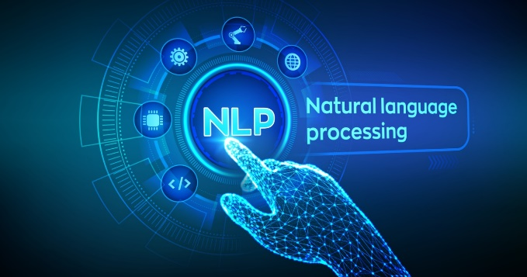

Figure 2.2 – NLP

In practice, NLU is used to mean NLP. It is the understanding that allows developers and users to interact with computers with natural sentences and communications by understanding the structure and meaning of computers, all languages. Computational linguistics (CL) is a scientific field that studies the computational properties of human languages. NLP, on the other hand, is an engineering discipline that deals with building computerized entities that understand, generate, or manipulate human language.

NLP studies began shortly after the invention of digital computers in the 1950s, and NLP draws on both linguistics and artificial intelligence. But major breakthroughs in the last few years have come from machine learning, a branch of artificial intelligence that develops systems that learn from data and make generalizations. Deep learning is a variant of machine learning that can learn very complex patterns from large data sets. So it's ideal for learning natural language complexities from web-sourced datasets.

NLP Programming Languages

Python:

NLP Libraries and toolkits are usually available in Python. This is because the vast majority of NLP projects are developed in Python. Python's interactive development environment makes it easy to develop and test new code.

Java and C++:

C++ and Java are generally preferred for handling large amounts of data because of their more efficient code support.

### 2.2.2 Pattern Recognition (Matching, Mapping)

"Pattern recognition" is the process of recognizing patterns, regularities, or relationships in data or information. It involves identifying and categorizing patterns, as well as detecting and describing relationships and dependencies between variables.

There are two main types of pattern recognition: matching and mapping.

"Matching" is the process of finding a pattern or a set of patterns in an input and comparing it to a set of stored patterns to determine the closest match. This is often used in image recognition, where an image is compared to a set of stored images to determine what object it depicts.

"Mapping" is the process of creating a map or a representation of the relationship between two sets of variables. This can be used to describe patterns in data, as well as to create predictions based on past observations.

Both of these techniques are widely used in a variety of applications, including machine learning, artificial intelligence, computer vision, and data analysis.

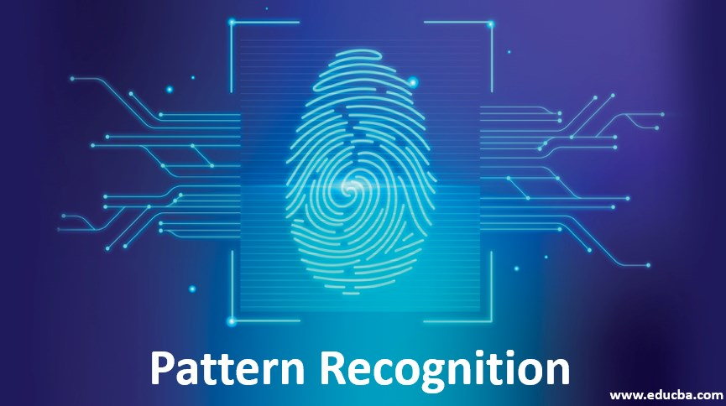

Figure 2.3 - Pattern Recognition

### 2.2.3 Semantic web:

The "Semantic Web" is an idea proposed by Tim Berners-Lee, the inventor of the World Wide Web. It refers to a vision of the Web where information is not only connected and accessible, but also meaningful and understandable by computers.

The Semantic Web is built on the concept of linking data and making it more machine-readable, so that computers can understand the relationships between different pieces of information and use this understanding to perform tasks such as data integration, reasoning, and decision making.

To achieve this, the Semantic Web uses technologies such as RDF (Resource Description Framework), OWL (Web Ontology Language), and SPARQL (SPARQL Protocol and RDF Query Language) to represent and link data in a machine-readable format. This allows computers to automatically process and analyze vast amounts of data, enabling new applications and services that were not possible before.

The Semantic Web is still an evolving field, and its full potential has yet to be realized, but it holds promise for transforming the Web into a more intelligent and interconnected space.

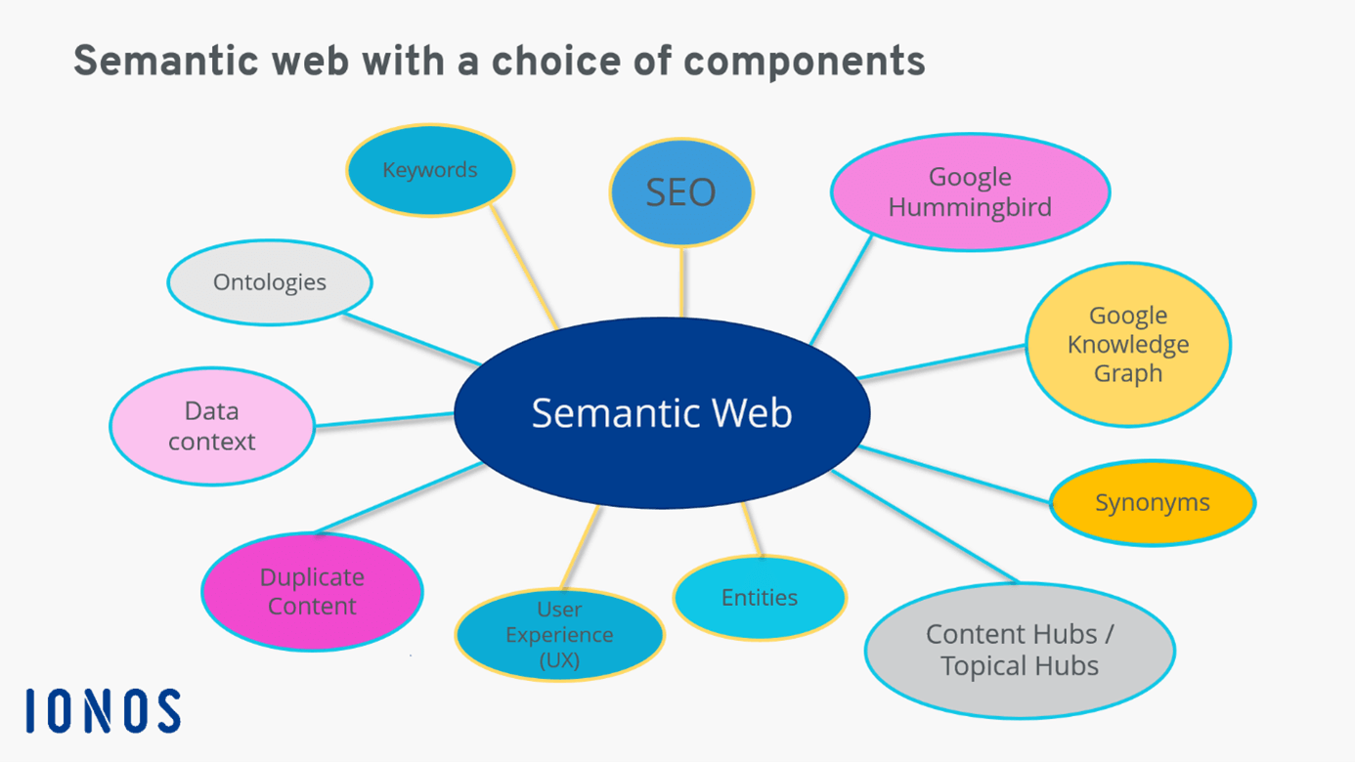Figure 2.4 - Semantic web with a choice of component

### 2.2.4 Data Mining

"Data mining" is the process of discovering patterns, relationships, and insights in large amounts of data. It involves the use of statistical and machine learning techniques to analyze and extract information from data, often with the goal of making better decisions and identifying new opportunities.

Data mining is used in a variety of industries and applications, including marketing, finance, healthcare, and scientific research. It can help organizations identify patterns and trends in customer behavior, detect fraud, improve customer relationships, and make more informed decisions.

Data mining typically involves several steps, including data preparation, pattern discovery, pattern evaluation, and knowledge representation. These steps help ensure that the information obtained from the data is accurate, meaningful, and useful.

Overall, data mining is an important tool for organizations that want to leverage their data to make better decisions and gain a competitive advantage.

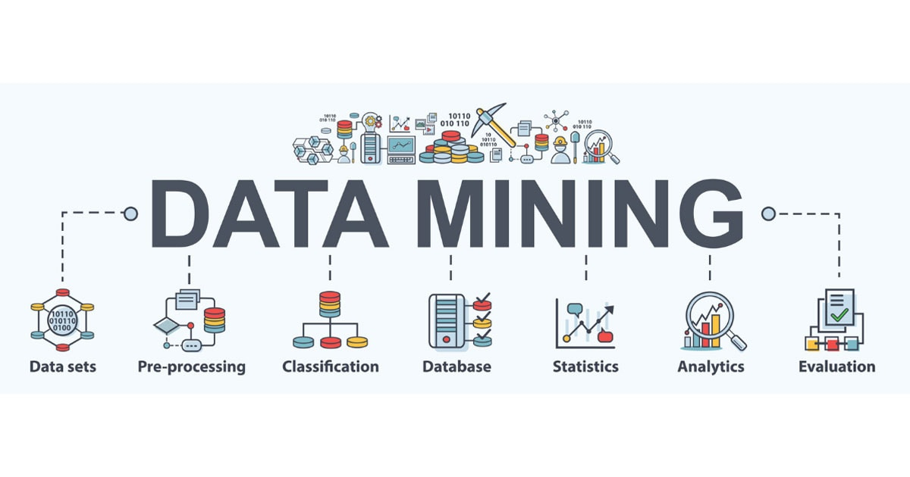

Figure 2.5 - Picture of where data mining can be used

## 2.3 Architecture of Chatbot

The architecture of a chatbot can vary depending on the specific requirements and objectives of the chatbot, but typically includes the following components:

Natural Language Processing (NLP): This component is responsible for understanding and processing the natural language used by users to interact with the chatbot. NLP techniques such as tokenization, stemming, and named entity recognition are used to extract meaningful information from user input.

Dialogue Management: This component is responsible for managing the flow of the conversation between the user and the chatbot. It determines the appropriate response to a user's input based on the context of the conversation and the information available.

Knowledge Base: This component stores the information and data that the chatbot uses to generate its responses. It may include databases, APIs, or other sources of information that the chatbot can access to provide relevant and accurate answers to users.

User Interface: This component is responsible for presenting the chatbot's responses to the user and allowing users to interact with the chatbot. This may include a graphical interface, text-based interface, or voice-based interface, depending on the chatbot's design and capabilities.

Analytics and Reporting: This component is responsible for collecting and analyzing data on user interactions with the chatbot. This information can be used to improve the performance and accuracy of the chatbot over time.

Overall, these components work together to provide a seamless and intuitive experience for users interacting with the chatbot, allowing them to easily access information and complete tasks (figure 2.6).

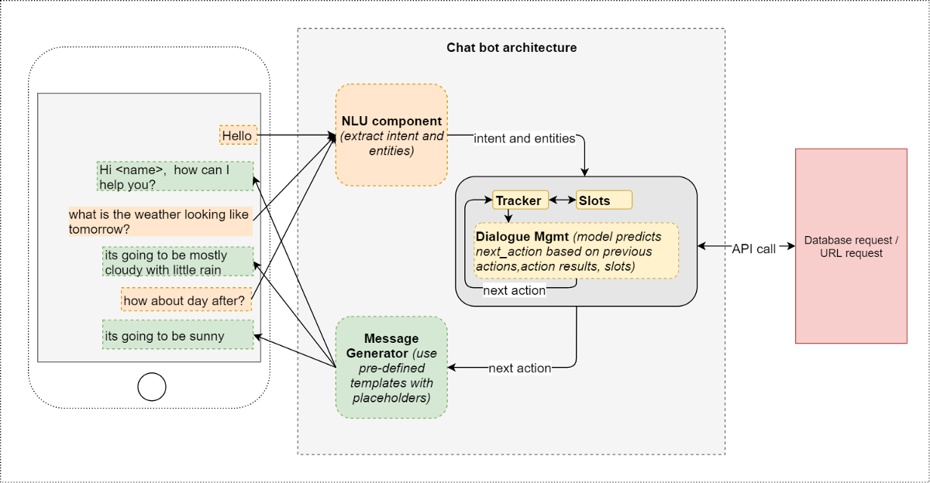

Figure 2.6 - Architecture of Chatbot

## 2.4 Choosing a chatbot development platform

When choosing a chatbot development platform, there are several factors to consider, including:

Functionality: Consider the features and capabilities offered by the platform, such as NLP, integration with external systems, and the ability to customize the chatbot's appearance and behavior.

Ease of Use: Look for a platform that is user-friendly and does not require extensive technical expertise to use. This can help speed up development and reduce costs.

Scalability: Consider the platform's ability to scale to meet the growing demands of your chatbot. Can it handle increasing traffic and data volumes, and does it provide the necessary resources to ensure reliable performance?

Integrations: Evaluate the platform's ability to integrate with other systems and technologies, such as databases, APIs, and messaging platforms.

Pricing: Consider the cost of the platform, including any ongoing fees and usage charges. Be sure to compare pricing and features across multiple platforms to find the best value for your budget.

Support and Documentation: Look for a platform that provides comprehensive support and documentation to help you get started and troubleshoot any issues that may arise.

Community and Resources: Consider the size and activity level of the platform's community and the availability of resources, such as forums, documentation, and tutorials. This can help you get answers to questions and find support when needed.

By considering these factors, you can choose a chatbot development platform that best meets your specific needs and requirements.

# 3 DESIGN AND IMPLEMENTATION OF AI CHATBOT

Define the purpose and scope of the chatbot: Before starting the design, you need to define the purpose and scope of the chatbot. For example, the chatbot can be used to answer employee questions about company policies, benefits, or provide assistance with onboarding.

Determine the platform and programming language: Once you have defined the purpose and scope, you need to determine the platform and programming language to use for the chatbot. There are various platforms available such as Dialogflow, IBM Watson, and Amazon Lex. You can also use programming languages such as Python, Java, or Node.js.

Create a conversational flow: After selecting the platform and programming language, create a conversational flow that maps out the possible interactions between the chatbot and the user. This should include the possible questions or statements that the user might make and the corresponding responses from the chatbot.

Develop the chatbot: Once you have created the conversational flow, you can start developing the chatbot. This involves coding the conversational flow into the chosen platform or programming language. You may also need to integrate the chatbot with other systems, such as HR databases or knowledge management systems.

Train the chatbot: To improve the chatbot's accuracy and effectiveness, you need to train it using a combination of supervised and unsupervised learning techniques. This involves providing the chatbot with sample questions and answers, and then using natural language processing algorithms to identify patterns and improve its responses.

Test and refine the chatbot: Once the chatbot has been developed and trained, it's important to test it thoroughly and refine it based on user feedback. This involves conducting usability tests, analyzing user feedback, and making improvements to the conversational flow and the chatbot's responses.

Deploy the chatbot: After testing and refining the chatbot, you can deploy it to your HR platform or website, making it available to employees.

Overall, designing and implementing an AI chatbot for HR requires a combination of technical expertise and understanding of HR policies and procedures. However, the benefits of having an AI chatbot for HR can be significant, including increased efficiency, improved accuracy, and enhanced employee satisfaction.

## 3.1 Design of AI chatbot

Here is a high-level overview of the design of an AI chatbot:

Identify the purpose and scope: The first step in designing an AI chatbot is to identify its purpose and scope. What problem does it solve? Who is the target audience? What kind of tasks or questions should the chatbot be able to handle?

Choose the platform and technology stack: Once you have a clear understanding of the chatbot's purpose and scope, you need to choose the platform and technology stack to use. There are many chatbot platforms available, including Dialogflow, IBM Watson, and Amazon Lex. You also need to choose the programming language and frameworks you will use to build and train your chatbot.

Define the conversational flow: Next, you need to define the conversational flow of the chatbot. This involves mapping out all the possible interactions that a user might have with the chatbot and the corresponding responses. You can use a tool like a flowchart or decision tree to visualize the conversational flow.

Develop and train the chatbot: With the conversational flow defined, you can begin developing and training the chatbot. This involves coding the conversational flow into the chosen platform or programming language and training the chatbot with appropriate data. You may also need to integrate the chatbot with other systems, such as databases or APIs.

Test and refine the chatbot: Once the chatbot has been developed and trained, you need to test it to ensure it is functioning as intended. You can use automated testing tools or perform manual testing to identify bugs or areas for improvement. Based on feedback from testing, you can refine the conversational flow and training data to improve the chatbot's performance.

Deploy the chatbot: Once you are satisfied with the chatbot's performance, you can deploy it to your desired platform or channels, such as a website or messaging app.

Monitor and maintain the chatbot: After deploying the chatbot, you need to monitor its performance and user feedback. This can help identify areas for further improvement or additional functionality. You may also need to maintain the chatbot by updating training data or fixing bugs that may arise over time.

Overall, designing an AI chatbot requires a combination of technical expertise, user research, and a deep understanding of the chatbot's purpose and audience. By following these steps, you can create an AI chatbot that meets your users' needs and delivers an engaging and efficient user experience.

Figure 3.1 shows the different classes in the chatbot for employee system. There are four classes which are employee class, chatbot class, natural language processing class and database class. The employee class stores the chat history in an array and basic information of employee. This employee class is where the method of giving a query and entering information. The chatbot class contains the queries and identified word tags and keywords.

Figure 3.1 - Chatbot for Employee Class Diagram

Generally, in sequence diagram (fig.3.2) flows in a timely manner. Figure 3.2 shows the sequence diagram of chatbot for employee. The first step is the employee enters a query that goes to the chatbot. The chatbot picks up the keywords of the query and check for a matching query in the database. If there is a matching keywork, the related answer is picked from the database and forwarded to the chatbot. If there is no matching keyword in the database the query is sent to the natural language processing. The natural language processing generates a response using cognitive services. Lastly, the response is displayed to the employee.

Figure 3.2 - Chatbot for Employee Sequence Diagram

Figure 3.3 is the communication diagram of chatbot for employee. The employee enters a query. The chatbot check for keyword of the question in the database. If the scope is available a response is generated. If the scope is unavailable the natural language processing analyses the question and generates response using cognitive services. The chatbot sends the request and the response is displayed to the employee.

Figure 3.3 - Chatbot for Employee Communication Diagram

Figure 3.4 shows an activity diagram of chatbot for employee. Firstly, the employee starts the process by either entering an information or entering a question. The information entered is stored in the database while the question entered goes to the chatbot where two outcomes can be made, either the question asked is within the scope or it is out of scope. If the question is within scope the chatbot uses intent and entity recognition to generate a response. If the question is out of scope the natural processing language uses machine learning and cognitive services to generate a new response. At the same time these new responses are stored in the database for future use. Lastly, the response is displayed to the employee.

Figure 3.4 - Chatbot for Employee Activity Diagram

## 3.2 Software implementation of AI chatbot

NLTK (Natural Language Toolkit) is a popular Python library used for natural language processing tasks such as tokenization, stemming, lemmatization, part-of-speech tagging, and text classification. It provides a comprehensive set of tools and resources for working with human language data.

Some key features of NLTK include:

1. Tokenization: The process of breaking up a text into words, phrases, symbols, or other meaningful elements, which are called tokens.

2. Part-of-speech tagging: The process of identifying and labeling the part of speech (e.g., noun, verb, adjective) of each word in a sentence.

3. Stemming and lemmatization: The process of reducing words to their base or root form, for example, "jumping" to "jump".

4. Named entity recognition: The process of identifying and categorizing named entities (e.g., people, organizations, locations) in a text.

5. Text classification: The process of categorizing a text into predefined categories or classes, based on its content.

NLTK provides a wide range of corpora, lexical resources, and models for natural language processing, as well as algorithms and tools for building your own language models and classifiers. It is widely used in research and education, as well as in industry applications such as chatbots, sentiment analysis, and text mining.

Python:

Python is a popular high-level programming language used for a wide range of applications, including web development, data analysis, machine learning, and more.

Python is known for its simplicity, readability, and ease of use, making it a great language for beginners to learn. It uses indentation to structure code, instead of using brackets or other symbols like some other programming languages.

Python has a large standard library, which provides pre-written modules and functions that you can use to perform various tasks without having to write the code from scratch. Additionally, there are many third-party libraries and frameworks available that can be easily installed and used in your Python projects.

Python is an interpreted language, which means that your code is not compiled into machine code before execution. Instead, the Python interpreter reads your code line-by-line and executes it on-the-fly. This makes it easier to test and debug code, but can sometimes result in slower performance compared to compiled languages.

Overall, Python is a versatile and powerful language that can be used for a wide range of applications, and its simplicity and ease of use make it a great choice for beginners and experienced programmers alike.

I use cleverbot and Google translate pack

Cleverbot: Cleverbot.com used to have a free API for their chatbot application. They have removed their free API in place of a tiered subscription API service.

cleverbotfree is a free alternative to that API that uses a headless Firefox browser to communicate with their chatbot application. You can use this module to create applications/bots that send and receive messages to the Cleverbot chatbot application.

Google Translate: Googletrans is a free and unlimited python library that implemented Google Translate API. This uses the Google Translate Ajax API to make calls to such methods as detect and translate.

Figure 3.5 – Example of Project program code for Chat Bot

That’s example of a Project program code for HR Code (Figure 3.5)

Figure 3.6 - Chatbot data base code (cont.)

Figure 3.7 - Chatbot data base code (cont.)

Program code for data base questions and answers are presented in fig.3.6-3.7.

## 3.3 Chat Bot Interface

An interface is a program that allows a user to interact with the computer or another computer over a network. This is the front end of a system. The purpose of an interface is to enable users to communicate with a computer with the most userfriendly way. There are two interfaces of chatbot for employee. The first is the web interface and the second is Facebook Messenger Integration interface.

The web interface is using basic HTML and CSS. The Chatbot is included to the webpage. This web application can be used on device that has a web browser. This is to allow users to use the Chatbot on any device. The text is in white and tht background is back to give a clear contrast for the users to read information on the website clearly. In the website, there is also options to email the admin if there are problems getting relevant answers. This is to help users seek for admin support.

Figure 3.8 shows the web interface of chatbot for employee.

Figure 3.8 - Web Interface of Chatbot

# 4. EXPERIMENTAL RESULTS

A chatbot for HR can be used to automate routine tasks, provide information, and answer common questions from employees. Here are some steps to develop a chatbot for HR:

1. Identify the purpose and scope of the chatbot: Determine what tasks the chatbot will perform, which employees it will serve, and what types of questions it will answer.

2. Define the conversational flow: Determine the questions the chatbot will ask and the responses it will provide based on the purpose and scope identified in step 1.

3. Develop the chatbot: You can use a natural language processing (NLP) platform such as Dialogflow, Wit.ai, or IBM Watson to develop the chatbot. These platforms allow you to define the conversational flow and train the chatbot to recognize and respond to specific intents.

4. Integrate with HR systems: The chatbot should be able to access employee data and HR systems to perform tasks such as checking leave balances, submitting expense claims, or updating personal information.

5. Test and iterate: Test the chatbot with a small group of employees and refine the conversational flow and responses based on feedback.

Once the chatbot is developed and integrated with HR systems, employees can interact with it through various channels such as Slack, Microsoft Teams, or a company intranet. The chatbot can help employees with a range of tasks such as scheduling appointments, answering benefits-related questions, or providing information on company policies.

Overall, a chatbot for HR can help streamline HR processes, reduce the workload of HR staff, and provide a better employee experience.

## 4.1 Analysis of changes in the work processes of the human resource service after the implementation of the chatbot

The implementation of a chatbot in the human resource service can lead to significant changes in work processes. Here are some potential impacts:

1. Reduced workload: The chatbot can handle repetitive and routine tasks, such as answering frequently asked questions, scheduling interviews, and processing paperwork. This can free up HR staff to focus on more complex and strategic tasks.

2. Increased efficiency: The chatbot can work 24/7 without breaks and can handle multiple inquiries simultaneously. This can result in faster response times and improved service delivery.

3. Improved accuracy: The chatbot can be programmed to provide accurate and consistent responses, reducing errors that can occur from manual processing.

4. Enhanced candidate experience: The chatbot can provide timely and personalized responses to candidates, enhancing their experience and improving their perception of the organization.

5. Data analysis: The chatbot can collect and analyze data on candidate inquiries and feedback, providing insights that can inform HR decision-making.

However, it's important to note that implementing a chatbot is not a one-size-fits-all solution. It's crucial to assess the needs and capabilities of the organization before implementing a chatbot and to ensure that the chatbot is integrated into the overall HR strategy. Additionally, human oversight is still necessary to ensure that the chatbot is providing accurate and appropriate responses.

The findings and discussion methods used is to get a reliable feedback from the users of the application. This is done through the distribution of questionnaires to users using a Google form. The main purpose of this is to identify if the users are satisfied with the web application.

Figure 4.1 - Survey Question 1

Based on the chart, 6.6% indicated Strongly Agree, 56.7% indicates Agree and 36.7% indicated Neutral. This shows users feel comfortable sharing information with a chatbot.

Figure 4.2 - Survey Question 2

Based on the chart, 63.3% would ask about Salary, 56.7% would ask about Leave, 53.3% would ask about working hours and 3.3% would ask about Allowance. This shows that most users will ask for their salary followed by leave and working hours.

Figure 4.3 - Survey Question 3

Based on the chart, 23.3% Strongly Agree, 43.3% respondents Agree and 33.3% are Neutral. This shows that most of the respondents have a positive feedback on the usefulness of a chatbot.

Figure 4.4 - Survey Question 4

Based on the chart, 90% wants instance responses feature. 66.7% wants 24-hour service. 40% wants a friendly and approachable 36.7% wants answers to simple questions. This means that users most wanted feature is instance responses followed by 24-hour service.

Figure 4.5 -Survey Question 5

Based on the chart, 16.7% Strongly Agree, 50% Agree and 33.3% Neutral. This shows that chatbot can definitely improve in terms of total reply time compared to traditional method of communication among company employee and human resource department.

Figure 4.6 - Survey Question 6

Based on the chart, 20% Strongly Agree, 46.7% Agree, 30% Neutral and 3.3% Disagree. Most of the respondent agree to this because an easier way is to get instant answers is by using a chatbot.

Figure 4.7 - Survey Question 7

Based on the chart, 23.3% Strongly Agree, 40% Agree, 33.3% Neutral and 3.4% Disagree. Most of the respondent have a positive view that chatbots can help improve employee productivity.

## 4.2 Analyze the labor and time required to develop and implement a chatbot:

Developing and implementing a chatbot can require a significant amount of labor and time, depending on the complexity of the chatbot and the resources available for development. Here are some factors that can impact the labor and time required:

1. Chatbot platform: There are several chatbot platforms available that provide a user-friendly interface to create chatbots without requiring extensive coding knowledge. These platforms can significantly reduce the time and labor required for chatbot development. However, more complex chatbots may require custom development, which can be more time-consuming and labor-intensive.

2. Chatbot functionality: The functionality of the chatbot can significantly impact the labor and time required for development. Basic chatbots that provide simple responses can be developed relatively quickly. However, more complex chatbots that can handle multiple tasks and integrate with other systems can require more development time and effort.

3. Integration with HR systems: If the chatbot needs to integrate with existing HR systems, such as an applicant tracking system or HRIS, additional development time may be required to ensure a seamless integration.

4. Training and testing: Once the chatbot is developed, it will need to be trained and tested to ensure that it can handle a variety of user inquiries and scenarios. This process can require additional labor and time, especially if the chatbot needs to be retrained or updated.

Overall, developing and implementing a chatbot can require significant labor and time. However, the benefits of a chatbot, such as increased efficiency and improved user experience, can make it a worthwhile investment for HR departments.

## 4.3 Chat Bot Testing

The main purpose of unit testing is to make sure that every button of the web application is tested and functions correctly. This is to ensure all functions of the web application works well without any errors.

Table 4.1 - Interface Unit Testing Results

|  |  |  |
| --- | --- | --- |
| ELEMENT | RESULT | STATUS |
| TextView | The textView hold anddisplay the text correctly. | Success |
| Button | All the buttons arefunctional and work as expected. | Success |
| TextBox | All the textbox holds andinserts text inside the box correctly. | Success |
| ImageView | All images are able todisplay and at the correct place. | Success |

This is the second testing phase that is completed after the unit testing. During the software testing it is important that the system scope is achieved. The purpose of the testing is to evaluate the system compliance with the system requirements. It is also important in the testing phase the web application reaches full functionality in terms of the scopes and objectives of this project.

The test is a documentation with details of objectives, target market, beta team and processes for a specific beta test for the software or hardware product. The plan consists of a detailed plan of the eventual workflow. A test plan is to ensure that the product or system meets its design specifications and requirements.

Table 4. - Testing Plan of System Testing

|  |  |  |  |  |
| --- | --- | --- | --- | --- |
| NO | Test | Objective | Test Input | Results |
| 1. | Launching of web application | To determine the website is functional. | Scan website QR code. | Website launches. |
| 2. | Testing Webhooks | To determineif the Chatbot is connected to the website. | Type a test message in website. | Chatbot able to reply. |
| 3. | Test integration with Facebook Messenger | To determine if the Azure Chatbot created is able to connect to Facebook Developer. | Type test message. | Chatbot able to reply. |
| 4. | Test Chatbot with various queries. | To determine if the Chatbot is able to perform as expected. | Type various questions. | Chatbot able to determine the best answer. |

The Bot framework emulator is a desktop application that allows bot developers to test and debug their bots, either locally or remotely. Using the emulator, developer or tester can chat with the bot and inspect the messages that it sends and receives. The emulator displays messages as they would appear in a web chat UI and logs JSON requests and responses. The bot emulator connects to the given endpoint URL, when chatbot application is running, and emulates a communication between bot and user.

The endpoint URL is configured in Bot Builder sdk and default endpoint for local debugging is usually <http://localhost:3978/api/messages>. Figure 4.8-4.11 shows the dialog and result outputs produced by the bot. The view helps developers see the sequence sent to the application and response from it. Logs of requests and responses in right lower corner with information about API activities and codes of statuses. For testing the posting menu GET method the specified URL can simply opened by web browser, as browsers by default send a GET request to the given address.

Figure 4.8 - Chatbot wrong input

If you ask the questions correctly (that is, if your question and its answer are registered in the chatbot), this is the answer you will get (Figure 4.8).

Figure 4.9 - Chatbot correct question and answer output

Figure 4.10 -Test code with input

# 5 ECONOMIC ANALYSIS

## 5.1 Building the Canvas business model of the project

Human Resource refers to personnel in an organization termed as an asset on the basis of skills and competencies. HRM refers to planning the human resource needs of the organization and hiring the right kind and number of people at the right time and placing them in the right job. It also involves developing the skills of the employees to make them more competent in the organization. HR bots are just machines which are designed to reduce the burden of the employees by accomplishing repetitive and routine tasks which if streamlined do not require human intervention. The HR bots can perform routine functions like onboarding, training, query resolutions, employee assessments and reviews, exit management, surveys etc.

The Canvas business model – one of the tools of strategic management for entrepreneurs which allows to graphically represent the business model of the project. It is primarily intended for existing businesses and companies and is used to analyze an existing business model in order to find weaknesses or growth points.

1. Customer segments. In this section it is necessary to specify key segments.
2. Key values. The uniqueness of the product.
3. Sales channels. The channels through which a company communicates with its customers are an integral part of any business. This takes into account all points of contact with customers.
4. Customer relationships.
5. Income flows.
6. Key resources.
7. Key activities.
8. Key partners.

9 Cost structure.

The Canvas business model developed for the diploma work is shown on figure 5.1.

|  |  |  |  |  |
| --- | --- | --- | --- | --- |
| *Key Partners*  - big companies;  - marketing agency for online stores; | *Key Activities*  - product quality control;  - control of personal data security;  - providing discount offers. | *Value Proposition*  - onboarding,  - training, query resolutions,  - employee assessments and reviews,  - surveys  - ensuring the security of personal data;  - the ability to use a mobile device. | *Customer Relationships*  - 24/7 support;  - seasonal offers;  - discount for regular customers;  - consultations for clients. | *Customer Segments*  - governmental enterprises,  - companies |
| *Key Resources*  - suppliers;  - administrator;  - marketer;  - facilities for products;  - technical support staff;  - IP and the Internet. | *Sales Channels*  - pages and advertising on Facebook, Instagram;  - sending information about new products to users by mail; - free promotion (original order packaging). |
| *Cost Structure*  - maintenance of the information system;  - Internet payment;  - payment for technical support;  - promotion costs;  - the cost of delivery when returning the goods. | | *Revenue Streams*   * HR management. | | |

Figure 5.1 – The Canvas business model

## 5.2 Calculation of the cost of software development

Development costs are one-time costs for the development of functional systems, or their elements at all stages of design, as well as the cost of their improvement. This includes the cost of salaries for specialists and the cost of purchasing equipment.

The total cost of designing the system, its development is determined by the formula (5.1):

(5.1)

where n – the number of employees involved in project development;

– salary costs of a worker of the 1st category, UAH;

– equipment purchase costs;

– the cost of purchasing additional software.

To calculate salary use the formula 5.2.

(5.2)

where – the average salary of an employee of the i-th category per day, UAH/day;

– the number of days that the employee of the i-th category worked.

When calculating wages, it was assumed that each employee worked at least 150 hours per month (30 days).

Table 5.1 shows salary for employees.

The salaries of middle-level Java programmers, junior Java programmers, testers and system administrators were calculated according to salary tariffs for the beginning of 2023.

Table 5.1 – Salary for employees

|  |  |  |  |  |
| --- | --- | --- | --- | --- |
| Position | Salary per month,  UAH | Salary per day,UAH | Development time,  man-days | Salary for the project,  UAH |
| Middle Java programmer | 75785 | 4042 | 40 | 161680 |
| Junior Java programmer | 42546 | 2269 | 63 | 142947 |
| Junior Java programmer | 42546 | 2269 | 63 | 142947 |
| Middle tester | 39887 | 2127 | 70 | 148890 |
| System administator | 35000 | 1867 | 70 | 130690 |
| Total | | | | 727154 |

For software development it is needed to buy 5 Dell Optiplex 9020 SFF computers, 5 Dell SE2419HR monitors, 5 pairs of manipulators, server rental for 2 months (with Intel Core i7-2600 configuration, 32GB RAM) and IDE Pycharm Prefessional license for organizations for 2 months.

Table 5.2 shows the equipment and software required for project development.

Table 5.2 – The equipment and software required for project development

|  |  |  |  |
| --- | --- | --- | --- |
| Equipment name/software | Number | Price per unit, UAH | Total price |
| Dell Optiplex 9020 SFF | 5 | 6 330 | 31650 |
| Dell SE2419HR Black monitor | 5 | 3 389 | 16945 |
| Manipulators (keyboard, mouse) | 5 | ~1200 | ~6000 |
| IDE Pycharm Prefessional license | 1 | 1060 | 1060 |
| Server rental for 2 months (Intel Core i7-2600, 32Gb RAM) | 1 | 1274 | 2548 |
| Total | | | 58212 |

Table 5.3 – Summary table of project costs

|  |  |
| --- | --- |
| Salary | 727154 UAH |
| Hardware and sofware | 58212 UAH |
| Total | 785366 UAH |

Thus the total cost of software development 785366 UAH.

## 5.3 Calculation of operating costs

Operating costs are costs to ensure the operability of the developed service throughout its service life. Such costs include salaries for new employees and fees for new hardware if the number of customers increases.

New employees are needed to ensure the operation process, namely: a business analyst, a project manager and one more tester. The project will be operated as long as it is economically justified.

Calculation of salary for all employees for six months with a worker at 8 hours and at least 150 hours per month.

Table 5.4 – Salary calculation

|  |  |  |
| --- | --- | --- |
| Position | Salary per month,  UAH | Salary for the project,  UAH |
| Middle Java programmer | 75785 | 454710 |
| Junior Java programmer | 42546 | 255276 |
| Junior Java programmer | 42546 | 255276 |
| Middle tester | 39887 | 239322 |
| Junior tester | 15955 | 95730 |
| System administrator | 35000 | 210000 |
| Business analyst | 25000 | 150000 |
| Project manager | 20000 | 120000 |
| Total | | 1780314 |

Due to the hiring of new employees, there are also costs for the equipment listed in the table 5.5.

Table 5.5 – Calculation of equipment costs

|  |  |  |  |
| --- | --- | --- | --- |
| Equipment name/software | Number | Price per unit, UAH | Total price |
| Dell Optiplex 9020 SFF | 3 | 6 330 | 18990 |
| Dell SE2419HR Black | 3 | 3 389 | 10167 |
| Manipulators (keyboard, mouse) | 3 | ~1200 | ~3600 |
| IDE Pycharm Prefessional license for 6 months | 1 | 1060 | 6300 |
| Server rental for 6 months (Intel Core i7-2600, 32Gb RAM) | 1 | 1274 | 7640 |
| Total | | | 46697 |

Equipment cost: 1780314+ 46697 =1 827011 UAH.

# CONCLUSIONS

Chatbot AI for HR refers to the use of artificial intelligence and chatbot technology to improve HR services and streamline HR-related tasks. Chatbot AI for HR can be used to improve employee engagement, communication, recruitment, onboarding, and many other HR functions.

One of the main benefits of chatbot AI for HR is that it allows HR teams to automate many routine tasks, such as answering common employee questions, scheduling interviews, and providing feedback to employees. This not only saves time and reduces the workload for HR teams, but it also ensures that employees can receive quick and accurate responses to their queries, which can improve employee satisfaction and engagement.

Chatbot AI for HR can also be used to improve the recruitment process by automating the screening of candidate resumes, scheduling interviews, and providing feedback to candidates. This can help to speed up the recruitment process and reduce the workload for HR teams, allowing them to focus on other important tasks.

Another benefit of chatbot AI for HR is that it can be used to improve the onboarding process for new employees. Chatbots can provide new hires with information about the company, its culture, policies, and procedures, as well as answer common questions that new hires may have. This can help new employees to feel more comfortable and confident in their new role, which can improve retention rates and reduce turnover.

Chatbot AI for HR can also be used to improve employee training and development. Chatbots can provide employees with personalized training and development plans based on their skills, experience, and career goals. This can help employees to acquire new skills and knowledge that they can use to advance their careers, which can improve employee satisfaction and engagement.

Overall, chatbot AI for HR has the potential to transform the way that HR services are delivered, making them more efficient, effective, and engaging for employees. As AI and chatbot technology continue to evolve, we can expect to see even more innovative uses of this technology in the HR space.

# LIST OF INFORMATION SOURCES

1 Information Processing Systems. [Online resource] // hups.mil.gov.ua – 2019. – Access mode: http://www.hups.mil.gov.ua/periodic-app/article/19319.

2 What are Chatbots and What Types Exist. [Online resource] // carrotquest.io – 2020. – Access mode: https://www.carrotquest.io/blog/chatbot-types/.

3 Types of Chatbots. Rule-Based Chatbots vs AI Chatbots. [Online resource] // mindtitan.com – 2020. – Access mode: https://mindtitan.com/resources/guides/chatbot/types-of-chatbots/.

4 Five Different Types of Chatbots. [Online resource] // medium.com – 2019. – Access mode: https://medium.com/voiceui/five-different-types-of-chatbot-17bb255b23b4.

5 Machine Learning and More: How Chatbots are Built. [Online resource] // bigdataschool.ru – 2020. – Access mode: https://www.bigdataschool.ru/blog/how-chat-bot-is-made.html.

6 TOP 10 Most Popular Messengers in Ukraine and the World. [Online resource] // eo-marketing.com.ua – 2020. – Access mode: https://eo-marketing.com.ua/top-10-naibilsh-populiarnykh-mesendzheriv-ukrainy-ta-svitu/.

7 Reach of Mobile Messenger Apps Among Android Users in Ukraine in June 2020, by Platform. [Online resource] // statista.com – 2020. – Access mode: https://www.statista.com/statistics/1188579/most-popular-messengers-in-ukraine/.

8 MTProto Mobile Protocol. [Online resource] // core.telegram – 2017. – Access mode: https://core.telegram.org/mtproto.

9 Bots: An Introduction for Developers. [Online resource] // core.telegram – 2017. – Access mode: https://core.telegram.org/bots.

10 Bot API: Frequently Asked Questions. [Online resource] // tlgrm.ru – 2017. – Access mode: https://tlgrm.ru/docs/bots/faq.

11 Why Python? [Online resource] // khashtamov.com – 2016. – Access mode: https://khashtamov.com/ru/why-python/.

12 HTTP. [Online resource] // developer.mozilla.org – 2021. – Access mode: https://developer.mozilla.org/en-US/docs/Web/HTTP.

13 The JSON Data Interchange Syntax. [Online resource] // ECMA-404_2nd_edition_December_2017. – Access mode: https://www.ecma-international.org/publications-and-standards/standards/ecma-404/.

14 Lutz M. Programming Python, Volume II, 4th Edition. – Translated from English – St. Petersburg: Symbol-Plus, 2011. – 992 p.

15 Matveeva N. Yu., Technologies of Creation and Application of Chatbots // N. Yu. Matveeva, AV Zolotaryuk. // Scientific Notes of Young Researchers. - 2018. - No. 1. - p. 28-30.

16 Chatbot for E-Learning: A Case Study. // J. Mech. Eng. Rob. Resdoi// [Online resource] // International Journal of Mechanical Engineering and Robotics Research Vol. 7, No. 5, September – 2018 – Access mode: http://www.ijmerr.com/uploadfile/2018/0831/20180831043721869.pdf.

17 Introduction to MongoDB [Online resource] // metanit.com – Access mode: https://metanit.com.