Due on November 2, 2022

**Project 2**

In this assignment you are asked to implement two responsive HTML pages. Although not necessary, you are allowed to use any of the CSS Frameworks we covered in class if you choose to use one.

**Problem 1: Implement a Responsive Landing Page**

In this problem, you are asked to implement a responsive landing page for three screen sizes (name your page landingPage.html):

|  |  |
| --- | --- |
| **Screen Size** | **Pixels** |
| Small | < 768 |
| Medium | 768-992 |
| Large | > 992 |

The page consists of 5 sections: A header, 3 main sections, and a footer, all stacked vertically on top of each other. Here is how the page will look like for different screen sizes:

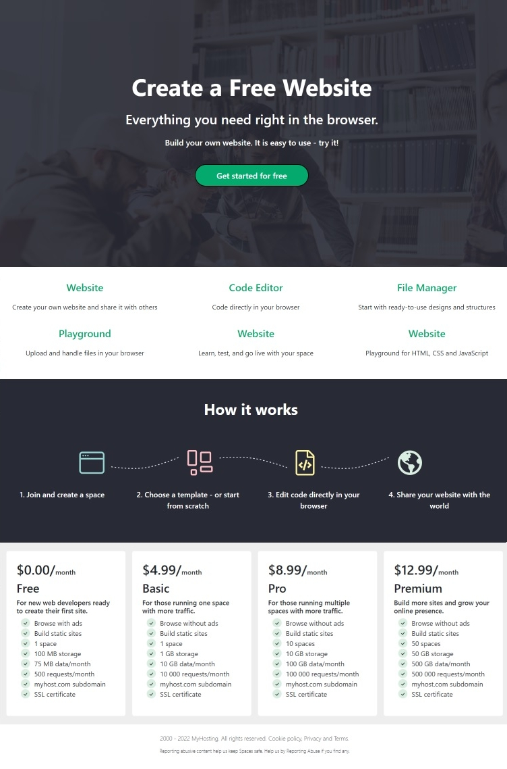 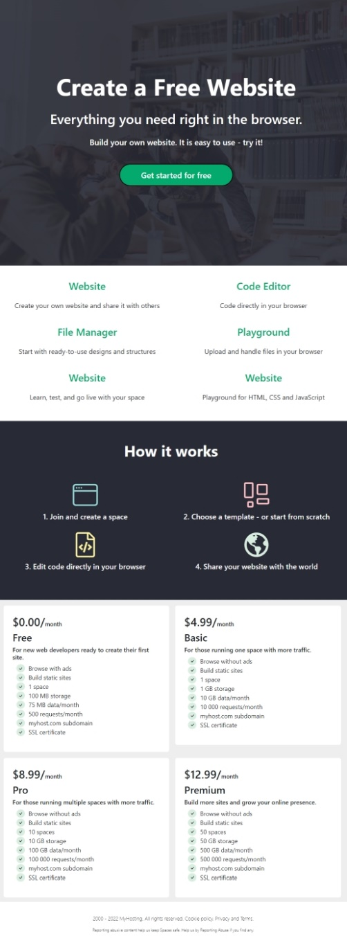 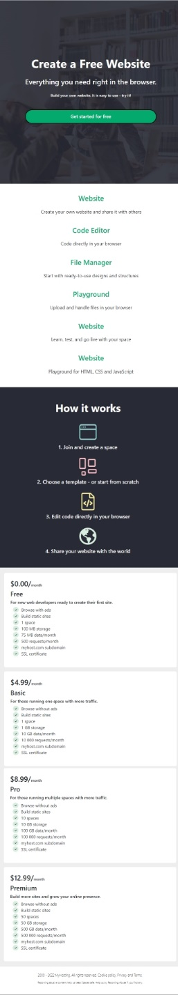

As you can see from the figures, the page starts with a header section that has a background image and some text and a button centered on the page. The height of this section is 630px for all screen sizes. Here is how you can insert the background into the header section:

|  |
| --- |
| background: linear-gradient(rgb(40, 42, 53, 0.90),rgb(40, 42, 53, 0.90)),url('img/bg-img.jpg');              background-size: cover;              background-repeat: no-repeat;              background-position: 50%; |

Make the header a flex container so that you can easily center the text & the button. Also notice that for the small screen size, the font-sizes of the text on top of the background image gets smaller so that it fits on a single line. You must write the necessary @media queries to achieve this.

Following the header comes the first main section that contains 6 items. Each item here contains a header centered inside the container and some text that comes below the header. For large screen size, the first 3 items reside on the first line and the last 3 on the second line. For the medium screen sizes, we have 3 rows each containing 2 items. Finally, for the small screen size, we have 6 rows each containing one item. This is how your page must respond to different screen sizes.

The third section contains some information about how things work. This section has a dark background, a header centered in the section and some images and text as shown on the left. When the screen size goes from large to medium as shown in the middle, this section totally changes. The curvy dashed line images that connect other images now disappear from the view, and the other images and the text below these images go into a 2-row by 2-column format. For the small screen, this section moves to a 4-row by 1-column format as shown on the right.

The last main section contains 4 cards, each giving information about different registration and payment plans. Again, all 4 card components are laid-out in a single line for large screens. For medium screens, we have a 2x2 layout, and for small screens we have a 4x1 layout as seen from the figures. The card components make use of the “check” icon. For this I used bootstrap icons. You can include bootstrap icons into your page as follows:

|  |
| --- |
| <link rel="stylesheet" href="https://cdn.jsdelivr.net/npm/bootstrap-icons@1.9.1/font/bootstrap-icons.css"> |

You can then use the “check” icon as follows:

|  |
| --- |
| i class="bi bi-check"></i> |

Finally, there is a footer section at the bottom of the page that spans the full width of the screen for all screen sizes. For this problem, we are giving you all the image files you need to implement the problem. We are also giving you the images that show how your page should look like for different screen sizes. Do not forget to download them from Uzem.

**Problem 2: Implement a Responsive Product Page**

In this problem, you are asked to implement a responsive product page from “hepsiburada.com” that responds to two screen sizes as follows:

|  |  |
| --- | --- |
| **Screen Size** | **Pixels** |
| Small and medium | < 992 |
| Large | >= 992 |

Here is how the page will look like for the two screen sizes (name your page productPage.html):

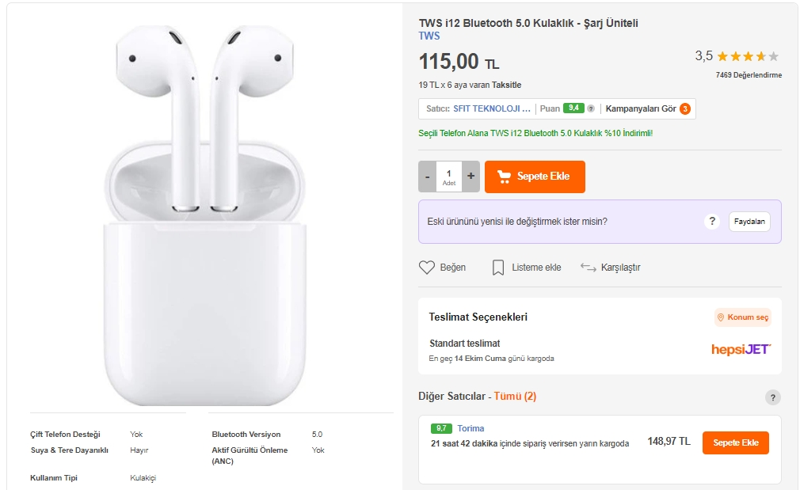 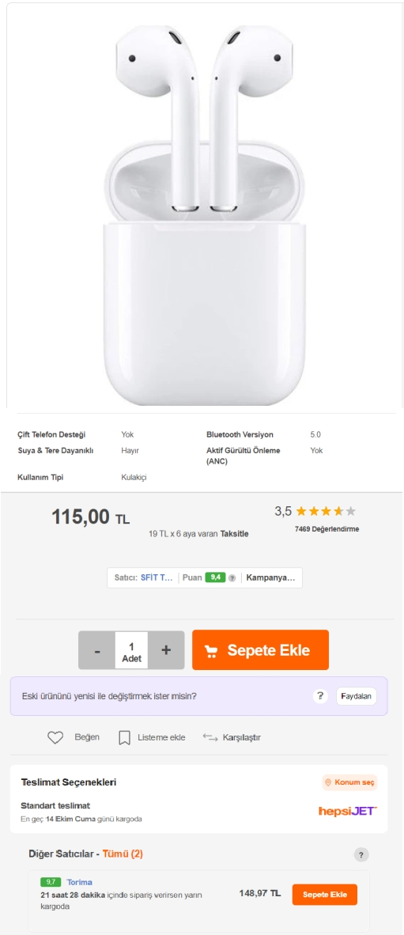

As you can see from the figures above, the page consists of two containers each occupying 50% of the full width for the large screen size. On the left, we have the product image and some information about the product laid out in two columns stacked on top of each other, and on the right we have other information about the product. When the screen size is less than 992 pixels, i.e., for small and medium screens, the page goes into a single column format as shown on the right.

This page contains several icons such as the full yellow star, half yellow star, shopping cart, bookmark, arrows etc. You can find these icons in the famous fontawesome icons library (<https://fontawesome.com/>). In order to use this library, simply include the fontawesome CSS library from the CDN as follows:

|  |
| --- |
| <link rel="stylesheet" href="https://cdnjs.cloudflare.com/ajax/libs/font-awesome/6.2.0/css/all.min.css" integrity="sha512-xh6O/CkQoPOWDdYTDqeRdPCVd1SpvCA9XXcUnZS2FmJNp1coAFzvtCN9BmamE+4aHK8yyUHUSCcJHgXloTyT2A==" crossorigin="anonymous" referrerpolicy="no-referrer" /> |

Here is the list of icons you need for this project:

|  |
| --- |
| <i class="fa-solid fa-star" style="color: yellow;"></i>      <i class="fa-regular fa-star-half-stroke" style="color: yellow;"></i>      <i class="fa-solid fa-cart-shopping"></i>      <i class="fa-regular fa-heart"></i>      <i class="fa-regular fa-bookmark"></i>      <i class="fa-solid fa-arrow-right-arrow-left"></i> |

Obviously, it would be better to define a “yellow” class in your style section and then add that class to your icon’s class list in order to fill it with the yellow color. But for the sake of example, I hard-coded that rule into the icon using inline CSS. You should change this and avoid using inline CSS as much as possible.

We are giving you the images that you need for the problem as well as the images that show how your screens should look like at different screen sizes. Do not forget to download them from Uzem.

**Submission**

In addition to the three pages (landingPage.html, productPage.html), create another text document named GroupMembers.txt and write the name and ids of the group members. Then zip/rar these 2 files, and submit the compressed file through Uzem. Do not submit the image files.