Due on November 9, 2022

**Project 3**

In this assignment you are asked to implement two responsive pages using HTML, CSS and JS. Although not necessary, you are allowed to use any of the CSS Frameworks we covered in class if you choose to use one.

**Problem 1: Implement a Digital Clock**

In this problem, you are asked to implement a digital clock that sits in the middle of your screen as follows:

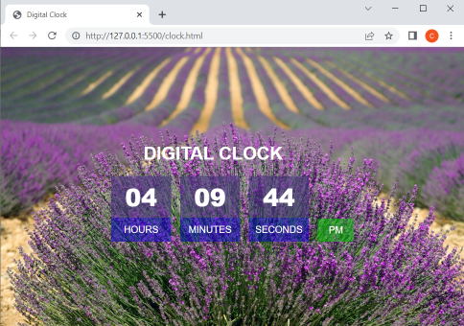

No matter what the size of screen may be, the clock must always be centered on the screen horizontal and vertically as shown above. This is a running clock. That is, you must update the time every second using some JS code. We are giving you the background image to be used for this project. The width and height of the containers displaying the hours, minutes and seconds is 100x100px. The height of the blue/green boxes seen at the bottom is 40px. The gap between different boxes is 15px. Notice that the text “DIGITAL CLOCK” is centered on top of the digits, not on top of all boxes. Furthermore, the boxes displaying the digits and the other text are transparent. That is, we can see the background through these boxes. You can achieve this by declaring the background using RGBA as follows:

|  |
| --- |
| background: rgba(0, 0, 200, 0.5); |

This is what I used for the background color of the blue boxes seen at the bottom of the numbers. As you can see, the background is pure blue with a transparency/opacity of 0.5, which lets us see through.

Put all your CSS styles and JS code inside a single file named “clock.html”.

**Problem 2: Implement a Responsive Page to Calculate YKS Scores**

In this problem, you are asked to implement a responsive page to calculate YKS scores that responds to two screen sizes as follows:

|  |  |
| --- | --- |
| **Screen Size** | **Pixels** |
| Small and medium | < 992 |
| Large | >= 992 |

Here is how the page will look like for the two screen sizes (name your page yks-score.html). As you can see, the screen simply goes from a two-column layout to a one-column layout when the screen is small or medium (< 992px).

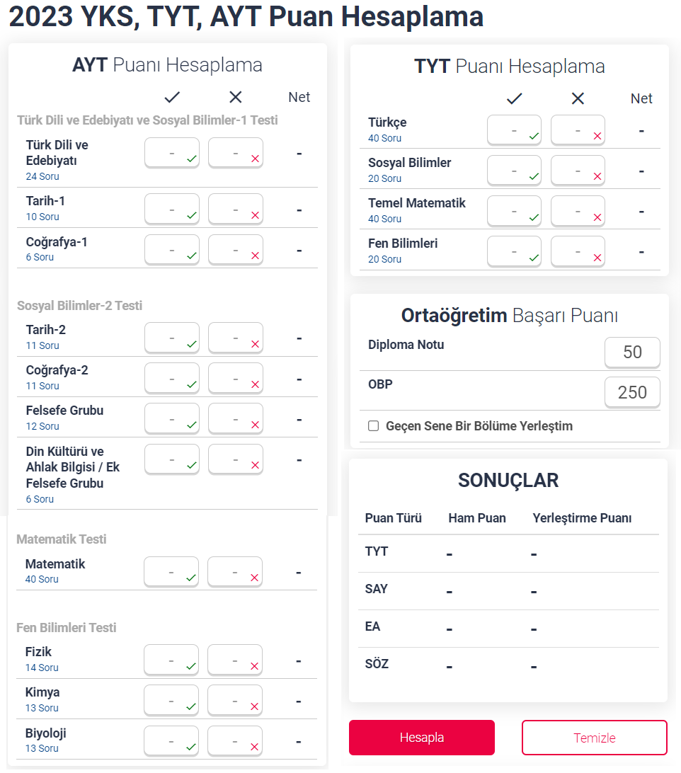 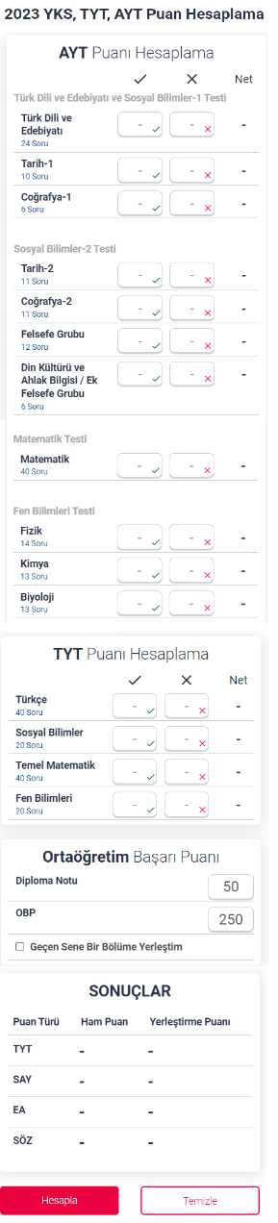

As you can see, we have input fields for each section of the exam, where we can enter the number of correct and the number of false answers we got in that section. You can also see the total number of questions in each section below the section title in blue color. If the total number of correct and false answers for a particular section exceeds this number, you have to alert the user with an error box so that the user can correct it. If the user does not enter any values for a particular input field, assume that it is 0. Furthermore, make sure that the user can only enter numbers from the input fields.

For “Ortaogretim Basari Puani”, the user must enter a value between 0-100. You should simply multiply this number by 5 and that becomes the user’s OBP. OBP cannot be changed by the user.

After the user enters all values correctly and presses “Hesapla”, you should compute the user’s TYT, SAY, EA, and SÖZ scores and display them in the “SONUÇLAR” section. Here are the formulas to calculate the scores:

OBP = 5*DiplomaNotu

For the sake of simplicity, we will assume that each “net” answer in TYT is worth 5 points, and each “net” answer in other tests is worth 6.25 points. So, the base score (Ham Puan) for TYT is calculated as follows:

TYT Ham Puan = 5*(Türkçe + Sosyal Bilimler + Temel Matematik + Fen Bilimleri)

To calculate “Yerleştirme Puanı”, you take “Diploma Notu” and multiply it with 0.6 and add it to the “Ham Puan”. If the user checks “Geçen sene bir bölüme yerleştim” checkbox, then you multiply “Diploma Notu” with 0.3 and add it to “Ham Puan”.

AYT Puan is also calculated similarly but by multiplying each “net” answer with 6.25. Thus, Ham Puan for AYT SAY is calculated as follows:

AYT SAY Ham Puan = 6.25*(Matematik + Fizik + Kimya + Biyoloji)

Then, your final SAY Ham Puan is calculated by taking 40% of your TYT score and 60% of your AYT SAY score as follow:

SAY Ham Puan = 0.6*(AYT SAY Ham Puan) + 0.4*(TYT Ham Puan)

To calculate SAY Yerleştirme Puanı, you then add “Diploma notu” as we described above.

AYT SÖZ score is calculated as follows:

AYT SÖZ Ham Puan = 6.25*(Türk Dili ve Edebiyatı + Tarih-1 + Coğrafya-1 + Tarih-2 + Coğrafya-2 + Felsefe Grubu + Din Kültürü ve Ahlak Bilgisi / Ek Felsefe Grubu)

Then, your final SÖZ Ham Puan is calculated by taking 40% of your TYT score and 60% of your AYT SÖZ score.

Finally, AYT EA score not only includes AYT SÖZ score, put also your score from the AYT Matematik Test. So, here is how you calculate it:

AYT EA Ham Puan = (AYT SÖZ Ham Puan + 12.5*(AYT Matematik Net))*0.5

Create a file named “yks.html” and put all HTML, CSS and JS code in that file.

**Submission**

Zip clock.html and yks.html and submit through UZEM. Do not forget to include the group member names.