Problem:

Thing description standard uses json for describing the specs of the thing but this limits the definitions to spectrum of json types. This is also true for input of actions. There is no defined literature for defining file formats that is not json.

Possible solutions:

a-) as in a regular api explaining the specs of the input in “description:” field and hold the end user responsible with providing a valid input.

b-) Sending each input in json object format. An example could be converting the file into a hexadecimal string, sending this payload as a json object and expect the end application handle the necessary conversions. Steps for such example is:

1-) In Thing Description under the “input:” of the relative “action:”, define the “type:” as “object”.

2-) Under “properties:” of this “object” define a keyword “payload:” which of type string. Define a keyword “fileFormat:” which is also a string that indicates the expected file format.

3-) As the end user convert the input file into a hexadecimal string and set this string as the value of “payload:”

4-) In the end application convert the payload to its original file format according to “fileFormat” if needed.

Note: For input check other keywords can be added.

Example TD:

{

"@context": "https://www.w3.org/2019/wot/td/v1",

"id": "urn:ex:thing",

"actions": {

"send_image": {

"input": {

"type": "object",

"description": "a bmp image displayed on scrollphat",

"properties": {

"fileFormat": {

"type": "string"

"enum":["bmp", "jpg"]

},

"payload": {

"type": "string"

}

}

},

"forms": [

{

"href": "/send_image",

"op": "invokeaction",

"htv:methodName": "POST",

"contentType": "bmp/image"

}

]

}

}}

Example client request:

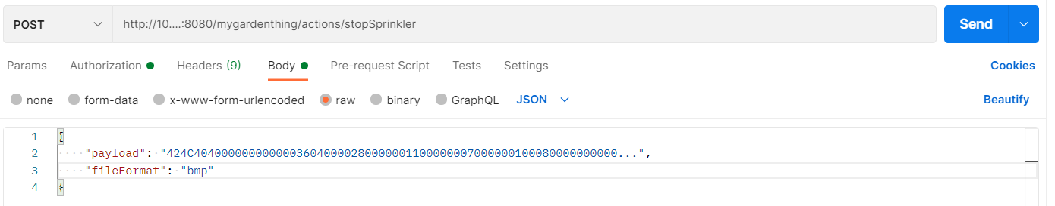

c-) Expanding the thing description standard so that it can define more types than json. This would require defining many built-in keywords for each input type that is supported.

Example TD:

{

"@context": "https://www.w3.org/2019/wot/td/v1",

"id": "urn:ex:thing",

"actions": {

"send_image": {

"input": {

"type": "bmp",

"description": "displays the image on scrollphat"

},

"forms": [

{

"href": "/send_image",

"op": "invokeaction",

"htv:methodName": "POST",

"contentType": "image/bmp"

}

]

}

}

}

Example Client request:



