Week 2 Task – Data Cleaning and Preprocessing Methodology
Applied to the supplied diabetic encounter dataset

1. Data Quality Assessment
The dataset contains 101,766 rows and 50 columns with no exact duplicate rows detected. The raw file uses '?' in several categorical fields to represent unavailable values; these were converted to missing values for assessment.
Field | Missing % | Treatment proposal
weight | 96.86% | Do not impute blindly; retain as missing or exclude from models where justified.
max_glu_serum | 94.75% | Treat as missing categorical test result; add a tested/not-tested indicator if useful.
A1Cresult | 83.28% | Treat missing as unavailable measurement, not a normal value.
medical_specialty | 49.08% | Use explicit missing category or carefully selected imputation.
payer_code | 39.56% | Use missing category if retained; assess usefulness before modeling.
race | 2.23% | Small missing proportion; use documented categorical imputation if required.

2. Proposed Cleaning Workflow
- Load the CSV and inspect shape, column names, data types, unique values, and summary statistics.
- Standardize placeholder values such as '?' to a consistent missing representation.
- Measure missingness by column and document whether missingness represents unavailable information or a true zero.
- Check exact duplicate records and identifier uniqueness; do not remove rows solely because two patients share a value in a non-identifier field.
- Validate numeric ranges, for example length of stay, procedure counts, medication counts, and diagnosis counts.
- Inspect categorical levels for inconsistent spelling or unexpected categories.
- Create the target variable for early readmission: 1 for '<30' and 0 for '>30' or 'NO', if the modeling objective is 30-day readmission.
- Perform preprocessing inside a reproducible training pipeline so that imputation and encoding parameters are learned from training data only.

3. Missing Value Strategy
Missing values must not automatically be converted to zero. For example, an unavailable HbA1c result means the test result is missing; it does not mean the patient's HbA1c was normal. Numeric variables can use median imputation when appropriate, while categorical variables can use the most frequent category or an explicit 'Missing/Unknown' category. For high-missingness variables such as weight, exclusion from a baseline model may be more defensible than aggressive imputation.

4. Outlier and Anomaly Handling
Use domain-aware range checks before statistical outlier rules. Box plots and quantiles can identify unusually high procedure or medication counts. A value should not be deleted merely because it is statistically unusual; it should first be checked for plausibility and data-entry issues. Where extreme but valid observations are retained, robust summaries and appropriate scaling can reduce their influence.

5. Categorical Data Preparation
- Binary medication fields can be mapped consistently after verifying their categories.
- Age ranges should remain ordered categories or be transformed to representative midpoints only when a numeric model requires it; the original categorical interpretation should be preserved in documentation.
- Diagnosis codes are high-cardinality categorical variables and require careful grouping/encoding rather than arbitrary numeric ordering.
- One-hot encoding can be used for selected categorical predictors in a baseline machine-learning model.

6. Pseudocode
LOAD dataset
REPLACE placeholder '?' WITH missing
CHECK schema, duplicates, ranges, and unique categories
CALCULATE missingness report
SEPARATE target from predictors
SPLIT data into train/test using stratification
FIT imputation and encoding on training data only
TRANSFORM train and test using fitted preprocessing
TRAIN model on transformed training data
EVALUATE only on held-out test data
DOCUMENT every transformation and assumption

7. Workflow Summary
Raw CSV → schema inspection → placeholder normalization → missingness assessment → duplicate/range/category checks → target definition → train/test split → training-only imputation and encoding → model-ready dataset → quality verification.

8. Libraries
- Pandas: loading, profiling, missing-value analysis, grouping, and transformations.
- NumPy: numerical operations and missing-value handling.
- Matplotlib/Seaborn: diagnostic plots.
- Scikit-learn: reproducible preprocessing pipelines and model evaluation.

9. Detailed Data Cleaning Flowchart

9. Detailed Data Cleaning Flowchart
The following flowchart presents the preprocessing sequence from raw data loading through validation. All process arrows intentionally point downward to show the workflow direction.
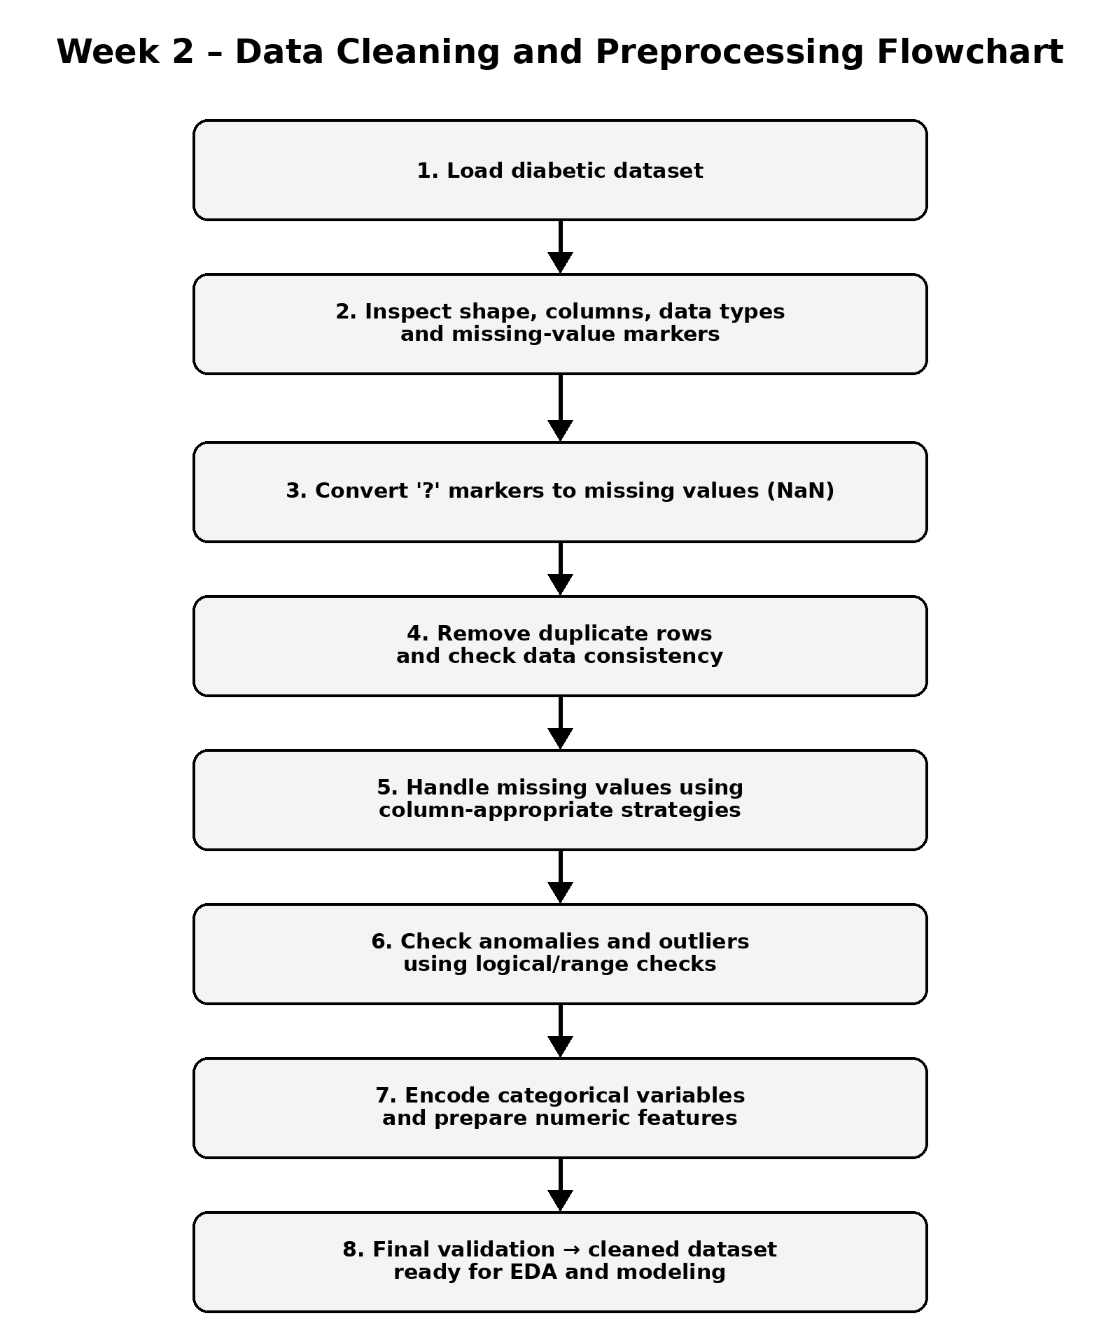

10. Requirement Coverage Check
- Missing values: identified and addressed using column-appropriate strategies.
- Anomalies/outliers: checked using logical and range-based validation before modeling.
- Normalization/scaling: numeric preprocessing is included where required by the selected model pipeline.
- Duplicates: exact duplicate rows are checked and removed if present.
- Categorical variables: prepared through encoding for downstream analysis/modeling.
- Pandas and NumPy: identified as the primary Python libraries for tabular cleaning, validation, and numerical operations.
- Pseudocode: included to describe the cleaning sequence without relying on executable code.
- Flowchart: included above with a clear top-to-bottom process and downward arrows.

