Week 3 Task – Exploratory Data Analysis and Visualization
Evidence-based EDA of the supplied diabetic encounter dataset

1. Dataset Understanding
The dataset contains 101,766 encounters and 50 variables. The fields cover demographics, admission information, utilization history, diagnoses, laboratory-related fields, medications, and readmission outcome.

2. Descriptive Statistics
Variable | Observed summary
Time in hospital | Mean 4.40 days; median 4 days
Number of lab procedures | Mean 43.10
Number of medications | Mean 16.02
Early readmission (<30 days) | 11,357 encounters (11.16%)
Readmission >30 days | 35,545 encounters (34.93%)
No readmission | 54,864 encounters (53.91%)

3. Readmission Distribution
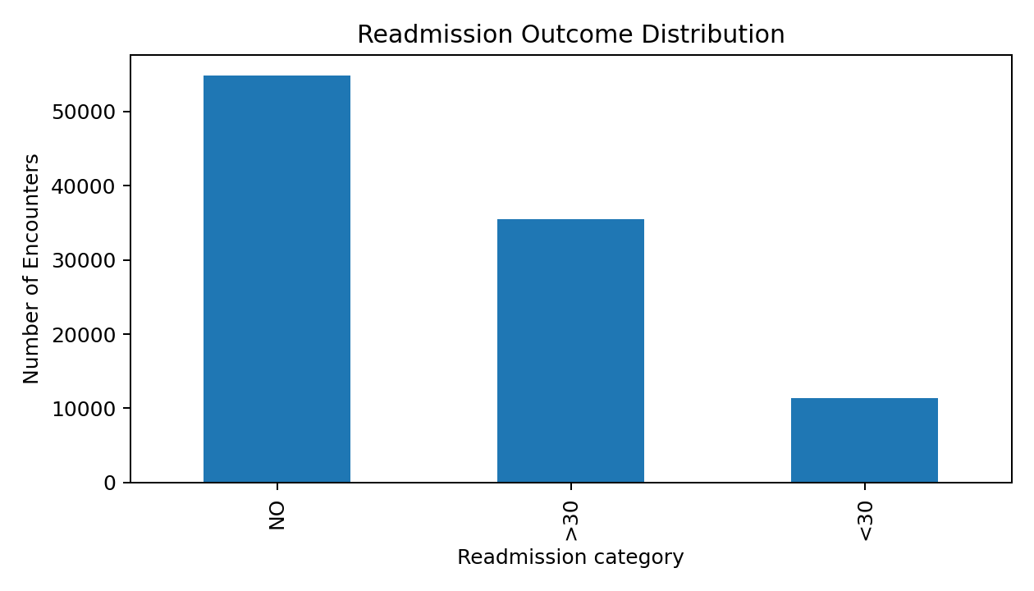
The outcome is imbalanced: the <30-day category represents about 11.16% of encounters. This is important for later modeling because a model can obtain a deceptively strong accuracy by under-detecting the minority class. Recall and precision should therefore be examined.

4. Age Distribution
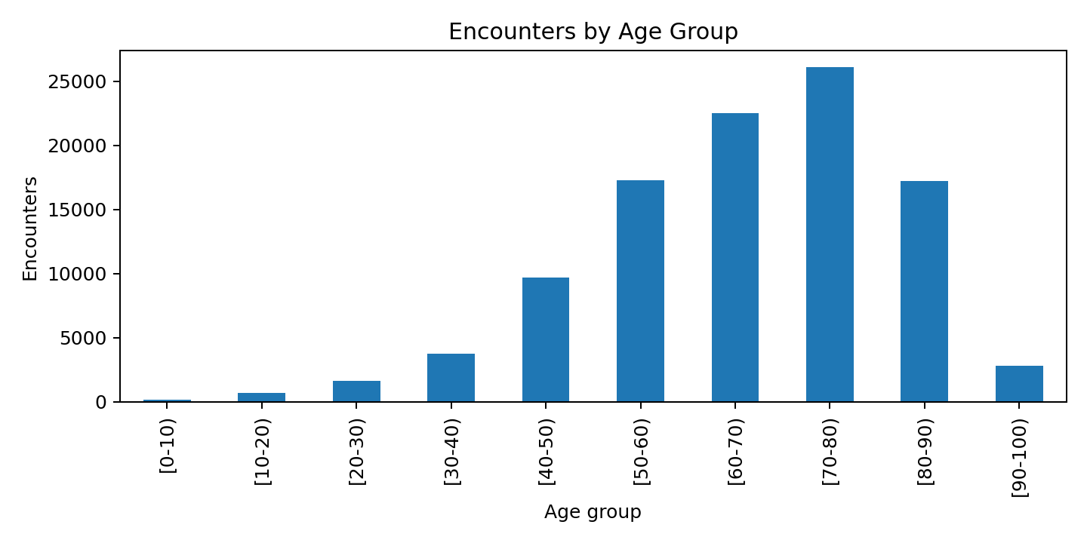
The largest encounter groups are concentrated in older age bands, particularly 70–80, 60–70, and 80–90. This describes the composition of the supplied encounters; it does not by itself establish that age causes readmission.

5. Readmission by Gender
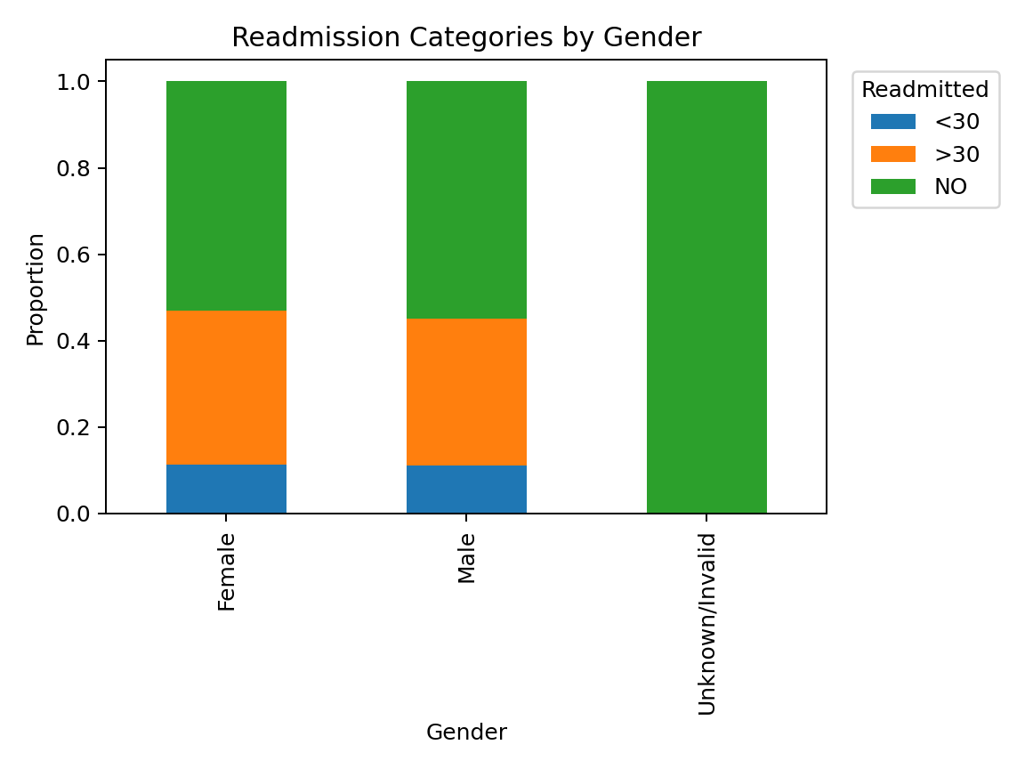
Female and male encounters have similar proportions of <30-day readmission in this dataset. The comparison is descriptive and should not be interpreted as a causal or clinical difference.

6. Recommended Additional Visualizations
Visualization | Question answered | Potential use
Histogram of length of stay | How are hospital stays distributed? | Identify skew and common stay durations.
Box plot of medications by readmission group | Do utilization distributions differ across outcome groups? | Compare spread and central tendency.
Bar chart of readmission by age group | How does outcome composition vary across age bands? | Identify segments for further investigation.
Correlation heatmap for numeric variables | Which numeric variables move together? | Detect redundancy and candidate predictors.
Stacked bar of HbA1c result vs readmission | How do observed test categories relate to outcome? | Describe potential association while respecting missingness.
Admission type vs outcome | Do outcome proportions differ across admission categories? | Support operational segmentation.

7. Insight Generation Principles
- Separate description from interpretation.
- Report denominators and percentages for group comparisons.
- Do not treat missing laboratory results as normal results.
- Use visualizations to identify patterns that warrant further analysis, not to prove causation.
- Carry important EDA findings into Week 4 feature selection and evaluation planning.

