Week 4 Task – Predictive Modeling and Algorithm Selection
30-Day Readmission Prediction Baseline

1. Problem Definition
The predictive task is binary classification: predict whether an encounter is associated with readmission within 30 days. The target is 1 for '<30' and 0 for '>30' or 'NO'. This target follows the supplied research description's definition of early readmission.

2. Model Selection Strategy
Model | Role | Rationale
Logistic Regression | Baseline | Interpretable, fast, suitable for binary outcomes, and useful as a benchmark.
Decision Tree | Comparison model | Captures non-linear rules and interactions but can overfit without constraints.
Random Forest | Non-linear comparison | Handles mixed patterns and interactions; useful for comparing with a linear baseline.

3. Feature Engineering
- Convert '?' placeholders to missing values.
- Treat age as an ordered categorical variable rather than assuming equal numeric spacing unless a numeric representation is justified.
- Encode selected categorical variables with one-hot encoding.
- Impute numeric variables using training-set statistics only.
- Consider utilization features such as prior outpatient, emergency, and inpatient visits.
- Avoid identifiers such as encounter_id and patient_nbr as predictive features.
- Avoid variables that would only be known after the prediction point, to reduce leakage risk.

4. Train/Test Strategy
Use an 80/20 stratified train/test split with a fixed random seed. Stratification preserves the approximate early-readmission rate in both partitions. All learned preprocessing operations should be fitted only on the training set.

5. Baseline Model Results
Metric | Test-set result
Accuracy | 0.6715
Precision | 0.1740
Recall | 0.5187
F1 | 0.2605
ROC-AUC | 0.6463
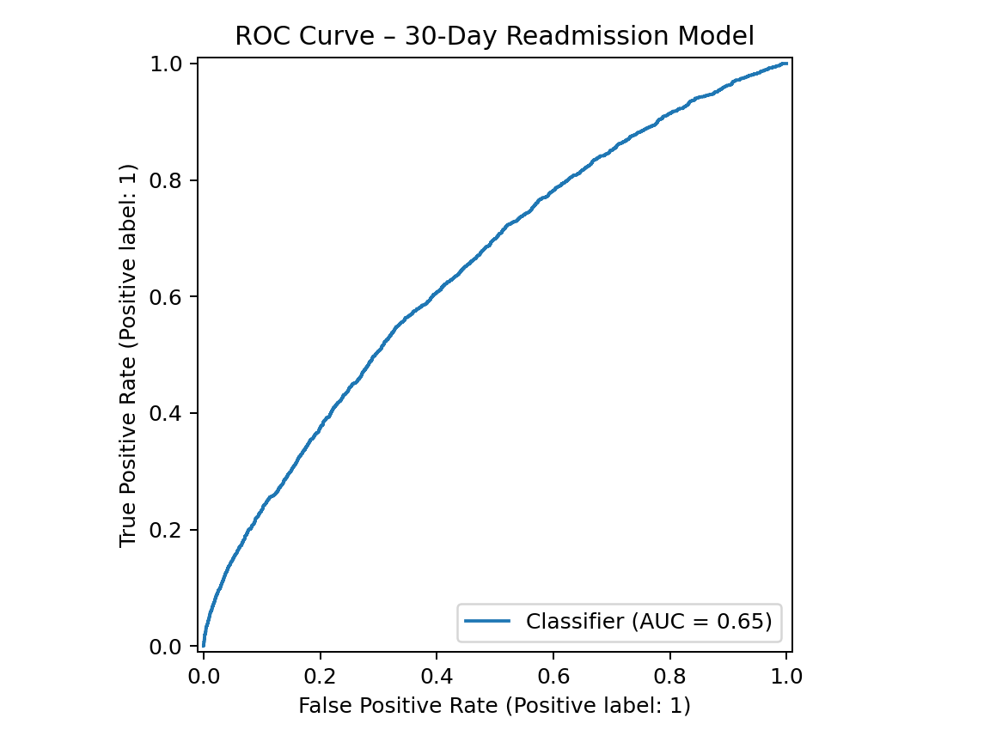
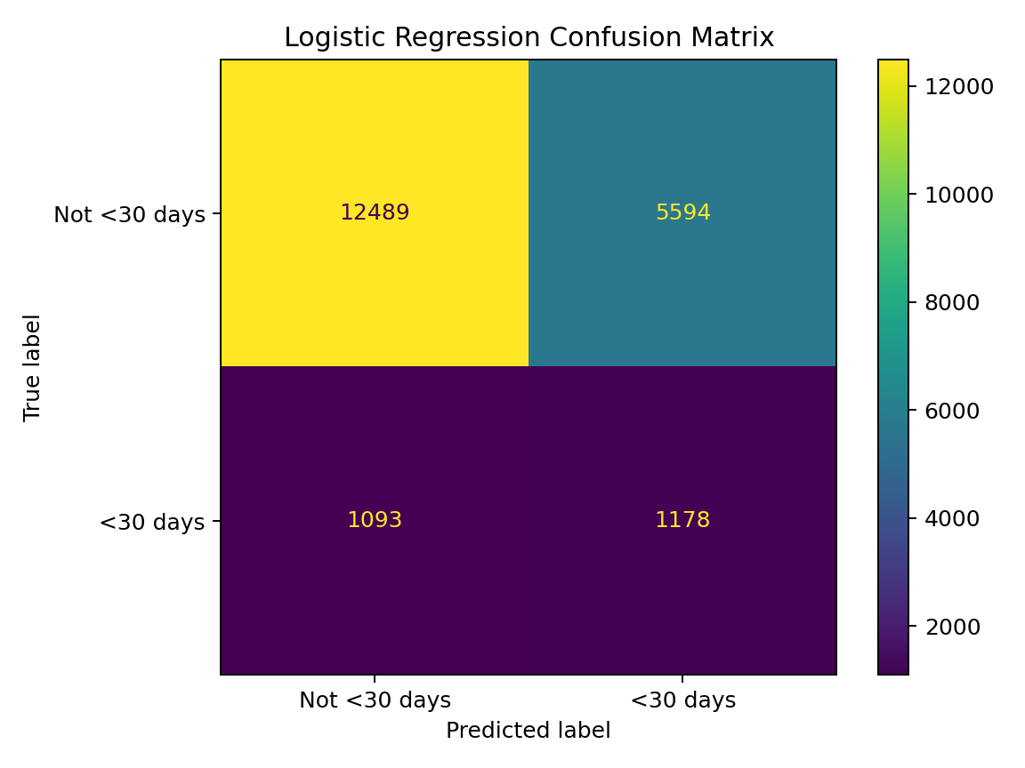
The baseline logistic regression used class weighting to reduce the tendency to ignore the minority early-readmission class. The test set contains 20,354 encounters. The model's recall is approximately 0.519, meaning it identified about half of the observed early-readmission cases in this test sample. Its precision is approximately 0.174, meaning many predicted positives were not actually early readmissions. These results are a baseline, not a clinically validated model.

6. Evaluation Metrics
- Accuracy: overall proportion of correct classifications; can be misleading under class imbalance.
- Precision: among predicted early-readmission cases, proportion actually early readmissions.
- Recall: among actual early-readmission cases, proportion detected by the model.
- F1-score: harmonic mean of precision and recall.
- ROC-AUC: ranking/discrimination measure across classification thresholds.
- Confusion matrix: shows false positives and false negatives directly.

7. Pseudocode
DEFINE target = (readmitted == '<30')
DROP identifier-only fields
SPLIT X/y using stratification
BUILD preprocessing pipeline:
impute numeric fields
impute/encode categorical fields
FIT logistic regression with class weighting
PREDICT probabilities on test set
CALCULATE accuracy, precision, recall, F1, ROC-AUC
INSPECT confusion matrix and ROC curve
COMPARE with tree-based models
VALIDATE before any operational use

8. Practical Interpretation
The model can be used in this internship project to demonstrate the predictive analytics workflow. A real healthcare deployment would require external validation, fairness analysis, calibration, clinical review, monitoring, and governance. The model should not be used to make individual treatment decisions based on this educational analysis.

9. Predictive Modeling Workflow Diagram
The diagram below summarizes the proposed predictive-modeling process from problem definition through validation. It complements the pseudocode and metric explanations already provided.
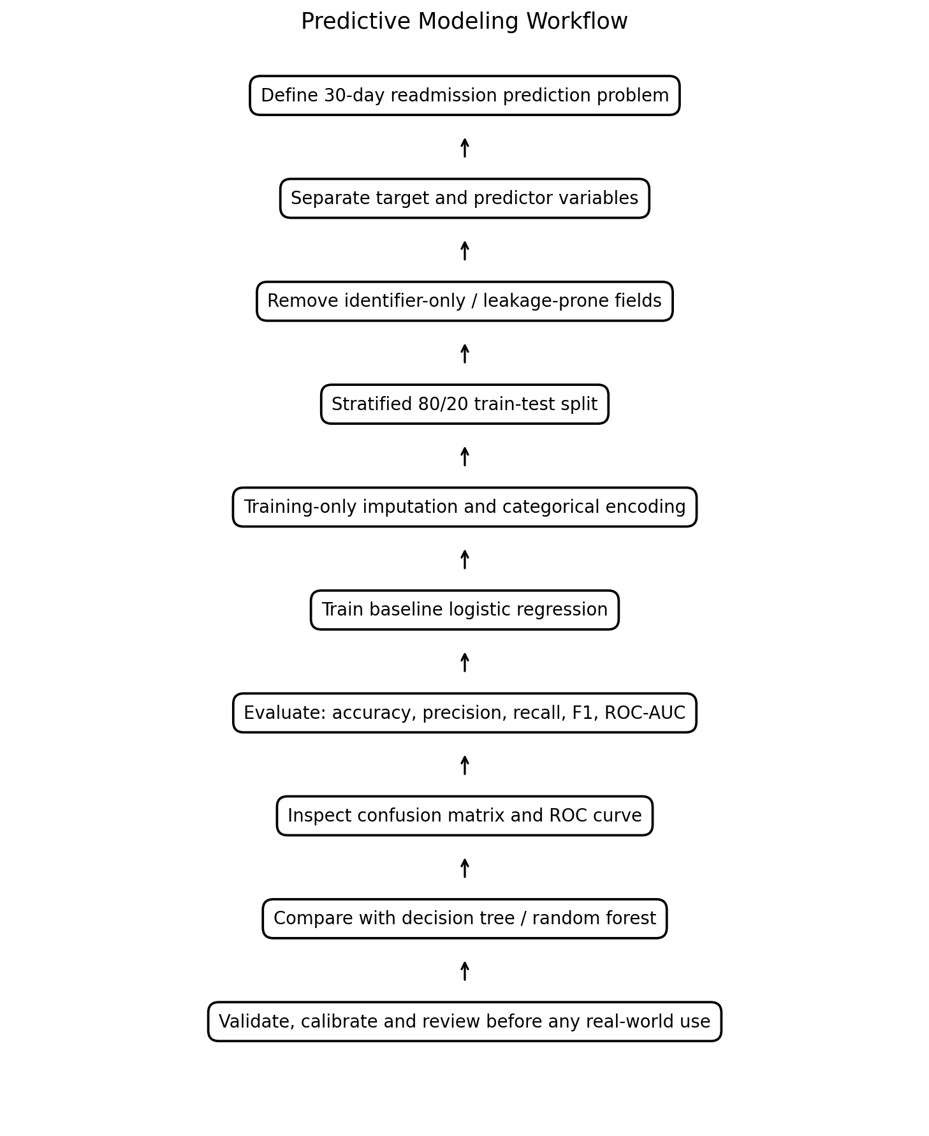
Figure 1. End-to-end predictive modeling workflow for 30-day readmission.

10. Diagram Interpretation and Technical Notes
- The target is defined before model fitting so the prediction objective remains explicit.
- Identifier-only variables are excluded because they represent records rather than meaningful predictive characteristics.
- The train/test split occurs before learned preprocessing to reduce information leakage.
- Imputation and encoding are fitted using training data and then applied to the held-out test set.
- The logistic regression is treated as a baseline benchmark, while tree-based models are proposed for comparison.
- Evaluation uses several metrics because the early-readmission class is relatively uncommon.
- Any future operational use would require additional validation, calibration, subgroup analysis, governance, and clinical review.

