Linux commands

Commands are of three types:
- Simple: Direct command(ls, pwd etc…)
- Compound: simple + complex (i.e. command ; command → ls -l ; pwd)
- Complex: ls -l, ls -a etc…

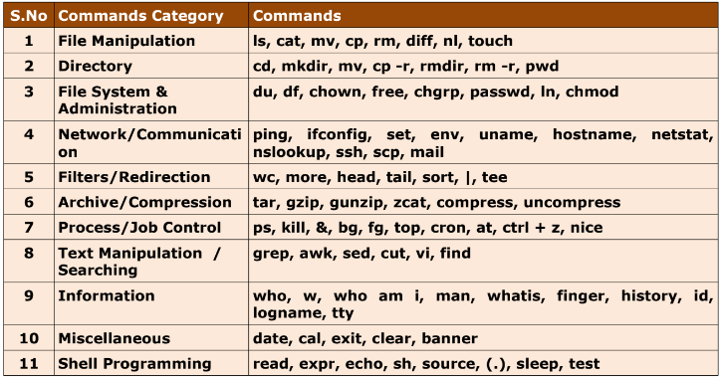

File Manipulation

- Cat– Allows you to Create, look, append or combine a file.

Create- cat > filename
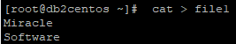

View- cat filename
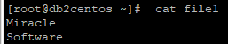

Append- cat >> filename
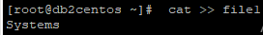
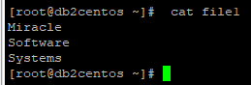

Combine- cat file1.txt file2.txt > file3.txt

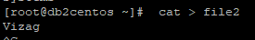
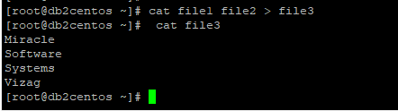

- mv: Renames a file or moves it from one directory to another directory.
Usage: mv oldname newname

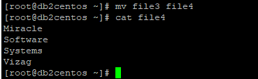

Renaming file:
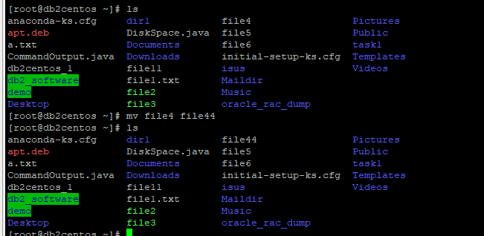

- cp: Copies files from one location to another.
Usage: cp <Source> <Target>
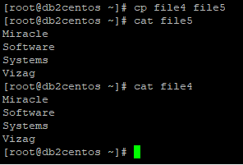

- rm: Deletes a file with confirmation (by default).
Usage: rm filenames/directory
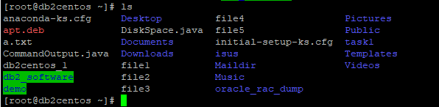

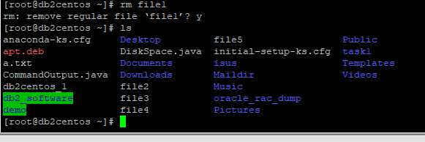

- diff : Displays two files and prints the lines that are different.
Usage: diff [file1 file2] [dir1 dir2]
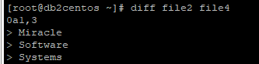

- nl: Number lines and write files
Usage: nl filename
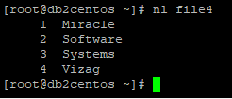

- touch: create more files
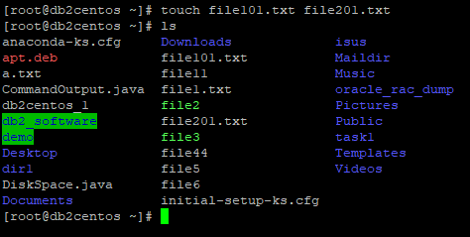
Directories:

- cd : Changes the directory.
Usage: cd [directory]
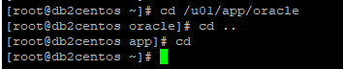

- mkdir: Short for make directory this command is used to create a new directory.
Usage: mkdir dirname
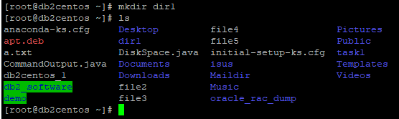
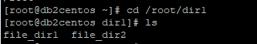

- cp -r: Copy directories recursively.
Usage: cp -r
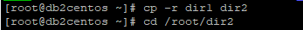
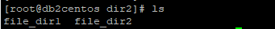

- rm -r : Remove directories and their contents recursively
Usage: rm -r <dir name>

- rm -rf: Forceful remove, without confirmation.
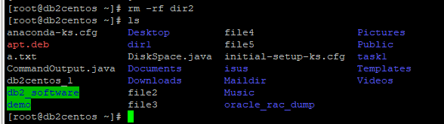

- pwd: Short for print working directory, the pwd command displays the name of the current working directory.
Usage: pwd
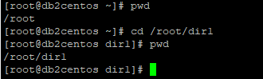

File System & Administration commands

- ls :List information about the FILEs (the current directory by default)
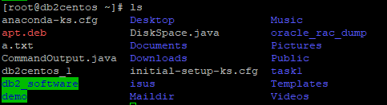

ls -a: displays hidden files as well.
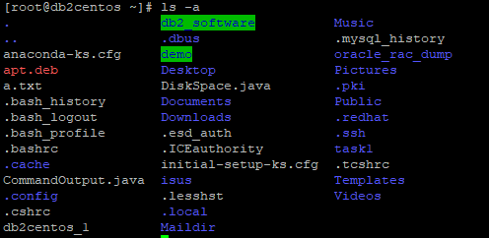

ls -r - reverse order
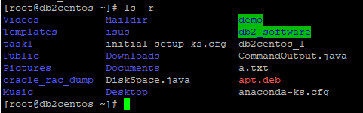

ls -R: Displays contents of the sub-directories.
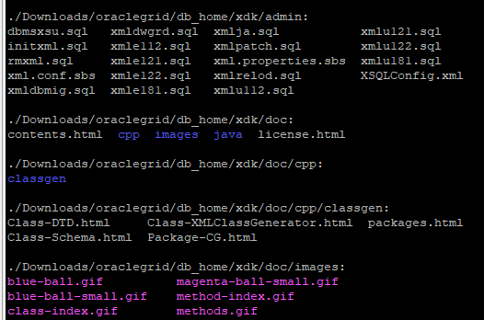

ls -n: Prints GroupID and OrderID instead of names.

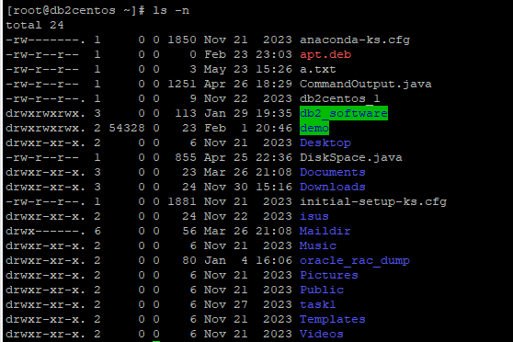

ls -li: Displays the index number in the first column.
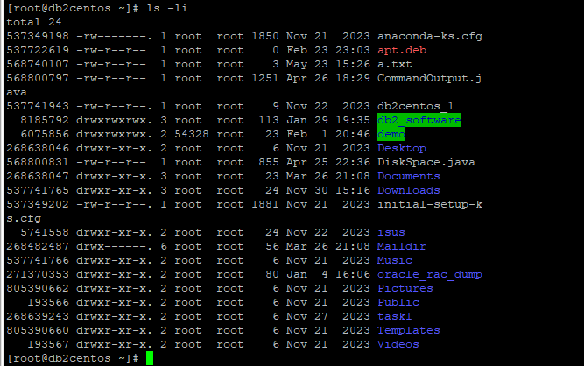

ls ~: Displays the home directories.
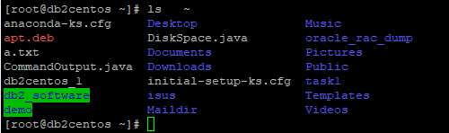

ls -g: group will be displayed for all files, without the owner.
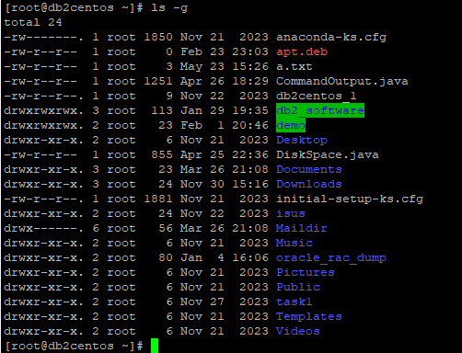

- du: Summarize disk usage of each FILE, recursively for directories.
Usage: du directories
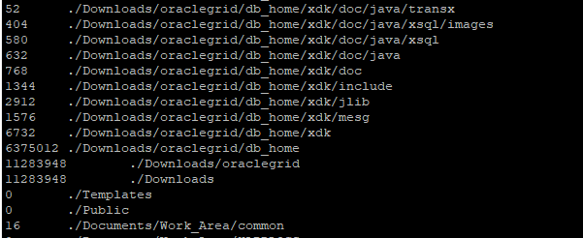

du -h: Human readable format of files sizes i.e in mb, gb, kb etc..

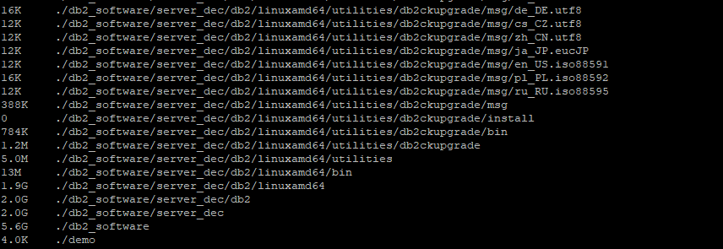

du -sh: Summary of total disk usage.
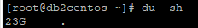

du -c: To calculate the total size of a directory and its sub-directories
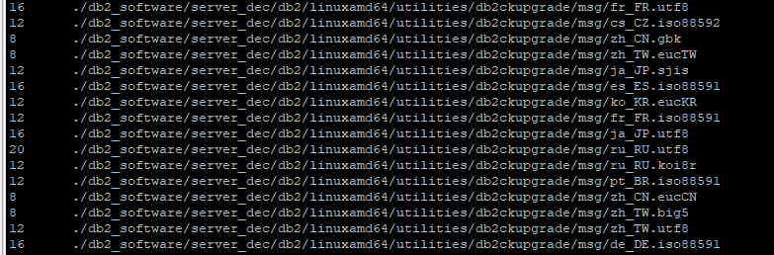

- df: To show the amount of disk space that is free on file systems.
Usage: df [file]
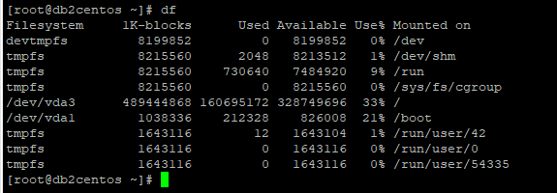

df -h: in k,m,g format.
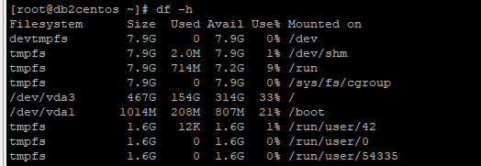

- chown: Command to change the owner/ group of a file.
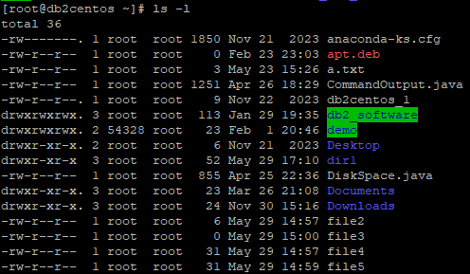
Changing owner and group for file2:

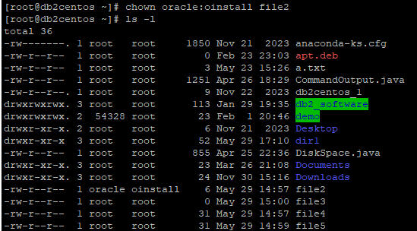

Changing only group:
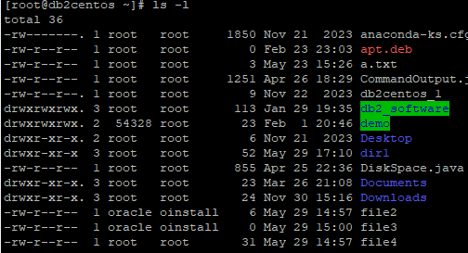

- chgrp : Changes the group that has access to a file or directory.
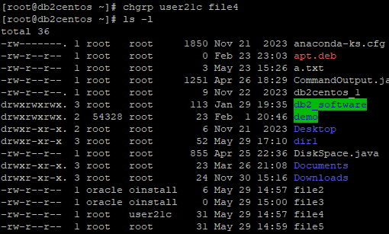

- chmod
Symbolic Method:
- u for user/owner
- g for group
- o for others
- a for all (user, group, and others)
- + to add permissions
- - to remove permissions
- = to set permissions explicitly
Numeric Method: Each permission is represented by a number
- 4 for read (r)
- 2 for write (w)
- 1 for execute (x)

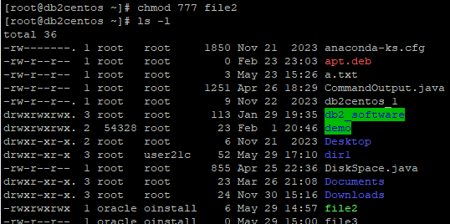

Changing owner permissions
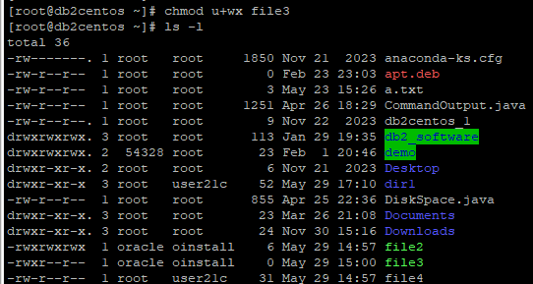

Changing group permissions
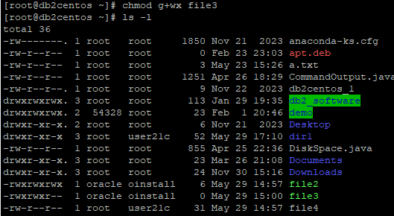

Changing other user permissions
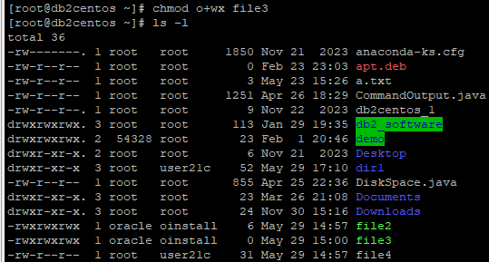

- free : Displays the total amount of free and used physical memory and swap space in the system.
Usage: free
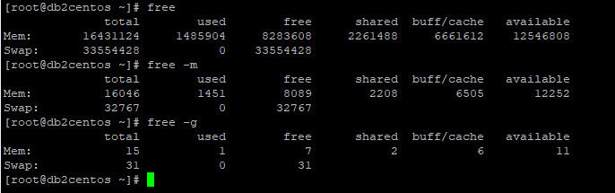

- passwd : Allows you to change your password.

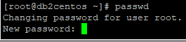

- ln: Creates a link to a file.

Network / communication commands

- ping: Displays server is in active state or not.
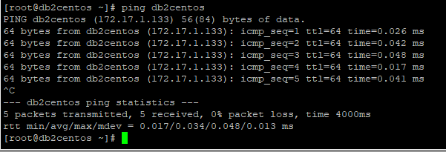

- Ifconfig: Configure a network interface
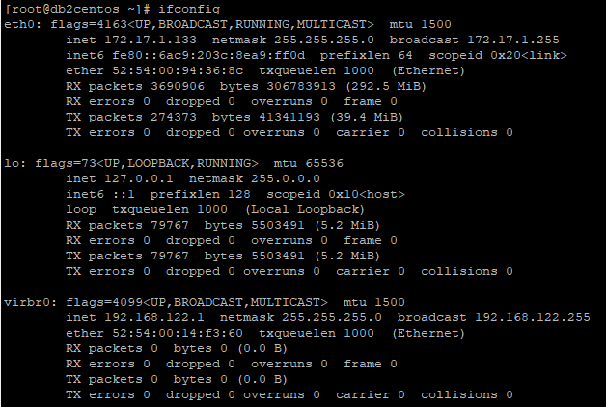

- uname: Print system information.

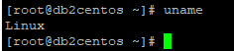

- hostname : Show or set the system’s host name .
Usage: hostname

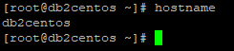

- netstat: Print network connections, routing tables, interface statistics.

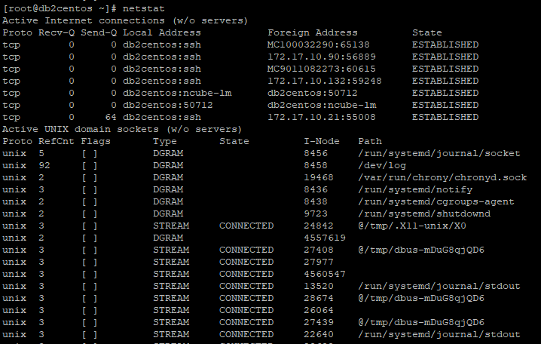

- nslookup: Query Internet name servers interactively .

- set: Sets the value of an environment variable. If no options or arguments are supplied, it displays the names and values of all shell variables and functions.

- ssh: Secure Shell (remote login program).
Usage: ssh username@ipaddress

- scp: Secure copy (remote file copy program).
Usage:
scp source_file username@ipaddress:destination_path

- mail: Send and receive mail.
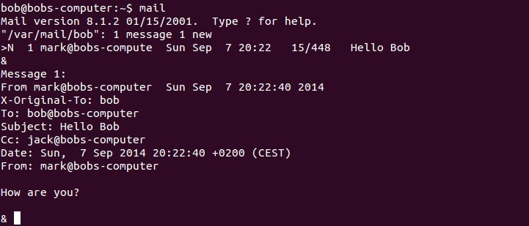

- env: Used to manage Linux system environment. Invoking env command with no option will print environment variables for the current user.

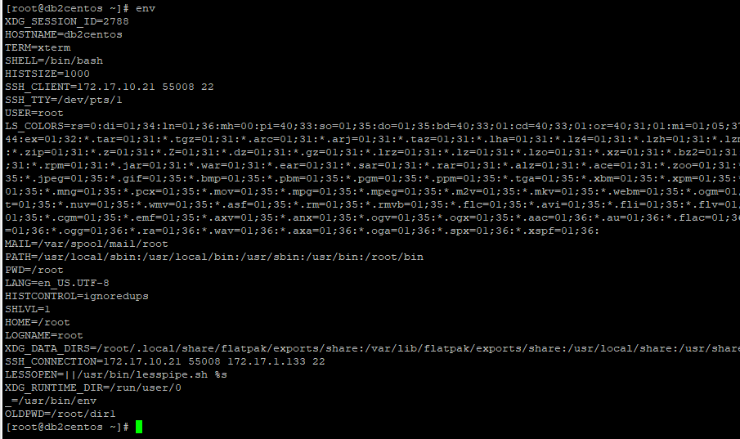

Filter commands

- wc: Prints the total number of lines, words, and characters contained in a file.

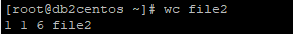
- 1 indicates the number of lines in the file.
- 1 indicates the number of words in the file.
- 6 indicates the number of bytes in the file.
- file2 is the name of the file for which the count is displayed.

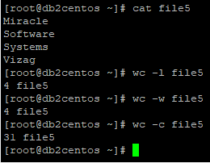
Usage:wc [-c] [-l] [-w] [ filename]
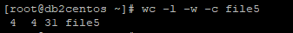

- head: Displays the first few lines at the top of a file. It can be useful when you want a quick peek at a large file, as an alternative to opening the file with a text editor. By default, head will show the first ten lines of a file, but you can also tell it how many lines to display.
Usage: head -5 filename

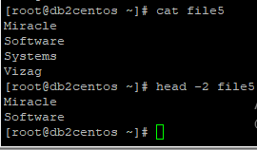

- tail: The tail command displays the last few lines of a file. Like head, it can save you time, because it's a lot quicker than calling up a file with a text editor and scrolling all the way down to the bottom. By default, tail will show the last ten lines of a file, but you can also tell it how many lines to display.
Usage: tail -5 filename

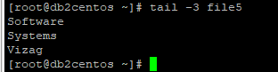

- |(pipe): The pipe symbol "|" is used to direct the output of one command to the input of another.

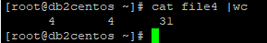

- sort: Sort lines of text files
Usage: sort [options] filename

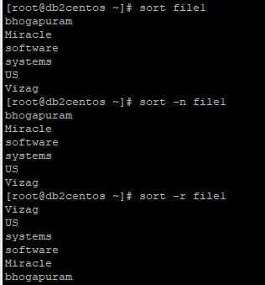

Archive commands

- gzip:
Compression Algorithm: Uses the DEFLATE algorithm.
File Extension: Compressed files typically end with .gz
Usage: Compresses files or directories.

- gunzip: The gunzip command is used to decompress .gz files created by gzip

- compress
Compression Algorithm: Uses the Lempel-Ziv-Welch (LZW) algorithm.
File Extension: Compressed files typically end with .Z
Usage: Compresses files or directories.
compress - compress file.txt

- uncompress
Usage: Decompresses files compressed with compress
uncompress- uncompress file.txt.Z

- tar: The tar (tape archive) used to create an archive file or to extract on a tape, disk drive, or floppy disk. The original files are not deleted after being copied to the tar file.

To tar the content of folder sample in sample.tar:
tar -cvf /home/sample.tar /home/sample/

To extract the contents of the tar file:
tar -xvf /home/sample.tar

To display the contents of the tar file:
tar -tvf /home/sample.tar

To tar and compress the content of the folder sample:
tar -cvzf /home/sample.tar /home/sample/

- zcat: Displaying the contents of compressed files in the "gzip" format.

Process/ Job control commands

- ps : ps is the shortage for Process Status.

ps aux: Display all processes owned by a user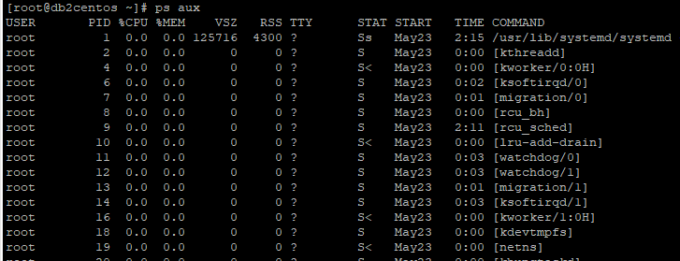
- kill : Terminate a process.
Usage: kill -9 <pid>

- bg: Restarts a suspended job, and runs it in the background

- fg : Used to bring a background job to the foreground.

- top : Displays top 20 processes dynamically which are taking more CPU memory.
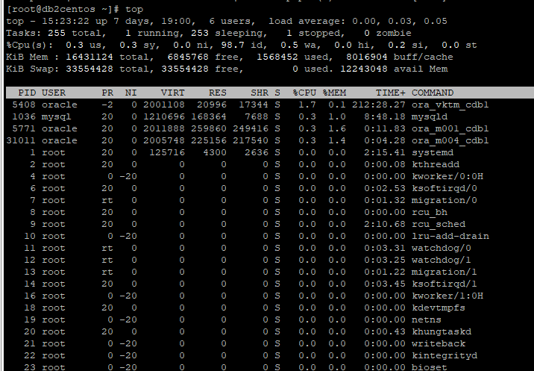

- at : Executes a job at a specified time. But it works multiple times.

- ctrl+z: It will suspend the current foreground job.
Usage: ctrl+z

Text Manipulation

- grep: By default, grep prints the matching lines. In addition, we can get what content we want.

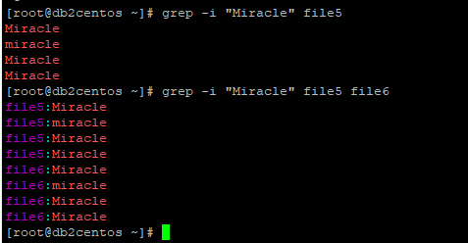
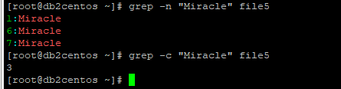

- awk: It is a pattern scanning and processing languages also known as oawk, gawk, mawk and nawk allows for pattern scanning and processing.

Common Variants of awk:
- oawk: The original version of awk.
- gawk: The GNU implementation of awk, which includes many extensions.
- mawk: A fast implementation of awk, focusing on performance.
- nawk: New awk, an updated version of the original awk.

- vi: Screen-oriented (visual) display editor.
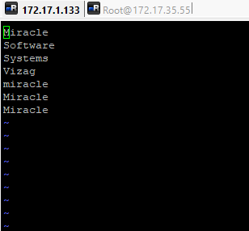

- sed: Stream Editor. We can replace, and we can search the data, insert.

sed -n '/Miracle\|Software/p' file1.txt: Searching
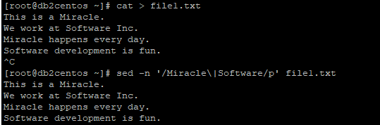

sed '/Software/d' file1.txt: Deleting.
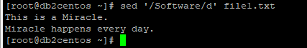

sed 's/Miracle/Success/g' file1.txt: Replacing

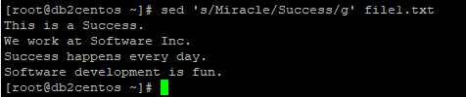

- cut: Cut out selected fields of each line of a file.

- find: Searches for the files based on the given input.

Information

- who & w: Displays who are logged in your system.
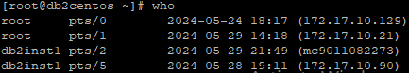

- whoami : Print effective userid.

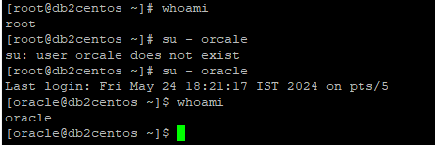

- man : The man command is short for manual and provides in depth information about the requested command or allows users to search for commands related to a particular keyword.
Usage: man <command name>
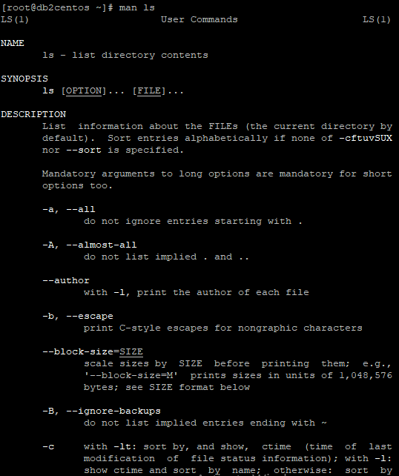

- whatis : Describes what function a command/word performs in a short way.
Usage: whatis keyword
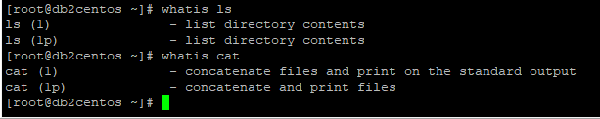

- finger : Lists information about the user.

- history: The 'history' utility allows you to use words from previous command lines in the command line you are typing. This simplifies spelling corrections and the repetition of complicated commands or arguments.
Usage: history [number]
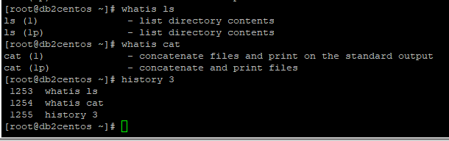

- id: Shows you the numeric user and group ID.
Usage: id [option] [username]

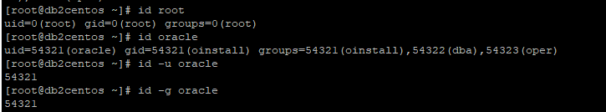

- logname: Print user's login name.

- tty: (Teletypewriter) Print the file name of the terminal connected to standard input.
Miscellaneous commands

- date: Print or set the system date and time.
Usage: date [options] [format]
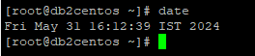

date -d "December 1, 2024": fetching the desired day
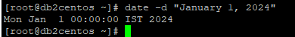

- cal: Displays a calendar.
Usage: cal [options] [[month] year]
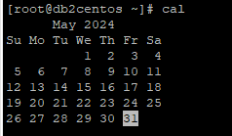

cal 12 2024: fetching specific month
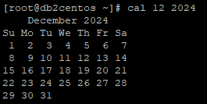

- exit: Allows you to exit from a program, shell or log you out of a Unix network.

- clear: Clear the terminal screen.

- banner: Used to print the ASCII character string in large letter to standard output.

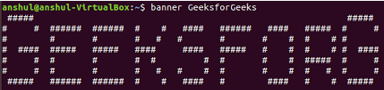

Shell programming

- read: Reads a line from standard input and assigns it to a variable.
- expr: Evaluates expressions.
- echo: Prints text to the standard output.
- sh: Executes commands specified in a script or interactively in the shell.
- source or . : Executes commands from a file in the current shell environment.
- sleep: Suspends execution for a specified period of time.
- test: Evaluates conditional expressions and returns true or false.

