MICROSOFT INVESTMENT MEMO
Buffett-Inspired Business Quality and DCF Assessment

Valuation date: August 6, 2026
Author: Yagni Patel

Current Price | Base DCF Value | 15% MOS Price | Stance
$499.86 | $367.85 | $312.67 | WATCH / WAIT
Exceptional business quality. Insufficient margin of safety.
Educational portfolio analysis - not investment advice

Executive Summary

Microsoft is an exceptional business with a broad moat, recurring enterprise revenue, high margins, strong cash conversion, and attractive returns on capital. The investment question is not whether Microsoft is a high-quality company. It is whether the current price provides a sufficient margin of safety after accounting for the extraordinary capital required to build AI and cloud capacity.
The base DCF values Microsoft at $367.85 per share, implying 26.41% downside to the $499.86 reference price. The reverse DCF indicates that the market price requires 7.41 percentage points of additional FY2027E consolidated revenue growth above the base case, taking implied growth from 16.22% to 23.62%, with the uplift fading to zero by FY2036E.
Decision metric | Result
Investment stance | WATCH / WAIT
Buffett-inspired overall score | 74.5 / 100
Business quality excluding valuation | 88.1 / 100
Base intrinsic value | $367.85
Current market price | $499.86
15% margin-of-safety price | $312.67
Reverse DCF FY2027E growth uplift | 7.41 pp

Investment question: Can Microsoft's AI and cloud investments generate sufficient long-term free cash flow growth and returns to justify its current valuation?
Conclusion: Microsoft's AI and cloud investments may justify today's valuation, but the market price already assumes a more aggressive monetization path than the base case.

Business Overview & Operating Momentum

Microsoft generated FY2026 revenue of $331.8 billion, up 18%, and operating income of $155.2 billion, up 21%. Azure annual revenue surpassed $100 billion, Microsoft 365 Copilot exceeded 30 million paid seats, and commercial remaining performance obligation reached $678 billion. These results support the durability of the enterprise franchise and the breadth of AI demand.
Segment | Revenue ($mm) | Growth | Operating margin
Productivity & Business Processes | 139,996 | 15.88% | 59.92%
Intelligent Cloud | 137,791 | 29.67% | 41.35%
More Personal Computing | 54,052 | (1.09%) | 26.62%
Productivity & Business Processes remains the primary margin engine. Intelligent Cloud is the main growth engine, but its economics are more capital-intensive and exposed to utilization, depreciation, energy, and AI-serving costs.
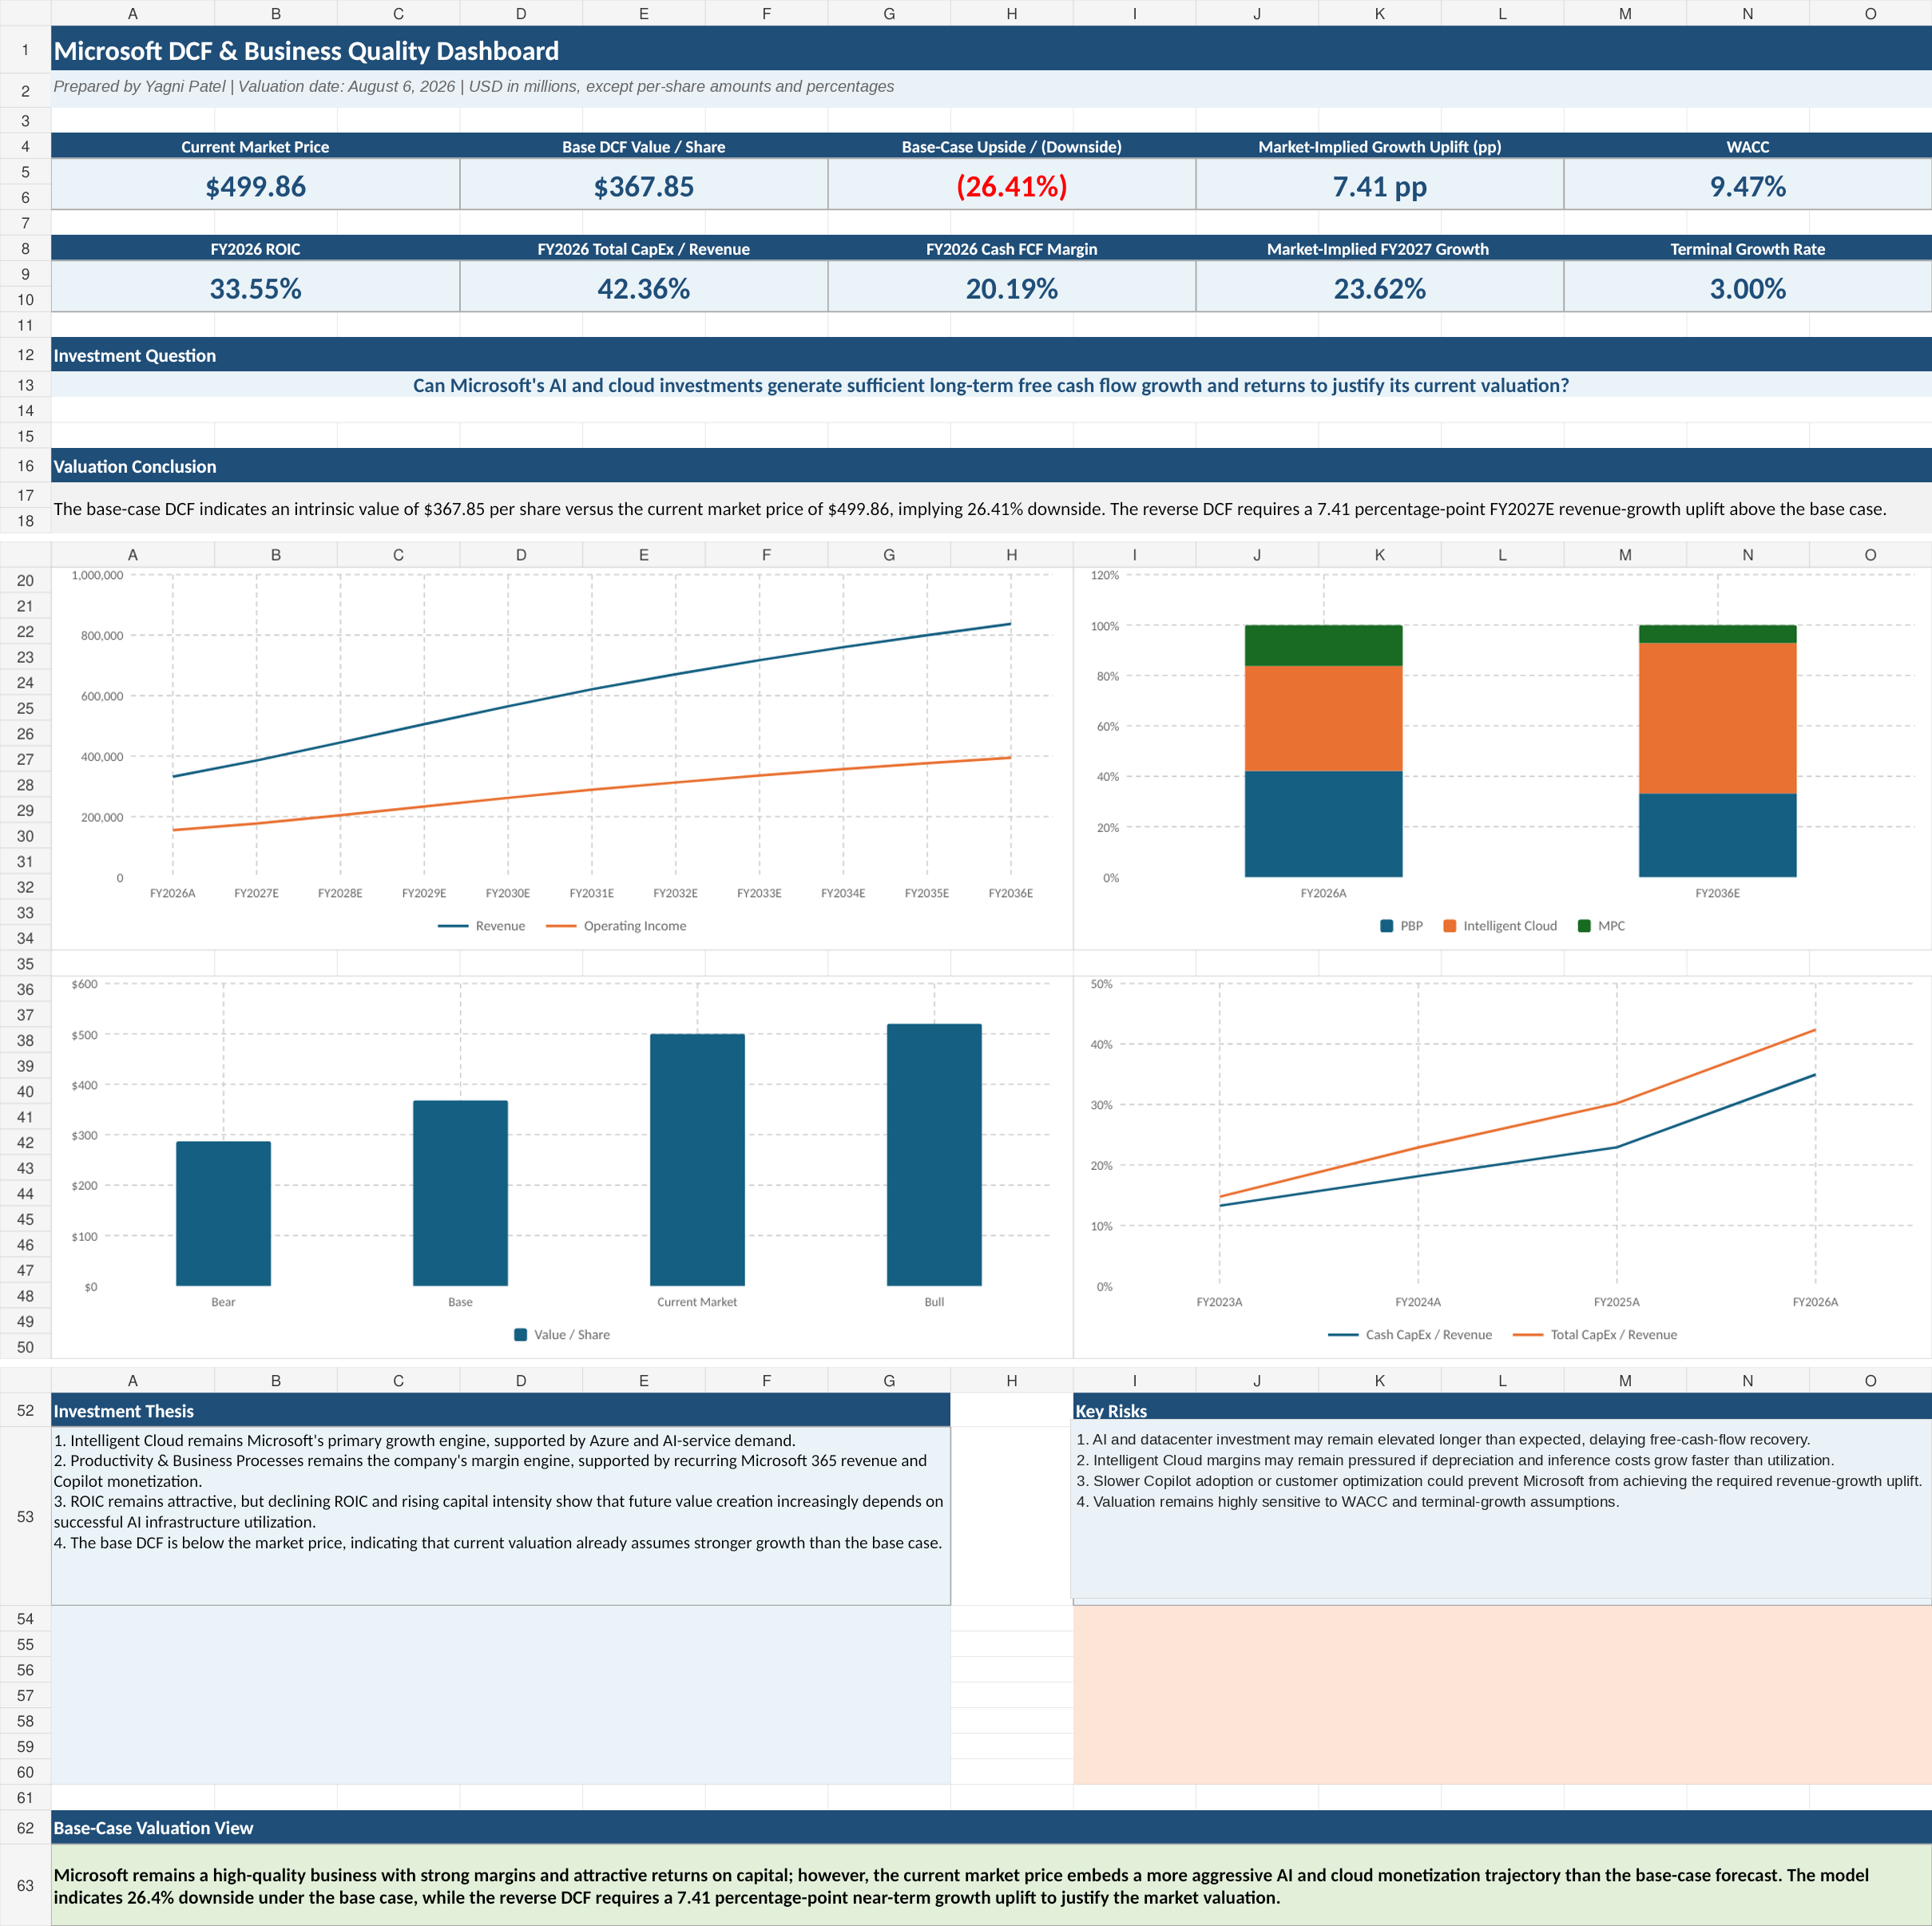
Figure 1 - Executive model dashboard
Buffett-Inspired Five-Tenet Assessment

The framework is analyst-created and is not an official Berkshire Hathaway checklist. It is designed to separate franchise quality from purchase-price discipline.
Tenet | Weight | Score | Verdict
Business clarity and predictability | 15% | 4.5 / 5 | Strong
Durable competitive advantage | 25% | 5.0 / 5 | Exceptional
Financial quality and earnings power | 20% | 4.5 / 5 | Strong
Capital allocation and incremental returns | 20% | 3.5 / 5 | Good / Monitor
Valuation and margin of safety | 20% | 1.0 / 5 | Weak
Overall | 100% | 74.5 / 100 | WATCH / WAIT
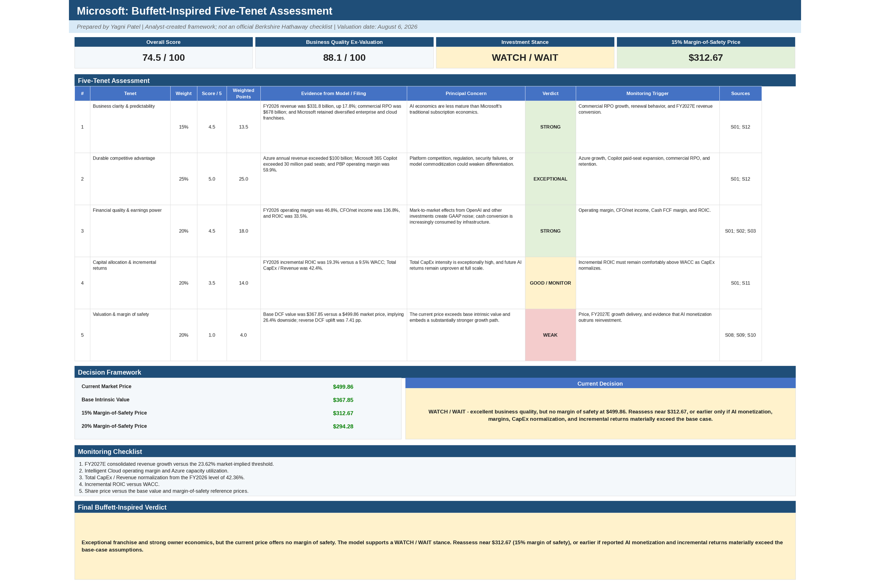
Figure 2 - Buffett-inspired scorecard and decision framework

Owner Earnings and AI Reinvestment Economics

Microsoft's FY2026 operating margin reached 46.78%, while CFO was 136.77% of net income. ROIC was 33.55%, but it declined as invested capital expanded. The most important trend is the divergence between accounting profitability and cash economics.
Metric | FY2026 result | Interpretation
Operating margin | 46.78% | Strong operating leverage and mix
CFO / Net Income | 136.77% | High reported earnings conversion
ROIC | 33.55% | Attractive, but declining as capital expands
Incremental ROIC | 19.34% | Above WACC; proof period continues
Cash CapEx / Revenue | 34.94% | Extremely high infrastructure intensity
Total CapEx / Revenue | 42.36% | Includes finance-lease additions
Cash FCF margin | 20.19% | Cash generation pressured by CapEx
Lease-Adjusted UFCF margin | 9.32% | Economic cash flow after total infrastructure investment
The model does not conclude that AI investment is destroying value. Incremental ROIC remains above the 9.47% WACC. The conclusion is that the proof period is incomplete: utilization and monetization must catch up with the installed capacity while CapEx intensity normalizes.
Figures 3-4 - Base DCF and WACC/terminal-growth sensitivity

Forecast, DCF & Market-Implied Expectations

The base forecast models each segment independently through FY2036E. Consolidated revenue growth declines from 16.22% in FY2027E toward 4.74% in FY2036E. Operating margin remains between roughly 46% and 47%, while Total CapEx / Revenue declines from 43% to 16% as the infrastructure cycle normalizes.
Valuation output | Result
WACC | 9.47%
Terminal growth | 3.00%
Enterprise value | $2,735,267 million
Equity value | $2,741,570 million
Intrinsic value per share | $367.85
Current market price | $499.86
Implied downside | (26.41%)
Terminal value / enterprise value | 65.90%
Implied terminal EV/UFCF | 15.92x
The reverse DCF holds operating margins, reinvestment, WACC, and terminal growth constant and solves for the revenue trajectory required to reproduce the market price.
Metric | Base case | Market-implied
FY2027E revenue growth | 16.22% | 23.62%
Growth uplift | - | 7.41 pp
Enterprise value | $2.735 trillion | $3.719 trillion
Implied share price | $367.85 | $499.86
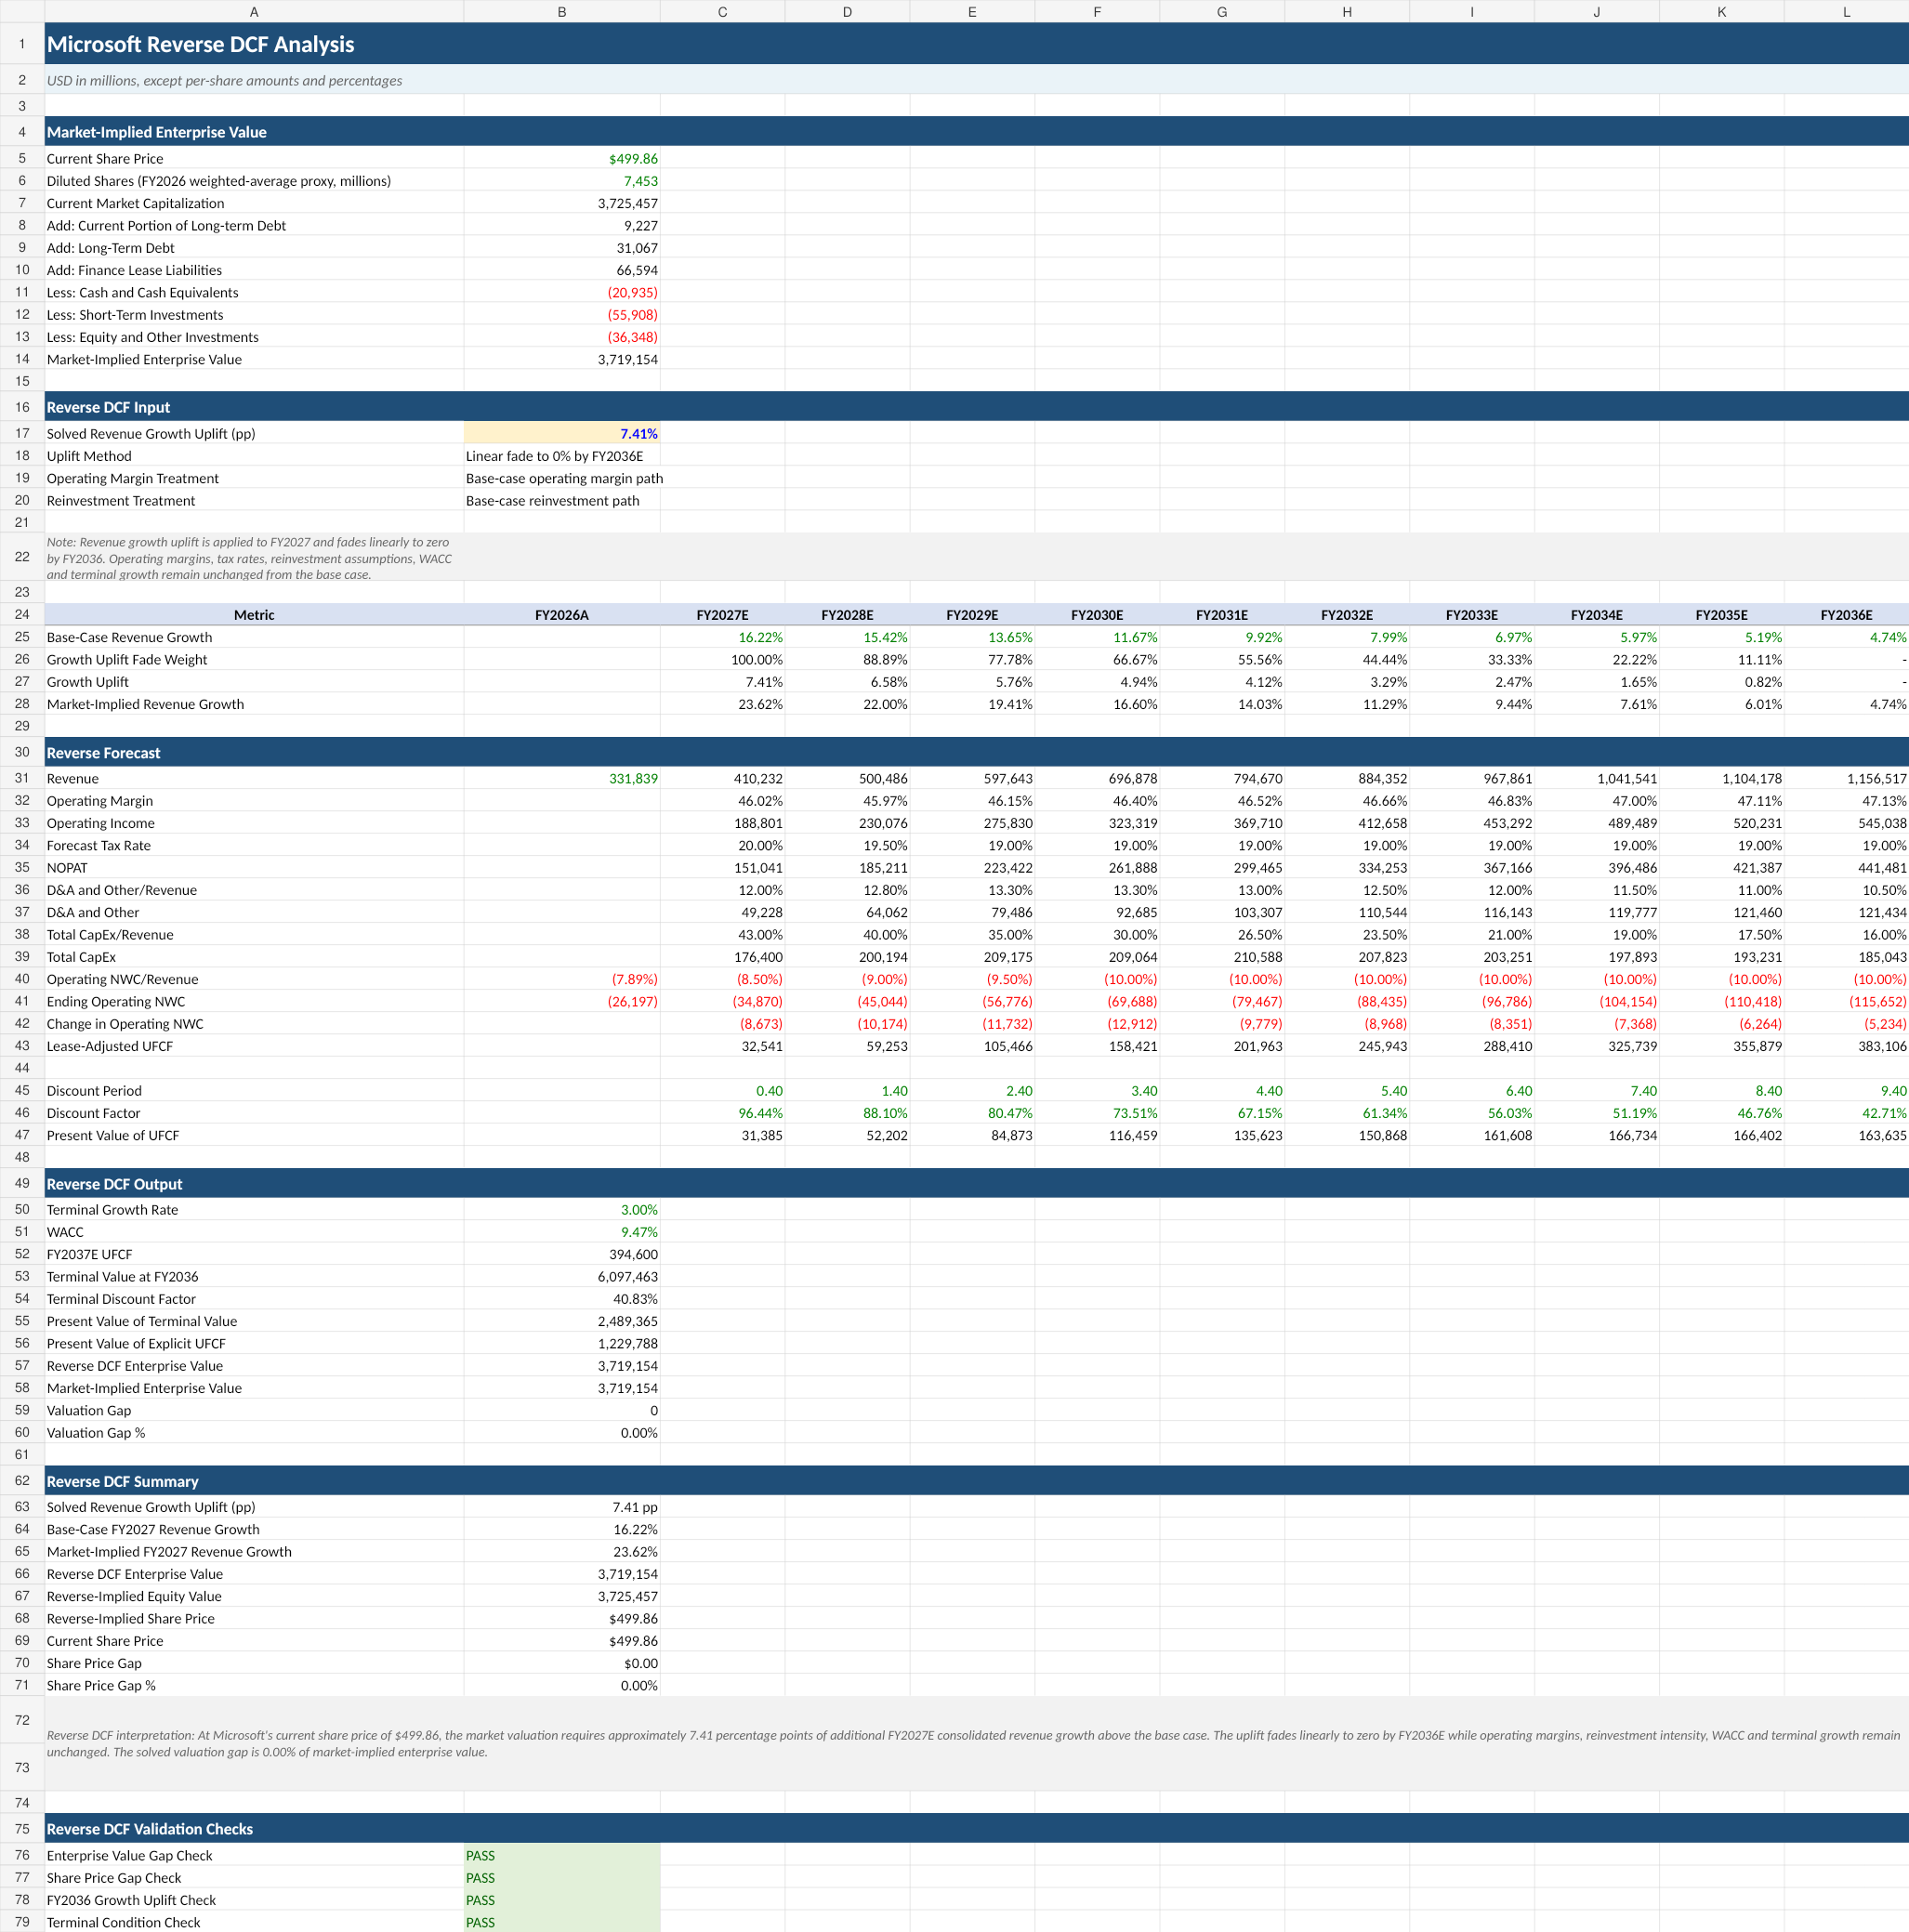
Figure 5 - Reverse DCF and market-implied growth path

Catalysts, Risks & Monitoring

Potential catalysts
- Azure growth remains near or above 40% while capacity constraints ease.
- Microsoft 365 Copilot paid seats convert into meaningful ARPU expansion.
- Intelligent Cloud operating margin stabilizes and begins to recover.
- Total CapEx intensity declines faster than modeled.
- Incremental ROIC remains above 15% as invested capital scales.
- The share price declines toward or below the margin-of-safety range.

Principal risks
- AI and datacenter investment remains elevated longer than expected.
- Capacity is underutilized or AI workload pricing becomes structurally less attractive.
- Competition compresses Azure, Copilot, or developer-platform economics.
- Security, privacy, regulatory, or antitrust events weaken the ecosystem.
- The terminal valuation remains highly sensitive to WACC and perpetual growth.
- The reverse DCF solves for one variable; other combinations could also justify the market price.

Quarterly monitoring framework
- Consolidated growth versus the 23.62% market-implied FY2027E threshold
- Azure growth and Intelligent Cloud operating margin
- Copilot paid seats, pricing, and reported monetization
- Total CapEx / Revenue and lease-adjusted UFCF recovery
- Incremental ROIC relative to WACC
Final Recommendation

WATCH / WAIT - Microsoft is an exceptional franchise, but the $499.86 reference price offers no margin of safety under the base case. The shares would merit renewed consideration near $312.67, or earlier only if AI monetization, margins, CapEx normalization, and incremental returns materially outperform the model.

Decision reference | Price
Base intrinsic value | $367.85
10% margin-of-safety price | $331.06
15% margin-of-safety price | $312.67
20% margin-of-safety price | $294.28

Sources, Methodology & Limitations

Primary sources
- Microsoft FY2026 Q4 earnings release and financial statements
- Microsoft FY2025 Annual Report
- Microsoft SEC filings
- U.S. Treasury daily yield curve rates
- NYU Stern current valuation data

Methodology summary
- Segment-driven operating forecast through FY2036E.
- Lease-adjusted UFCF subtracts Total CapEx, including finance-lease additions.
- Mid-year DCF with 9.47% WACC and 3.00% terminal growth.
- Reverse DCF solves for a consolidated revenue-growth uplift while holding other variables constant.
- Buffett-inspired scorecard is an analyst-created decision framework, not an official Berkshire checklist.

Limitations
- FY2026 diluted weighted-average shares are used as a proxy rather than a full treasury-stock-method dilution schedule.
- Bear/Base/Bull scenarios vary WACC and terminal growth rather than using independent operating forecasts.
- The reverse DCF changes one variable while holding margins and reinvestment constant.
- ERP, beta, debt cost, market price, and Treasury inputs should be refreshed when the valuation date changes.
- This memo is an educational portfolio analysis and is not investment advice.
Model workbook: Microsoft_DCF_Analysis_Final.xlsx

