**ChatGPT-Based Storytelling Project**

* **Title: The Lost City of Aurelia – An Interactive Mystery Adventure**
* **Objective:**

To demonstrate the capabilities of Generative AI through an engaging, interactive storytelling experience where the user collaboratively builds a dynamic narrative with ChatGPT—without any code or external platform.

* **Theme:**

Mystery Adventure — set in an ancient, mythical lost city named *Aurelia*, filled with puzzles, branching decisions, and hidden truths.

* **Main Character:**

**Aria Solis** – a brave, young archaeologist driven by curiosity and a legacy left behind by her missing mentor. She is intelligent, resourceful, and willing to make hard choices for the greater good.

* **Interactive Format:**

The story unfolds in a **"choose your own adventure"** format. At the end of each scene, ChatGPT provides 2–3 choices to guide the story’s path. The user selects an option, and the story continues based on that choice. Each interaction can lead to a unique narrative arc and ending.

* **Key Features & AI Use:**

• **Prompt-Driven Decisions:** The user is constantly involved through decision-making prompts.

• **Narrative Generation:** ChatGPT expands the story based on the user's choices in real-time.

• **Dynamic Story Branching:** Multiple narrative possibilities based on path chosen.

• **Creative AI Collaboration:** No need for code; just creativity and engagement.

* **Sample Story Branches:**

• Explore the temple or follow the footprints

• Descend into hidden chambers or inspect ancient artifacts

• Confront mysterious figures or hide in the shadows

• Choose to wield power, seek truth—or destroy it altogether

* **Screenshot:**

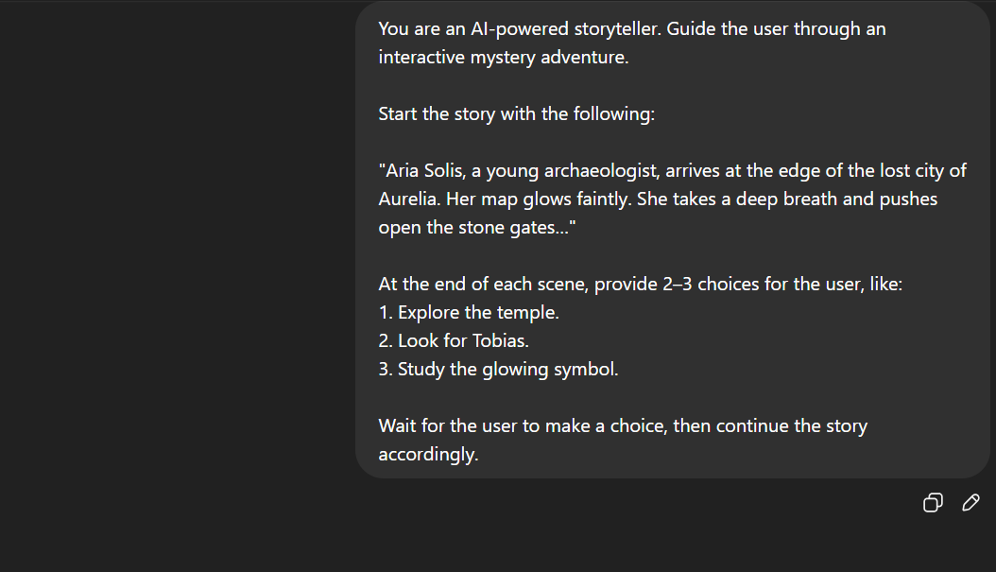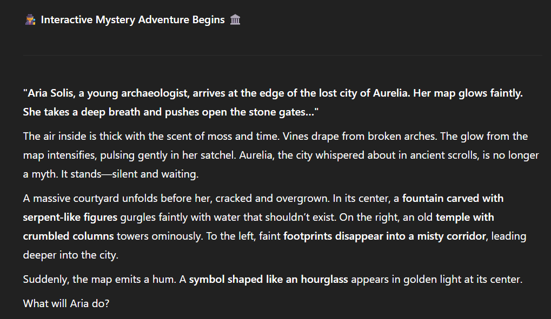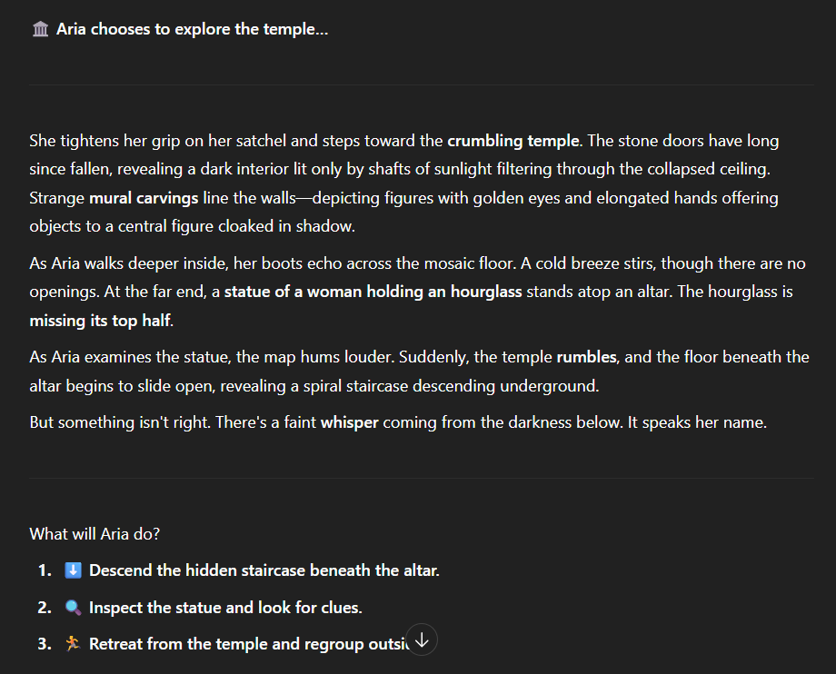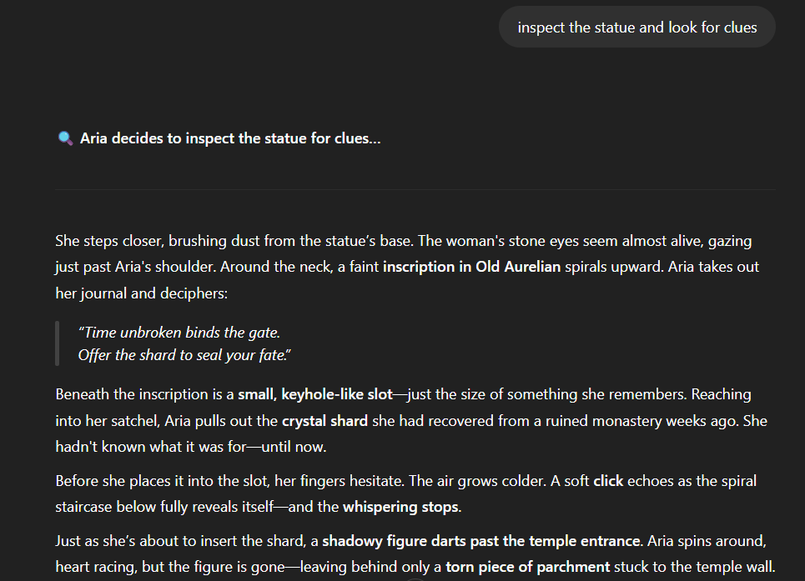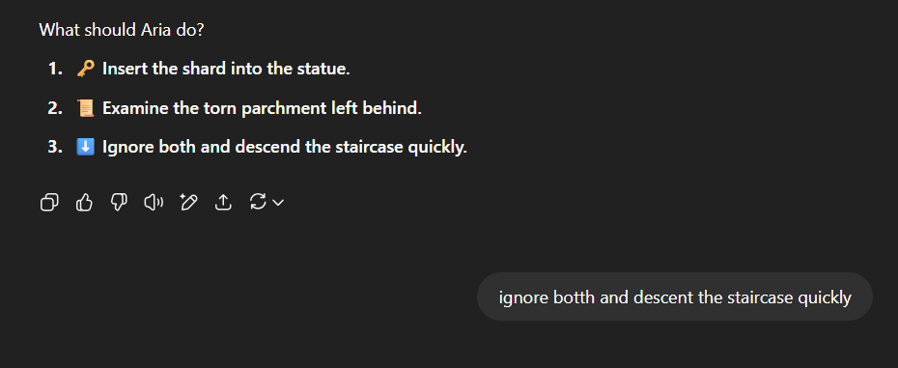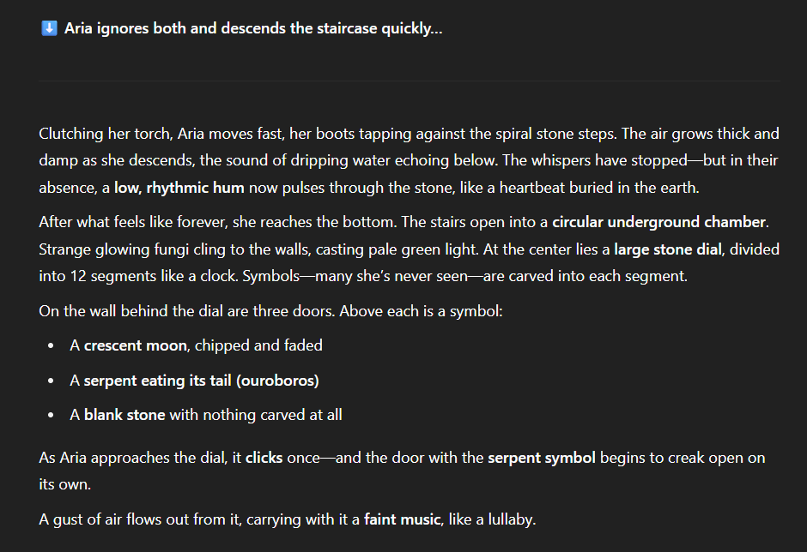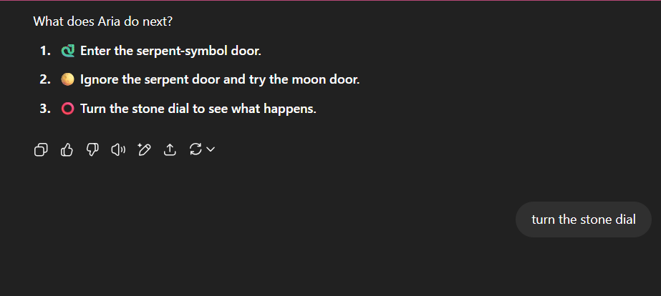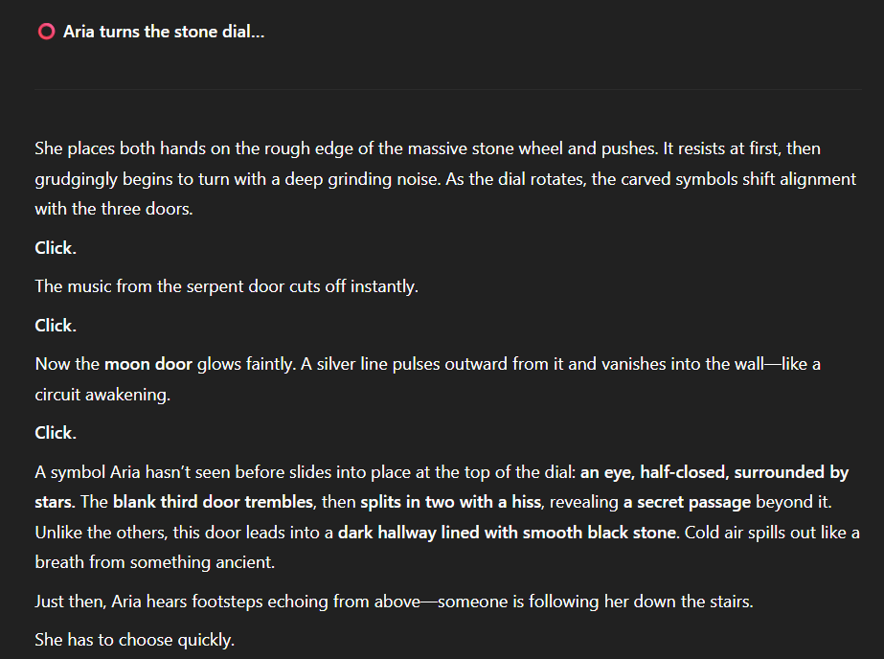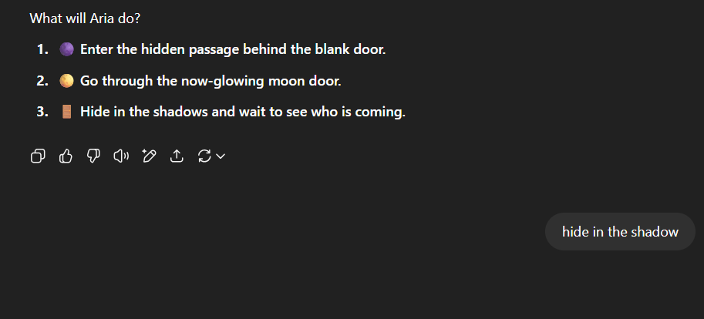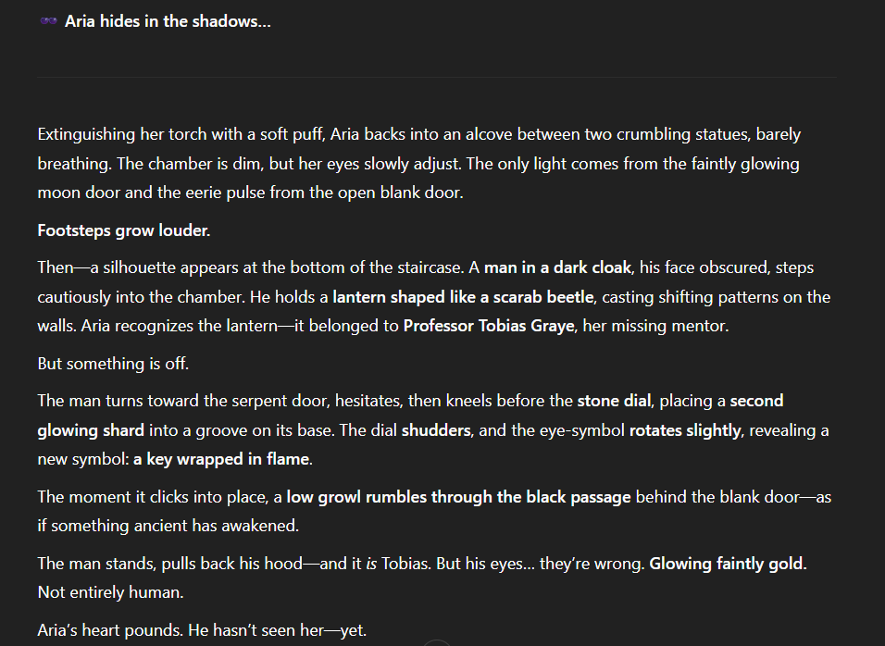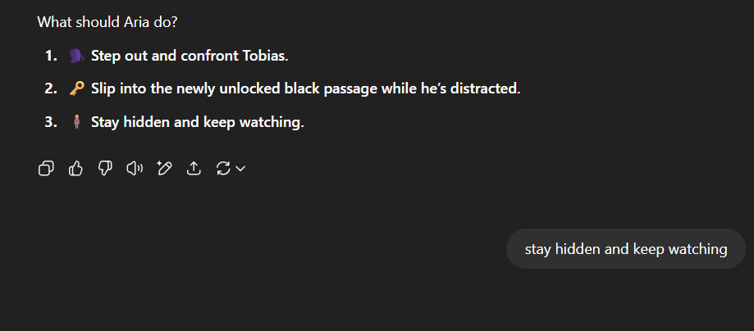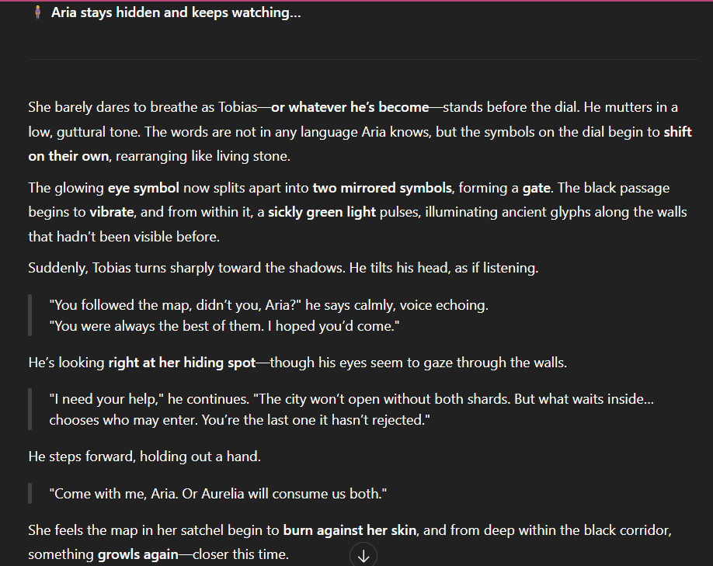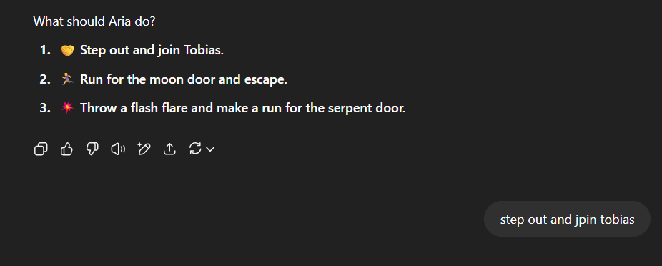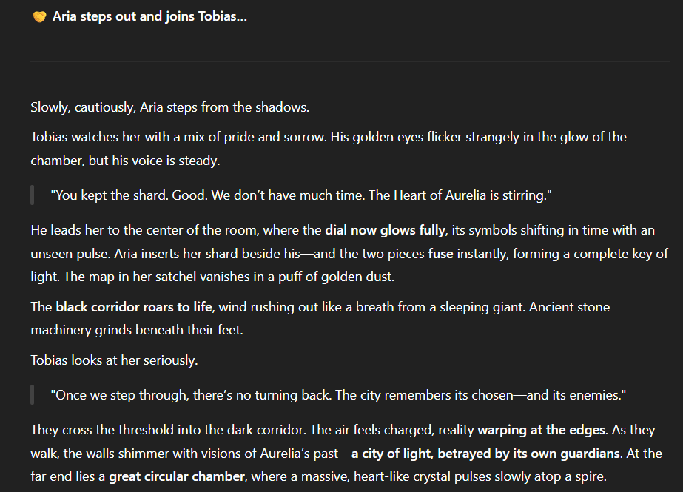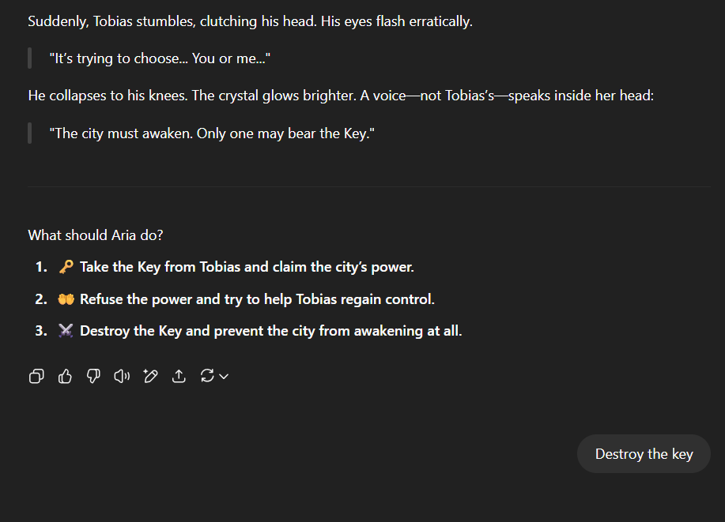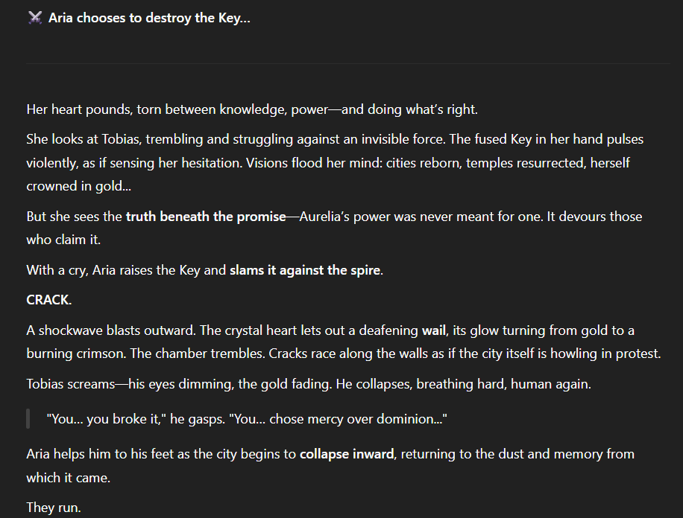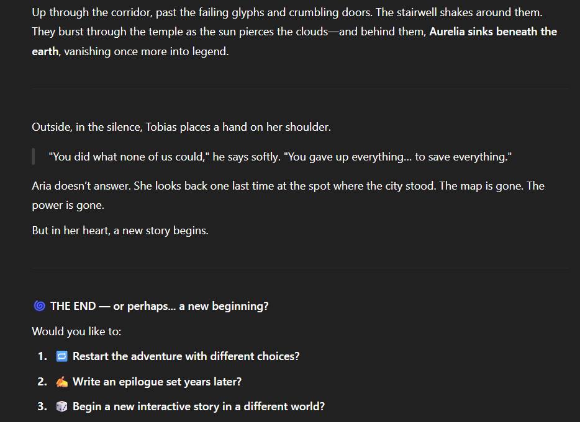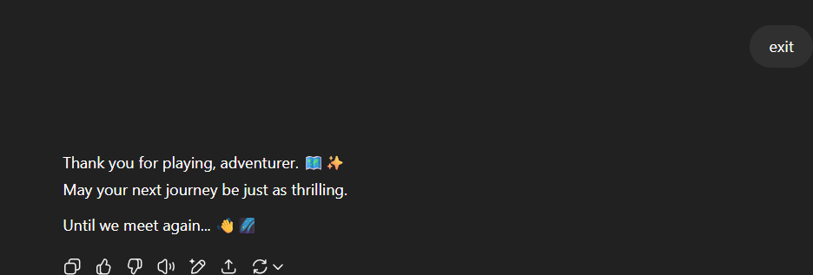

* **Conclusion:**

The project culminates in the user choosing to destroy the Key, saving the world from the corrupt power of the lost city. The adventure showcases how ChatGPT can serve as both a narrator and improvisational storyteller, adapting to each input creatively.

This project highlights the power of LLMs like ChatGPT to build immersive, user-driven narratives—ideal for entertainment, education, and prototyping game logic.