Git

Github

What is gitignore file?

This file will hode file such as API key, secret passwords etc to load locally to remote repo.

This file will give the information the files which is present locally but not want to add on git repo.

On windows go to folder -->>view-->select hidden item

On linux and mac ls -la

Create gitignore file

Add the list of file that you don’t want to publish to git onine repo.

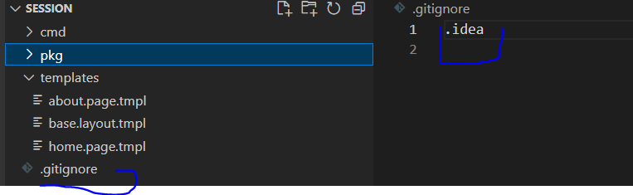

How to add all text file in gitignore

\*.txt //Ignore all the file to push to remote repo, or add all the .txt file into gitignore file

git init

Initialise local github repository

git add .

This will add all the files into local git

git commit -m "Intitial commit"

This will add commit in local

Go to hithub.com

Crete new repo or open existing repo

Copy the link you want to publish those files.

To push from local to online repo

git remote add origin git@github.com:yagnikpokal/golang.git

This will add the files locally to your speicifed git repo.

git branch -M main //This can be skip

This will push to main branch

git push -u origin main

This will push all change to online repo

git status

This command will show untrack changes in git

git add . //Add all the chnages into local git

git add filename.txt //Will add single file into local git

git log // This file will give all the commit

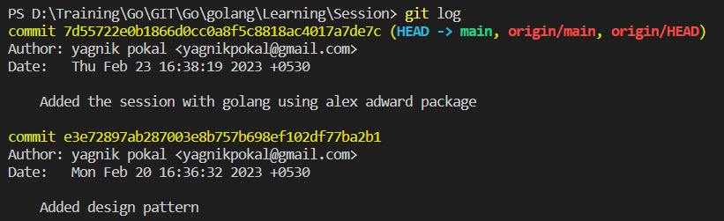

Totally there will be 3 stages

Working directory

Local repositories

Stage Area

Remote

repositories

Git push

Git commit

Git add

How to check which file I have changed in my local repositories?

git diff filename //This will give details of loaclly made change and last commit

How to switch to the last version in localrepository?

Let us say I have make one file and I have commited it in local repo.

Now I hav updated that file. But I want go to last change that I commited then below command will use.

git checkout filename //Restore to the last version of the specific file

Remove the all the things from stageing in local repo

git rm --cached -r .

Remove specific file from the staginging and just add it to working directory

git rm --cached -r filename

To check wether file removed or not from the staging we can use git status

Take remote repo to local machine first time

git clone nameofrepo

Fork and pull request

Fork is the process of taking the other person git repo to your git repo.

Once modifed in your repo then you can create a pull request.

Why fork is needed?

1. To give open source contribution
2. To take code of other persons remote repo to our own repo and modify it in our repo.

In a pull request if original branch owner approves then and only then our code will be merged.

Other persons github and you want to contribute

Your Github

1

1

1

2

3

2

3

2

Your Remote

repositories

Remote Repository

Local

repositories

Local Repository

FORK

Other persons github and you want to contribute

Your Github

Remote Repository

1

1

Your Remote

repositories

Local

repositories

Local Repository

1

2

2

2

3

3

PULL request

Other persons github and you want to contribute

Your Github

1

1

1

2

3

2

3

2

Your Remote

repositories

Remote Repository

Local

repositories

Git pull

Local Repository