HTML Markup langauge

Hyper text markup langauge

CSS Styling langauge

Cascadiing style sheet

JAVASCRIPT Programming langauge

URL -->> Uniform resorce location

Resources might be html pages, video files, fonts, image etc

HTTP -->> Hyper text transfer protocol

HTTPS -->> HTTP with encryption

DOM -->> Document object model

First request from browser to server

GET /index.html HTTP/1.1

Host: [www.codewithmosh.com](http://www.codewithmosh.com)

Accept-Langauge: en-us

Response fron the server to browser

HTTP/1.1 200 OK

Date: 1 Jan 2021 09:00

Content-Type: text/html

<!DOCTYPE html>

<html>

…

</html>

**Things need to remember while using the HTML**

1. HTML is not a case sensitive langauge
2. Browser will remove all the whitespaces from the html so space is not necessory
3. Take a look at
   1. Text
   2. Links
   3. Images
   4. Lists and tables
   5. Container elements
   6. structural elements

Write index.html

<!DOCTYPE html>

<html>

    <head>

        <title>

            My first webpage

        </title>

    </head>

    <body>

    </body>

</html>

Right click on the anywhere in VS editor

Click on open with live server

This will open a new window on the browser and link is http://127.0.0.1:5500/index.html

Add image to html

This will comes into body section

<img scr=”” alt=””>

Here you have to add the sources of the image

Alt is the test if your image not appears then it shows some text there.

To add a paragraps can use

<p> </p>

<!DOCTYPE html>

<html>

    <head>

        <title>

            My first webpage

        </title>

    </head>

    <body>

        <img src="images/yagnik.png" alt="">

        <p>@yagnikpokal</p>

        <p>I am learning HTML</p>

    </body>

</html>

CSS will improve the looks and feel of the websites.

To add a CSS style we can use the

<style></style>

Now let us say we want to reduce the size of the image then

        <style>

            img {

                width: 100px;

            }

        </style>

So the full code will be

<!DOCTYPE html>

<html>

    <head>

        <title>

            My first webpage

        </title>

        <style>

            img {

                width: 100px;

            }

        </style>

    </head>

    <body>

        <img src="images/yagnik.png" alt="">

        <p>@yagnikpokal</p>

        <p>I am learning HTML</p>

    </body>

</html>

Result output will be

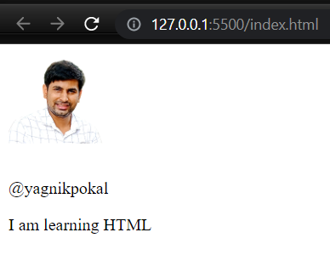

This image looks like a squere

Now to make this radial from all 4 circle we can use a property called border-radius: 50px;

<!DOCTYPE html>

<html>

    <head>

        <title>

            My first webpage

        </title>

        <style>

            img {

                width: 100px;

                border-radius: 50px;

            }

        </style>

    </head>

    <body>

        <img src="images/yagnik.png" alt="">

        <p>@yagnikpokal</p>

        <p>I am learning HTML</p>

    </body>

</html>

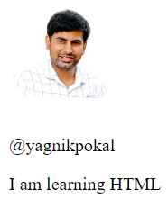

To make these image to left side can use

float: left;

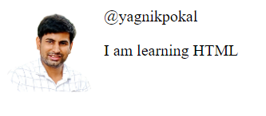

To add a margin in between image and text

margin-right: 10px;

<!DOCTYPE html>

<html>

    <head>

        <title>

            My first webpage

        </title>

        <style>

            img {

                width: 100px;

                border-radius: 50px;

                float: left;

                margin-right: 10px;

            }

        </style>

    </head>

    <body>

        <img src="images/yagnik.png" alt="">

        <p>@yagnikpokal</p>

        <p>I am learning HTML</p>

    </body>

</html>



To make username bold we have to allocate a class to to user name as below and need to add style as below

<p class="username">@yagnikpokal</p>

            .username {

                font-weight: bold;

            }

So the final code will be

<!DOCTYPE html>

<html>

    <head>

        <title>

            My first webpage

        </title>

        <style>

            img {

                width: 100px;

                border-radius: 50px;

                float: left;

                margin-right: 10px;

            }

            .username {

                font-weight: bold;

            }

        </style>

    </head>

    <body>

        <img src="images/yagnik.png" alt="">

        <p class="username">@yagnikpokal</p>

        <p>I am learning HTML</p>

    </body>

</html>



To check the HTML source code we can upload that file to the below link and it will give you error.

<https://validator.w3.org/>

To check the CSS validation

[https://jigsaw.w3.org/css-validator/](https://jigsaw.w3.org/css-validator/" \t "_blank)

Referance

<https://www.youtube.com/watch?v=qz0aGYrrlhU>

How to get a basic HTML template in VS?

Press ! then enter it will gove basic html template as below

<!DOCTYPE html>

<html lang="en">

<head>

    <meta charset="UTF-8">

    <meta http-equiv="X-UA-Compatible" content="IE=edge">

    <meta name="viewport" content="width=device-width, initial-scale=1.0">

    <title>Document</title>

</head>

<body>

</body>

</html>

Can add a keywords and descirption as below

    <meta name="keywords" content="semiconductor, chips, webdevelopement">

    <meta name="description" content="This is all that what website is about">

Shortcut to add the meta and other things

Can type meta in new line and select the what we have to write then it eill write all things automatcallyt.

To see result on the screen while editing go to the

<https://codepen.io/pen>

<center>

<hr size="3" noshade>

<h1>THE ADVENTURE OF</h1>

<br>

<h1>THE SHERLOCK HOLMES</h1>

<br>

<h3> BY </h3>

<br>

<h1> SIR ARTHUR CONAN DOYLE</h1>

<hr size="3" noshade>

</center>

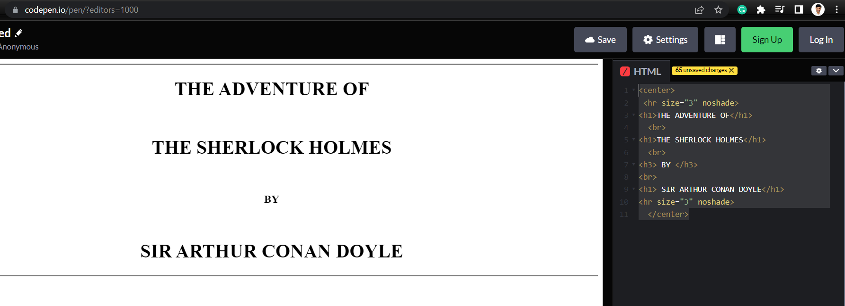

HTML heading elements

<https://devdocs.io/html/element/heading_elements>

HTML boilerlate

type ! and then enter in vs code will gove below item which is called as boilerplate.

<!DOCTYPE html>

<html lang="en">

<head>

    <meta charset="UTF-8">

    <meta http-equiv="X-UA-Compatible" content="IE=edge">

    <meta name="viewport" content="width=device-width, initial-scale=1.0">

    <title>Document</title>

</head>

<body>

</body>

</html>

Create a new line

<hr>

Make tex bol

<strong> </strong>

Make text italic

<em> </em>

Can also use<i> </i>

<!DOCTYPE html>

<html lang="en">

<head>

    <meta charset="UTF-8">

    <meta http-equiv="X-UA-Compatible" content="IE=edge">

    <meta name="viewport" content="width=device-width, initial-scale=1.0">

    <title>Yagniks website</title>

</head>

    <body>

        <h1>This is Yagniks website</h1>

        <p><em>Software developer <strong>with golang, javascript and html</strong></em></hp>

        <hr>

    </body>

</html>

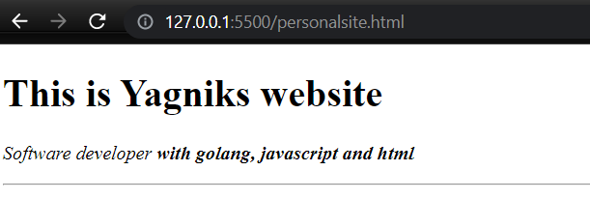

How to add a bullte points in HTML?

There are many type

1. unordererd
2. ordered

**HTML List Tags**

Tag Description

<ul> Defines an unordered list

<ol> Defines an ordered list

<li> Defines a list item

<dl> Defines a description list

<dt> Defines a term in a description list

<dd> Describes the term in a description list

**Unordered type**

    <h1> <strong>My working</strong></h1    >

    <ul>

        <li>I am a golang developer</li>

        <li>I am working with embedded Software</li>

    </ul>

# ****My working****

* I am a golang developer
* I am working with embedded Software

**Ordered list**

    <h3>Who am i</i></h3>

    <ol>

        <li>This is Yagniks</li>

        <li>I am a golang developer</li>

    </ol>

### Who am i

1. This is Yagniks
2. I am a golang developer

List start with roman number

    <p>Roman number list</p>

    <ol type="i">

        <li>first</li>

        <li>Secomd</li>

    </ol>

Roman number list

i. first

ii.Secomd

List with attributes

1. Start with specific number

<!DOCTYPE html>

<html lang="en">

<head>

    <meta charset="UTF-8">

    <meta http-equiv="X-UA-Compatible" content="IE=edge">

    <meta name="viewport" content="width=device-width, initial-scale=1.0">

    <title>Document</title>

</head>

<body>

    <ol start="4">

        <li>Fourth</li>

        <li>Fifth</li>

    </ol>

</body>

</html>

<!--

4. Fourth

5. Fifth

-->>

Image element in HTML

Take the image from server

Take the image from local folder

    <img src="yagnik.png" alt="Yagniks image">

    <br>

    <img src="https://0.gravatar.com/avatar/09ae4bbb8475dda13980b6fc2239f98e?s=180&d=identicon&r=G" alt="">



Till now we talk about markup langauge only.

Now

We talk about hyper text. Which means that we will use links on the text.

Link can be created with the help of the anchor tag.

Add hyper link or link

There are 2 types of links

1. External web
2. Internal web

    <h3>HTML Links</h3>

    <a href="https://www.linkedin.com/">My linkeinp profile</a>

    <br>

    <a href="personalsite.html">personalsite</a>

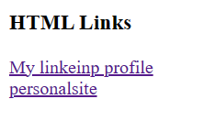

How to open the link into new browser?

   <a href="http://linked.com" target="\_blank">Linkedin</a>

Create a multiple pages and add a link

<!DOCTYPE html>

<html lang="en">

<head>

    <meta charset="UTF-8">

    <meta http-equiv="X-UA-Compatible" content="IE=edge">

    <meta name="viewport" content="width=device-width, initial-scale=1.0">

    <title>Document</title>

</head>

<body>

    <a href="http://linked.com" target="\_blank">Linkedin</a>

    <br>

    <a href="mycontact.html" target="\_blank">My contact</a>

</body>

</html>

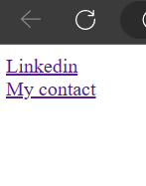

When clicked on the my contact then

