Install dbvewer

<https://dbeaver.io/download/>

Create database called users

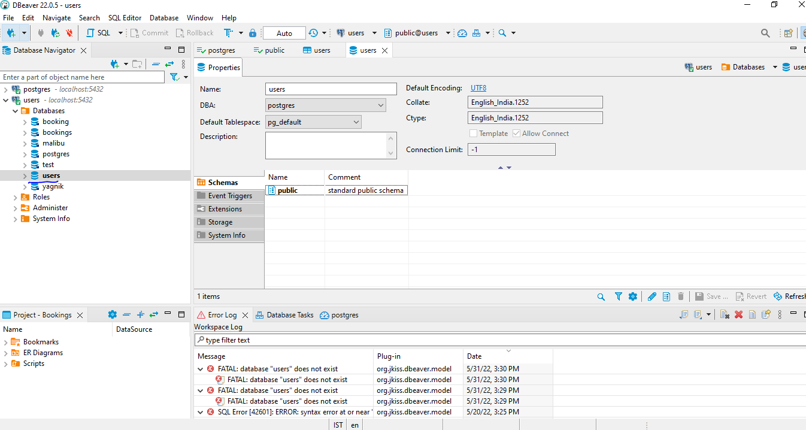

Close the dbveaver

Open beekeeper

Install beekeeper studio

<https://www.beekeeperstudio.io/>

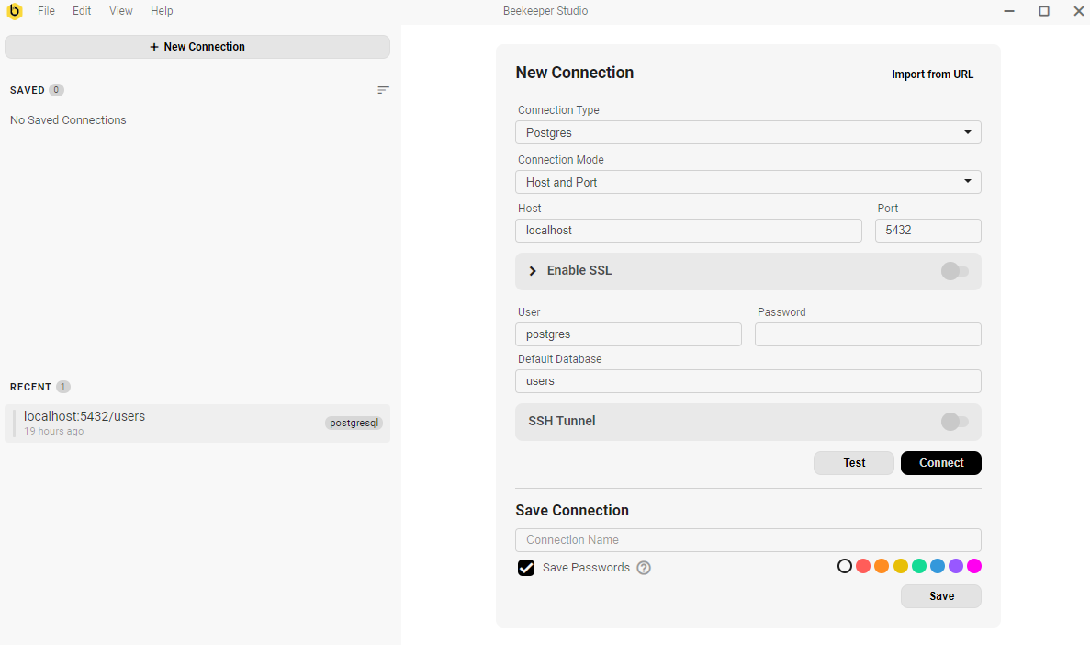

User will be postgre

Password will be password

Test connection It must show green notification with connected message

Download source code from

<https://github.com/yagnikpokal/golang/tree/main/Microservice>

Open VI studio

Browse package

Go to main directory of project

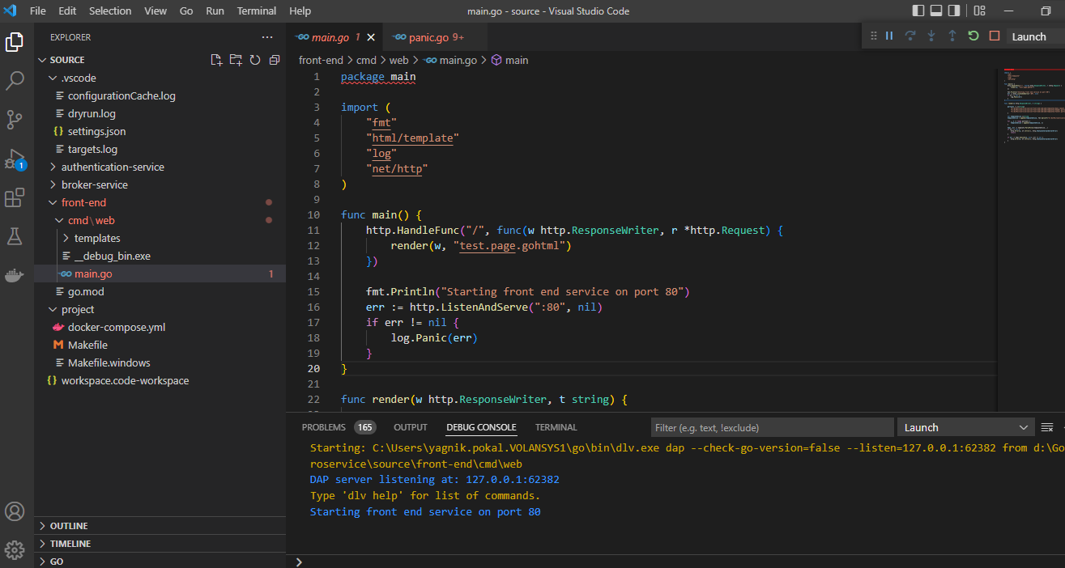

Go to run -->> Start debugging

It will shows application started on the port 80

Now go to browser

<http://localhost/80>

Check the videos how it will looks like