ADANA ALPARSLAN TÜRKEŞ SCIENCE AND TECHNOLOGY UNIVERSITY

DEPARTMENT OF COMPUTER ENGINEERING

CEN221 – Web Design and Programming

PROJECT REPORT

ONLINE ELECTRONIC DEVICE SHOPPING WEBSITE

prepared by

Gazi Akviran - 180101045

Yağnur TETİKCAN - 170101045

submitted to

Asst. Prof. Dr. Fatih ABUT

Adana, 2019

Our project is a website about Online Electronic Device Shopping. On this site you can see:

* The brand and logo of the website
* A **navbar** which contains the categories of the product
* A search box (visually).
* A **slider** that contains advertisement of the products
* 3 featured product **cards** with scale effect
* 3 separated **sliders** named “Bestsellers, On Sale, New Arrived” respectively.
* A **footer** that contains contact informations.
* Products that are connected to **database** and their informations(images, price, quality) in a aesthetics responsive card structure on the phone.php page.
* Filtering section visually (not related to database) on the phone.php page.
* **Comment** section that is connected to database.
* In our project, we have 3 .css files and 3 main .php files.
* We used separated .css files for each page on the website.

Index.css

Phone.css

productPage.css

* And we used 3 separated .php files for each page on the website.

Index.php

Phone.php

Product.php

* We also used 4 more .php files to connect database and to organize the codes we used frequently with functions in a folder that is named “php”:

connectDB.php

footer.php

nabvar.php

productCard.php

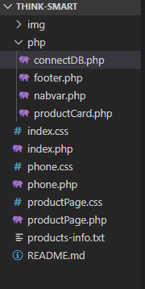

**INDEX.PHP / INDEX.CSS**

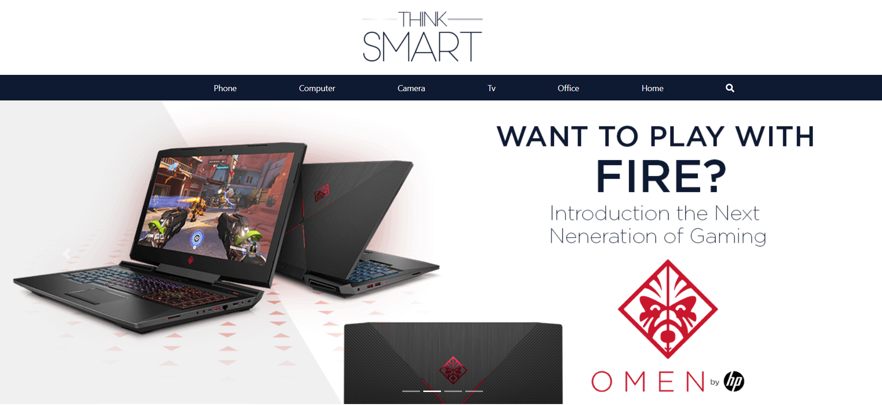

Here is our home page. First of all we designed the logo and the images of the slider for advertisement with **Photoshop**

Then, we created a minimalistic navbar with **Bootstrap 4**. We have a search box (as a*textbox*) inside the navbar. Plus, we created a function named **nabvar()** inside the “**nabvar.php**” to make a code simplicity because we used the navbar section more than 1 page .

When we click the search icon, the items of navbar are disappeared and the search box is appeared. We did this action with a **Javascript function**:

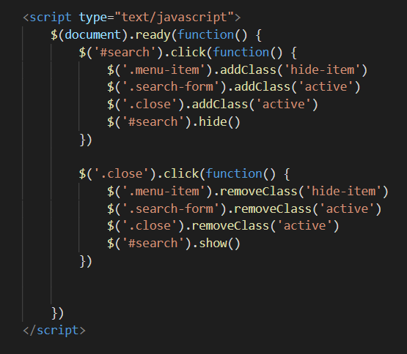

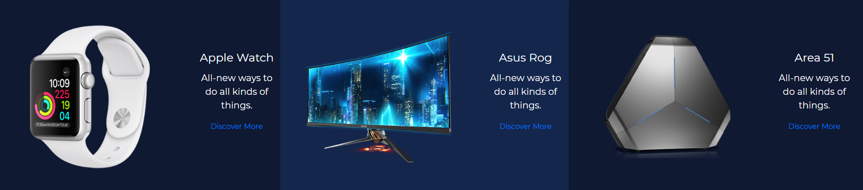

In the next content, we used a grid system of **Bootstrap4**.

In the **CSS** part, we worked on **hover effects**. When we came over the images, the images are scaling up.

We also used the **link** in the “Discover More” text.

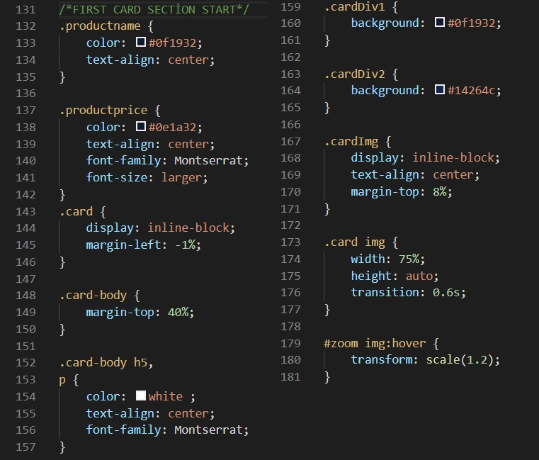

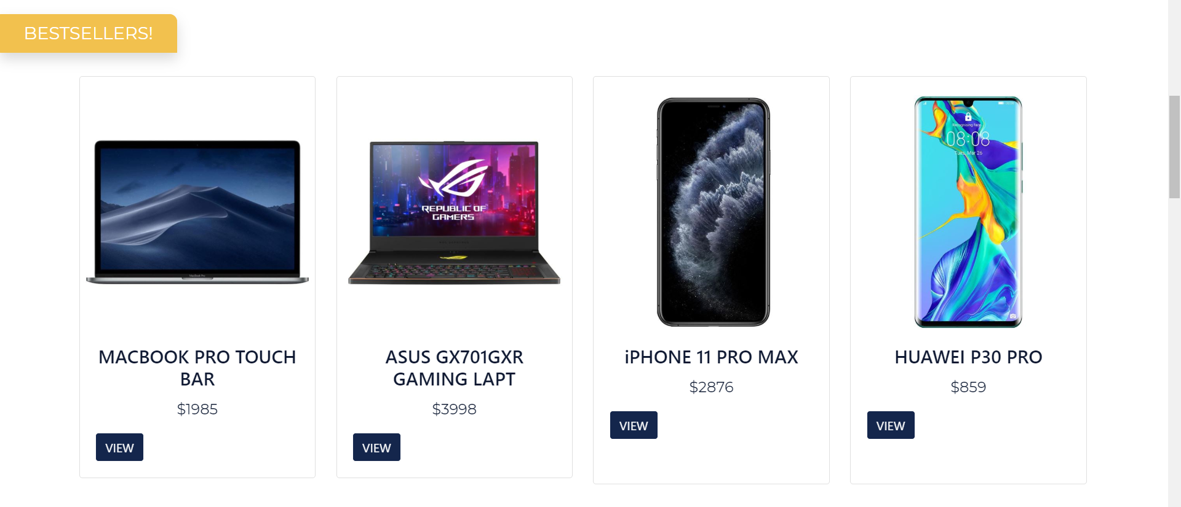

In this section, we created a slider that contains cards made by Bootstrap. When we hover over the product card, the first image of the product change into second image of that product.

We fetched the datas(images and informations of products) that are on the cards from the our **database** named Products .

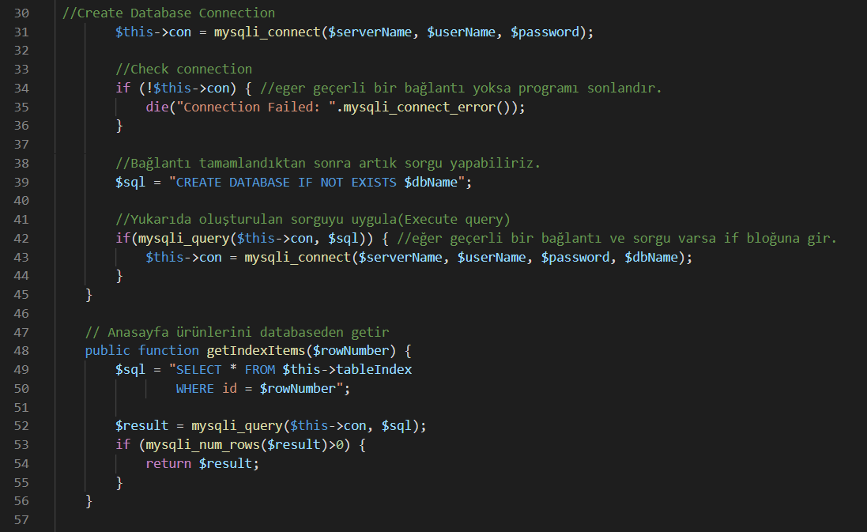

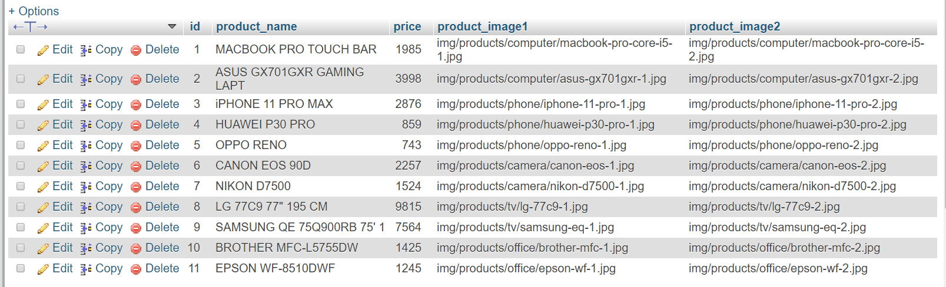

*The table that is related to our product card we mentioned above.*

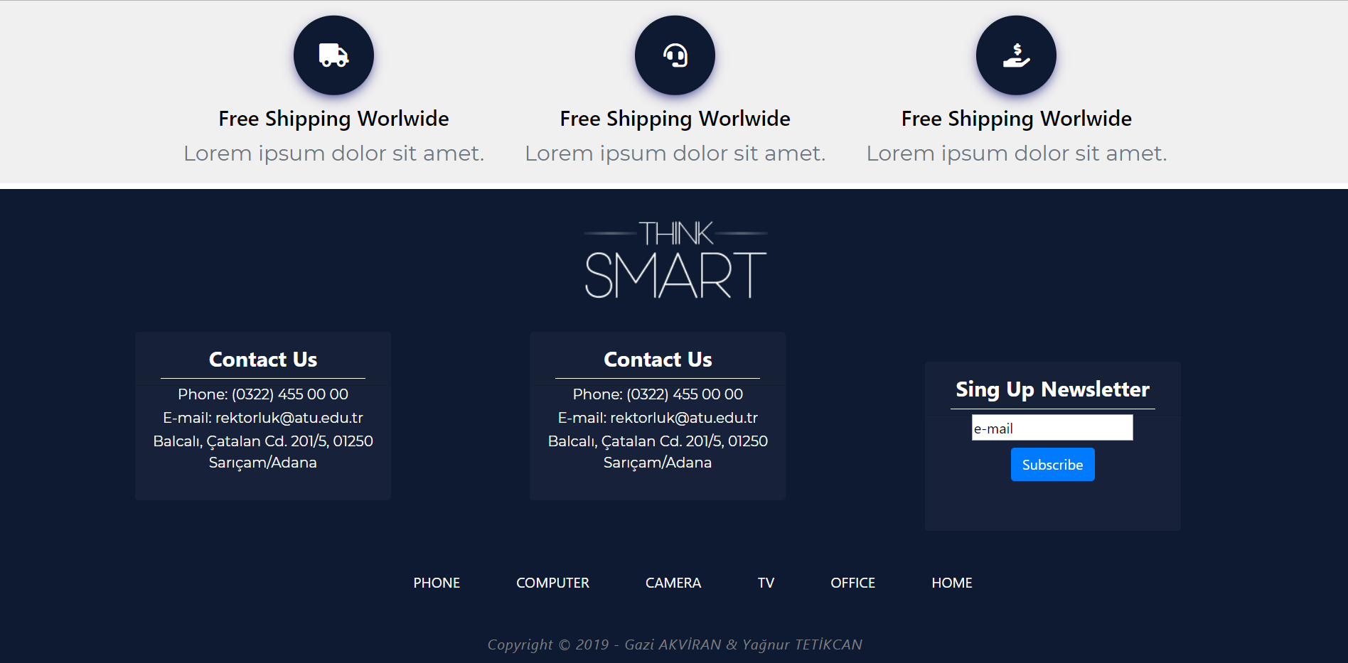

In the last section of homepage, we created a section that contains a general information about the website.

Under the general informations section we created a footer section which is about contact. We used the card structure of Bootstrap for the “contact us” and “sign up newsletter” parts.

Plus, we linked the pages to navigate at the end of the footer.

We created a function named **footer()** inside the “**footer.php**” to make a code simplicity because we used the navbar section more than 1 page .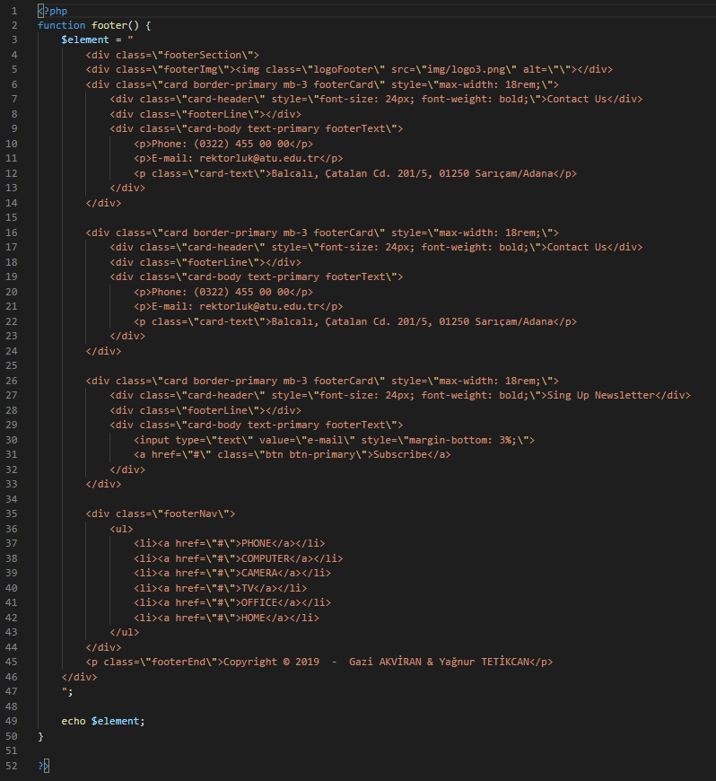

**PHONE.PHP / PHONE.CSS**

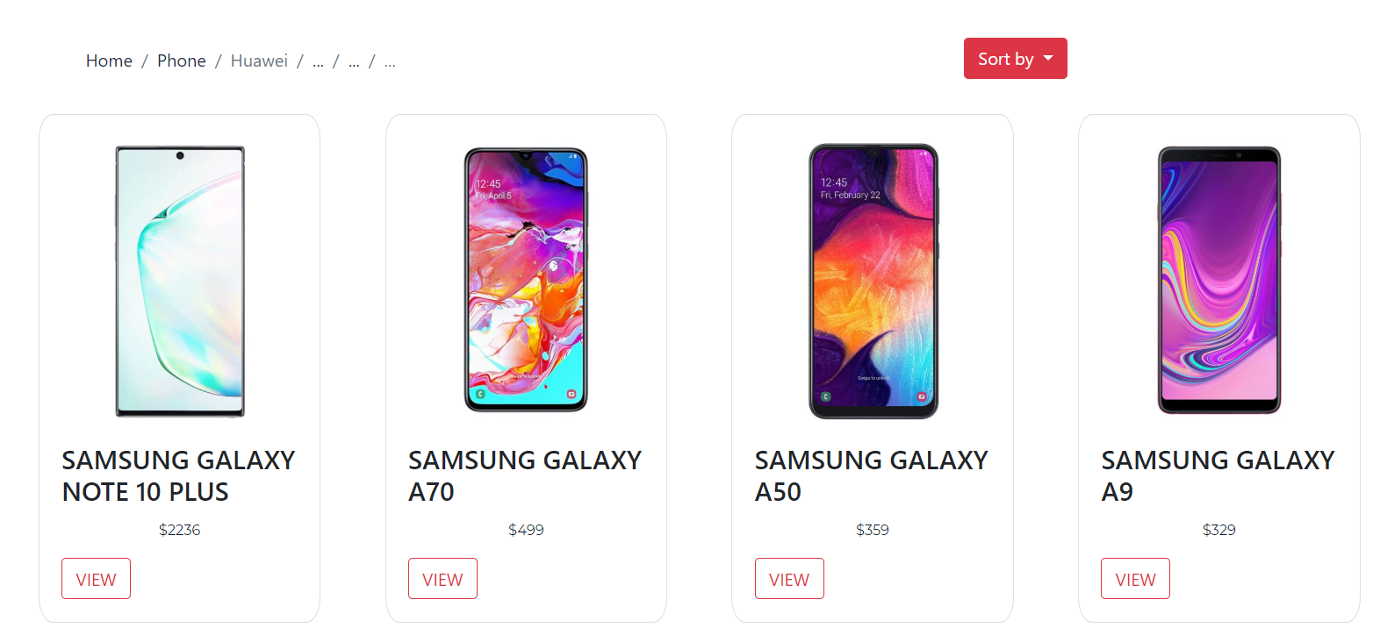

We created a breadcrumb part top of the page that shows which page we are on.

We have a **dropdown button** named “Sort by” (it appears just visually).

When we press the “VIEW” button it refers to the Product Page **(productPage.php)**.

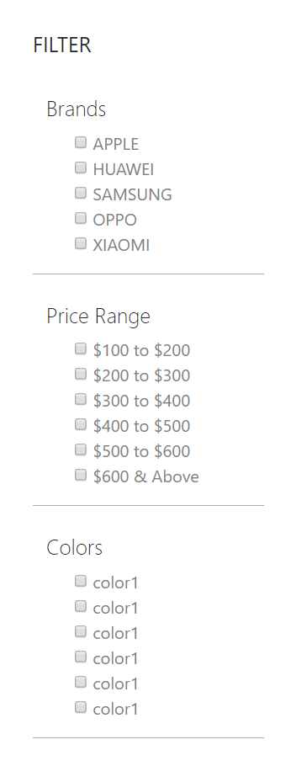

At the left side of the page we have a filtering part (visually).

When we click the Brands, Price Range and Colors titles, the sub-menus of the title are opened.

We used **check boxes** to filter products. (not related to database.)

**PRODUCTPAGE.PHP / PRODUCTPAGE.CSS**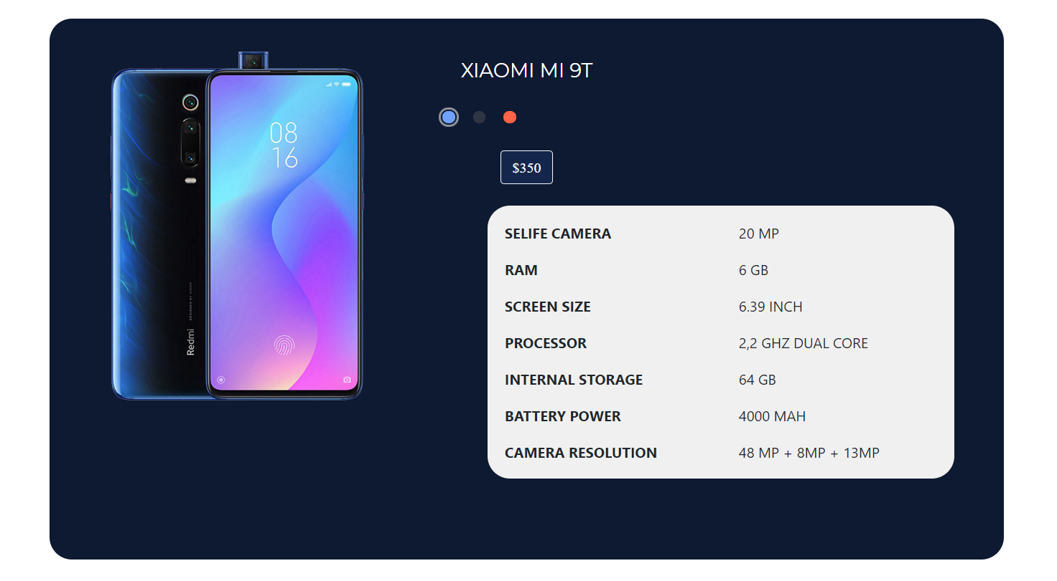

In the product page, we have a big card which shows the product picture and its informations. The special thing of this card is that when we press on the color buttons, the color of the product changes with an animation we made by Javascript.

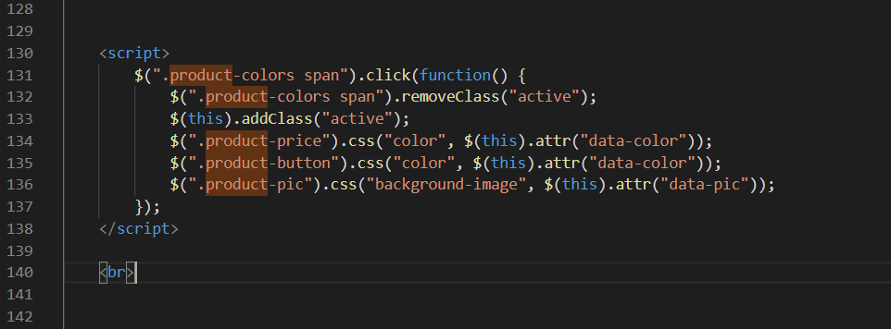

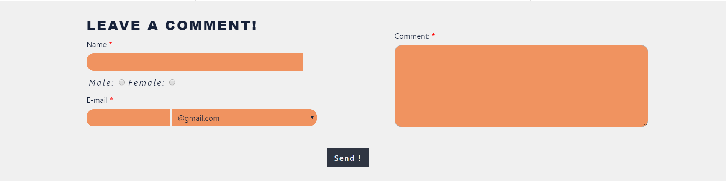

Here is our comment section. This section is **connected to the database.** We used the data **manipulating** in this section.

We took couple of inputs from the user and we **inserted** these inputs to the **table named “comment”** on tha database.

We also used the **radio button, text-field, text area, dropdown box and submit button.**

* On the **radio button**, we took the gender of the user to send a database.
* Our e-mail section has 2 parts. In the first part we took the users e-mail adresses and in the second part we restricted the user to they use the other e-mail suppliers.

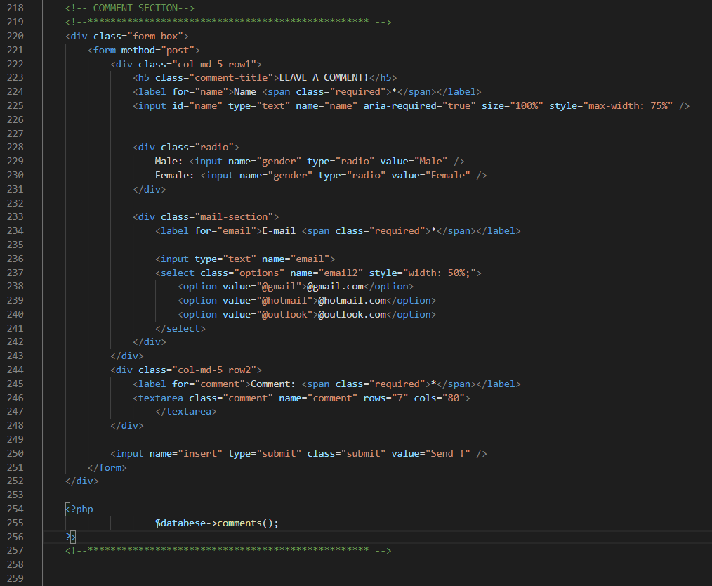When the user press the “Send!” button, all datas in the comment section are **inserted** to the **“comment” table on the database.**

