Submission Report
- Submission generated at 09/30/2025 at 17:41:14
- Machine info: Darwin mac.boisestate.edu 24.6.0 Darwin Kernel Version 24.6.0: Mon Jul 14 11:30:40 PDT 2025; root:xnu-11417.140.69~1/RELEASE_ARM64_T8132 arm64

Note to Students
Please read this report carefully before submission. Ensure that all sections are complete and accurate. Look for any errors in the build or test outputs. If you find any issues, correct them before submitting. Post any questions on the class discussion board for help.

README

Project X
- Name: John Doe
- Email: johndoe@u.boisestate.edu
- Class: 452-001

Known Bugs or Issues
TODO: Are there any known issues?

Experience
TODO: Describe your experience with the project (struggles, breakthroughs, etc.).

Analysis
TODO: Provide your analysis of the results. If the assignment does not require analysis, you can remove this section.
Here is an example of how to include a plot in your README:

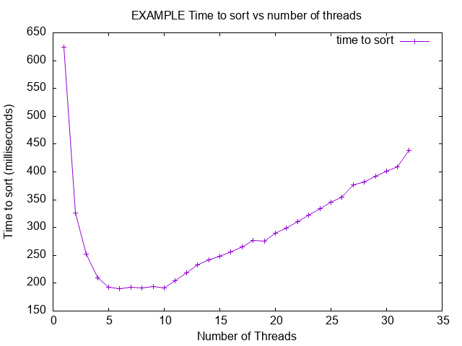

Build Output
This section was generated by running make all in the project root directory.
mkdir -p build/debug
cc -g -O0 -DDEBUG -fno-omit-frame-pointer -fsanitize=address -c src/lab.c -o build/debug/lab.c.o
mkdir -p build/debug
cc -g -O0 -DDEBUG -fno-omit-frame-pointer -fsanitize=address -c src/main.c -o build/debug/main.c.o
cc -g -O0 -DDEBUG -fno-omit-frame-pointer -fsanitize=address build/debug/lab.c.o build/debug/main.c.o -o build/debug/myapp_d -fsanitize=address
mkdir -p build/release
cc -Wall -Wextra -O2 -fPIE -MMD -MP -Wformat -Wformat=2 -Wconversion -Wsign-conversion -Wimplicit-fallthrough -fstack-protector-strong -Werror=format-security -Werror=implicit -Werror=incompatible-pointer-types -Werror=int-conversion -c src/lab.c -o build/release/lab.c.o
mkdir -p build/release
cc -Wall -Wextra -O2 -fPIE -MMD -MP -Wformat -Wformat=2 -Wconversion -Wsign-conversion -Wimplicit-fallthrough -fstack-protector-strong -Werror=format-security -Werror=implicit -Werror=incompatible-pointer-types -Werror=int-conversion -c src/main.c -o build/release/main.c.o
cc -Wall -Wextra -O2 -fPIE -MMD -MP -Wformat -Wformat=2 -Wconversion -Wsign-conversion -Wimplicit-fallthrough -fstack-protector-strong -Werror=format-security -Werror=implicit -Werror=incompatible-pointer-types -Werror=int-conversion build/release/lab.c.o build/release/main.c.o -o build/release/myapp
mkdir -p build/tests
cc -g -O0 -DTEST -fprofile-arcs -ftest-coverage -c src/lab.c -o build/tests/lab.c.o
mkdir -p build/tests
cc -g -O0 -DTEST -fprofile-arcs -ftest-coverage -c src/main.c -o build/tests/main.c.o
mkdir -p build/tests/harness/
cc -g -O0 -DTEST -fprofile-arcs -ftest-coverage -c tests/harness/unity.c -o build/tests/harness/unity.c.o
mkdir -p build/tests/
cc -g -O0 -DTEST -fprofile-arcs -ftest-coverage -c tests/lab-test.c -o build/tests/lab-test.c.o
cc -g -O0 -DTEST -fprofile-arcs -ftest-coverage build/tests/lab.c.o build/tests/main.c.o build/tests/harness/unity.c.o build/tests/lab-test.c.o -o build/tests/myapp_t -fprofile-arcs -ftest-coverage
mkdir -p build/debug-test
cc -g -O0 -DDEBUG -DTEST -fno-omit-frame-pointer -fsanitize=address -c src/lab.c -o build/debug-test/lab.c.o
mkdir -p build/debug-test
cc -g -O0 -DDEBUG -DTEST -fno-omit-frame-pointer -fsanitize=address -c src/main.c -o build/debug-test/main.c.o
mkdir -p build/debug-test/harness/
cc -g -O0 -DDEBUG -DTEST -fno-omit-frame-pointer -fsanitize=address -c tests/harness/unity.c -o build/debug-test/harness/unity.c.o
mkdir -p build/debug-test/
cc -g -O0 -DDEBUG -DTEST -fno-omit-frame-pointer -fsanitize=address -c tests/lab-test.c -o build/debug-test/lab-test.c.o
cc -g -O0 -DDEBUG -DTEST -fno-omit-frame-pointer -fsanitize=address build/debug-test/lab.c.o build/debug-test/main.c.o build/debug-test/harness/unity.c.o build/debug-test/lab-test.c.o -o build/debug-test/myapp_td -fsanitize=address
Builds completed. You can run the application with: ./build/release/myapp
You can run the debug build with: ./build/debug/myapp_d
You can run the test build with: ./build/tests/myapp_t
You can run the debug-test build with: ./build/debug-test/myapp_td

Coverage Report
This section was generated by running make report in the project root directory.
Setting up tests...
Tearing down tests...
tests/lab-test.c:32:test_get_greeting:PASS
-----------------------
1 Tests 0 Failures 0 Ignored
OK
./build/tests/myapp_t
Setting up tests...
Tearing down tests...
tests/lab-test.c:32:test_get_greeting:PASS
-----------------------
1 Tests 0 Failures 0 Ignored
OK
mkdir -p ./build/report/html
mkdir -p ./build/report/txt
gcovr -r . --html --html-details --exclude-directories build/tests/harness --exclude '.*main\.c$' --exclude '.*test\.c$' -o ./build/report/html/coverage_report.html
(INFO) Reading coverage data...
(INFO) Writing coverage report...
gcovr -r . --txt --exclude-directories build/tests/harness --exclude '.*main\.c$' --exclude '.*test\.c$'
(INFO) Reading coverage data...
(INFO) Writing coverage report...
------------------------------------------------------------------------------
GCC Code Coverage Report
Directory: .
------------------------------------------------------------------------------
File Lines Exec Cover Missing
------------------------------------------------------------------------------
src/lab.c 9 9 100%
------------------------------------------------------------------------------
TOTAL 9 9 100%
------------------------------------------------------------------------------

Address Sanitizer Report
This section was generated by running make leak-test in the project root directory.
==68281==AddressSanitizer: detect_leaks is not supported on this platform.
/bin/bash: line 1: 68281 Abort trap: 6 ASAN_OPTIONS="detect_leaks=1" ./build/debug-test/myapp_td
make: *** [leak-test] Error 134

Src Files

lab.c
#include "lab.h"
#include <stdio.h>
#include <stdlib.h>
char *get_greeting(const char *restrict name)
{
if (name == NULL)
{
return NULL;
}
// Allocate memory for the greeting message
int length = snprintf(NULL, 0, "Hello, %s!", name);
if (length < 0) // GCOVR_EXCL_START
{
return NULL; // snprintf failed
} // GCOVR_EXCL_STOP
//Casting is safe here because we know length is non-negative
size_t alloc_size = (size_t) length + 1; // +1 for the null terminator
char *greeting = malloc( alloc_size);
if (greeting == NULL) // GCOVR_EXCL_START
{
return NULL; // Memory allocation failed
} // GCOVR_EXCL_STOP
// Create the greeting message
snprintf(greeting, alloc_size, "Hello, %s!", name);
return greeting;
}

lab.h
#ifndef LAB_H
#define LAB_H
/** * @brief Returns a greeting message.
*
* This function returns a string that contains a greeting message.
* The string is allocated with malloc and should be freed by the caller.
* @param name The name to include in the greeting.
* @return A greeting string.
*/
char* get_greeting(const char* restrict name);
#endif // LAB_H

main.c
#include "lab.h"
#include <stdio.h>
#include <stdlib.h>
#ifdef TEST
#define main main_exclude
#endif
int main(void)
{
char *greeting = get_greeting("World");
if (greeting) {
printf("%s\n", greeting);
free(greeting); // Free the allocated memory for the greeting
} else {
printf("Failed to create greeting.\n");
}
return 0;
}

Tests Files

lab-test.c
#include <stdlib.h>
#include <stdio.h>
#include "harness/unity.h"
#include "../src/lab.h"
void setUp(void) {
printf("Setting up tests...\n");
}
void tearDown(void) {
printf("Tearing down tests...\n");
}
void test_get_greeting(void) {
char *greeting = get_greeting("Alice");
TEST_ASSERT_NOT_NULL(greeting);
TEST_ASSERT_EQUAL_STRING("Hello, Alice!", greeting);
free(greeting); // Free the allocated memory for the greeting
greeting = get_greeting(NULL);
TEST_ASSERT_NULL(greeting);
greeting = get_greeting("");
TEST_ASSERT_NOT_NULL(greeting);
TEST_ASSERT_EQUAL_STRING("Hello, !", greeting);
free(greeting);
}
int main(void) {
UNITY_BEGIN();
RUN_TEST(test_get_greeting);
return UNITY_END();
}

Scripts Files
Report generated on 09/30/2025 at 17:41:18

End of Report
SHA-256 Hash of the report: e1ffdff024780271a3230891b152f327d21b7670f522a4af8a0dd9192bdba0b0
Do not edit the generated report. Any changes will be reported as academic dishonesty

