GuardrailIQ
Deterministic GRC Compliance Copilot
Architecture & Build Guide
Single-file Streamlit application • No external LLM • Fully explainable
Field | Detail
Deliverable | guardrailiq_app.py (single-file Streamlit app)
Input | Governance Excel workbook — Governance_Documents · Clauses · Design_Descriptions
Output | Cited Compliant / Non-compliant / Gap findings, dashboard, remediation plan, audit export
Approach | Deterministic rules + TF-IDF/cosine + NetworkX. Zero LLM calls, offline, reproducible
Validation | 12 / 12 seeded design descriptions classified correctly

Table of Contents

1. Executive Overview
GuardrailIQ turns scattered governance documents into a structured, de-duplicated and fully traceable guardrail model, then evaluates an uploaded design description against that model. Every verdict it produces — Compliant, Non-compliant or Gap — cites the exact guardrail and source clause it is based on, satisfying the challenge's single non-negotiable rule: no finding without its source.
Why deterministic and LLM-free? In a compliance setting a reviewer must be able to click straight through to the clause behind every verdict. A rules-plus-classical-NLP engine is transparent, reproducible and offline — the same input always yields the same, explainable output, with no hallucination risk and no data leaving the machine.

1.1 What it does
- Ingests a governance Excel with flexible schema / alias mapping (survives renamed sheets and columns).
- Synthesises guardrails from clauses, tagging each with severity, modality and a control concept.
- De-duplicates overlapping policy language using TF-IDF + cosine similarity + a NetworkX graph, preserving ALL source clause references.
- Detects conflicts — cross-document numeric-threshold disagreements (e.g. 12 months vs 90 days) are surfaced, never auto-resolved.
- Evaluates designs from DOCX / PDF / PPTX / TXT via negation-aware keyword-evidence matching.
- Explains & exports — dashboard, remediation planner and a multi-sheet audit workbook, plus a built-in architecture / demo tab.

2. Solution Architecture
The application is a linear, inspectable pipeline. Each stage consumes the previous stage's typed output and can be tested in isolation. The Streamlit UI is a thin presentation layer over pure, side-effect-free functions.

2.1 Architecture diagram
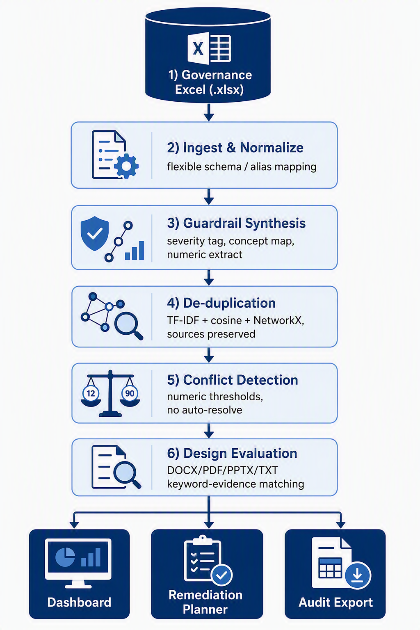

2.2 Stage responsibilities
Stage | Key functions | Responsibility
1 Ingest | load_workbook, build_clauses | Resolve sheets/columns by alias; produce typed Clause records.
2 Synthesis | synthesize_guardrails, infer_severity, map_concept, extract_numeric | One guardrail per clause; attach severity, modality, concept, numeric thresholds.
3 De-dup | deduplicate | Build similarity graph; merge connected components; keep every source reference.
4 Conflicts | detect_conflicts, subject_signature | Group thresholds by subject; flag cross-document disagreements.
5 Evaluate | extract_text, evaluate_design, design_verdict | Parse design; match evidence; emit cited findings + rollup verdict.
6 Present | dashboard / remediation / build_audit_export | Visualise, plan remediation, export 7-sheet audit workbook.

3. Core Data Model
Five lightweight dataclasses keep the pipeline strongly typed and the citations intact end-to-end.
Dataclass | Purpose & key fields
Clause | Raw addressable requirement: clause_id, doc_id, heading, text, flag.
Guardrail | Structured control: severity, modality, concept, source_clause_ids, source_doc_ids, merged_from, numeric.
Conflict | Cross-document numeric disagreement: subject, unit, values[], note.
Finding | Evaluation result: status, rationale, evidence, source_clause_ids, source_doc_ids.
(alias maps) | SHEET_ALIASES / COLUMN_ALIASES drive the flexible, modified-copy-safe ingest.

4. Key Algorithms (Explainable by Design)

4.1 Severity & concept tagging
Severity is inferred from a ranked keyword ruleset (Critical > High > Medium > Low); modality (Mandatory / Recommended) from modal verbs (“must”, “should”). Each clause is mapped to a control concept (e.g. mfa, encryption_rest, public_storage) by counting topic-keyword hits. Concepts are the semantic backbone used by both de-duplication and evaluation, so detection is by meaning, not by memorised IDs.

4.2 De-duplication (TF-IDF + cosine + NetworkX)
- Vectorise every guardrail's title + requirement with a 1–2 gram TF-IDF model.
- Compute the pairwise cosine similarity matrix.
- Draw an edge when two guardrails share the same single-control concept (cosine recorded as evidence) OR their text is near-identical (cosine ≥ 0.85).
- Take NetworkX connected components; collapse each into ONE guardrail, unioning all source clause and document IDs and recording provenance in merged_from.
Guardrails against over-merging: coarse concepts (e.g. secure_sdlc, logging) and numeric-threshold concepts (password_length, data_retention) are excluded from concept-merge, and a numeric-conflict check blocks merging two clauses that state different values — so genuine conflicts are never hidden by de-duplication.

4.3 Conflict detection (no auto-resolve)
Each clause is assigned a subject signature by meaning (e.g. password_min_length, log_retention). Numbers and units are extracted and normalised to a comparable base (months → days). When two different documents state different values for the same subject, a Conflict is raised and surfaced for a human decision — the system deliberately does not pick a winner.

4.4 Design evaluation (negation-aware evidence matching)
For each guardrail whose control concept is present in the design text:
- Non-compliant — a violation phrase is found (not itself negated).
- Compliant — a satisfaction phrase is found and is NOT inside a negation / uncertainty scope.
- Gap — the topic is raised but evidence is absent AND an explicit “missing-info” cue is present (e.g. “does not specify”).
- Not-Applicable — topic not addressed; hidden from the verdict to avoid noise.
Negation window: before accepting any evidence phrase, the ~45 characters preceding it are scanned for negators/uncertainty cues (“not”, “no”, “whether”, “does not”…). This prevents a phrase like “does not state whether a security assessment was completed” from being mis-read as compliant.
Design-level verdict: Non-compliant overrides Gap, which overrides Compliant — a single failing mandatory control fails the design.

5. Setup & Run Steps

5.1 Prerequisites
Python 3.10+ and the packages listed in requirements.txt (all standard, offline).

5.2 Windows (batch files)
setup.bat :: one-time: create .venv and install dependencies
run.bat :: launch the app at http://localhost:8501

5.3 macOS / Linux
python -m venv .venv
source .venv/bin/activate
pip install -r requirements.txt
streamlit run app/guardrailiq_app.py

5.4 First-run workflow
- In the sidebar, upload the governance Excel workbook (data/GuardrailIQ_Dataset_v2.xlsx).
- (Optional) adjust the de-dup similarity threshold slider.
- Click “Build guardrail model” — the pipeline runs and the Dashboard populates.
- Go to “Evaluate Design”, upload a file from sample_designs/ (or paste text) and click Evaluate.
- Review cited findings, open the Remediation tab, then download the Audit Export.

6. Application Walkthrough (UI Tabs)
Tab | What it shows
Dashboard | Clause/guardrail counts, merges, conflicts, orphans; severity & domain charts; broken-reference table.
Guardrail Model | The consolidated, filterable guardrail table plus de-duplication evidence (sources preserved).
Conflicts | Each cross-document numeric conflict with both values and clause citations — surfaced, not resolved.
Evaluate Design | Upload/paste a design; view Compliant / Non-compliant / Gap findings, each citing guardrail + clause.
Remediation | Prioritised (P1–P3) remediation actions for every Non-compliant and Gap finding.
Audit Export | One-click 7-sheet .xlsx: Summary, Guardrail_Model, Findings, Conflicts, Deduplication, Orphan_References, Remediation_Plan.
Architecture & Demo | In-app architecture diagram and a suggested five-step demo script.

7. Design Decisions & Governance
- Deterministic & explainable — no LLM; identical input yields identical, traceable output.
- Traceability gate — a finding is only ever shown with its guardrail and source clause IDs attached.
- Modified-copy safe — alias mapping, concept lexicon and numeric parsing detect by meaning; nothing is keyed to sample IDs.
- Human-in-the-loop — the tool recommends, never auto-gates; conflicts and gaps are surfaced for a person to decide.
- No fabricated verdicts — missing information returns a Gap, never an inferred pass/fail.
- Sources preserved on merge — de-duplication unions references so nothing becomes untraceable.

8. Mapping to Challenge Requirements
Mandatory outcome | Status | Where it is met
Extract traceable guardrails from governance text | Met | Stage 2 — synthesize_guardrails keeps source_clause_ids
De-duplicate, preserving all source references | Met | Stage 3 — deduplicate (union of refs, merged_from)
Hold a queryable model (domain, requirement, severity, source) | Met | Guardrail dataclass + filterable Guardrail Model tab
Evaluate a text design end-to-end | Met | Stage 5 — extract_text + evaluate_design
Cite every finding (guardrail + clause) | Met | Finding carries both ID sets; shown in UI & export
Explain for non-experts | Met | Plain-language rationale + evidence per finding
Go deep on one domain (Information Security) | Met | Concept lexicon focused on InfoSec controls
Clear-fail returns Non-compliant + citation | Met | e.g. DSN-0004 → Non-compliant, cites CL-0052/CL-0021
Missing info returns Gap, not a fabrication | Met | Uncertainty detection → DSN-0007, DSN-0012 = Gap

9. Validation Results
Run against the supplied synthetic workbook, the engine reproduces every seeded scenario and classifies all twelve design descriptions in line with their Expected_Outcome.
Design | Expected | Engine verdict | Result
DSN-0001 | Compliant | Compliant | Pass
DSN-0002 | Non-compliant | Non-compliant | Pass
DSN-0003 | Compliant | Compliant | Pass
DSN-0004 | Non-compliant | Non-compliant | Pass
DSN-0005 | Compliant | Compliant | Pass
DSN-0006 | Non-compliant | Non-compliant | Pass
DSN-0007 | Gap | Gap | Pass
DSN-0008 | Compliant | Compliant | Pass
DSN-0009 | Non-compliant | Non-compliant | Pass
DSN-0010 | Compliant | Compliant | Pass
DSN-0011 | Non-compliant | Non-compliant | Pass
DSN-0012 | Gap | Gap | Pass
Seeded scenarios also reproduced: MFA / least-privilege / secrets / backup / classification / supplier duplicates consolidated; password (12 vs 8 chars) and security-log-retention (12 months vs 90 days) conflicts surfaced; the orphan reference (CL-9999 / DOC-0099) flagged as untraceable.

10. Assumptions & Limitations
- Only synthetic / provided data is used; no real policy content is ingested.
- The control-concept lexicon targets Information Security; new domains are added by extending CONCEPTS (data, not code changes to the engine).
- Evaluation depends on the design text describing controls in natural language; scanned image-only PDFs would need OCR (out of scope).
- Numeric-conflict detection covers the common unit families (characters, days, months, hours); additional units extend NUM_PATTERNS.
Definite on the problem, broad on the solution — and never a finding without its source.

