CLB Encoder:

This design is based on one counter.

Basis to design:

*Application Note*

***C2000™ Position Manager PTO API Reference Guide***

***Chapter* 5 PTO – QepOnClb QEP Decoder**

We implement loosely based on.

# Relation to TI design:

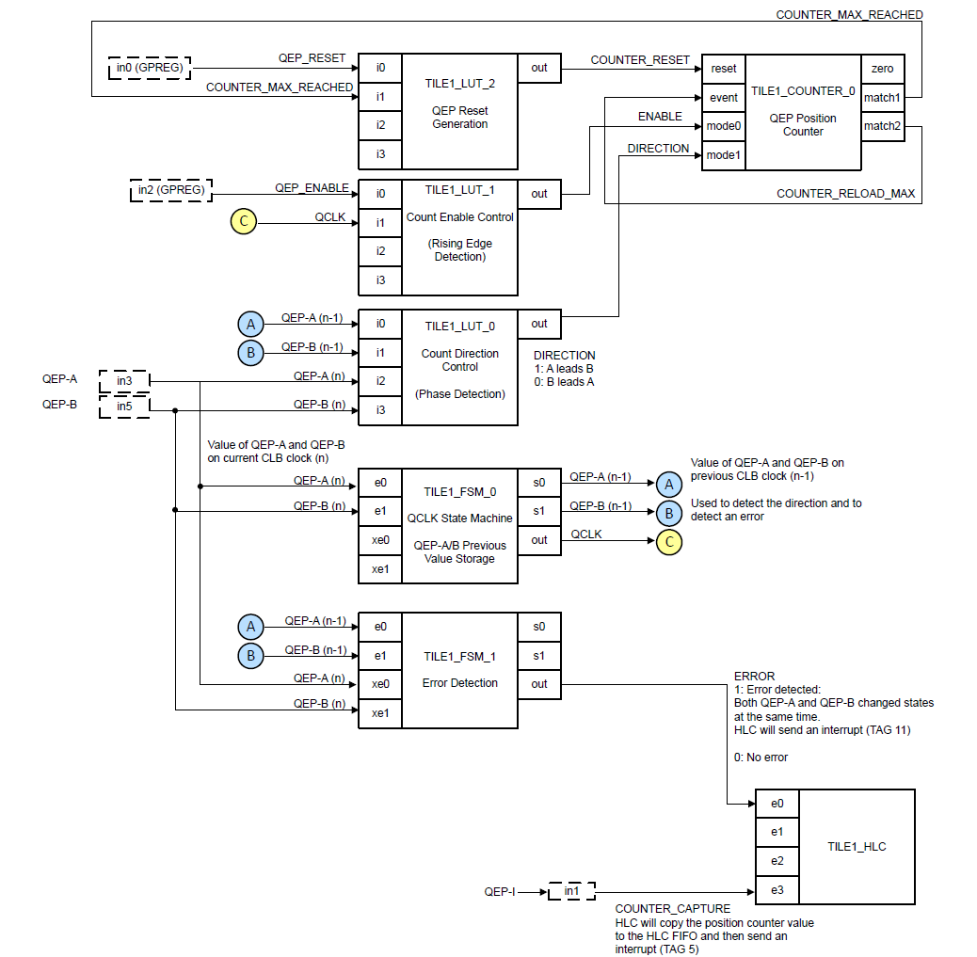

|  |  |  |
| --- | --- | --- |
| FSM0 | Count up state machine |  |
| FSM1 | Count down state machine |  |
| COUNTER 0 | QEP counter | Always positive, counts FSM0 events |
| COUNTER 1 | QEP counter | Always negative, counts FSM0 events |
| External read / HLC | New | Read evet to HLC causes counter read & subtract and output to FIFO |

FSM 0 equation:

Direction = up

E1 fell with E0=0, E0 fell with E1=1 , E1 rise with E0 = 1 , E0 rise with E1 Low

(!s0 & s1 & !e0 & !e1)|(s0 & s1 & !e0 & e1)|(s0 & !s1 & e0 & e1)|(!s0 & !s1 & e0 & !e1)

FSM 1 equation:

Direction = down

(!s0 & s1 & e0 & e1) |(s0 & s1 & e0 & !e1)| (s0 & !s1 & !e0 & !e1) |(!s0 & !s1 & !e0 & e1)

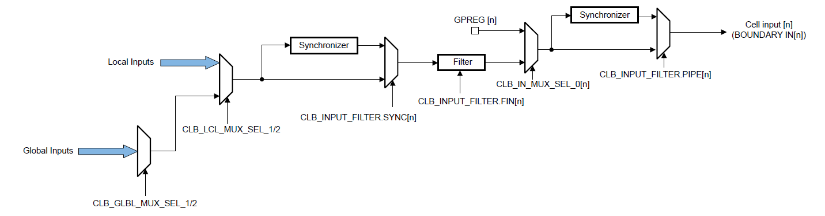

CLB_GLBL_MUX_SEL_1/2 (don’t care)

CLB_LCL_MUX_SEL_1/2

CLB_INPUT_FILTER.SYNC[n]

CLB_INPUT_FILTER.FIN[n]

CLB_IN_MUX_SEL_0[n]

CLB_INPUT_FILTER.PIPE[n]

CLB_INPUT_XBAR , INPUT 1 as GPIO28 → Local input 48 INPUT1SELECT = 48

CLB_INPUT_XBAR , INPUT 2 as GPIO16 → Local input 49 INPUT2SELECT = 49

**Pp3248**