ITAMAR DSP SW maintenance

# Project arrangement

Both the LP and the PD are arranged in the same way in the flash memory



Figure : Memory map

CPU wakes into Address 0x80000. There naturally resides the boot start branch.

The boot code can take up to 0x84000.

The project start branch is at the fixed address 0x84000

The project itself starts at 0x84002. Now allowed till 0x90000, but this may be extended by future needs till 0xbdfff.

At 0xbc000 resides the calibration data (specific to robot like exact potentiometer offsets).

At 0xbe000 resides the statistics.

Code beyond 0xbe010 is don’t care.

Especially, flash bank #1 is not used at all.

If the project is burned by emulator, only address 0xbe000 is populated by the long number 0x90abcdef.

If burned by the FW loader, then:

0xbe000: 0x12345678

0xbe004: First project used address

0xbe008: Last project used address

0xbe00c: int32 checksum of the code from * (long *)0xbe004 to * (long *)0xbe006

The code start and end addresses are int32 boundaries. If the program does not align to int32, the code is artificially padded with 0xff.

No CLA code is used.

# CAN Services

The LP and the PD projects are accessed via CAN communication, using the CANOpen (DS301) protocol.

The baud rate is 500000.

|  |
| --- |
| The terminators for both the CAN networks are on the LP card.  When the LP card is present, do **NOT** use a terminator.  When connecting the PD out of the robot with LP not present, you MUST use a terminator. |

The DS301 protocol is not fully implemented, just the necessary minimum.

The LP has the CAN ID of 124

The PD has the CAN ID of 126

The CAN access from a PC computer is only supported for Kvaser CANLeaf adapter (via USB)

Prior to usage, the CANLeaf drivers should be installed, from

<https://www.kvaser.com/downloads-kvaser/>

It is strongly recommended to download and install also the CanKing free utility from the same site.

Use CAN1 (always) or CAN2 (not in FW download) to access the LP

Use CAN2 to access the PD

# Matlab environment

## General

The Matlab environment is built for Matlab2016.

The notation

>> xxx

Means: Type xxx at the Matlab prompt.

Before dealing any software you must enter the project interface directory:

>> cd ….\Software\Kvaser\[LPTest|PDtest]

Where above … stands for any preceding root path.

|  |
| --- |
| The root path must be typed correctly into  ….\Kvaser\LPTest\AtpStart.m  and  ….\Kvaser\PDTest\AtpStart.m  For the Matlab interface to work correctly |

## Initializing the work

For work initialization, enter the project and run

>> AtpStart

This is necessary to start the CAN services, and also for definition of work directory.

|  |
| --- |
| NEVER put the PD project (PDTest) or the LP project (LPTest) in the matlabpath, as source location confusion may result.  The PD and the LP environments contain files with similar names for similar functionalities. |

|  |
| --- |
| Although the AtpStart macros are very similar for both projects, you must re-run AtpStart  When switching a project |

# Code Composer (CCS) Environment

The CCS environment supports 3 projects:

* ItamarPD
* ItamarLP
* Boot377

## Target configurations

It has 3 user-defined configurations.

Note that a configuration is valid for a card/emulator combination, the same for the boot and for the operational software. Thus, when working the boot, different target configurations should be selected per the card used.

* LPTargetXDS100.ccxml for the LP
* PDTargetBlackHawk560.ccxml for the PD, using a BlackHawk emulator
* PDTargetXDS200 for the PD, using a XDS200 emulator

The Target configurations are backed in [Proj root]\Itamar\Software\CCSTargetConfig

The Target configurations should reside in the folder

C:\Users\[Your user name]\ti\CCSTargetConfigurations

|  |
| --- |
| For the target configurations to be useful, you should copy them from their backup directory the use directory |

## Directory Tree

The Directory tree is built under [Proj root]\Itamar\Software

The tree is as follows:



Each projects has a workspace, located under CCProj.

You open a project by opening CCS and specifying the workspace directory in the starting dialog.

|  |
| --- |
| If you checked “Do not ask again” at the starting dialog, you can still select a workspace by  File->Switch workspace |

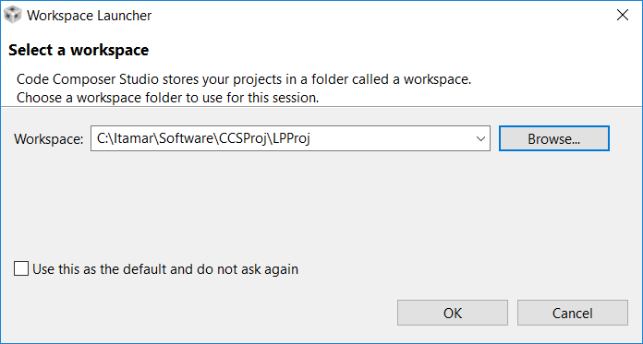

Figure : Opening a workspace, CC start menu (LP in this example)

## Burning FW

Firmware may be burnt only after

* Launching the relevant Target Configuration (View->Target Configurations)

Use, from the relevant project, Run->Load Program

Select the FW to burn using the “Browse Project” button. It will be a .out file, at the Debug directory of the project.

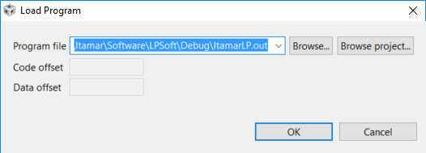

**Before the loading (must be after target configuration is launched):**

Check the Tools->On Chip Flash Dialog

* Auto ECC generation MUST be checked
* Erase setting should be for Necessary Sectors Only (otherwise burning a FW may destroy the boot)

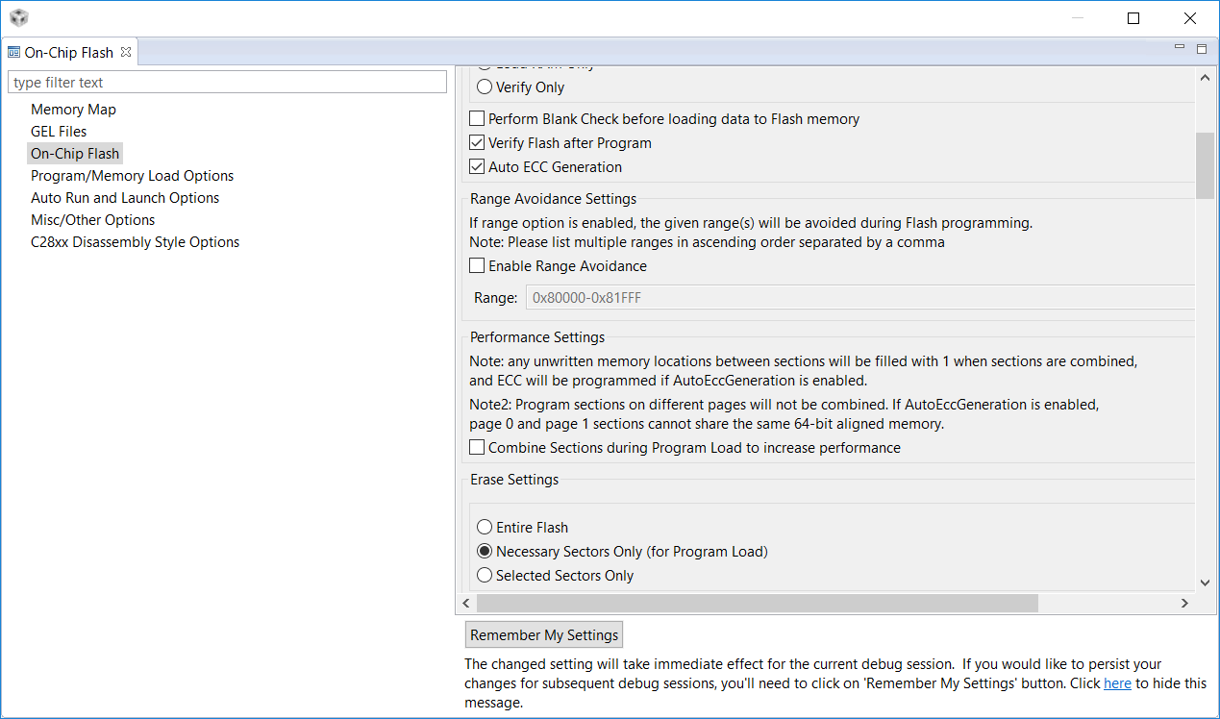

## C2000 Hex generation

Software is downloaded via the boot.

The PC loader accepts the software as Tektronics Hex file (ItamarLP.hex or ItamarPD.hex).

The hex file is generated automatically on project build.

For this to be done, in the project properties pages, select the C2000 Hex Utility page.

There, check “Enable C2000 Hex Utility”

Command: "${CG_TOOL_HEX}"

Command line pattern: ${command} ${flags} ${output_flag} ${output} ${inputs}

The flags to be set are: --memwidth=16 --romwidth=16

The output file is found as

…ProjRoot…\Itamar\Software\PDSoft\Debug\[ItamarPD|ItamarLP].hex

# FW downloading

|  |
| --- |
| Before FW downloading, power-cycle the cards (in the robot: Use the On-Off switch)  The Mushroom emergency switch MUST be depressed for FW downloading to work properly and safely. |

Enter the Matlab directory of the project

>> cd ….\Kvaser\[LPTest|PDtest]

Verify electricity is ON (PS + On/Off switch) and that the emergency mushroom is depressed.

Then

>> DownFW

Everything will work automatic

|  |
| --- |
| Following a FW download, you need to power-cycle the robot, because the two cards of the robot lost synchronism |

# Appendix : Installation checklist

* Decide a root path
* Generate a directory called Itamar
* Copy there the Software file system
* Update the root directory in ATPStart.m at ….\Kvaser\[LPTest|PDtest]
* Copy the target configurations from the backup to their use directory (See)

# Appendix: Working with CanKing

|  |
| --- |
| CAN King and Matlab cannot work on the same Kvaser adapter.  For a single adapter, either you work the CAN from within Matlab, or you observe the CAN traffic using the CAN King |

After invoking CanKing, first dialog is: Select “Tempate”, then OK

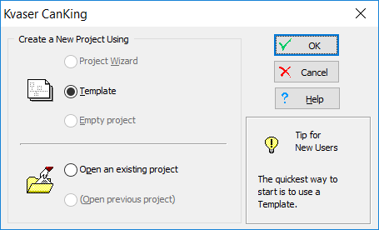

Figure : First dialog

Next, select 1 channel , press ok

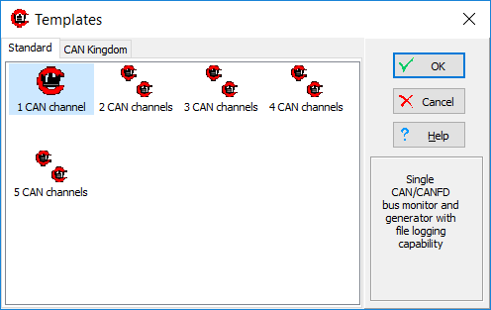

At the next dialog , verify the Channel as Kvaser Can Leaf 1/1

|  |
| --- |
| If the Kvaser or its driver is not installed correctly in the PC, you will see a Virtual channel instead.  Do not proceed – close the CanKing and install the Kvaser & driver correctly |



Go to the bus parameter tab , select baud rate of 500000



**Return the bus statistics tab , and press “Go Bus On”. Green LED should turn ON.**

In the next, uncheck the “Standard Text Format”, then select options;



Set to Hex display and OK

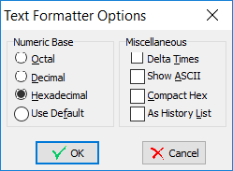

Then check the “Standard Text Format” ON.

The CAN traffic will appear on the Output Window.