SRR Document:

GFT G3 control core (GCore)

Based on the P650 processor
Prepared by:
S. Safonov, Y. Theodor
ChatGPT OUTSIDE

- | First draft | 13-Jan-26
1.0 | Elaborate FSI enslavement mode | 14-Jan-26
1.1 | JH comments | 14 Jan 2026
1.2 | Add multiple axis by EtherCAT and HW requirements | 14-Jan-26
1.3 | Update boot sequence after discussion w. Shmuel | 14-Jan-26
1.4 | Added HW specification | 17-Jan-26
1.5 | Added EtherCAT Detail | 19-Jan-26
1.6 | Added FW download guidelines, STO response  SRR topics | 21-Jan-26
1.7 | Added simulation mode | 25-Jan-26
Table 1: Table of revisions


Contents
1 Introduction 5
1.1 Scope: 5
1.2 Glossary 5
1.3 Referenced documents 7
2 Functional description 7
2.1 Core roles 7
2.1.1 Cores 7
2.1.2 Core interconnects 8
2.2 Motion controller (CPU1 + CLA or HOT) description 9
2.2.1 General features [Descriptive]: 9
2.2.2 Safety & security module 9
2.2.3 FSI enslavement 10
2.2.4 Boot flow 12
2.2.5 Firmware downloading 12
2.2.6 FW download implementation guidelines [Descriptive] 13
2.2.7 Object dictionary 14
2.3 The Client (CPU 2) 15
2.3.1 Client roles 15
2.3.2 EtherCAT 15
2.3.3 CAN Open and EtherCAT coexistence 16
2.3.4 Multiple axes and EtherCAT 16
2.4 Client-server interconnect 17
2.4.1 Data interconnect 17
2.4.2 Core synchronization 19
3 Emergency and Safety 20
3.1 STO 20
4 Simulation ability 21
4.1 G-Core support 21
4.2 PC support 21
5 Appendix: HW requirements 22
6 Appendix: Roadmap and Work to do 23
6.1 Mapping of DftServo feature for reuse 23
6.2 Feature updates 23
6.3 Feature families 26
7 Appendix: SRR topics 28


Introduction

Scope and overview:
This document outlines the next-generation P650 core for GFT-Servo, referred to as “G Core.”
While based on the existing GFT-Servo architecture, it introduces a new design direction.
- The P650 revision focuses on several key objectives:
- Establishing a unified control core across the entire GFT product family
- Providing limited built-in safety features, with certified safety functionality delegated to an external high-level CPU
- Standardizing low-level communication interfaces
- Enabling a wide range of applications through a flexible, dynamically configurable application core
This document is prepared for SRR. It is intended to confirm alignment on the overall direction before investing in the extensive, time-consuming detailed work.
It reflects the results of formal architecture discussions, consolidating and structuring many informal conversations.
It does not aim to be comprehensive, or fully refined as PDR level documentation.

Glossary
Term | Means
BIT | Built In Test
CAN | Control Area Network
CAN FD | CAN with Frequency with Flexible Data rate
CBC | Cycle By Cycle
CLA | Control Law Accelerator, a dedicated coprocessor for algorithm number crunching
CoE | Can over EtherCAT (DS301 profile over EtherCAT physics)
CS | Cyclical Synchronous
DC | Distributed Clock (EtherCAT)
DMA | Direct Memory Access
DS402 (now IEC61800-7) | A general device profile (ICD) for a servo drive
EEPROM | Electronic-Erasable Programmable Read Only Memory
ESC | EtherCAT Subordinate Controller
EtherCAT | A determistic high speed serial communication that may run on Ethernet hardware.
EUT | Equipment Under Test
FMMU | Field Memory Management Interface  An EtherCAT unit the directly controls the transfers between message partitions to specific CPU-accessible memory location
FoE | File over EtherCAT, a protocol to pass bulk data over the EtherCAT
G3 or GCore | Generation 3  G1 was before GFT servo SW  G2 is the present GFT servo SW
HOT CPU | On systems which require electrical isolation, a separate CPU that replaces the CLA functionality beyond the insulation barrier
HW | Hardware
ICD | Interface Control Document, details communication formats and contents.
I2C | Inter Integrated Circuit, a primitive open collector serial communication
IPC | Inter Processor Communication: a dual ported enhanced message box between the two cores of the P650
MAC | Media Access Controller. An on board peripheral that translates messages at the CPU side to physical media requirements
PDO | Process Data Object. A mapped communication object for CoE
PDR | Preliminary Design Review
PHY | "Physical" – by the commands of a MAC, produce actual signals on the physical transmission lines.
P650 | A core by TI, intended for next gen use
RMII | Redudec Medeia Independent Interface, a protocol serving between MAC and PHY
SDFM | Sigma Delta Filter Module
SRR | System Requirements Review
SSC | Slave Stack Code (Beckhoff ESC support code)
SW | Software
TBD | To Be Defined
TBR | Same as TBD

Referenced documents
#1 | GFT G3 control core (GCore) Test descriptions | GFT

Functional description

Core roles

Cores
The 650 SW is made of 3 cores:
[Requirement 1000]
Core#1: Speed and Position:
- Control functions,
- sensor interfaces, (Hall, Encoders, IMU)
- reference profilers (single or dual axes)
- safety part, (optional)
[Requirement 1001]
CLA: Current control (single or dual axes)
Or:
Hot CPU: Current control (single or dual axes)
[Descriptive]
Core#2: Services:
- Communications, protocols,
- interpreters,
- user programs VM,
- external interfaces

Core interconnects
[Requirement 1003]
Core#1 to CLA interconnect: Via CLA mailboxes and shared memory
Or
[Requirement 1004]
Core#1 to HOT CPU interconnect: Via UART, 3 to 6MB/sec
[Requirement 1005]

Core#1 to Core#2 interconnect: Through IPC
Block Diagram [Descriptive]

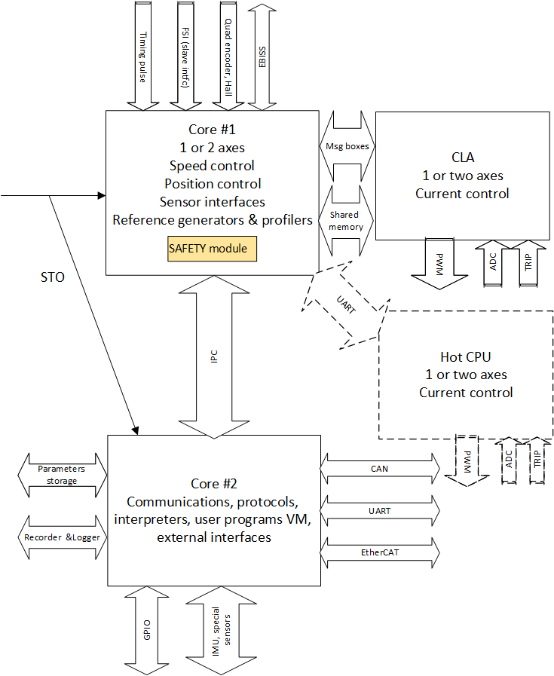
Figure 1: Core arrangement. HOT CPU is dashed; it is a replacement to CLA work, on applications where electrical isolation is required.
Notes:
- The USB connection, although planned, is not shown. From the controller’s perspective, USB functions simply as a high-speed UART interface.
- When two axes operate on the same core, they share the same sampling period and remain synchronized. Each axis receives its own interrupt, with the interrupts staggered by half a cycle.
- The HOT CPU interface is currently defined only at the hardware-allocation level. There is no near-term requirement for HOT CPU functionality, so detailed development is postponed. A HOT CPU does not benefit from the tight coupling available to the CLA; it intentionally trades control bandwidth for galvanic isolation. Because a typical message to the HOT CPU is around 16 bytes, transmission requires roughly 60 µs, resulting in a total delay of up to 100 µs. Consequently, systems using a HOT CPU will have their velocity-loop bandwidth limited to approximately 500 Hz, which is acceptable for most applications.

Motion controller (CPU1 + CLA or HOT) description

General features [Descriptive]:
The controller core is designed with the following principles:
• Structural isolation: The control architecture is kept independent from project‑specific logic to simplify maintenance.
• Strict command model: The core accepts commands exclusively through an object dictionary and performs no high‑level command interpretation.
• Standardized machine interface: The core is intended solely for machine‑level interaction, using a standardized interface (object dictionary, command structure, feedback structure, and setup‑report structure) compatible with SEAL implementations.
• Partial safety integration: Although not intended for full safety certification, a safety module is embedded within the compact direct‑control code and operates as an independent module. It has its own periodic service (via CpuClock2) and a software watchdog.
Low‑grade safety compliance: Due to its focused scope, the control core can be fully specified for lower‑tier safety requirements. High‑level standards such as ISO 26262 or IEC 61508 ASIL4 are not feasible here and would require a C29xx‑class architecture.
- The control core does not perform current control which is handled either by the CLA or by a “HOT” CPU via communication.

Safety & security module
[Requirement 1006]
The safety module:
- Operates as an independent process with its own dedicated flash sector.
- Uses minimal code and runtime resources.
- It is not replaced during standard software updates.
- Reserves the watchdog and CPUTimer2 exclusively for its own operation, preventing conflicts and ensuring it can respond even if the main application blocks interrupts or starves it of CPU time.
- Can be configured through parameters such as maximum speed, position limits, stop deceleration, encoder scaling, and matching information. The configuration will be flashed, and shall survive FW updates

FSI enslavement
[Requirement 1007]

The FSI real time command channel allows a remote master to directly control core#1 without core#2 mediation. This is done where the main role of core#2, i.e. interface and process control, is taken by a remote master, and passing through core#2 will:
- Add unnecessary delays
- Burden the core#2 SW, which should be cheap to maintain, a strictly timed process.
For this purpose, the FSI communication works as strict reference generator, in one of
IEC61800-7 CS(Cyclic Synchronous) modes.
The FSI is one-lane wide, and bidirectional. Its back path carries feedback and status, namely position, speed, current, voltage, power consumption and status bits, as well as slots for programable reports. A part of the FSI communication (always 15 words) is devoted to object dictionary set/get, only for 2-words (long or float) objects. All the objects concerned with CS motion are accessible via 2-word objects.
The FSI timing must be expanded to 2-axis use:
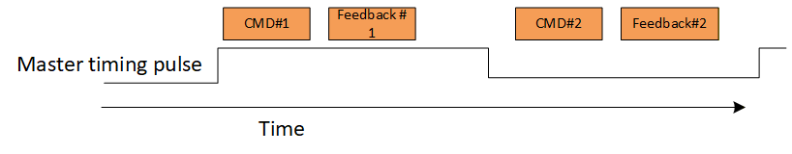
Figure 2: FSI connection and timing
Notes:
- FSI enslavement is an internal GFT mode. It assumes near-perfect hardware driven timing by a master whose internal clock may not deviate > 300ppm of the enslaved G-Core.
- Reliable FSI is better with a master timing pulse as in the diagram above
- The use of a master timing pulse is not a must. Timing can be locked, as in Moshe (no timing pulse there) on the communication packet itself
- At this mode, the slave sampling time adjusts and synchronizes to the FSI communication (a clock shift up to 300ppm, greater deviation creates an exception). As core#2 is timed by core#1, the core#2 timing is also automatically synchronized to the master's timing
- FSI enslavement is disabled by default and must be explicitly enabled by configuration

Boot flow
[Requirement 1008]
The diagram for CPU#1 is below:
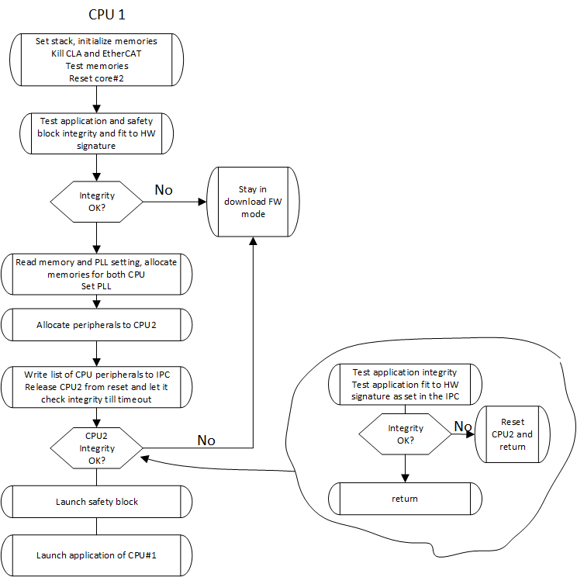
Figure 3: Boot flow diagram
Boot communication by default is 232400 for UART, 500000 and ID = 90 for CAN.
These data items are configurable in a small sector associated with the boot.
UART communication is always 1-stop bit, no parity, 8bits.
Notes:
- CPU2 does not have a boot. The operational SW will make its initialization, then waits an infinite loop for CPU1 to announce initialization complete.
- CPU2 does not have independent flash and PLL settings
- If CPU1 remains in FW download mode, CPU2 is in reset
- CPU#2 must have in it the expected CPU#1 version. Unless this, integrity check must fail.

Firmware downloading
[Requirement 1009]
CPU1 is the master CPU.
CPU1 normally owns no communications (but the HOT CPU option and FSI slave port). In boot mode, it needs to communicate via EtherCAT or CAN. This means that the basic EtherCAT and CAN handlers need be programmed into CPU1 boot – it needs be larger than usual.
CPU1 is the only one that performs FW update.
In boot mode it allocates to itself the entire set of flash blocks, and programs the FW for CPU2 as well. For this reason, CPU2 has no FW download mode.
The responsibility of matching versions between the cores is entirely the PC-side loader program. Although the FW downloading is dumb and it is possible to program any CPU alone, no mechanism exists in the boot of the embedded device to enforce CPU version matching. It is advisable to update both CPU always, and to defer the writing of both their statistics modules to be last.
Note:
The statistics block is erased first and re-written last.
This way, on partial loads, e.g., by on-loading power failure, the SW integrity check by the boot SW will fail, and the faulty load module will never run; the device will remain in boot mode, ready for FW downloading retry.

FW download implementation guidelines [Descriptive]
The FW downloader will follow these guidelines:
- Only CPU#1 has boot and makes flashing (see above boot description).
- On firmware downloading, CLA is killed in CPU#2 is held at reset. CPU#1 overtakes the flash banks of CPU#2.
- The treatment will be independent of transport lines, be them EtherCAT, CAN, UART,… . The treatment is "you get a stream (if long, composed by several sub-streams), process each sub-stream, and acknowledge".
- HOT CPU is not directly targeted by the Boot. HOT flashing will be by the CPU#2 and CPU#1 providing transparent channel to the HOT CPU to any PC software. The BOOT is not aware of the HOT if any exists. This means that just loading a file through the EtherCAT will not update a HOT CPU.
- The DOL Catalog definitions will remain. But we have only two catalog lines for CPU#1 and for CPU#2.
- EtherCAT will use FOE for buffer transfer. The file name being equal to the name in the catalog is by itself a command for FW update.
- CAN will use specific SDO. Block transfers are supported. The data sent must be exactly similar to that of EtherCAT, with the only difference that each block is headed by 4-byte index. Blocks must be sent exactly in sequence.
- In the boot, CAN will use the MCAN "Restricted Operation Mode" to adjust the baud rate. This means that either: (1) In a network the master knows the CAN ID and the baud rate in advance. (2) With single node, the master sends a sequence of "This is your ID" SDO's until baud rate is right, and slave acknowledges with given ID.
- UART: Invent something that will send the blocks in sequence, like the CAN does (same contents, go to the same handler following transport handling). UART boot always starts with 0x7 bytes sequence, until answered correctly. This serves for the boot to adapt baud rate. Take the baud rate discoverer from PVS.
- Statistics blocks have their own fixed address. Data for statistics block is written to RAM and wait there for conclusion.
- When entering FW update, the CPU will check all the program space for erasure. Each un-erased sector will be erased before further action.
- After the entire data of a CPU is transferred
  - Statistics are written to place
  - CPU reboots, only if that was the catalog file name of CPU#2. Otherwise, it needs a special command to reboot.
Notes:
- FoE uses the standard BUSY protocol to time consecutive segments
- Partial flash writes are native to this implementation. They make no harm; if the flash is not fully written, the G-core partly-flashed module will not wake and the device will stay in boot mode.
- When a given communication was identified by the boot, all other communications are blocked until reset. This is to avoid concurrent protocol interference during flash operations.

Object dictionary
[Requirement 1010]
Objects of DS402 require direct CPU#1 support. Their supportive objects there will be indexed exactly as the DS402 dictionary, including the 0x800 offset between objects associated with the 2 axes.
In addition, a commissioning object dictionary will expose all the commissioning parameters (Core #1 by itself cannot access commissioning parameters from external storage, they must be read and programmed by core#2).
The commissioning dictionary is indexed linearly (no subindices). Topic continuity is not desired – any new parameter will increment the top index regardless of context.
Note:
Choosing indexed MMI will require strict discipline.
- No living index may change semantics
- Removed indices must return error when accessed
- New indices must be faithfully documented
CPU#1 never accesses external memories other than Core#2 and CLA interfaces.
CPU#1 never accesses the operational communication directly

The Client (CPU 2)

Client roles
[Requirement 1011]
The client will run
- Clocking and initialization of any peripheral CPU2 uses
- All operational communication interfaces
- Interpreters that map communicated objects to server and local objects
- Any state machines other than the generic drive DS402
- Any user programs (microPython, SEAL, Legacy)
- Nonstandard sensor interface (resolver, potentiometers, etc)
- IMU interface, inertial integration TBD
- Target filtering or any other operational path calculations
- Any mission specific BIT

EtherCAT
[Requirement 1012]
EtherCAT will enable DC. The timing will be down to 200usec.
This will impose much stricter timing for Rx/Tx of coherent uncorrupted messages.
This will entail corresponding changes in the SSC. The ESC – PDO memory should be copied by DMA to a stable image.
SYNC0 (if DC is active) or SM0 event should trigger bidirectional DMA between ESC memory and image. This means that all status reports are late.
All the semantics of CanOpen – DS402 run on the DMA image.
PDO treatment is by running object callbacks.
Each time a mapping is done, a mapping list that contains
- Relative data position
- Data size
- Handler function
is prepared to loop on PDO acceptance.
Notes:
- SSC code adaptations are non-trivial, thus deferred to later milestone:
  - Non-trivial DMA ownership rules
  - Careful handling of SM events vs SYNC0
- EtherCAT slave can still work without DC or with non-matching period. In those case command jittering is expected. So non-DC-locked operation is suitable for service point-to-point motion, but much less for CS modes.

CAN Open and EtherCAT coexistence
[Requirement 1013]
CAN Open and EtherCAT CoE share exactly the same semantics (same object dictionary and interpreting functions)
SDO and PSO may be accessed either by CAN or by EtherCAT. However, with EtherCAT state higher then PRE-OP, it is impossible do deal PDO by CAN. SDO communication shall be very limited, e.g., status reports (GET objects), and recorder and logging functions access.
Object dictionary will have to flag "dual master objects" explicitly, the default is "No".
Even for dually accessible SET objects will have to monitor being used twice at the same time, leading to an exception.

Multiple axes and EtherCAT
[Descriptive]
Each CPU may run 2 servo axes.
Each CPU has one EtherCAT, with 8 x FMMU and 8 x Sync Managers.
This makes sense as each axis has two Rx PDO, to Tx PDO, and 4 sync managers for service objects and bulk data.
When going to larger systems, say 4 axes, one EtherCAT interface would not suffice, so each axis pair will run its own EtherCAT.
A possible solution for a 4-axis system is depicted below:
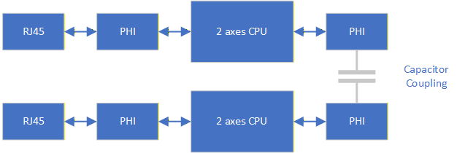
Figure 4: Four axes EtherCAT system
Note that:
- the two PHYs are directly connected by capacitors, no transformer necessary. This is possible assuming same ground plane and <10cm of traces.
- The two CPU must be fed by the same 20ppm crystal.

Client-server interconnect

Data interconnect
IPC interconnect will consist of the following:
[Requirement 1014]

Client (CPU2) to server (CPU1):
- Dual virtual sensor slots. If a non-standard (such as resolver) is used, it will be decoded by CPU2 as application
- Command interface, SEAL compatible
- Object interface stack. The stack will include 16 members, each having a double precision value, a command code (long, that may be interpreted as Index/Subindex), index, and data type. The command interface stack will also have a command put pointer
Client inventory:
  - List of peripherals and IO allocated for the server
  - List of memory banks allocated to the server
  - PLL setting

Server (CPU1) to client (CPU2)
[Requirement 1015]
- Dual feedback & status interfaces, SEAL compatible
- Dual configuration report buffers, SEAL compatible. These buffers reflect commonly used the control limitations: current limits, position limits, speed, acceleration and jerk limits etc.
- Recorder buffer variables (32 slots). Recorder data shall be placed there by one or two axes, the same buffer.
- Raw ADC data as shorts (if client consumes ADC, it needs know the scaling)
- Command buffer fetch counter
- Server inventory
  - Number of axes
  - Sensor configuration for each axis
Data integrity
[Requirement 1016]
Each non-atomic data unit (e.g., feedback buffer report) has an update 16bit counter. The counter increments and becomes odd when the buffer starts update, and is again incremented to even value on update completion. This way any data consumer must verify that the counter is even before data fetch; and that the counter value remained until after fetch completion.
The counters provide also a mean to detect overflow (counter incremented more than 2 between consecutive reads). Overflow detection and response strategies for Core#2 are left for the application designer.
If Core #1 detects update fault while a motor is on (client counters do not update as expected), it should throw an exception by the predefined DS-402 abort mode. A timing event in one axis will throw both axes.
Timing exception is legal when all motors are off – it may happen legally (e.g., on debugging)
The client may issue commands to the server via the command stack, updating the put counter accordingly. The server, upon executing a command:
- Sets result or completion status into the value slot of the corresponding stack member
- updates the fetch counter.
If client commands overflow, an attempt to update the put counter will equal it to the fetch counter. In that case the client stalls, and if time is out, issues an exception.

Core synchronization

General
[Requirement 1017]
The server core times it all. Core#2 is not allowed to affect Core#1 control timing.
The server core will program a spare PWM to issue interrupts to the clients.
There will be two interrupts:
- Axis #1 interrupt, periodic by TS
- Axis #2 interrupt (optional): periodic by TS, offset by TS/2 to 1st interrupt
The client will be required to arrange its real-time in synchronism to the server.
A client cycle is interleaved with the server cycle:
When the client runs axis#1 code the server runs axis#2 and vice versa, this way each side enjoys fresh data from the other.
Each axis shall apply the recorder separately; and increment the buffer pointer as needed. Start/Trigger/Ending conditions will be checked and applied by axis #1 only.

Adjustment by enslavement
[Requirement 1018]
Core #1 may be synchronized by external events, adapting the sampling time up to 300ppm. This may be either by FSI enslavement or by EtherCAT enslavement.
For FSI enslavement, it can only happen between GFT devices, so we can mandate jitter-free transmissions and compatible sampling times.
As per EtherCAT, sampling time adjustment (again up to 300ppm) will be only under distributed clock conditions, and if the period time of the EtherCAT is an integer multiple of the controller sampling time
SYNC0 of the EtherCAT, or SYNC pulse edge for FSI, should fall on interrupt time; so PWM edge must be T_ADC_Conversion before that.
Note:
As core#1 synchronizes both Core#2 and the CLA, it follows that the scheme described here synchronizes the entire system.

CLA synchronization
[Requirement 1019]
The CLA runs current loop. The sampling time of core#1 refers speed and position loops.
The CLA is synchronized to the slower rate of the CPU. It can run, however, at any period that is an integer division of the CPU control period.
The CLA is timed by its PWM to the power bridge. A comparator on this PWM triggers the ADC; CLA routine is called when ADC conversion completes. The PWM is synchronized to the same PWM (used just as timer) that times the main control loop. This PWM may be adjusted by DC or FSI enslavement, which may reflect directly to CLA timing jumps. The P650 protects PWM violations in hardware (MINDB block MUST be used), so this is acceptable.
Angle feedback to the CLA will only update at the CPU rate.

Emergency and Safety

STO
[Requirement 1020]
STO will be visible to all the cores (CPU#1, CPU#2, CLA) immediately after application.
STO has a predefined "grace time" in which the driver may try to decelerate the motion to complete stop, using the "Stop Deceleration".
After the physical grace time (We knowingly accept the large physical grace tolerance because of inaccurate implementation) the high side motor drivers shall be disabled in hardware. After the nominal grace time (always shorter than the physical, configured in project identity), the CLA will pass to emergency stop mode. In this mode:
- PWM is no-more complementary
- High side switch commands are inactive
- CLA Sampling time goes to 10usec.
- Low side switch commands are modulated independently for each half bridge, as hysteretic as follows:
- If absolute current value exceeds the identity-set limit, cut the switch CBC comparator/SDFM comparator
- If on a CLA interrupt the absolute current value is below 70% of the identity-set limit, restore the low switch to ON. If SFDM is used, work with the secondary (short circuit detection) filter only. The P650 allows its direct reading.
Note that if the CLA responded in software correctly to the STO, the physical STO inhibition will have no further effect.
Low side shorting will remain if STO stays de-asserted, and bridge temperature is ok.
Motor OFF commands will not affect STO response.

Simulation ability

G-Core support
[Requirement 1021]
The G-Core should have a simulation module that shall allow at least:
- Simulation of a motor with given R-L-KT
- Simulation of voltage source for VDc
- Simulation of Motor Inertia + Load Inertia + connecting compliance + Coloumb friction + Viscous friction
- Simulation of virtual sensors for motor and load positions, with programmable resolution.
Simulation will allow also intentionally diverging control in which maximum current is continuously retained, positive or negative.
Under this setup, G-Core may run a simulated target with its standard operation environment.

PC support
[Requirement 1022]
The G-Core module shall be wholly compiled in Visual C environment.
It will be wrapped in communication drivers allowing SolFlo communication (NOT EtherCAT)
The wrapped G-Core, subject to correct configuration, will allow full operation inside SOLFlow.
This includes all the stages of tuning-comissioning.

Appendix: HW requirements
The following hardware peripherals are required to support the complete set of G-Core features, with 2-axes per CPU. Partial implementations may omit features not needed for a particular customization.
Peripheral | Instance | Per axis | Per unit
EtherCAT (1) | EtherCAT |  | 1
CAN (2) | Operational |  | 1
 | Debug |  | 1
UART(4) | IMU |  | 1
 | Hot CPU | 1
 | UI (USB) |  | 1
GPIO/PWM (12) | UART DIR Control |  | 4
 | STO |  | 1
 | FSI Sync |  | 1
 | Limit Switch | 2
 | Shunt control | 1
FSI (2, full set) | RX, 1-lane, another CPU interface |  | 1
 | TX, 1 lane, another CPU interface |  | 1
 | RX, 1-lane, extensions
 | TX, 1-lane, extensions
Encoder interface (EQEP) (2)  Full set: A/B/Z |  | 1
SPI (4) | COPI only:  BISS interface (complemented by CLB) | 1
 | Serial RAM (e.g. IS66WVS4M8BLL-104NLI-TR) |  | 1
 | Serial flash for parameters (two ANDed chip selects) |  | 1
I2C (1) | EEPROM for parameters |  | 1
Reset line | CPU2 must be able to reset the entire device |  | 1
STO line | CPU2 must be able to activate STO |  | 1
Quarz accuracy | Must be to 20ppm |  | 1
Table 2: Communication and sensor interfaces
In addition:
- PWMs for transistor drive 2x3 per axis
- SDFM x 3 per axis, each having a PWM as SDFM clock
- Analog input for DC voltage, input current, motor phase currents, moto phase voltages, temperatures, HW version indication, …
- DAC outputs as required for phase voltage indications.

Appendix: Roadmap and Work to do

Mapping of DftServo feature for reuse
Projects | Features | remarks
DOL | EtherCAT with Ds402 | EtherCAT supports single axis only
GPT | Latest position control and basic sensor-less, MCAN drivers
Dugit | Reading Biss by SPI+CLB
Kevesh | Listener of Biss by CLB | Latest CLB version
PIT202x | Latest User program implementation, DFT_Compiler
DftTuner | DFT_IDE: sources of Legacy User program compiler and IDE
Moshe | FSI enslaving

Feature updates
Immediate (1): required for first P650 release, to operate GPT650
Immediate (2): required to operate GPT650, customer distribution
Optimization: deferred to later stage
Removal: explicitly deprecated, no migration planned

Feature | Change | Priority
Division to cores | Partition SW as specified | Immediate (1)
CPU1 dictionary | Add separate dictionary for commissioning variables. Update of the commissioning variables dictionary in CPU flash independent of FW. | Immediate (1)
Standard Clarke-Park transformations, correct I/Q definitions | From non-standard implementation | Immediate (1)
PWM dead time protections | New | Immediate (1)
CAN | Set to MCAN with FD option | Immediate (1)
Configuration sector for operational SW | Define memory block allocations,  Is burned in CCS  IsHotCpu  Assumed HW peripherals  Peripherals allocated to CPU2  SW start address  SW end address  SW revision  PLL settings  Product code  IsDigitallySigned, digital signature  Adler32 checksum of SW  Adler32 checksum of configuration | Immediate (1)
Device data | We will be supported with the new enhancements. Shall be given a specialized sector inside the device flash | Immediate (1)
Interrupt timing | Changed interrupt scheme | Immediate (1)
Control code untangle pre-emptions | Control interrupt is to be non-preempted.  Inter interrupt preemption and thread safety controls to be removed | Immediate (1)
Flash drivers | Revised | Immediate (1)
Recorder | External interface exists in Core #2.  Core #1 places recorder results in IPC, to be used by CORE#2. This way one recorder session may present data from both cores in synchronism.  Recorder list length increased to 32 | Immediate (1)
CAN driver to MCAN | Revised drivers | Immediate (1)
Tuning support |  | Immediate (1)
2-axes support | Clean the existing CPU+CLA and CPU+HotDsp interfaces for 2 axes support  Add second axis objects for EtherCAT interface | Immediate (1)
High speed DMA based process data transmission | USB support | Immediate (1)
Dictionary support of multiple axes | According to DS402, other axis has similar dictionary with address offset | Immediate (2)
Exception handling | Sensor and other exceptions shall apply even if the motor is off. An exception on motor off shall be timed out; If a failure disappears for a given time, it is deleted.  Motor start shall not be attempted under failure conditions. | Immediate (2)
Sensor arbitration between peripherals | Encoder sockets shall be shared between the axes; there is no predefined socket-axis association.  It will be checked that a socket is not used twice. | Immediate (2)
Boot | Flow diagram revised | Immediate (2)
 | FW downloading revised | Immediate (2)
EtherCAT | Direct interface, not through IPC | Immediate (2)
Battle short | Relaxation of driver-preserving limits such as over-temperature by mode | Immediate (2)
FSI | Expansion to 2-axis timing | Immediate (2)
Serial storage RAM on SPI | For recorded data | Optimization
CAN FD | Update to CAN FD standards (SDO and block logics revised, PDO enlarged…) | Optimization
Simulation support | Enable simulation either using G-Core HW or simulated drive- | Optimization
Position profiler | From int64 to double | Optimization
Assembly code | Removal | Optimization
High speed DMA based process data transmission | EtherCAT support | Optimization
RT FFT analysis for identification | Removal, to be replaced by PC code | Optimization
Shunt management | Each axis reports its predicted power requirement, coordinated shunt or burn-over-the-motor management | Optimization
User programming | Include MPY VM with debugging support in DSP and PC. | Optimization
Interface with BISS for w/r |  | Optimization
Safety | Include safety procedure with watchdog (optional) | Optimization

Feature families
Sensors
Sensor | Features | Remarks
Quad encoder | 2 encoders
Halls sensors |  | Fix implementation as universal sensor
Resolver |  | No recorded request at recent years.  Supported by legacy systems like SK  To be removed
Potentiometer |  | No recorded request at recent years  Supported by legacy systems like SK  To be removed
Tachmeter | No support planned
Abs encoder | SSI,BISS 2 encoders (mix with Quad encoder) | To implement reading by CLB only, introduce full parametrization
 | ENDAT | No support planned
 | TAMAGAWA | No support planned
Analog halls (sin/cos) | Implementation exists, never tested in practical system | No recorded request at recent years, but common in modern systems.
EmfSensor | Sensor less

Tuning support
Features |  | remarks
Sine generator for current/position loop identification
Fast “noise” generator for position identification
Step response test for current loop
Special internal procedure for current loop start-step
Internal FFT calculation for single testing frequency |  | To be done on PC.

Simulation
Features |  | remarks
Plant simulation | Partially implemented as simulation sensor | Interface: to implement simulation of plant and mapping to the configured sensors.

Other features
Features | status | remarks
Auto phasing | Not implemented in the latest versions, and shall not be supported | No recorded use in recent years
HOT CPU | Not implemented initially | Protocol shall be defined and communication lines reserved. For 2-axis systems with HOT CPU, one HOT CPU is assumed to handle both the axes.  No mixed CLA-HOT options are planned
Legacy User program VM | Implementation for VM exists, should be integrated with flash and RAM. | At optimization state as application option if requested
Legacy User program PC interface | Exists only Delphi-written IDE, should be integrated with PC communication, preferable should me re-written for modern GUI. | At optimization state as application option if requested
Interpreters | Mnemonic (XX[] ) and system function interpreter exist. Using this interpreter very slow updates Tuner GUI | At optimization state should add binary direct object access.
Can Open | supported

Appendix: SRR topics
The following topics need be discussed at the SRR:
Topic | Issue | Detail
Documentation | Given the time & budget constraint, which level of documentation do we want? | Do we rehearse the entire DFT-SERVO user manuals?  Do we put all the software to formal documentation (SRS, SDD, SDP,…)
Testing | Who and when does the testing program?  To which level we aim for the tests? | Are we establishing a rigorous recursive testing platform? Should it use a 3rd party testing framework? Building testing lab?
SolFlow integration | Integration plan | Does SloFlow keep the old-slow textual interpreting?  Does SolFlow support high speed recording & display?
Man power | Enough Indians for the work | Alla for Boots? Percentage?  Integrators?  Testers?  Lab?
Dead lines | Approval of milestones | Practical dates for milestones

