Initial thoughts:

GFT G3 control core (GCore)

Based on the P650 processor
Prepared by:
S. Safonov, Y. Theodor
ChatGPT OUTSIDE

- | First draft | 13-Jan-26
1.0 | Elaborate FSI enslavement mode | 14-Jan-26
1.1 | JH comments | 14 Jan 2026
1.2 | Add multiple axis by Ethercat and HW requirements | 14-Jan-26
1.3 | Update boot sequence after discussion w. Shmuel | 14-Jan-26
Table 1: Table of revisions
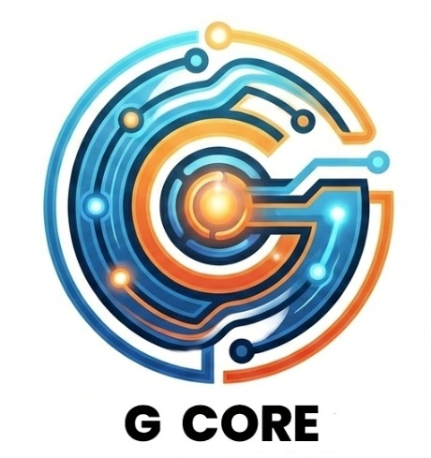

Contents
1 Introduction 3
1.1 Scope: 3
1.2 Glossary 3
2 Functional description 4
2.1 Core roles 4
2.1.1 Cores 4
2.1.2 Core interconnects 5
2.2 Motion controller (CPU1 + CLA or HOT) description 6
2.2.1 General features: 6
2.2.2 Safety security module 7
2.2.3 FSI enslavement 7
2.2.4 Boot flow 9
2.2.5 Firmware downloading 9
2.3 The Client (CPU 2) 10
2.3.1 Client roles 10
2.3.2 Multiple axes and EtherCAT 10
2.4 Client-server interconnect 11
2.4.1 Data interconnect 11
2.4.2 Core synchronization 12
3 Appendix: HW requirements 13
4 Appendix: Roadmap and Work to do 14
4.1 Mapping of DftServo feature for reuse 14
4.2 Feature updates 14
4.3 Feature families 16

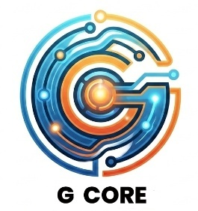
Introduction

Scope:
This document outlines the next-generation P650 core for GFT-Servo, referred to as “G Core.”
While based on the existing GFT-Servo architecture, it introduces a new design direction.
- The P650 revision focuses on several key objectives:
- Establishing a unified control core across the entire GFT product family
- Providing limited built-in safety features, with certified safety functionality delegated to an external high-level CPU
- Standardizing low-level communication interfaces
- Enabling a wide range of applications through a flexible, dynamically configurable application core
This document is an early draft intended to confirm alignment on the overall direction before we invest in the extensive, time-consuming detailed work.
It reflects the first day’s results of formal architecture discussions, consolidating and structuring the many informal conversations of recent weeks. Now it also contains corrections by colleague responses.
It does not aim to be highly precise, comprehensive, or fully refined.

Glossary
Term | Means
BIT | Built In Test
CAN | Control Area Network
CAN FD | CAN with Frequency with Flexible Data rate
CLA | Control Law Accelerator, a dedicated coprocessor for algorithm number crunching
DS402 (now IEC61800-7) | A general device profile (ICD) for a servo drive
EEPROM | Electronic-Erasable Programmable Read Only Memory
EtherCat | A determistic high speed serial communication that may run on Ethernet hardware.
FMMU | Field Memory Management Interface  An EtherCat unit the directly controls the transfers between message partitions to specific CPU-accessible memory location
G3 or GCore | Generation 3  G1 was before GFT servo SW  G2 is the present GFT servo SW
HOT CPU | On systems which require electrical isolation, a separate CPU that replaces the CLA functionality beyond the insulation barrier
HW | Hardware
ICD | Interface Control Document, details communication formats and contents.
I2C | Inter Integrated Circuit, a primitive open collector serial communication
IPC | Inter Processor Communication: a dual ported enhanced message box between the two cores of the P650
MAC | Media Access Controller. An on board peripheral that translates messages at the CPU side to physical media requirements
PHI | "Physical" – by the commands of a MAC, produce actual signals on the physical transmission lines.
P650 | A core by TI, intended for next gen use
RMII | Redudec Medeia Independent Interface, a protocol serving between MAC and PHI
SW | Software

Functional description

Core roles

Cores
The 650 SW is made of 3 cores:
Core#1: Speed and Position:
- Control functions,
- sensor interfaces, (Hall , Encoders, IMU)
- reference profilers (single or dual axes)
- safety part, (optional)
CLA: Current control (single or dual axes)
Or:
Hot CPU: Current control (single or dual axes)
Core#2: Services:
- Communications, protocols,
- interpreters,
- user programs VM,
- external interfaces

Core interconnects
Core#1 to CLA interconnect: Via CLA mailboxes and shared memory
Or
Core#1 to HOT CPU interconnect: Via UART, 3 to 6MB/sec
Core#1 to Core#2 interconnect: Through IPC
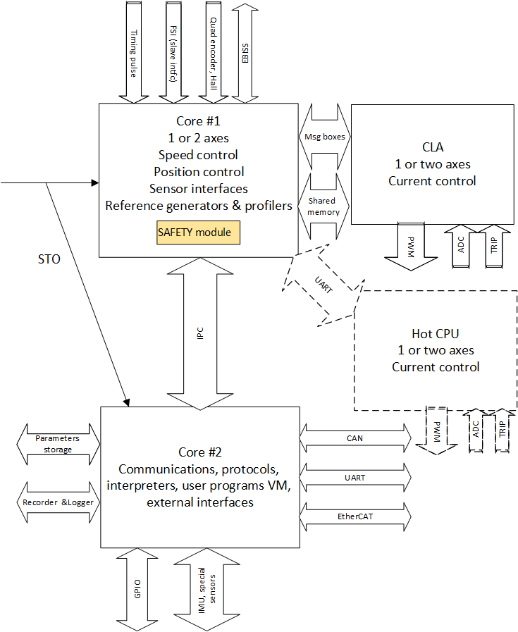

Figure 1: Core arrangement. HOT CPU is dashed; it is a replacement to CLA work, on applications where electrical isolation is required.
Notes:
- The USB connection, although planned, is not shown. From the controller’s perspective, USB functions simply as a high-speed UART interface.
- When two axes operate on the same core, they share the same sampling period and remain synchronized. Each axis receives its own interrupt, with the interrupts staggered by half a cycle.
- The HOT CPU interface is currently defined only at the hardware-allocation level. There is no near-term requirement for HOT CPU functionality, so detailed development is postponed. A HOT CPU does not benefit from the tight coupling available to the CLA; it intentionally trades control bandwidth for galvanic isolation. Because a typical message to the HOT CPU is around 16 bytes, transmission requires roughly 60 µs, resulting in a total delay of up to 100 µs. Consequently, systems using a HOT CPU will have their velocity-loop bandwidth limited to approximately 500 Hz, which is acceptable for most applications.

Motion controller (CPU1 + CLA or HOT) description

General features:
The controller core is designed with the following principles:
• Structural isolation: The control architecture is kept independent from project‑specific logic to simplify maintenance.
• Strict command model: The core accepts commands exclusively through an object dictionary and performs no high‑level command interpretation.
• Standardized machine interface: The core is intended solely for machine‑level interaction, using a standardized interface (object dictionary, command structure, feedback structure, and setup‑report structure) compatible with SEAL implementations.
• Partial safety integration: Although not intended for full safety certification, a safety module is embedded within the compact direct‑control code and operates as an independent module. It has its own periodic service (via CpuClock2) and a software watchdog.
Low‑grade safety compliance: Due to its focused scope, the control core can be fully specified for lower‑tier safety requirements. High‑level standards such as ISO 26262 or IEC 61508 ASIL4 are not feasible here and would require a C29xx‑class architecture.
- The control core does not perform current control which is handled either by the CLA or by a “HOT” CPU via communication.

Safety security module
The safety module:
- Operates as an independent process with its own dedicated flash sector.
- Uses minimal code and runtime resources.
- Is not replaced during standard software updates.
- Reserves the watchdog and CPUTimer2 exclusively for its own operation, preventing conflicts and ensuring it can respond even if the main application blocks interrupts or starves it of CPU time.
- Can be configured through parameters such as maximum speed, position limits, stop deceleration, encoder scaling, and matching information.

FSI enslavement
The FSI real time command channel allows a remote master to directly control core#1 without core#2 mediation. This is done where the main role of core#2, i.e. interface and process control, is taken by a remote master, and passing through core#2 will:
- Add unnecessary delays
- Burden the core#2 SW, which should be cheap to maintain, a strictly timed process.
For this purpose, the FSI communication works as strict reference generator, in one of
IEC61800-7 CP(Cyclic Periodic) modes.
The FSI is one-lane wide, and bidirectional. Its back path carries feedback and status, namely position, speed, current, voltage, power consumption and status bits, as well as slots for programable reports. A part of the FSI communication (always 15 words) is devoted to object dictionary set/get, only for 2-words (long or float) objects. All the objects concerned with CP motion are accessible via 2-word objects.
The FSI timing must be expanded to 2-axis use:
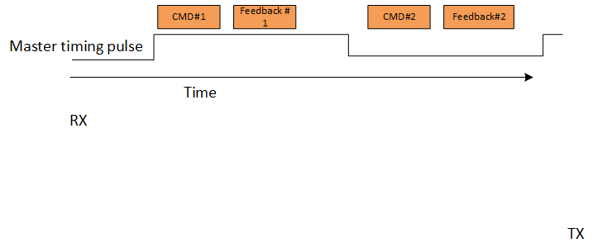
Figure 2: FSI connection and timing
Notes:
- Reliable FSI is better with a master timing pulse as in the diagram above
- The use of a master timing pulse is not a must. Timing can be locked, as in Moshe (no timing pulse there) on the communication packet itself
- At this mode, the slave sampling time adjusts and synchronizes to the FSI communication (a clock shift up to 300ppm, greater deviation creates an exception). As core#2 is timed by core#1, the core#2 timing is also automatically synchronized to the master's timing

Boot flow
The diagram for CPU#1 is below:
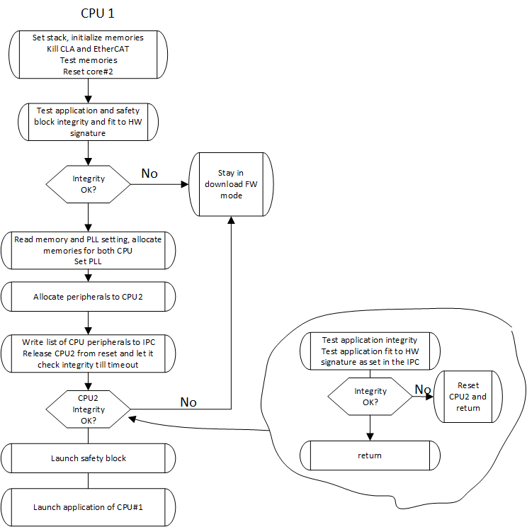
Figure 3: Boot flow diagram
Notes:
- CPU2 does not have a boot. The operational SW will make its initialization, then waits an infinite loop for CPU1 to announce initialization complete.
- CPU2 does not have independent flash and PLL settings
- If CPU1 remains in FW download mode, CPU2 is in reset

Firmware downloading
CPU1 is the master CPU.
CPU1 normally owns no communications (but the HOT CPU option and FSI slave port). In boot mode, it needs to communicate via EtherCAT or CAN. This means that the basic EtherCat and CAN handlers need be programmed into CPU1 boot – it needs be larger than usual.
CPU1 is the only one that performs FW update.
In boot mode it allocates to itself the entire set of flash blocks, and programs the FW for CPU2 as well. For this reason, CPU2 has no FW download mode.
The responsibility of matching versions between the cores is entirely the PC-side loader program. Although the FW downloading is dumb and it is possible to program any CPU alone, no mechanism exists in the embedded device to enforce CPU version matching. It is advisable to update both CPU always, and to defer the writing of both their statistics modules to be last.
Note:
The statistics block is erased first and re-written last.
This way, on partial loads, e.g., by on-loading power failure, the SW integrity check by the boot SW will fail, and the faulty load module will never run; the device will remain in boot mode, ready for FW downloading retry.
FW update option should be supported by all “config” communication protocols via core 2

The Client (CPU 2)

Client roles
The client will run
- Clocking and initialization of any peripheral CPU2 uses
- All operational communication interfaces
- Interpreters that map communicated objects to server and local objects
- Any state machines other than the generic drive DS402
- Any user programs (microPython, SEAL, Legacy)
- Nonstandard sensor interface (resolver, potentiometers, etc)
- IMU interface, inertial integration TBD
- Target filtering or any other operational path calculations
- Any mission specific BIT

Multiple axes and EtherCAT
Each CPU may run 2 servo axes.
Each CPU has one EtherCat, with 8 x FMMU and 8 x Sync Managers.
This makes sense as each axis has two Rx PDO, to Tx PDO, and 4 sync managers for service objects and bulk data.
When going to larger systems, say 4 axes, one EtherCat interface would not suffice, so each axis pair will run its own EtherCat.
A possible solution for a 4-axis system is depicted below:
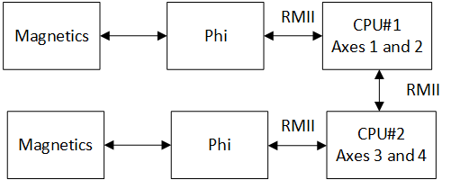
Figure 4: Four axes EtherCat system
Note that the two CPUs are directly connected by RMII lines.

Client-server interconnect

Data interconnect
IPC interconnect will consist of the following:
Client (CPU2) to server (CPU1):
- Dual Object interfaces. Objects use the IPC set/clear/ack mechanism.
- Dual virtual sensor slots. If a non-standard (such as resolver) is used, it will be decoded by CPU2 as application
- Command interface, SEAL compatible
Server (CPU1) to client (CPU2)
- Dual feedback & status interfaces, SEAL compatible
- Dual configuration report buffers, SEAL compatible. These buffers reflect commonly used the control limitations: current limits, position limits, speed, acceleration and jerk limits etc.
- Recorder buffer variables (32 slots). Recorder data shall be placed there by one or two axes, the same buffer.
- Raw ADC data as shorts (if client consumes ADC, it needs know the scaling)
- Server inventory
  - Number of axes
  - Sensor configuration for each axis
- Client inventory:
  - List of peripherals and IO allocated for the server
  - List of memory banks allocated to the server
  - PLL setting
Data integrity
Each non-atomic data unit (e.g., feedback buffer report) has an update 16bit counter. The counter increments and becomes odd when the buffer starts update, and is again incremented to even value on update completion. This way any data consumer must verify that the counter is even before data fetch; and that the counter value remained until after fetch completion.
The counters provide also a mean to detect overflow (counter incremented more than 2 between consecutive reads). Overflow detection and response strategies for Core#2 are left for the application designer.
If Core #1 detects update fault while a motor is on (client counters do not update as expected), it should throw an exception by the predefined DS-402 abort mode. A timing event in one axis will throw both axes.
Timing exception is legal when all motors are off – it may happen legally (e.g., on debugging)

Core synchronization

General
The server core times it all. Core#2 is not allowed to affect Core#1 control timing.
The server core will program a spare PWM to issue interrupts to the clients.
There will be two interrupts:
- Axis #1 interrupt, periodic by TS
- Axis #2 interrupt (optional): periodic by TS, offset by TS/2 to 1st interrupt
The client will be required to arrange its real-time in synchronism to the server.
A client cycle is interleaved with the server cycle:
When the client runs axis#1 code the server runs axis#2 and vice versa, this way each side enjoys fresh data from the other.
Each axis shall apply the recorder separately; and increment the buffer pointer as needed. Start/Trigger/Ending conditions will be checked and applied by axis #1 only.

Adjustment by enslavement
Core #1 may be synchronized by external events, adapting the sampling time up to 300ppm. This may be either by FSI enslavement or by EtherCat enslavement.
For FSI enslavement, it can only happen between GFT devices, so we can mandate jitter-free transmissions and compatible sampling times.
As per EtherCat, sampling time adjustment (again up to 300ppm) will be only under distributed clock conditions, and if the period time of the EtherCat is an integer multiple of the controller sampling time

CLA synchronization
The CLA runs current loop. The sampling time of core#1 refers speed and position loops.
The CLA is synchronized to the slower rate of the CPU. It can run, however, at any period that is an integer division of the CPU control period.
Angle feedback to the CLA will only update at the CPU rate.

Appendix: HW requirements
The following hardware peripherals are required to support the complete set of G-Core features, with 2-axes per CPU. Partial implementations may omit features not needed for a particular customization.
Peripheral | Instance | Per axis | Per unit
EtherCat (1) | EtherCat |  | 1
CAN (2) | Operational |  | 1
 | Debug |  | 1
UART(4) | IMU |  | 1
 | Hot CPU | 1
 | UI (USB) |  | 1
GPIO/PWM (12) | UART DIR Control |  | 4
 | STO |  | 1
 | FSI Sync |  | 1
 | Limit Switch | 2
 | Shunt control | 1
FSI (2, full set) | RX, 1 lane, slave interface |  | 1
 | TX, 1 lane, slave interface |  | 1
 | RX, 1-lane, extensions
 | TX, 1-lane, extensions
Encoder interface (EQEP) (2)  Full set: A/B/Z |  | 1
SPI (4) | COPI only:  BISS interface (complemented by CLB) | 1
 | Serial RAM (e.g. IS66WVS4M8BLL-104NLI-TR) | 1
 | Serial flash for parameters | 1
I2C (1) | EEPROM for parameters | 1
Table 2: Communication and sensor interfaces
In addition:
- PWMs for transistor drive 2x3 per axis
- SDFM x 3 per axis, each having a PWM as SDFM clock
- Analog input for DC voltage, input current, motor phase currents, moto phase voltages, temperatures, HW version indication, …
- DAC outputs as required for phase voltage indications.

Appendix: Roadmap and Work to do

Mapping of DftServo feature for reuse
Projects | Features | remarks
DOL | Ethercat with Ds402 | Ethercat supports single axis only
GPT | Latest position control and basic sensor-less, MCAN drivers
Dugit | Reading Biss by SPI+CLB | Not clear
Kevesh | Listener of Biss by CLB | Latest CLB version
PIT202x | Latest User program implementation, DFT_Compiler
DftTuner | DFT_IDE: sources of User program compiler and IDE
Moshe | FSI enslaving

Feature updates
Immediate (1): required for first P650 release, to operate GPT650
Immediate (2): required to operate GPT650, customer distribution
Optimization: deferred to later stage
Removal: explicitly deprecated, no migration planned

Feature | Change | Priority
Division to cores | Partition SW as specified | Immediate (1)
CPU1 dictionary | Add separate dictionary for commissioning variables | Immediate (1)
Standard Clarke-Park transformations, correct I/Q definitions | From non-standard implementation | Immediate (1)
PWM dead time protections | New | Immediate (1)
CAN | Set to MCAN with FD option | Immediate (1)
Configuration sector for operational SW | Define memory block allocations,  Is burned in CCS  IsHotCpu  Assumed HW peripherals  Peripherals allocated to CPU2  SW start address  SW end address  SW revision  PLL settings  Product code  IsDigitallySigned, digital signature  Adler32 checksum of SW  Adler32 checksum of configuration | Immediate (1)
Device data | We will be supported with the new enhancements. Shall be given a specialized sector inside the device flash | Immediate (1)
Interrupt timing | Changed interrupt scheme | Immediate (1)
Control code untangle pre-emptions | Control interrupt is to be non-preempted.  Inter interrupt preemption and thread safety controls to be removed | Immediate (1)
Flash drivers | Revised | Immediate (1)
Recorder | External interface exists in Core #2.  Core #1 places recorder results in IPC, to be used by CORE#2. This way one recorder session may present data from both cores in synchronism.  Recorder list length increased to 32 | Immediate (1)
CAN driver to MCAN | Revised drivers | Immediate (1)
Dictionary support of multiple axes | According to DS402, other axis has similar dictionary with address offset | Immediate (2)
Exception handling | Sensor and other exceptions shall apply even if the motor is off. An exception on motor off shall be timed out; If a failure disappears for a given time, it is deleted.  Motor start shall not be attempted under failure conditions. | Immediate (2)
Sensor arbitration between peripherals | Encoder sockets shall be shared between the axes; there is no predefined socket-axis association.  It will be checked that a socket is not used twice. | Immediate (2)
Boot | Flow diagram revised | Immediate (2)
 | FW downloading revised | Immediate (2)
EtherCat | Direct interface, not through IPC | Immediate (2)
Battle short | Relaxation of driver-preserving limits such as over-temperature by mode | Immediate (2)
FSI | Expansion to 2-axis timing | Immediate (2)
Serial storage RAM on SPI | For recorded data | Optimization
CAN FD DS1301 | Update to CAN FD standards (SDO and block logics revised, PDO enlarged…) | Optimization
Position profiler | From int64 to double | Optimization
Assembly code | Removal | Optimization
High speed DMA based process data transmission | Addition | USB support:  Immediate  Ethercat support:  Optimization
RT FFT analysis for identification | Removal, to be replaced by PC code | Optimization
Shunt management | Each axis reports its predicted power requirement, coordinated shunt or burn-over-the-motor management | Optimization

Feature families
Sensors
Sensor | Features | Remarks
Quad encoder | 2 encoders
Halls sensors |  | Fix implementation as universal sensor
Resolver |  | No recorded request at recent years.  Supported by legacy systems like SK  To be removed
Potentiometer |  | No recorded request at recent years  Supported by legacy systems like SK  To be removed
Tachmeter | No support planned
Abs encoder | SSI,BISS 2 encoders (mix with Quad encoder) | To implement reading by CLB only, introduce full parametrization
 | ENDAT | No support planned
 | TAMAGAWA | No support planned
Analog halls (sin/cos) | Implementation exists, never tested in practical system | No recorded request at recent years, but common in modern systems.
EmfSensor | Sensor less

Tuning support
Features |  | remarks
Sine generator for current/position loop identification
Fast “noise” generator for position identification
Step response test for current loop
Special internal procedure for current loop start-step
Internal FFT calculation for single testing frequency |  | To be done on PC.

Simulation
Features |  | remarks
Plant simulation | Partially implemented as simulation sensor | Interface: to implement simulation of plant and mapping to the configured sensors.

Other features
Features | status | remarks
Auto phasing | Not implemented in the latest versions, and shall not be supported | No recorded use in recent years
HOT CPU | Not implemented initially | Protocol shall be defined and communication lines reserved. For 2-axis systems with HOT CPU, one HOT CPU is assumed to handle both the axes.  No mixed CLA-HOT options are planned
User program VM | Implementation exists | Must be integrated with resources of DSP ( flash for the user program co-existed with parameters sector, to be separated)
PC interface | Exists Delphi-written IDE. (sources remained in DftTuner) | Should be re-integrated with communication of DftTuner etc. In the nearest future to be re-written for modern GUI.
Interpreters | Mnemonic (XX[] ) and system function interpreter exist | Using this interpreter very slow updates Tuner GUI
MCAN | Basic MCAN HW drivers exist
Can Open | supported
CAN FD (1301 standard?) | Not implemented
2-axes support | Control:  For CPU+CLA supported  For CPU+HotDsp yet not supported  Ethercat: yet only single axis supported | Need little fixes for latest features (sensorless commutation)

