Testing the PD

# Introduction

## Scope

This document establishes an acceptance test for the PD card of Itamar

Please get familiar with the entire ATP before executing it

The ATP course instructs you what and where to connect. Please act exactly per the ATP instructions, at their exact order.

|  |
| --- |
| TAKE CARE:  The PD board has connectors that are similar, so it is possible to insert a connector in the wrong place.  Inserting the wrong connection can damage the cards irreparably, so please note very carefully the connector marking |

|  |
| --- |
| The I2C provision is not tested. |

## Equipment

|  |  |  |
| --- | --- | --- |
| Equipment |  | Comments |
| Test jig for the PD |  |  |
| Scope |  | Requires valid calibration |
| DVM |  | Requires valid calibration |
| Power supply 36V, Tunable, with current measurement and at least 5A drive |  | If power supply can only deliver 32V, this is still acceptable |
| Power supply 54V, Tunable, with current measurement and at least 10A drive |  |  |
| XDS200 emulator or XDS560-V2 emulator |  |  |
| Pin swapping adapter for emulator |  | See note 1 below |
| PC computer with:   * TI code composer, 6.2 and up * MATLAB 2016 and above |  |  |
| CAN leaf CAN adapter | Kvaser |  |
| CAN cable |  |  |
| CAN terminator 120R |  | Actually part of the jig |

Note 1:

The pin swap adapter is only for layout #1, because the ICE connector has been side-misplaced. The spa should be between the rows, so 1<->2, 3<->4, … 13<->14.

## Abbreviations

|  |  |
| --- | --- |
| Abbreviation | For |
| CCS | Code Composer Studio software by TI |
| ECR | Engineering Change Requirement |
| TI | Texas Instruments |
| LP | The LaunchPad card of Itamar |
|  |  |
|  |  |

# Applicable document

|  |  |
| --- | --- |
| Document | Comment |
| PD card ECR |  |

# Visual inspection

Inspect that:

* The card is clean
* Connectors clean and undamaged
* All ECRs are made per the ECR document

# Test setup

Copy the tester files to c:\Itamar\BHT\Kvaser\PDtest

Set the PD and in the test jig.

Connect the return path of the 36V PS and the 54V PS

Open Matlab and set the work directory:

>> cd ‘C:\Itamar\BHT\kvaser\PDtest’

# Functional tests

|  |
| --- |
| Please connect the connectors of the PD card exactly in the order and sequence said in this form.  Please set the PS On/off exactly in the order said in the test.  Failure to do this may enhance the damage if the tested card was faulty |

## Power supply and global switch test

Tune the power supply to 36V +1/-5V

Tune the power supply to 54V +1/-5V

|  |
| --- |
| The returns (- lines) of the 36V PS and the 54V PS must be connected  Otherwise circuit may be damaged |

Turn off both PS

Connect J3, and set the bananas GND and 36V to the PS.

Connect J2, set the safety mushroom to pressed, and the global on-off switch to off

Turn on the PS, write down the consumption.

Then turn on the global on-off

|  |  |  |
| --- | --- | --- |
| Test | Criteria | Pass |
| Consumption from the PS, global switch at OFF | 0A |  |
| Consumption from the PS, global switch at ON | 0.17A to 0.22A |  |

Turn on the global on-off again for the rest of the test

## Load software

Power off.

Connect the emulator (XDS200 or XDS560V2) between the PD and the PC.

|  |
| --- |
| Layout 1 of PD:  The emulator must be fitted with standard TI 100mil/14pin/No pin 6 connection.  A swapping connector (1<->2, 3<->4, …,13<->14 MUST be fitted. |
| Be careful to connect the emulator in the correct polarity (pin 1 to the 1 side) and USE the swapping connector.  Failure to do this will destroy both the DSP and the emulator |

Turn the 36V power on.

Open the CCS, and configure the target: use

View->TargetConfigurations

You should see among the User Defined configuration “XDS200_PD“

If not, By mouse right click, import (by the type of used emulator) the configuration

C:\Itamar\BHT\kvaser\LPTest\CCS\ XDS200_PD.ccxml

C:\Itamar\BHT\kvaser\LPTest\CCS\ XDS560V2_PD.ccxml

Right click and launch the configuration XDS200_PD or XDS560V2_PD, respectively.

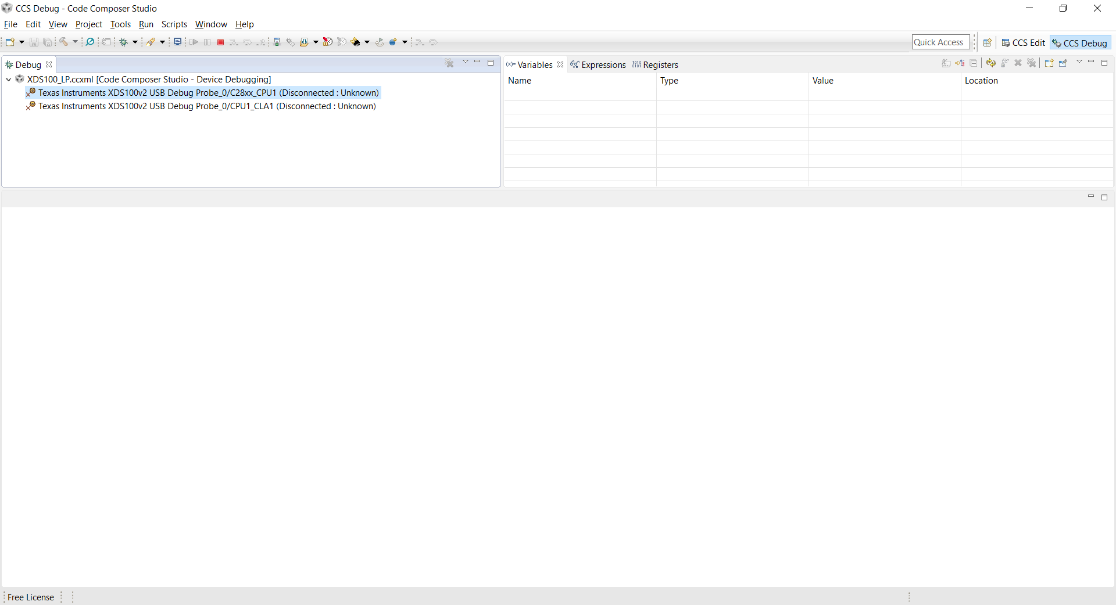

Right click the CPU1 line in the debug window (highlighted in the above figure) and select “Connect Target”.

Then Run->Load->Load Program and select

C:\Itamar\BHT\kvaser\PDTest\CCS\Example_28377SLaunchPad.out

The dialog should look like that:

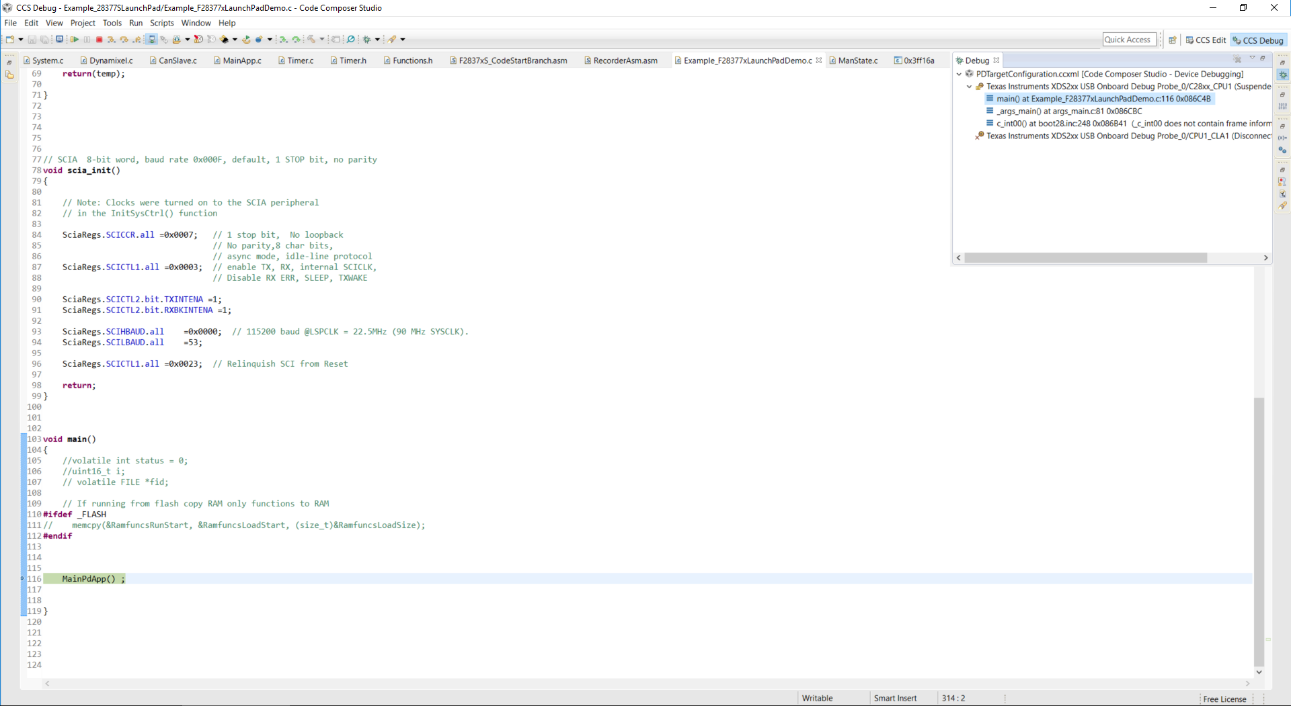

Then Run->Resume

|  |  |  |
| --- | --- | --- |
| Test | Criteria | Pass |
| Software download | All the above stages passed without errors |  |

## CAN communication, wake from flash, and basic supplies test

Do as follows:

* Turn off the 36V and 54V supply
* Connect J1 at the jig
* Connect the Kvaser to the CAN connector at J1 (terminator is needed – normally part of the jig)
* Turn on the 36V and 54V supply
* Connect the 9-pin D-types of the RS485 MAN and the RS485 STOP

At the Matlab prompt type

>> CanTest

Then

>> ComTest

|  |  |  |
| --- | --- | --- |
| Test | Criteria | Pass |
| CAN #1 test | Display of  CAN Test + CPU timing passed ok |  |
| RS422 spare (SCIA) | Test PASSED |  |
| Discrete lines Disc1 and Disc2 test | Test PASSED |  |
| RS485 MAN/STOP test | Test PASSED |  |

Now type at the Matlab prompt

>> Analogs

Verify the following:

|  |  |  |
| --- | --- | --- |
| Test | Criteria | Value/Pass |
| 5V stable | Reads 4.8 to 5.2V |  |
| 36V input | Actual PS voltage +/- 5% |  |
| 54V input | Actual PS value +/-5% |  |
| Safety mushroom state | State displayed correctly when mushroom is pressed or released |  |

Do NOT close the Analogs dialog.

## Main Servo supply test

Set the 54V PS on with the safety mushroom pressed.

At the Matlab prompt, type

>> Test54

## Test power supplies

Connect J7 and J8.

## Test

Connect J10