**What is Multicast?**

Multicast is a method of data transmission where a **single data** stream is sent from one source to **multiple destinations simultaneously**. This is achieved by sending the data to a multicast group address, which is a **unique IP** address that represents a group of receivers interested in receiving the data.

**Typical Use Cases:**

* **Videoconferencing:** From Zoom calls to mass video training sessions, multicasting allows many entrants to participate in the same event without overwhelming the server.
* **Streaming**: This is one of the most widely used multicasting applications, allowing video or other media to be delivered to users across a corporate campus, school, or hotel property. Live streaming of events and concerts is also sometimes done via multicast.
* **Stock Exchange Feeds:** Distributing financial data to multiple subscribers.

**Simple explanation:**There are three types of traffic that we can choose from for our networks:

* Unicast
* Broadcast
* Multicast

## **Unicast vs Broadcast vs Multicast** Why do you want to use multicast instead of unicast or broadcast? That’s best explained with an example. Let’s imagine that we want to stream a high-definition video on the network using unicast, broadcast, or multicast. You will see the advantages and disadvantages of each traffic type. Let’s start with unicast:

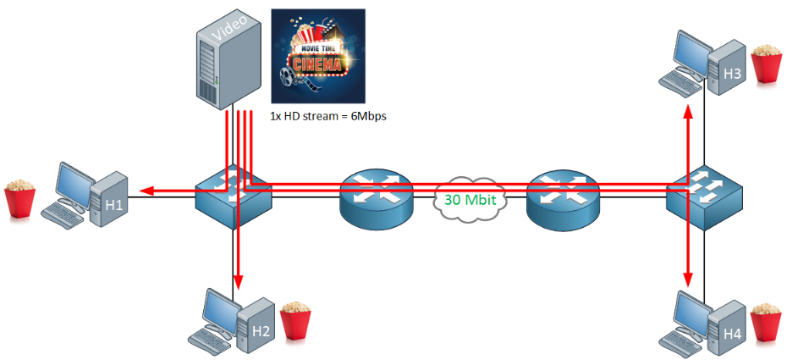

Above we have a small network with a video server that is streaming a movie and four hosts who want to watch the movie. Two hosts are on the same LAN. The other two hosts are on another site that is connected through a 30 Mbit WAN link.

The main problem with unicast traffic is that it **is not scalable**.

Are there any advantages? It’s simple since unicast works “out of the box”. You will see that multicast requires some additional protocols to make it work. Also, multicast **only supports UDP traffic,** so we can’t use the advantages of TCP, like windowing and acknowledgments.

What about broadcast traffic?

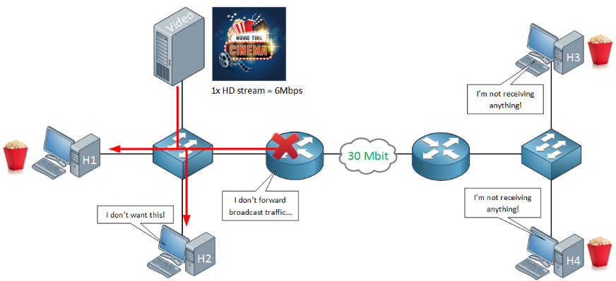

If our video server would broadcast its traffic, then the load on the video server will be reduced. It’s only sending the packets once. The problem, however is that everyone in the broadcast domain will receive it…whether they like it or not.

What about multicast traffic?

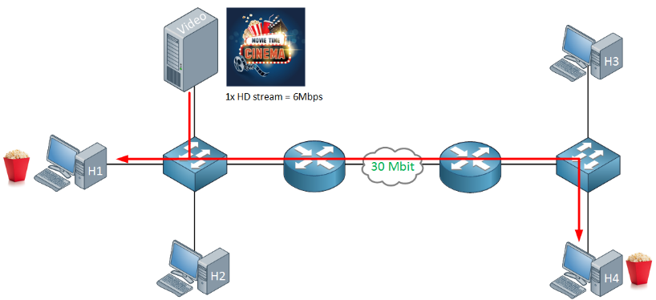

Multicast traffic is very efficient. This time, we only have two hosts that are interested in receiving the video stream. The video server will only send the packets once. The switches and routers will only forward traffic to the hosts that want to receive it. This reduces the load of the video server and network traffic in general.

When using unicast, each additional host will increase the load and traffic rate. With multicast, it will remain the same.

## **Multicast Components**

Multicast is efficient but it doesn’t work “out of the box”. There are a number of components that we require:

First of all, we use a designated range of IP addresses that is exclusively used for multicast traffic. We use the class D range for this: 224.0.0.0 to 239.255.255.255. These addresses are only used as **destination addresses**, not as source addresses.

The source IP address will be the device sending the multicast traffic, for example, the video server.  
When a router receives multicast traffic, somehow, it has to know if anyone is interested in receiving the multicast traffic. Take a look at the picture below:

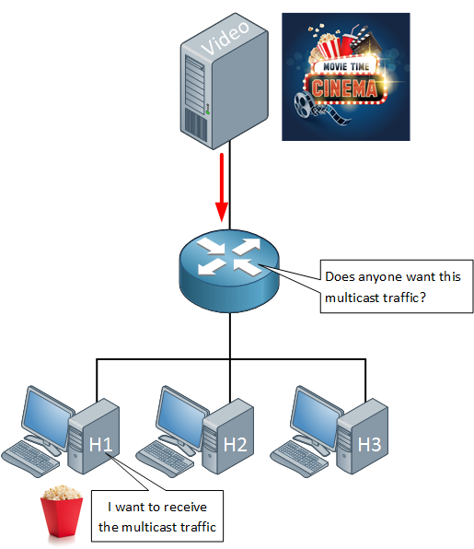

Above, you can see the router is receiving the multicast traffic from the video server. It doesn’t know where and if it should forward this multicast traffic.

We need some mechanism on our hosts that **tells the router when they want to receive multicast traffic**. We use the [IGMP (Internet Group Management Protocol)](https://networklessons.com/multicast/igmp-version-1) for this. Hosts that want to receive multicast traffic will use the IGMP protocol to tell the router which multicast traffic they want to receive..

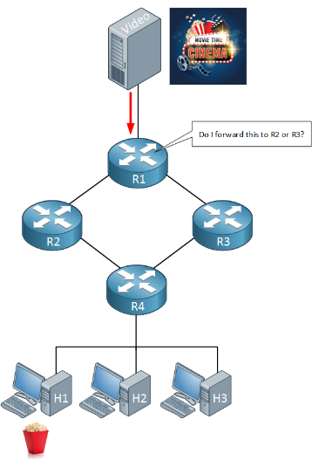Last but not least, we need a multicast routing protocol:

Above, we have our video server that is forwarding multicast traffic to R1. On the bottom, there’s H1 who is interested in receiving it.

With unicast routing, each router advertises its directly connected interfaces in a routing protocol. Routers who receive unicast packets only care about the **destination address**. They check their routing tables, find the outgoing interface, and forward the packets to the destination. With multicast routing, things are not that simple…the destination is a multicast group address, and the multicast packets have to be forwarded to multiple receivers throughout the network.

To accomplish this, we use a multicast routing protocol:

* DVMRP (Distance Vector Multicast Routing Protocol)
* MOSPF (Multicast Open Shortest Path First)
* PIM (Protocol Independent Multicast)

The most popular multicast routing protocol is PIM, which we will cover in different lessons.

**PIM (Protocol Independent Multicast):** A widely used multicast routing protocol. It has two modes: Sparse Mode (PIM-SM) and Dense Mode (PIM-DM). PIM-SM is used for large networks with widely dispersed multicast receivers, while PIM-DM is suitable for smaller networks with dense receiver populations.

**Conclusion**

You have seen the difference between unicast, broadcast, and multicast and how multicast is far more scalable than the other two traffic types. We also discussed the different protocols that are required to make multicast work:

* IGMP so hosts can tell routers they want to receive multicast traffic.
* Multicast routing: we need a protocol like PIM that can route multicast traffic

**Scenario: IPTV Broadcasting**

**Context:** An Internet Service Provider (ISP) wants to deliver live TV channels to multiple subscribers using multicast.

**Solution:**

1. **Multicast Group Addresses:** Each TV channel is assigned a unique multicast group address (e.g., 239.1.1.1 for Channel 1, 239.1.1.2 for Channel 2).
2. **Source (TV Station):** Sends the live TV feed to the respective multicast group address.
3. **Subscribers (Users):** Use IPTV set-top boxes configured to join the multicast group addresses of the channels they want to watch.
4. **Multicast Routing:** The ISP's network uses multicast routing protocols like PIM-SM to ensure the multicast traffic is efficiently delivered to all subscribers.

**Example Flow:**

* The TV station sends the video stream for Channel 1 to multicast group 239.1.1.1.
* Subscribers who want to watch Channel 1 join multicast group 239.1.1.1.
* The ISP's network routes the video stream to all subscribers in the group.