**Tugas 2 Pemograman Internet 4**



**Yahdi Firdaus**

**4513210036**

**Teknik Informatika 2013**

**Fakultas Teknik**

**Universitas Pancasila**

1. **Instal vagrant**

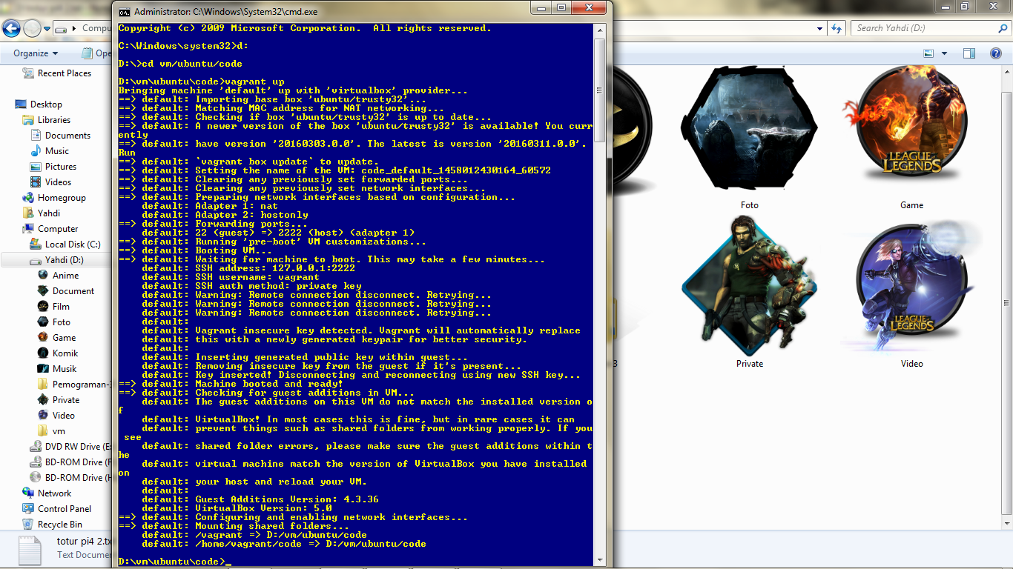

1. **Ikuti Langkah-langkag di bawah ini**

## Install Lingkungan Laravel di Trusty32

## update dan upgrade paket yang ada

$ sudo apt-get update && sudo apt-get upgrade -y

## Set Local id_ID

$ sudo locale-gen id_ID.utf8

## install paket dasar

$ sudo apt-get install -y build-essential dos2unix git libmcrypt4 libpcre3-dev python2.7-dev python-pip re2c supervisor unattended-upgrades whois mcrypt

## Install A Few Helpful Python Packages

$ sudo pip install httpie

$ sudo pip install fabric

$ sudo pip install python-simple-hipchat

## Install nginx

$ sudo apt-add-repository ppa:nginx/stable -y

$ sudo apt-get update && sudo apt-get install nginx -y

## Install PHP5.6

$ sudo apt-add-repository ppa:ondrej/php5-5.6 -y

$ sudo apt-get update && sudo apt-get install -y php5-fpm php5-cli php5-common php5-curl php5-json php5-gd php5-intl php5-mysql php5-sqlite php5-mcrypt php5-xdebug php5-recode php5-memcached php-pear php5-imap php5-dev php5-tidy php5-redis

## Konfigurasi nginx

$ sudo vim /etc/nginx/sites-available/default

## isinya seperti ini

server {

listen 80 default_server;

listen [::]:80 default_server;

# ganti document root php sesuai lokasi file php berada

root /home/vagrant/code;

index index.php index.html index.htm index.nginx-debian.html;

# ganti nama server sesuai dengan konfigrasi Anda

server_name trustybox.dev;

location / {

try_files $uri $uri/ /index.php?$query_string;

}

location ~ \.php$ {

try_files $uri /index.php =404;

fastcgi_split_path_info ^(.+\.php)(/.+)$;

fastcgi_pass unix:/var/run/php5-fpm.sock;

fastcgi_index index.php;

fastcgi_param SCRIPT_FILENAME $document_root$fastcgi_script_name;

include fastcgi_params;

}

}

## restart nginx

$ sudo service nginx restart

## Install composer

$ curl -sS https://getcomposer.org/installer | php

$ sudo mv composer.phar /usr/local/bin/composer

## Install Redis

$ sudo apt-add-repository ppa:rwky/redis -y

$ sudo apt-get update && sudo apt-get install redis-server -y

## Install nodejs

$ curl -sL https://deb.nodesource.com/setup_5.x | sudo -E bash -

$ sudo apt-get install -y nodejs

## Install Grunt

$ sudo npm install -g grunt-cli

## Install Gulp

$ sudo npm install -g gulp

## Install Bower

$ sudo npm install -g bower

## Install PM2

$ sudo npm install -g pm2

# install beanstalkd

$ sudo apt-get install -y beanstalkd

#install laravel envoy

$ composer global require "laravel/envoy=~1.0"

$ chmod +x ~/.composer/vendor/bin/envoy

# Laravel Installer

$ composer global require "laravel/installer"

$ chmod +x ~/.composer/vendor/bin/laravel

## tambahkan path envoy dan installer ke .bashrc

$ vim ~/.bashrc

# tambahkan ke baris akhir

export PATH="$PATH:$HOME/.composer/vendor/bin"

# simpan di vim tekan ESC lalu ketik ':wq'

# aktifkan path tersebut

$ . ~/.bashrc

# Install SQLite3

$ sudo apt-get install -y sqlite3 libsqlite3-dev

# Install MySQL

$ sudo apt-get install -y mysql-server

## Install Laravel

# install laravel di direktori code

# buat folder code

$ mkdir code

# pindah ke code

$ cd code

# install laravel

$ laravel new Test

# ubah document root nginx ke /home/vagrant/code/test/public

$ sudo vim /etc/nginx/sites-available/default

# ubah root menjadi

root /home/vagrant/code/test/public;

# simpan di vim tekan ESC lalu ketik ':wq'

# restart nginx

$ sudo service nginx restart## Install Lingkungan Laravel di Trusty32

## update dan upgrade paket yang ada

$ sudo apt-get update && sudo apt-get upgrade -y

## Set Local id_ID

$ sudo locale-gen id_ID.utf8

## install paket dasar

$ sudo apt-get install -y build-essential dos2unix git libmcrypt4 libpcre3-dev python2.7-dev python-pip re2c supervisor unattended-upgrades whois mcrypt

## Install A Few Helpful Python Packages

$ sudo pip install httpie

$ sudo pip install fabric

$ sudo pip install python-simple-hipchat

## Install nginx

$ sudo apt-add-repository ppa:nginx/stable -y

$ sudo apt-get update && sudo apt-get install nginx -y

## Install PHP5.6

$ sudo apt-add-repository ppa:ondrej/php5-5.6 -y

$ sudo apt-get update && sudo apt-get install -y php5-fpm php5-cli php5-common php5-curl php5-json php5-gd php5-intl php5-mysql php5-sqlite php5-mcrypt php5-xdebug php5-recode php5-memcached php-pear php5-imap php5-dev php5-tidy php5-redis

## Aktifkan php di nginx

$ sudo vim /etc/php5/fpm/php.ini

## ganti ke cgi.fix_pathinfo=0

## enable mcrypt extension

$ sudo php5enmod mcrypt

## restart php5-fpm

$ sudo service php5-fpm restart

## Konfigurasi nginx

$ sudo vim /etc/nginx/sites-available/default

## isinya seperti ini

server {

listen 80 default_server;

listen [::]:80 default_server;

# ganti document root php sesuai lokasi file php berada

root /home/vagrant/code;

index index.php index.html index.htm index.nginx-debian.html;

# ganti nama server sesuai dengan konfigrasi Anda

server_name trustybox.dev;

location / {

try_files $uri $uri/ /index.php?$query_string;

}

location ~ \.php$ {

try_files $uri /index.php =404;

fastcgi_split_path_info ^(.+\.php)(/.+)$;

fastcgi_pass unix:/var/run/php5-fpm.sock;

fastcgi_index index.php;

fastcgi_param SCRIPT_FILENAME $document_root$fastcgi_script_name;

include fastcgi_params;

}

}

## restart nginx

$ sudo service nginx restart

## Install composer

$ curl -sS https://getcomposer.org/installer | php

$ sudo mv composer.phar /usr/local/bin/composer

## Install Redis

$ sudo apt-add-repository ppa:rwky/redis -y

$ sudo apt-get update && sudo apt-get install redis-server -y

## Install nodejs

$ curl -sL https://deb.nodesource.com/setup_5.x | sudo -E bash -

$ sudo apt-get install -y nodejs

## Install Grunt

$ sudo npm install -g grunt-cli

## Install Gulp

$ sudo npm install -g gulp

## Install Bower

$ sudo npm install -g bower

## Install PM2

$ sudo npm install -g pm2

# install beanstalkd

$ sudo apt-get install -y beanstalkd

#install laravel envoy

$ composer global require "laravel/envoy=~1.0"

$ chmod +x ~/.composer/vendor/bin/envoy

# Laravel Installer

$ composer global require "laravel/installer"

$ chmod +x ~/.composer/vendor/bin/laravel

## tambahkan path envoy dan installer ke .bashrc

$ vim ~/.bashrc

# tambahkan ke baris akhir

export PATH="$PATH:$HOME/.composer/vendor/bin"

# simpan di vim tekan ESC lalu ketik ':wq'

# aktifkan path tersebut

$ . ~/.bashrc

# Install SQLite3

$ sudo apt-get install -y sqlite3 libsqlite3-dev

# Install MySQL

$ sudo apt-get install -y mysql-server

## Install Laravel

# install laravel di direktori code

# buat folder code

$ mkdir code

# pindah ke code

$ cd code

# install laravel

$ laravel new Test

# ubah document root nginx ke /home/vagrant/code/test/public

$ sudo vim /etc/nginx/sites-available/default

# ubah root menjadiroot /home/vagrant/code/test/public;

# simpan di vim tekan ESC lalu ketik ':wq'

# restart nginx

$ sudo service nginx restart

**3.Akan muncul tampilan di bawah ini**

