**Bid For You**

**Screens:**

**login: MainScreen:**

**Bid For You**

**Create Bid**

**my Bids Groups**

**Username**

**Show Bids**

**Password**



**Log In**

**Click on "Create Bid":**

**Search your product.**

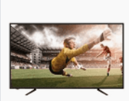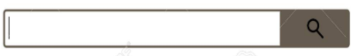

**Name of Tv**

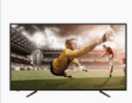

**Name:….**

**Price: ….**

**Bit price: __________**

**Amount :__________**

**After chose your product.**



**Name:….**

**Price: ….**

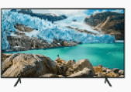

**Let the user filter the bid , by the rates of the customers and suppliers and more…**

**Filter**

**Name:….**

**Price: ….**

**Create Bid Group**

**Send to all customers that relevant the Bid, and send to Suppliers. And anyone want to join, click on this bid and join.**

**This bid supposed to take a few days to get accept from all customers and suppliers.**

**If you press "Show my Bids" after login screen you go to this screen.**

****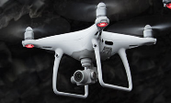****

**Amount :15/15. Suppliers accept: 2 Manager:me**

**My Bid Groups**

**After Click ,"Close Deal" the deal is finish and the supplier get the accept and the payment.**

**Close Deal**

**After click One from the "Ready" Bids**

**"Ready" when all the customers accept.**

**Its perform the info of the Bid.**

**After click One from the "awaiting" Bids**

**"Awaiting" when not all the customers accept.**

**Its perform the info of the Bid**

**Contact with partners**

**Ready**

**65 inch Samsung**

**awaiting**

**awaiting**

**awaiting**

**Ready**

**Dji pro drawn**



**Manager: Yosi**

**Amount of Customers :1/5.**

**Amount :1/5. Manager: Yosi**

**Contact with partners**

**Amount :2/30. Manager: Yosi yosi**

**Go back**

**Go back**

**Amount of Customers:15/15.**

**Suppliers accept: 2**

**Chose supplier**

**If you press on the main screen "Show bids"**



**Iphone 11 256GB**

**After click "Join this bid group" .**

**Bid Price: … Amount :12/15. Suppliers accept: 2**



**Join this Bid Group**



**Bid Price: … Amount :2/5. Suppliers accept: 0**

****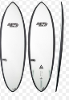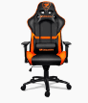

**Join Bid group**

**Suppliers info**

**Info about Manager**

**Bid Price: … Bid Manager : Yahel Barnoam**

**Amount :12/15. Suppliers accept: 2**

**Join this Bid Group**

**Join this Bid Group**

**Join this Bid Group**

**Bid Price: … Amount :2/5. Suppliers accept: 3**

**Bid Price: … Amount :3/20. Suppliers accept: 1**