**Project name:** Homes’ Devices Automation

**Project sponsor:** Ministry of electricity and energy.

**Project manager:** Eng. AL-Bashar Gamal.

**Starting:**1/2/2022. **EOP:**15/4/2022.

*______________________________________________________*

**Purpose of the project:** management and controlling Devices outside home.

**Business case:**

The application in used to bring money by saving electricity by controlling homes’ devices outside. If you keep devices plugged in and running when they're not in use the result is an increase in electrical use.

for this the ministry of electricity decided to make a mobile phone app that enable you to control of your home electricity from any place. The app will be attached with all devices at your home and  
about it you can turn on/off any devices you want from any place even if you are out of home,  
the app also will show you which devices are turned on and which  
turned off.

**project Scope:**

1. Allowing the user to control devices at home when he is outside the home.
2. Show the user status of all devices (turned on or turned off).
3. Sending a notification about the most devices that consumes electricity and suggesting turning them off.

**Key deliverables:**

1. Designing remote devices and defining the operating system.
2. Designing Android & IOS Applications.
3. Testing Hardware and software.
4. Extracting licenses and publishing the app in the market.

**Project milestones:**

* Requirements review: collecting suitable information on remote control and consumption of electrical devices for 2 weeks.
* Engineers will design remote receivers within one month.
* A team of programmers will make the mobile app within 3 weeks.
* Testing application for a week.
* Deployment of the app ended by 15/4/2022.

**Project Resources:**

1. Staff:

* Four electrical engineers.
* A team of programmers.

1. Hardware:

* Devices of receivers.
* 5 laptops and 2 servers

1. Budget: Budget allocated for this project is 700,000$.

**Constraints:**

1. The project must take time less than 10 weeks.
2. The project must not exceed 700,000 $.
3. Laptops must be bought from HP company.

**Assumption:**

1. All resources required must be collected.
2. The project costs no more 700,000$.
3. The project does not take more than specified time.
4. All the staff continues to the end of the project.

**High Level Risk:**

1. Inaccurate information.
2. Staff misunderstands the requirements.
3. The project costs much more than 700,000$.
4. Receivers are damaged.
5. Not to satisfy the users of product.

**Work Breakdown Structure (WBS):**



**Responsibility Matrix:**

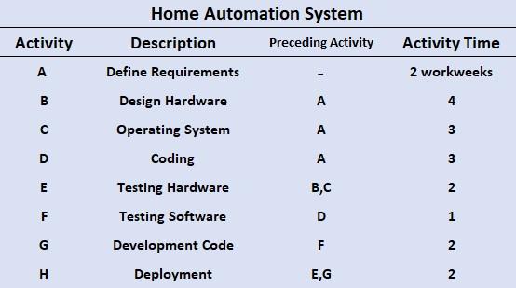



**Project Network:**



**Gantt Chart:**

**Resource-Constrained Project:**

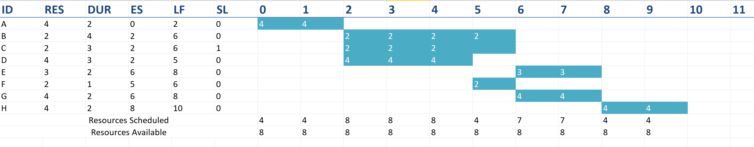

**New, resource scheduled network:**

**Time Phased Budget:**

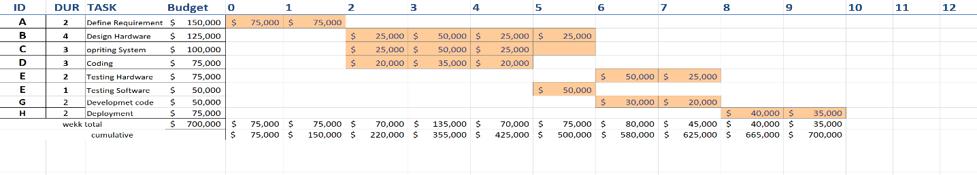

Risk:

1. Interruption of the internet.
2. Devices Damage.
3. Hacking Devices.
4. Another competitive company make the same technology with better quality than us. Not to satisfy the user end.
5. The lack of efficiency sufficient in the receiver or the terms.
6. Many apps Without secure authorization may allow people other than you to impersonate you.

How to deal with these risks:

1. Constant maintenance of the internet and equipment.
2. Implementation of an idea that distinguishes the company from the rest of its competitors.
3. Sit with the user and carry out all his requests.
4. Reduce the risk of data breach affecting you by sharing minimal personal information with smart devices.

* Team members:

1. AL-Bashar Gamal “Leader”
2. Yousef Essam
3. Islam Muhammed
4. Yehia Zakaria
5. Mohamed Ashraf
6. Alnakhely Mohamed