ATLAS · QODER
Using Atlas Flight Booking Skill
in Qoder
A visual guide to installation, authorization, flight search, and Sandbox testing
Purpose Use natural language in Qoder to search and compare flights. On first use, Qoder checks the required environment and guides you through Atlas authorization.

Before you begin
- Install and sign in to Qoder.
- Use an existing ATRIP account, or create one during authorization.
- An internet connection is required for the initial installation and search.
Scope This guide covers Skill installation, Atlas authorization, flight search and comparison, and a complete Sandbox booking rehearsal through payment confirmation and test ticketing.

STEP 1 Install Atlas Flight Booking Skill
Enter the following command in the Qoder chat box and send it:
npx --yes skills add https://github.com/atlas-doc/atlas-flight-booking-skill --skill atlas-flight-booking

Wait for Qoder to complete the installation. The message atlas-flight-booking skill has been installed successfully confirms that the Skill is ready.
Tip Installation is required only once. For future searches, describe your flight request directly; you do not need to name the Skill in your prompt.

STEP 2 Describe your flight request in natural language
Include the origin, destination, departure date, and number of passengers. For example:
Search for flights from Shanghai to Tokyo on September 4, 2026, for one adult.

Qoder recognizes the flight-search task, invokes the installed capability, and checks your Atlas authorization status.
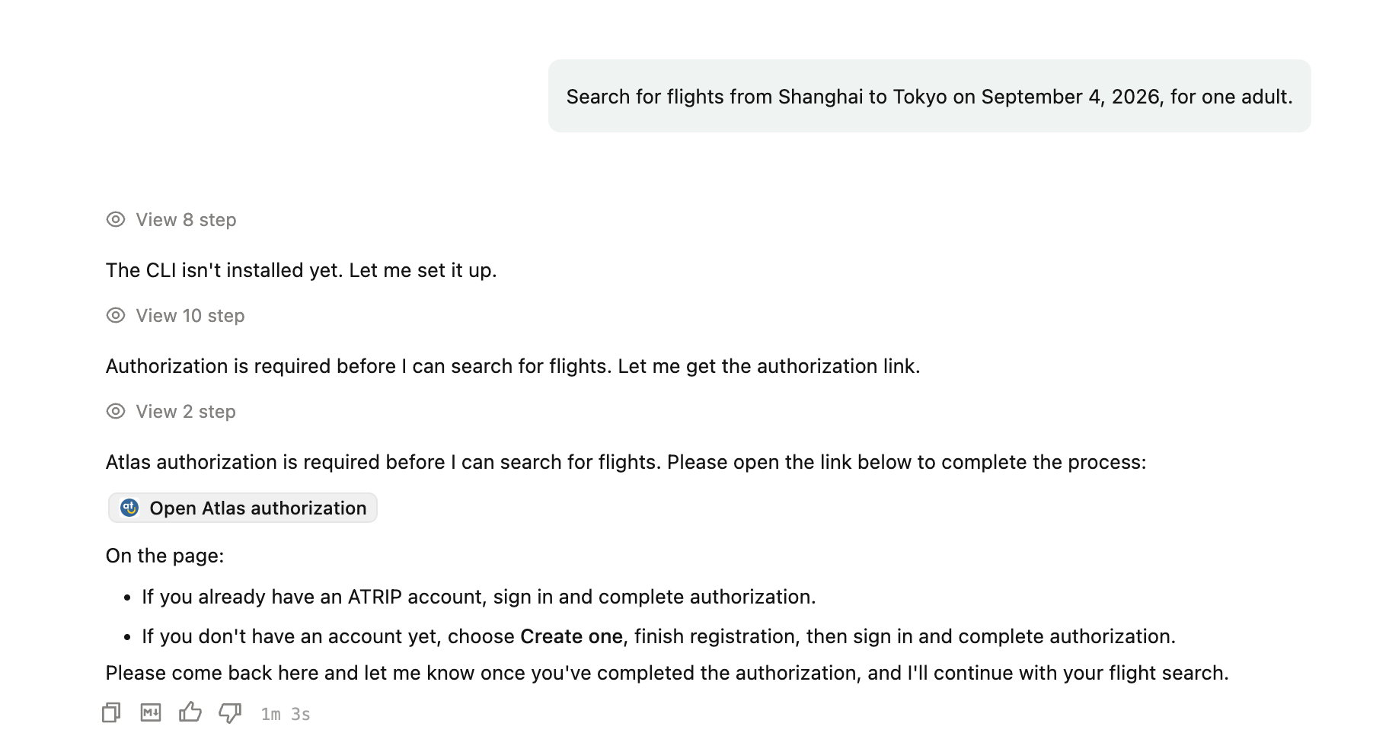
Figure 1. Qoder checks the environment and provides the Atlas authorization link

STEP 3 Open the Atlas authorization page
Select Open Atlas authorization in the Qoder response. Your browser opens the ATRIP sign-in page.
- Existing ATRIP user: enter your account details and sign in.
- New user: select Create one, complete registration, and then sign in.
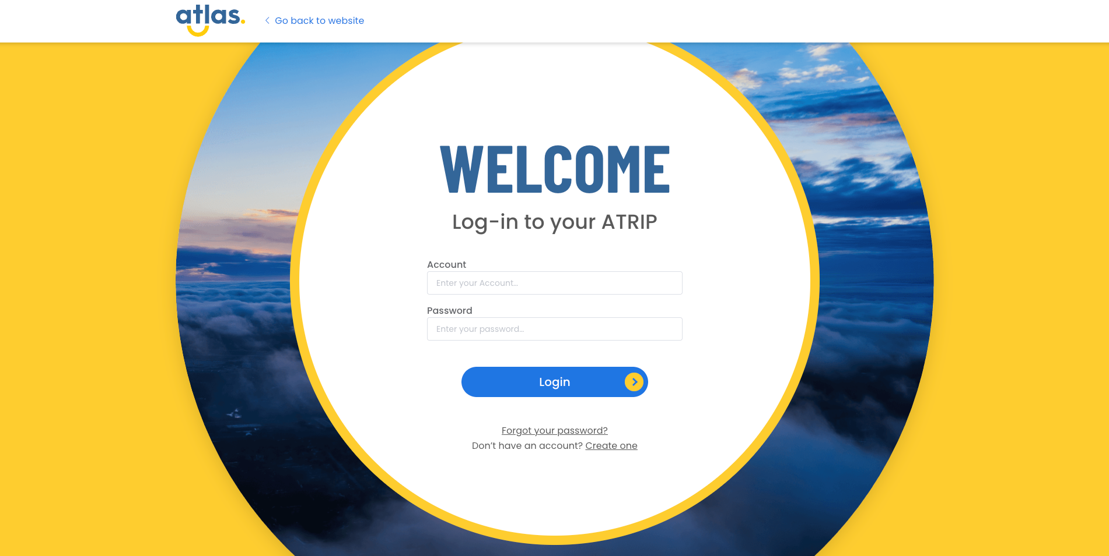
Figure 2. ATRIP sign-in page
Note Keep the Qoder conversation open while you complete authorization in the browser.

STEP 4 Review and authorize the Skill
After signing in, the page displays the active Atlas account and the permissions requested by the Skill. Review the information, then select Authorize and continue.
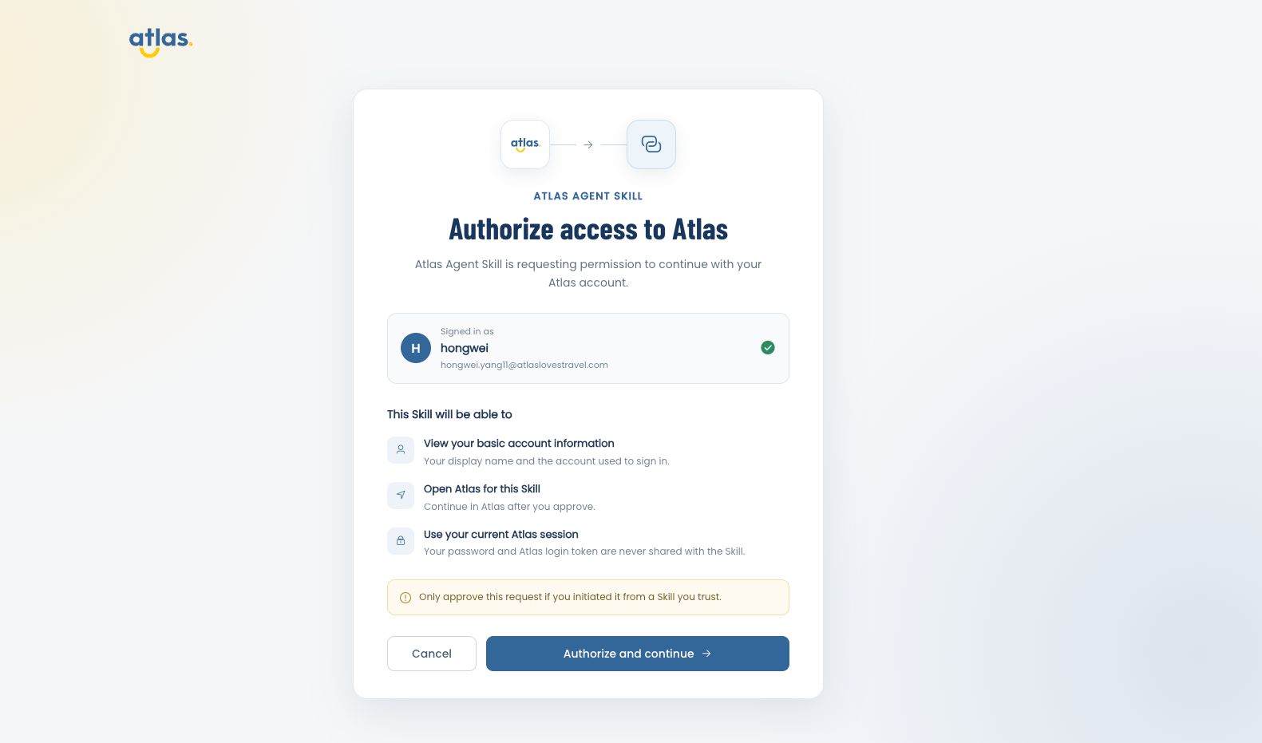
Figure 3. Atlas Skill authorization page
Privacy The authorization uses your current Atlas session. The permission scope is shown on the page, and your password and Atlas login token are never shared with the Skill.

STEP 5 Return to Qoder and continue
When the page displays Authorization complete / You’re all set, close it and return to the original Qoder conversation.
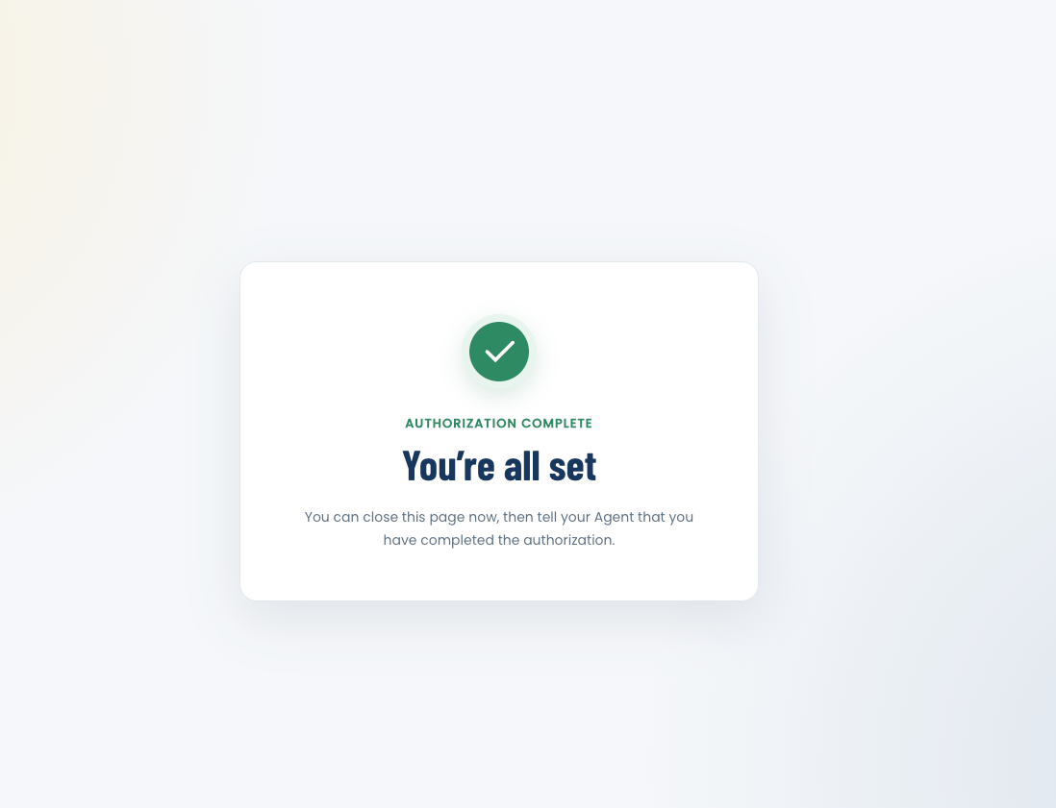
Figure 4. Atlas authorization completed
Enter the following message in the same conversation:
I’ve completed the Atlas authorization. Please continue with the flight search.

Qoder confirms the authorization and resumes the original flight search. You do not need to repeat the complete request.
If authorization is not detected Confirm that the browser page shows Authorization complete, then continue in the same Qoder conversation rather than starting a new one.

STEP 6 Review and compare the flight results
When the search is complete, Qoder organizes the available results. These typically include flight number, route, departure and arrival times, duration, stop information, and reference price.
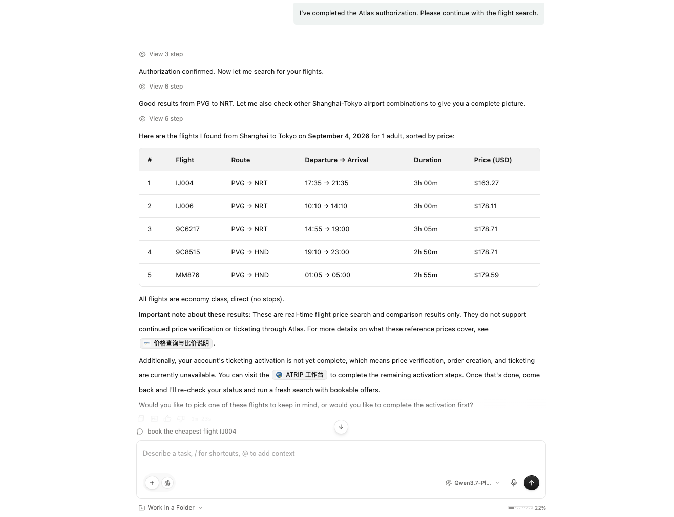
Figure 5. Example flight-search results
Important The example shows real-time flight search and comparison results. If an offer is marked as a reference price, it is for comparison only and cannot proceed to price verification or ticketing. Always follow the offer status returned by Qoder and your account activation status.

Sandbox booking rehearsal
Use Sandbox to rehearse the booking workflow with test inventory and test prices. Sandbox does not create a real booking or charge a real payment method.
Before you continue Complete Atlas authorization first. Switching environments changes the local CLI configuration, so start a new flight search after the switch and do not reuse offers returned earlier.

STEP 7 Switch to Sandbox
Run the following command in a terminal:
atlas-flight environment use sandbox --json

Figure 6. Atlas configuration updated for Sandbox
STEP 8 Check authorization and ticketing status in Qoder
Return to Qoder and ask the Agent to check the current account status:
Please check my current Atlas authorization and ticketing status.

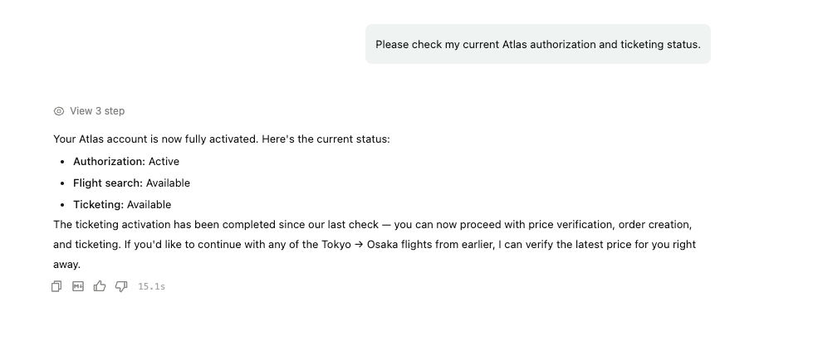
Figure 7. Authorization and ticketing are available
Status check Continue only when authorization is active and ticketing is available. If the Agent reports a blocker, complete the action it provides before proceeding.

STEP 9 Start a new flight search
Enter a complete request with the route, date, and passenger count. For example:
Search for flights from Tokyo to Osaka on September 4, 2026, for one adult.

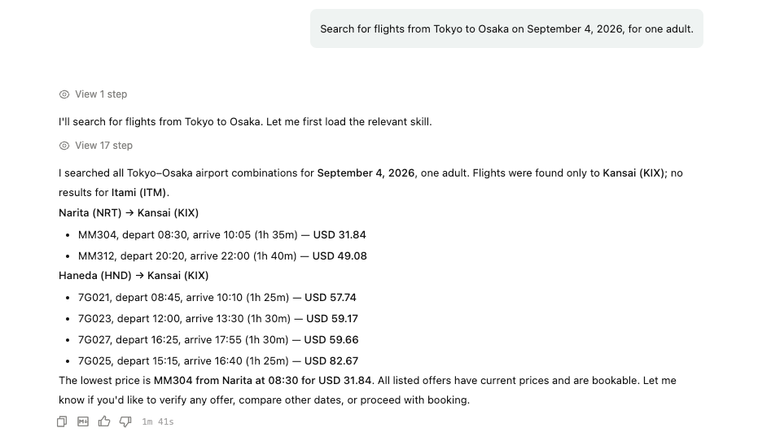
Figure 8. Bookable Tokyo-to-Osaka offers in Sandbox
Reminder Sandbox prices and availability are test data. Select an offer from the current search before continuing to price verification.

STEP 10 Select a flight and verify the price
Choose one of the returned flights. In this example:
I'd like to book flight MM304 from NRT to KIX.

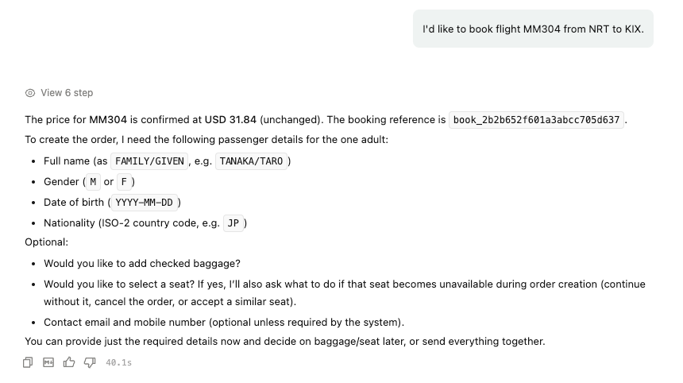
Figure 9. Price confirmed and passenger details requested
Price checkpoint If the verified price increases, review the previous and current totals and explicitly accept the new amount before continuing.

STEP 11 Create a Sandbox test order with fictional passenger details
For a Sandbox rehearsal, use fictional data only. Baggage and seat selection are optional; this complete example proceeds without either service.
Please use the following fictional passenger details for this booking:
Full name: TEST/TRAVELER
Gender: Male
Date of birth: 1990-01-01
Nationality: Japan (JP)
Travel document: Passport
Document number: TR0000001
Issuing country: Japan (JP)
Expiry date: 2032-12-31
Contact name: TEST/TRAVELER

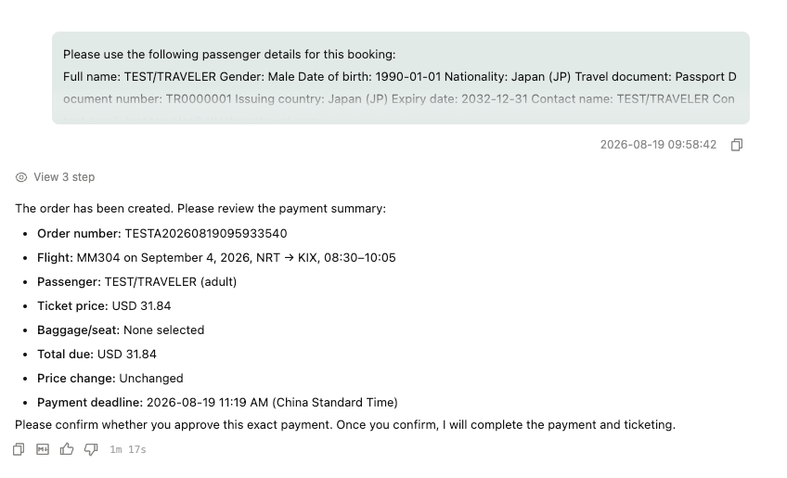
Figure 10. Sandbox order created and payment summary displayed
Payment checkpoint Review the displayed flight, passenger, optional services, price breakdown, total amount, currency, and payment deadline. Do not confirm payment unless the displayed summary is correct.

STEP 12 Confirm payment and check the ticketing result
After reviewing the exact payment summary, send an explicit confirmation:
Yes, I approve this exact payment.

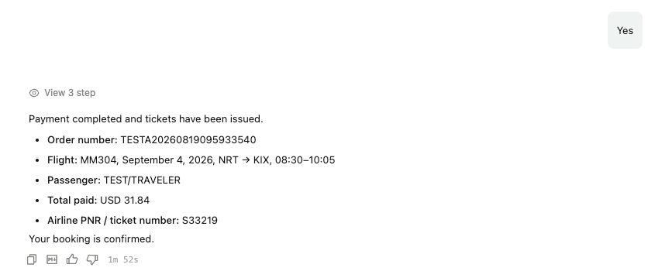
Figure 11. Sandbox payment completed and ticket issued
Sandbox result The returned order number, PNR, and ticket number are test results in the Sandbox environment. This flow does not create a real booking or charge a real payment method.

Return to the production environment
After testing is complete, switch the local configuration back to production and start a new search:
atlas-flight environment use production --json

Useful prompts and operating notes

A more detailed search request
Add cabin, direct-flight preference, departure time, and other conditions in the same request. For example:
Search for direct economy flights from Shanghai to Tokyo on September 4, 2026, for one adult, departing after 10:00 AM.

Continue after authorization
I’ve completed the Atlas authorization. Please continue with the flight search.

Operating notes
- You do not need to mention atlas-flight-booking in every prompt; simply describe the flight task.
- On first use, Qoder may install or check a supporting CLI. Allow it to complete.
- Flight prices and inventory can change. Final availability is determined during price verification.
- If ticketing is activated for the account and a bookable offer is returned, follow Qoder’s prompts for price verification and order creation.
- Baggage and seat selection are optional. If you select a seat, provide a fallback choice in case the exact seat becomes unavailable.
- Review and explicitly confirm any price increase, seat fallback, payment, or other critical step before continuing.
- After switching between Sandbox and production, start a new search and do not reuse an earlier offer.
In one line Install the Skill → authorize Atlas → switch to Sandbox → check status → start a new search → verify the price → enter fictional passenger details → review the order → explicitly confirm payment → receive the test ticketing result.

Related links
Skill repository: github.com/atlas-doc/atlas-flight-booking-skill
Atlas API documentation: https://resources.atriptech.com/api-document/readme-1

