Step 1:

Uploading data to the s3 bucket

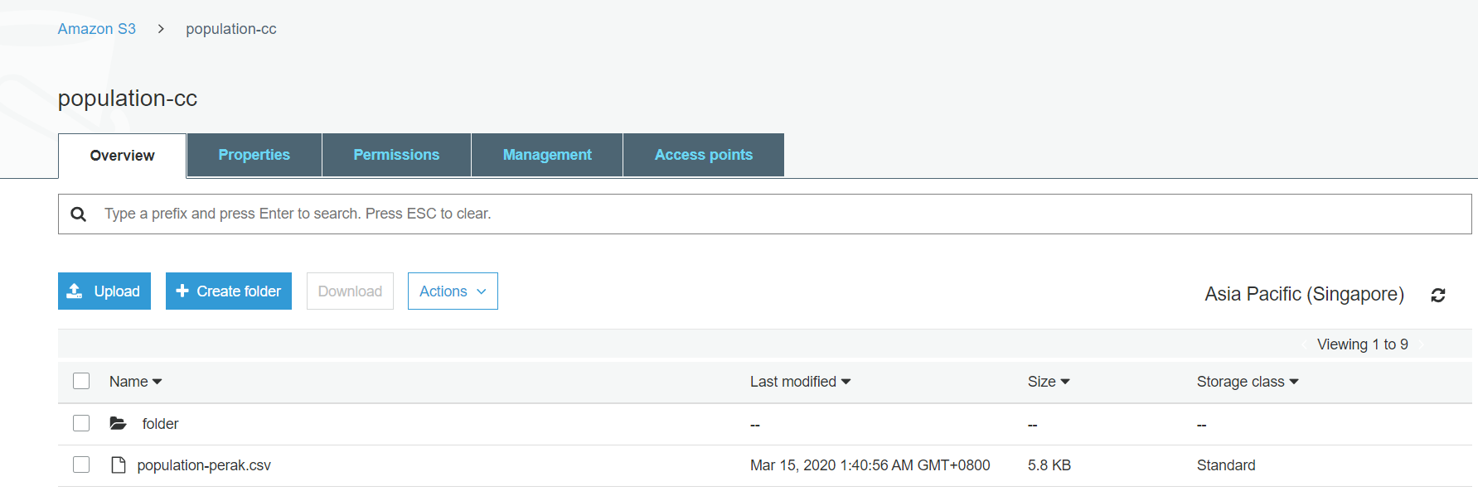

Step 2 configuring the AWS Glue Crawler

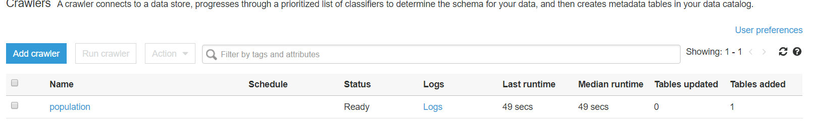

Step 3 add job aws glue

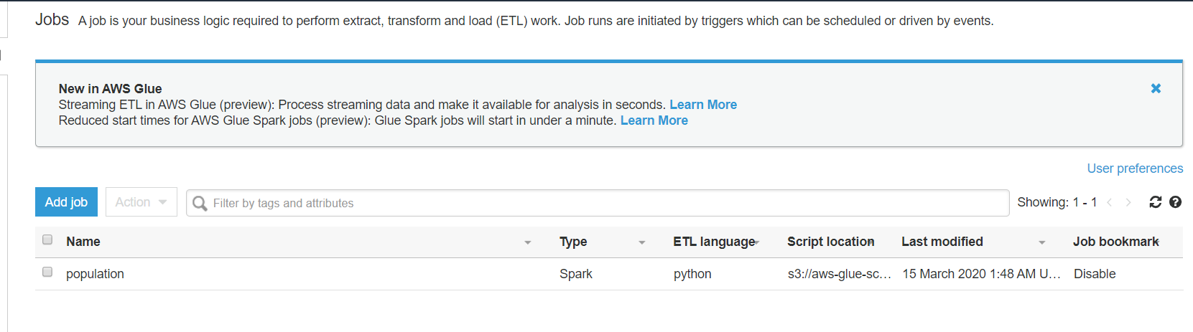

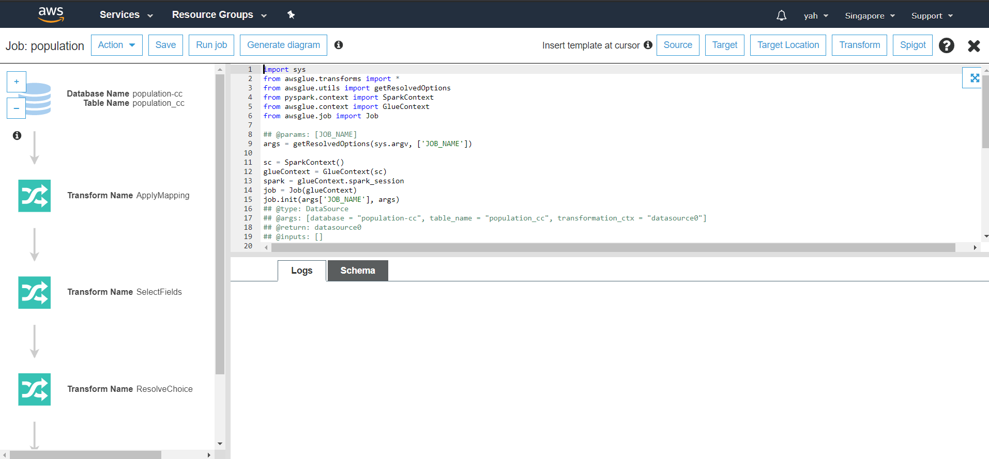

Step 4: data analysis using Athena

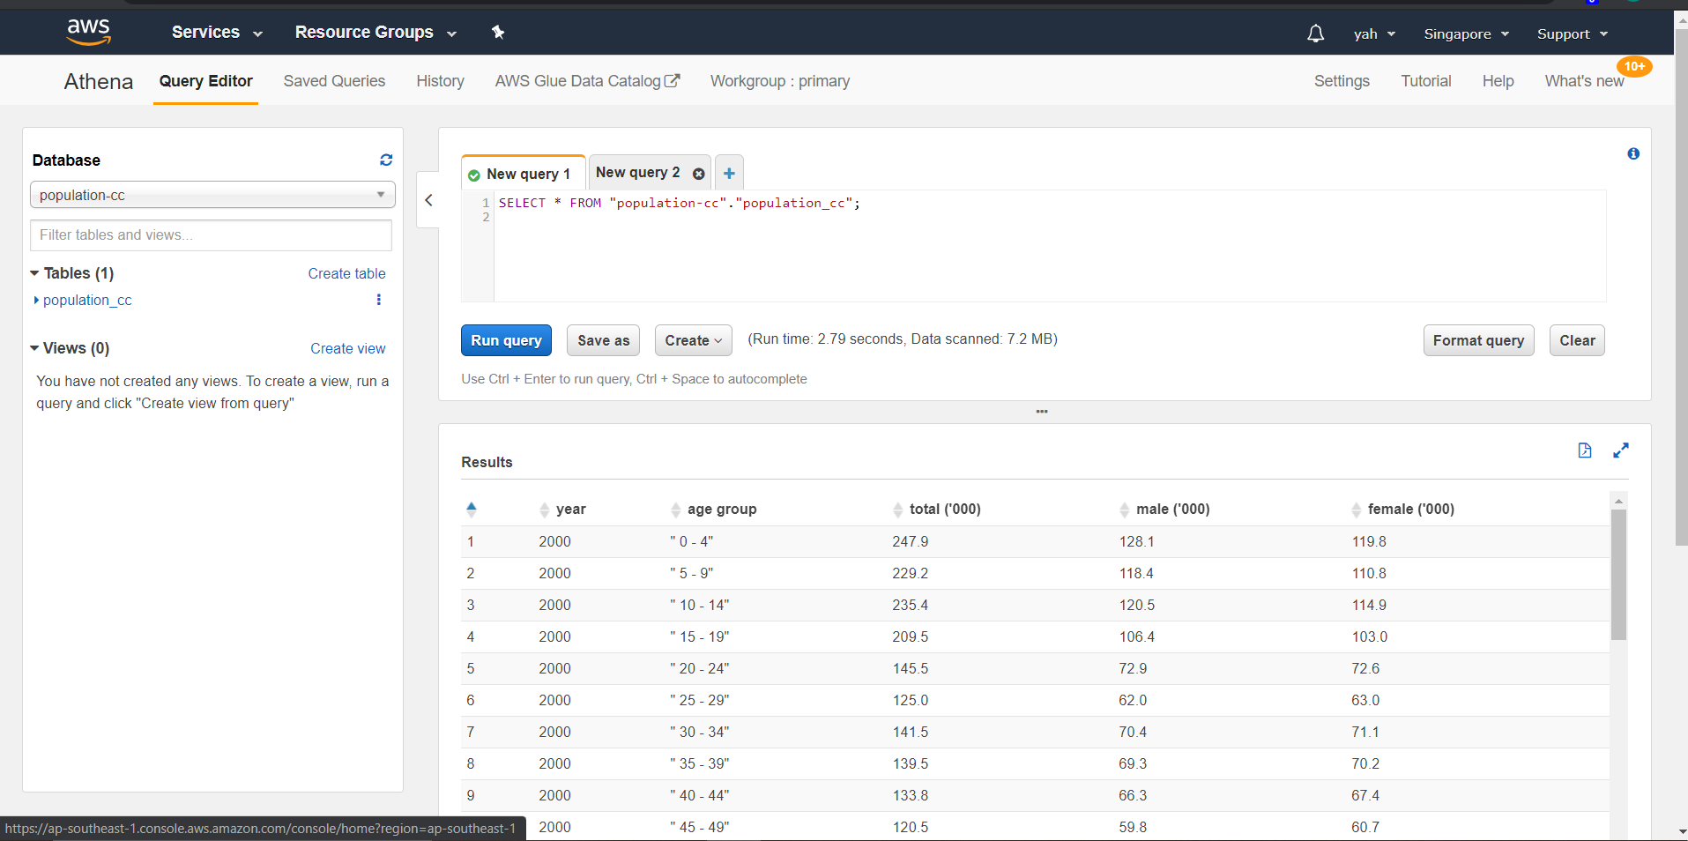

It should be last step is create reports with QuickSight tapi service QuickSight tuh kena bayar and sir tak sarankan kite buat so kite buat sampai Athena je. Nanti dalam video demo and online presentation explain lebih sikit sal kite nye plan asal and kenape kite tak boleh teruskan sampai final step.