Experiment Name | Mini Project 1
Group | 14
Team ID | 9

Experiment Date

Submission Date
Team Members | Member 1 | Name | Amir Emad Gerges
Team Members | Member 1 | ID | 19-6642
Team Members | Member 2 | Name | Mohamed El Menisy
Team Members | Member 2 | ID | 19-5654
Team Members | Member 3 | Name | Yahia El Gaaml
Team Members | Member 3 | ID | 19-1023

How the program works?
Simply by running FirstWindow.java after building build.xml and demo.xml.

The program consists of a single window and two modes. The first window gives access to both the Text Mode and the Voice Mode.
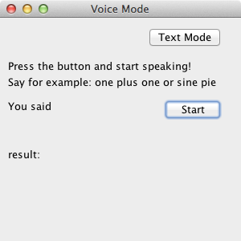

To use the Voice Mode, simply click Start and start saying the needed calculations. Operators supported are plus, minus, times, over, sin, cos, tan, log. Numbers can be pronounced in both English words (one thousand two hundred and nine) or numbers (one two zero nine). Any number can be easily squared by pronouncing the number and then saying “square” or “squared” ex. log one thousand squared or two squared plus 4 squared.

The recognized text will be displayed under “You Said” section. That is the plain English version. The answer to the query will be displayed under the results.
Different variable are supported. For example, by saying store last variable it is stored in variable called temp. You can easily use any variable by calling it in any calculation. Other variables are supported. Namely x,y,z and temp (we didn’t add many other variables as they mde recognizing number harder). So one can use them in conjunction like:

Store x One thousand two hundred and twenty two squared
Log two two zero
Store last result
Temp plus x plus 20

The Text Mode can be access by clicking on “Text Mode” button on top. In that mode, the user can simply write simple queries like 1 + 2 or sin 30. It is possible to get back to the original window by clicking on voice mode.
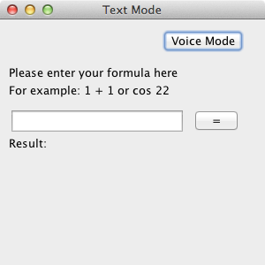

What are the main Parts of the Engine?
The Engine consists of a single class, namely Calc class. This class contains all the logic needed to parse and compute results. It contains different public and private methods (public to be used with the GUI, and private for internal usage).

Public variables are
// A processed array in which numbers are converted to a double
// string representation ex. "120.0". Note that it is encoded to handle
// doubles not integers (twelve will be "12.0" not "12")
// it also handles variables x,y,z,temp (that’s why it is String).
public String[] operands;
// A string either {store, define, retrieve, operation}
public String operation;
// a raw string returned from the recognizer
public String recognizedString;
// A double representing the result (encoded as doubles)
public double result;
public String lastError;
public boolean errorHappend;

Private ones
private Recognizer recognizer;
private Microphone microphone;

The Calc instance simply allocates the recognizer and microphone. The main method for using the engine is through listenOnce. This method is a thin layer between sphinx engine and our parser. The parsing procedures starts with routeToHandler(resultTest); This method is responsible of routing the current recognized text to different handlers. Each handler of the handlers is responsible of a different operation (store, retrieve, arithmetic, define). The rest of the code is mainly the logic needed to handle different representation of numbers (with suffixes, only digits, squared, ..).

buildNumber(String s).This method is responsible of translating a number said by the user (ex. one hundred and twenty two) to the corresponding value.

handleOperation(String s). This method is method called from the router in case the user want to make any arithmetic operation. This method supports both 1 or 2 operation sentences.

We also have a small test suite for the engine. Mainly test(), test2(), test3() methods. Each one represents a set of different examples and situations (around 20 test case).

Regarding the Text Mode, it uses the exact same engine as the Voice Mode. So it can handle 3 operators as well.

After finishing everything, there is a stop() method to deallocates the microphone and recognizer.

