IEC 61850 Protocol Service — User Manual
This manual describes how to operate the IEC 61850 Protocol Service from the router’s web management interface. It covers day-to-day configuration

1. Getting Started

1.0 Service packages (delivered with the device)
The IEC 61850 service is provided as add-on software packages that accompany the TesproOS firmware. A complete installation consists of the firmware plus the following four packages:
Package | Purpose
libiec61850 | IEC 61850 / MMS protocol library
libopen62541 | Supporting library required by the service
iec61850-mmsd | IEC 61850 MMS access daemon
iec61850-proto-tespro-combined | The IEC 61850 Protocol Service (web UI + collection + upload)
All other required components are already built into the TesproOS firmware, so the four packages above are the complete IEC 61850 add-on set.
Tip: Obtaining and installing: These packages are supplied by your vendor together with, or as an update to, the device firmware. Please contact your supplier to obtain the correct package set for your device model and firmware version, and to have the service installed and enabled on the device. No manual package handling or low-level configuration is required from the user.
Once the service is installed and running, everything below is operated from the web interface.

1.1 Open the service page
- Log in to the router web interface.
- In the left menu choose Services → IEC 61850 Protocol.
The service page opens on the Device Configuration tab.

1.2 Service status and start / stop
At the top of the page you will see:
- Service title and version, e.g. IEC 61850 Protocol Service v1.0.0-r64.
- A status badge: Running (green) when the service is active.
- A Stop / Start button on the top-right:
  - Click Stop to halt the service (no collection / no upload while stopped).
  - Click Start to run it again.
Tip: Configuration changes are applied after saving; if a change does not take effect, stop and start the service once.

1.3 The three tabs
Tab | Purpose
Device Configuration | Define IED devices and the data points to collect.
Northbound Configuration | Define where collected data is uploaded (MQTT / TCP).
Service Logs | View runtime logs for troubleshooting.

2. Device Configuration
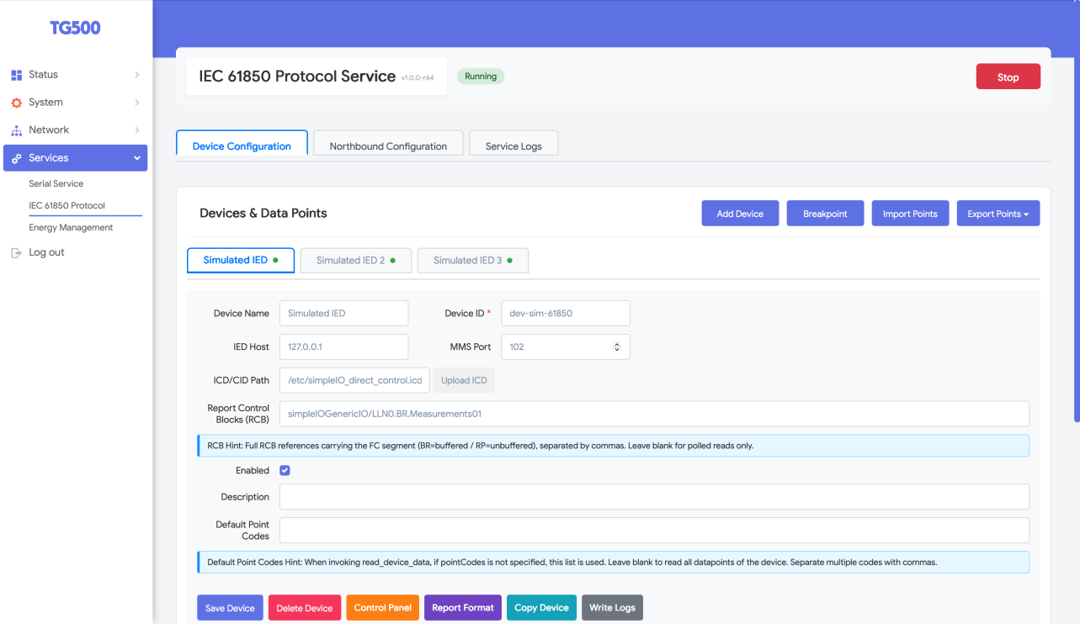
Device Configuration

2.1 Page layout
- Device tabs (e.g. Simulated IED, Simulated IED 2, …): one tab per configured IED. A green dot next to a device name means the device is currently connected; no dot / grey means disconnected.
- Top-right buttons: Add Device, Breakpoint, Import Points, Export Points.
- Device form: the connection and identity settings of the selected device.
- Bottom action buttons: Save Device, Delete Device, Control Panel, Report Format, Copy Device, Write Logs.
- Data Points table (below the form): the points collected from this device.

2.2 Device fields
Field | Meaning
Device Name | Friendly name; also used as the device tab label.
Device ID (required) | Unique identifier of the device. It is reported as deviceCode in upload messages.
IED Host | IP address or hostname of the IED to connect to.
MMS Port | MMS/TCP port of the IED (default 102).
ICD/CID Path | Path of the device model file (ICD/CID). Use Upload ICD to upload a file from your computer.
Report Control Blocks (RCB) | Comma-separated list of full RCB references (with the FC segment, BR=buffered / RP=unbuffered). Leave blank to use polled reads only.
Enabled | Tick to activate this device.
Description | Optional free text.
Default Point Codes | Comma-separated point codes used when a read request does not specify points. Blank = read all points of the device.

2.3 Add / edit / delete / copy a device
- Add: click Add Device (top-right), fill the form, then click Save Device.
- Edit: select the device tab, change fields, click Save Device.
- Delete: select the device tab, click Delete Device and confirm.
- Copy: click Copy Device to duplicate the current device (useful for several identical IEDs); then adjust Host / Port / Device ID and save.

2.4 Data Points
The Data Points table lists what is collected from the selected device:
Column | Meaning
Name | Point name (unique per device).
Object Reference | IEC 61850 object reference, e.g. simpleIOGenericIO/GGIO1.AnIn1.mag.f.
FC | Functional constraint, e.g. MX (measurement).
Data Type | e.g. float32.
Interval (s) | Polling interval in seconds.
Realtime Value | Latest collected value (auto-refreshed).
Actions | Edit / Delete the point.
Buttons above the table: Model Tree and Add Point.

2.4.1 Add or edit a data point
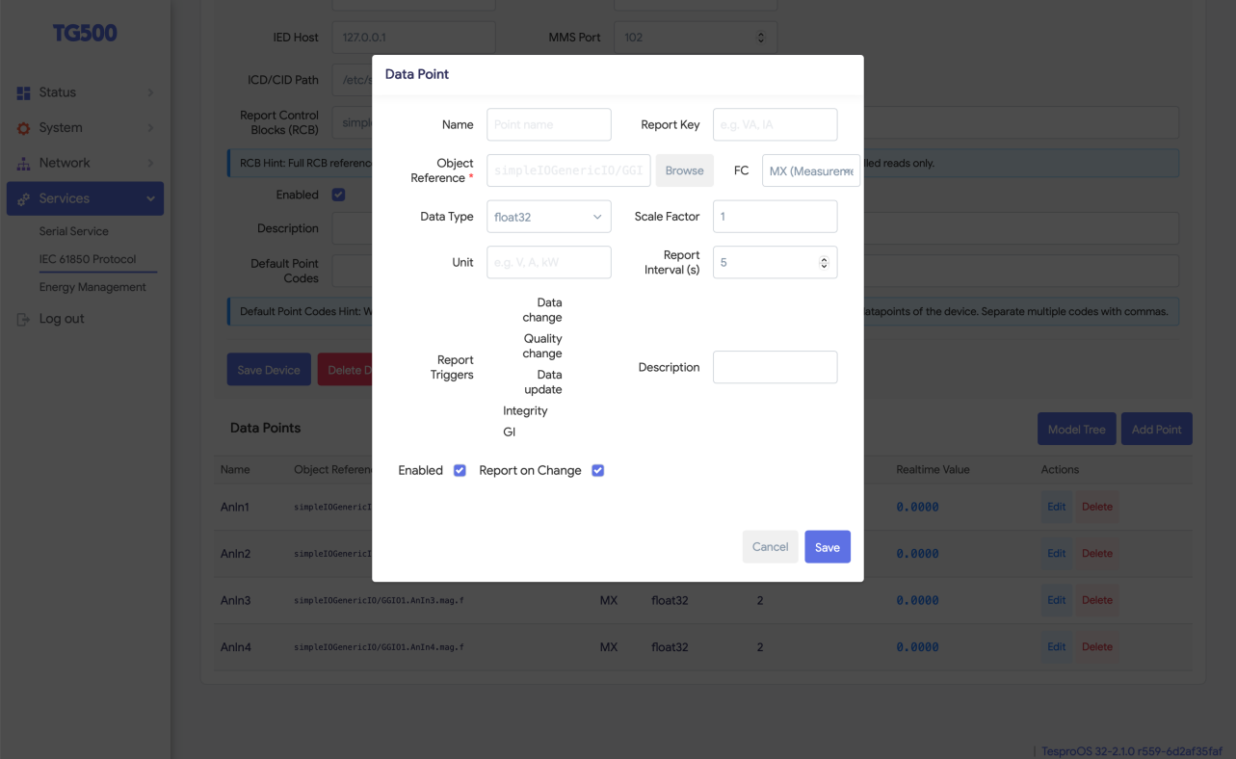
Data Point editor
Click Add Point (or Edit on a row) to open the editor:
Field | Meaning
Name | Point name.
Report Key | Key used for this point inside the uploaded properties object.
Object Reference (required) | The IEC 61850 reference to read. Use Browse to pick it from the model tree instead of typing.
FC | Functional constraint (e.g. MX).
Data Type | Value type (e.g. float32).
Scale Factor | Multiplier applied to the raw value (default 1).
Unit | Engineering unit label (e.g. V, A, kW).
Report Interval (s) | Polling interval in seconds.
Report Triggers | RCB trigger options: Data change / Quality change / Data update / Integrity / GI.
Description | Optional free text.
Enabled | Tick to collect this point.
Report on Change | Tick to upload immediately when the value changes (in addition to periodic reporting).
Click Save to store the point, Cancel to discard.

2.4.2 Browse the model tree
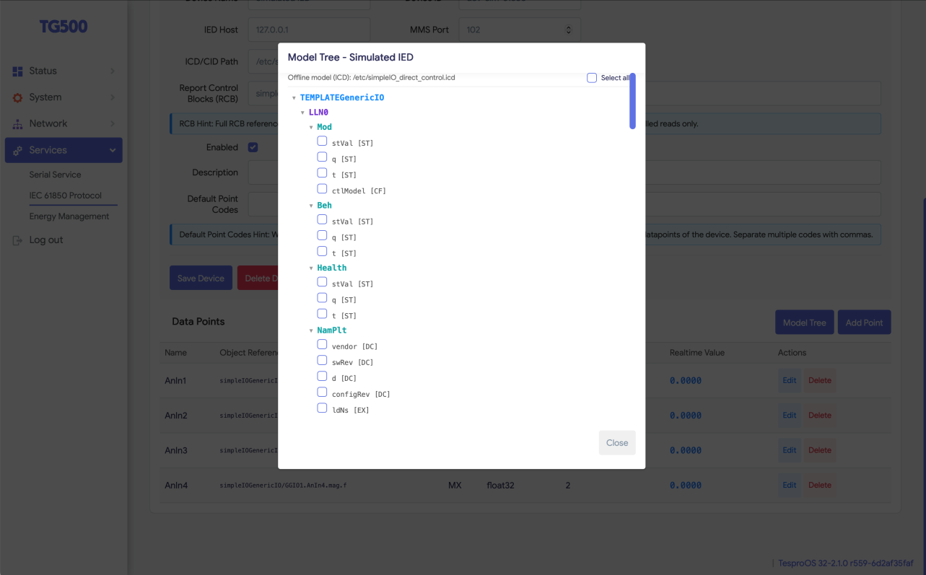
Model Tree
Click Model Tree (or Browse inside the point editor) to open the model browser:
- The header shows the model source, e.g. Offline model (ICD): /etc/....icd. When the device is online the live model is shown instead.
- Expand LD → LN → DO → DA nodes; each leaf shows its functional constraint (e.g. [ST], [MX], [DC]).
- Tick the checkboxes of the leaves you want (or use Select all) to add them as data points, then close the dialog.

2.5 Import data points (bulk)
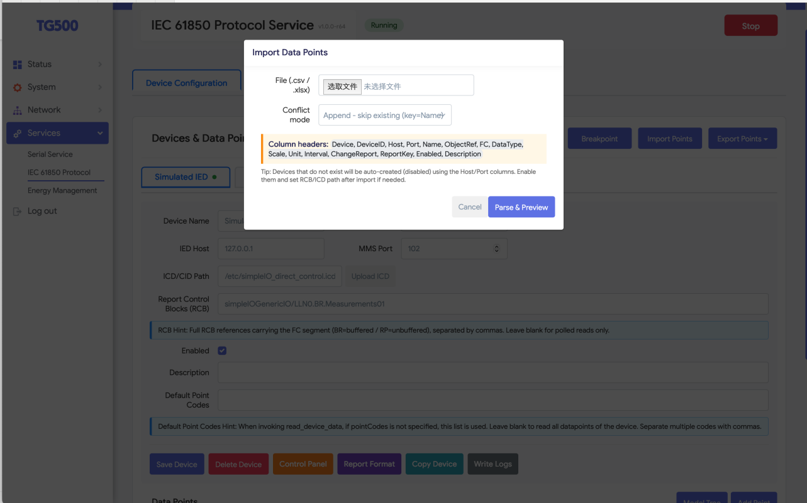
Import Data Points
Click Import Points to bulk-load points from a spreadsheet:
- File: choose a .csv or .xlsx file.
- Conflict mode: e.g. Append - skip existing (key=Name) — rows whose Name already exists are skipped.
- The expected column headers are shown in the dialog: Device, DeviceID, Host, Port, Name, ObjectRef, FC, DataType, Scale, Unit, Interval, ChangeReport, ReportKey, Enabled, Description.
- Click Parse & Preview, check the preview, then confirm to import.
Tip: Devices referenced in the file that do not exist yet are created automatically in a disabled state; enable them and set the RCB / ICD path afterwards if needed.

2.6 Export data points
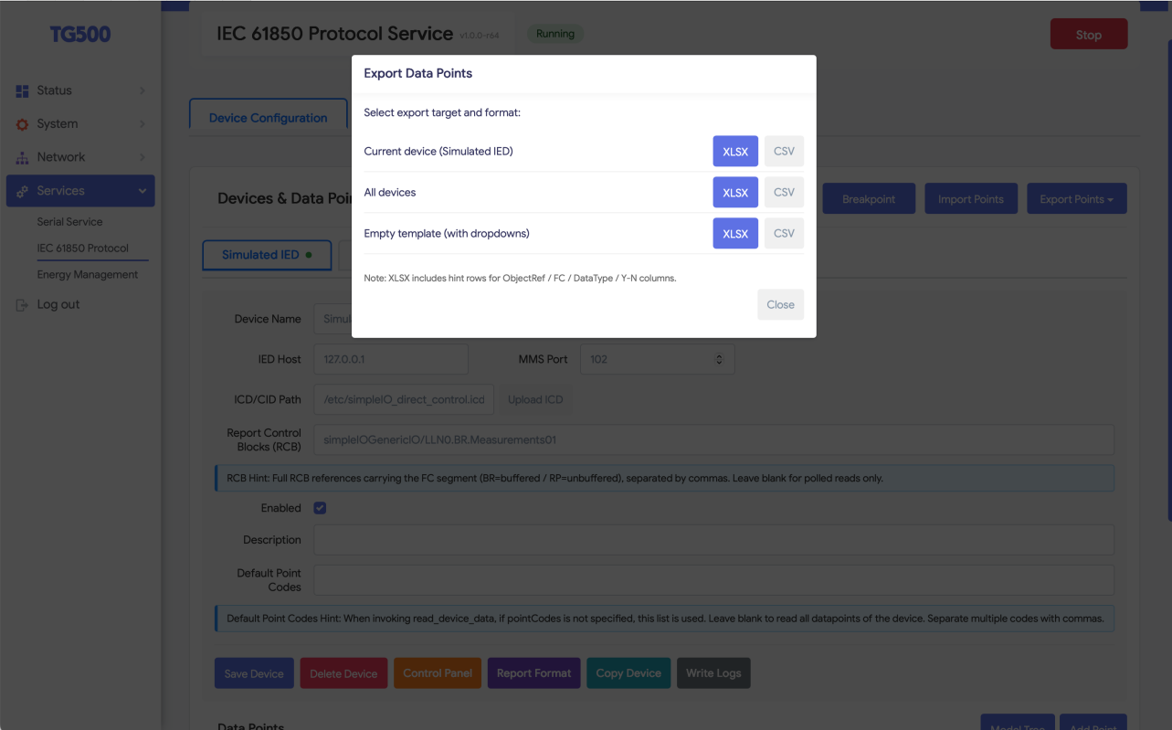
Export Data Points
Click Export Points and choose a target and format:
Target | Content
Current device | Points of the selected device only.
All devices | Points of every configured device.
Empty template (with dropdowns) | A blank template with valid-value dropdowns, for filling in offline.
Formats: XLSX or CSV. The XLSX template includes hint rows for the ObjectRef / FC / DataType / Y-N columns.

2.7 Report format (upload JSON template)
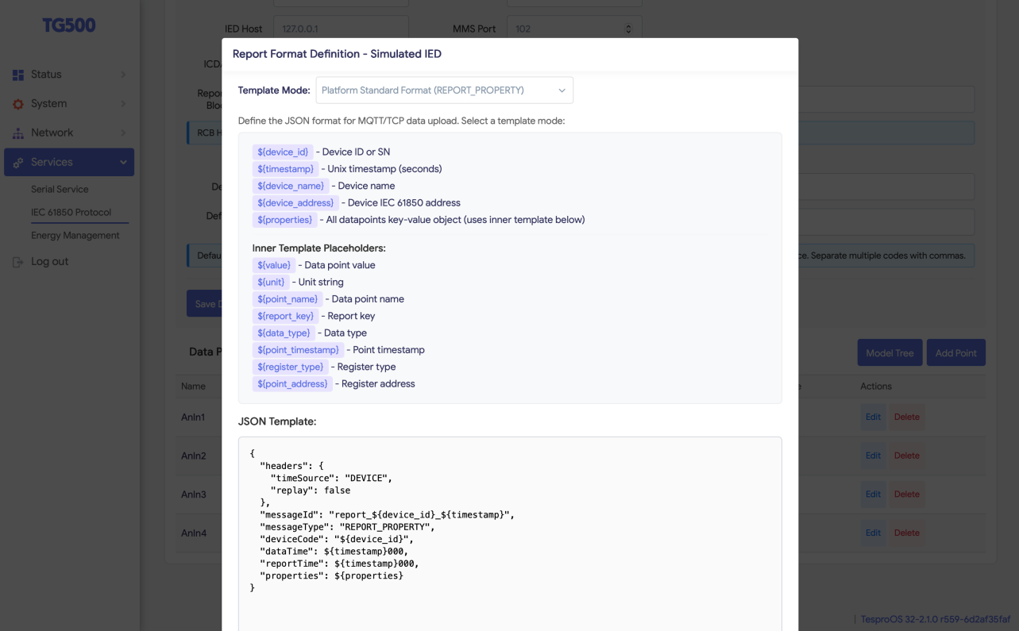
Report Format
Click Report Format to define the JSON message sent to the northbound channels.
- Template Mode: choose a preset, e.g. Platform Standard Format (REPORT_PROPERTY).
- Placeholders you can use in the template:
  - Outer: ${device_id}, ${timestamp}, ${device_name}, ${device_address}, ${properties}
  - Inner (per point, inside ${properties}): ${value}, ${unit}, ${point_name}, ${report_key}, ${data_type}, ${point_timestamp}, ${register_type}, ${point_address}
- JSON Template: the editable message skeleton. The default standard format looks like:
{
"headers": { "timeSource": "DEVICE", "replay": false },
"messageId": "report_${device_id}_${timestamp}",
"messageType": "REPORT_PROPERTY",
"deviceCode": "${device_id}",
"dataTime": ${timestamp}000,
"reportTime": ${timestamp}000,
"properties": ${properties}
}
Edit only if your platform requires a different payload; otherwise keep the standard format.

2.8 Other device buttons
- Control Panel: open the manual control / test panel for the selected device.
- Write Logs: write a diagnostic snapshot to the service log.
- Breakpoint: resume/continue a paused (breakpoint) collection session.

3. Northbound Configuration (data upload)
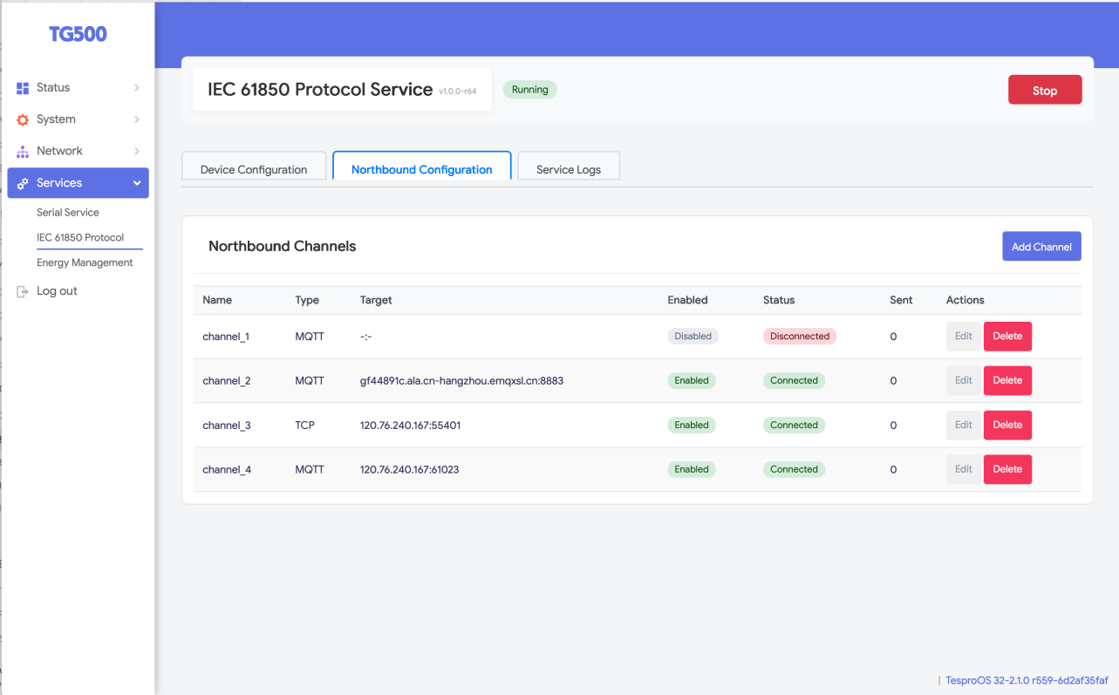
Northbound Channels
The Northbound Configuration tab lists the upload channels.
Column | Meaning
Name | Channel name (e.g. channel_1).
Type | MQTT or TCP.
Target | Broker / server address (host:port).
Enabled | Whether the channel is active.
Status | Live link state: Connected (green) / Disconnected (red).
Sent | Number of messages sent on this channel.
Actions | Edit / Delete.
Click Add Channel to create a channel; Edit to modify one.

3.1 Channel settings
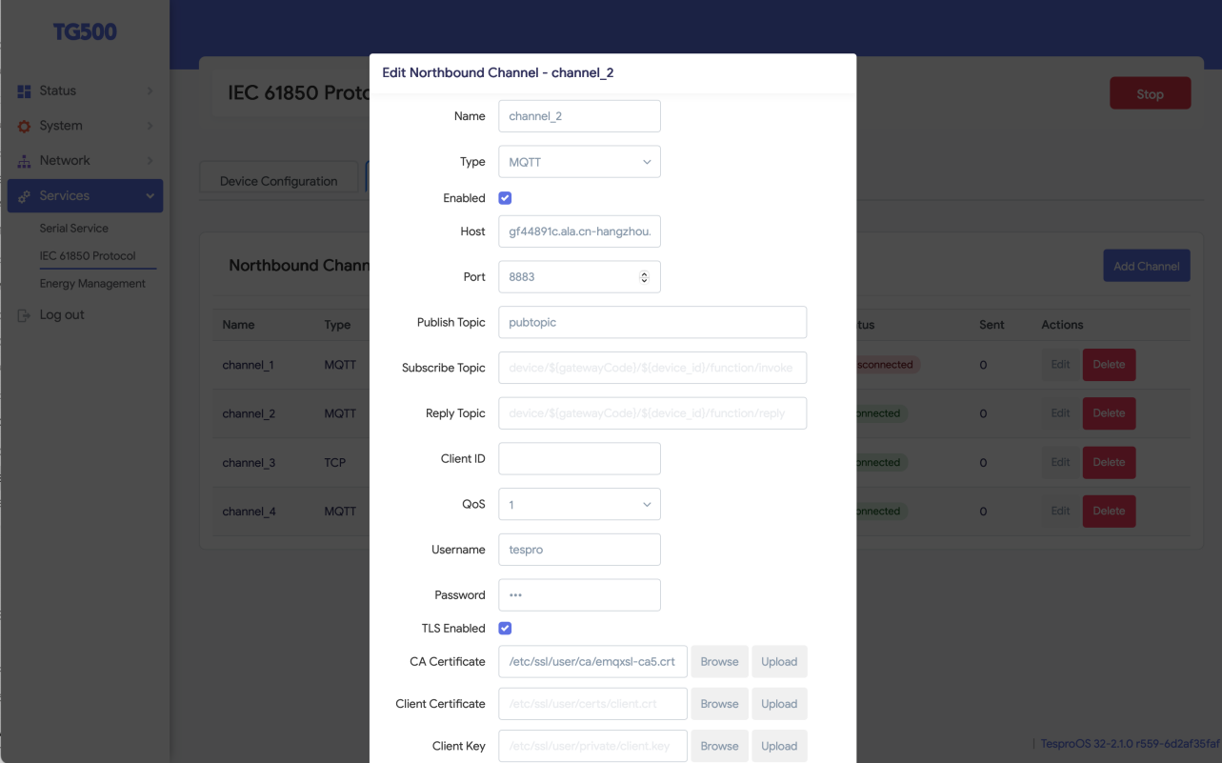
Edit Northbound Channel
Field | Meaning
Name | Channel name.
Type | MQTT or TCP.
Enabled | Tick to activate the channel.
Host / Port | Broker (MQTT) or server (TCP) address.
Publish Topic | MQTT topic the reports are published to.
Subscribe Topic | MQTT topic for downlink commands (supports ${gatewayCode} / ${device_id} placeholders).
Reply Topic | MQTT topic used to reply to downlink commands.
Client ID | MQTT client identifier (leave blank to auto-generate).
QoS | MQTT QoS level (0/1/2).
Username / Password | Broker credentials, if required.
TLS Enabled | Tick to use TLS/SSL for the connection.
CA Certificate | Path to the CA cert; use Browse / Upload to provide a file.
Client Certificate / Client Key | Client cert & key for mutual-TLS, if required.
For a plain (non-TLS) TCP/MQTT link, leave TLS Enabled unticked and the certificate fields empty. Save the channel; the Status column then shows Connected once the link is up.

4. Service Logs
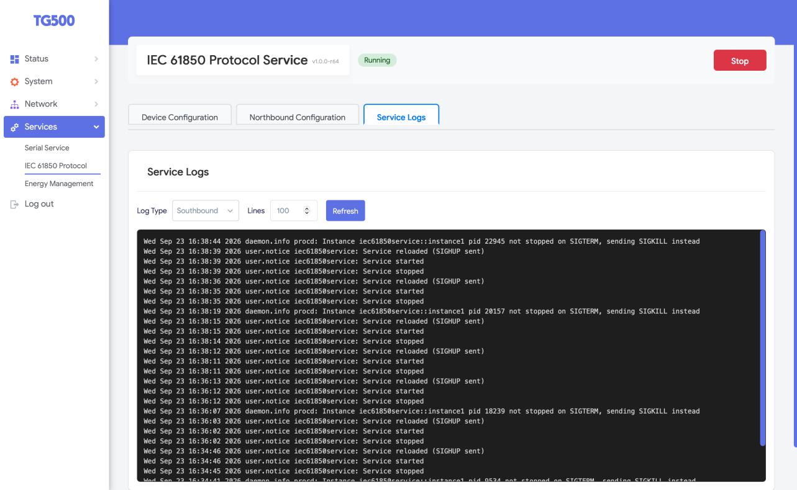
Service Logs
The Service Logs tab shows runtime logs for troubleshooting:
- Log Type: choose the log source (e.g. Southbound).
- Lines: how many recent lines to display (e.g. 100).
- Refresh: reload the log view.
Use the logs to confirm connections, reporting activity and errors. When contacting support, attach a refreshed log capture.

5. Typical workflow (quick reference)
- Services → IEC 61850 Protocol, ensure the service is Running.
- Device Configuration → Add Device: set Device ID, IED Host, MMS Port; upload the ICD/CID; optionally set RCB references; Save Device.
- Add data points: Add Point (or Model Tree to browse, or Import Points for bulk).
- Optionally tune the upload payload via Report Format.
- Northbound Configuration → Add Channel: configure MQTT/TCP target (and TLS if needed).
- Verify: device tab shows a green dot, channel Status = Connected, Sent counter increases, and Realtime Value updates.
- If anything misbehaves, check Service Logs.

