Radar Target Generation and Detection

1. Implementation steps for the 2D CFAR process, Selection of Training, Guard cells and offset.

* Select the number of Training Cells in both the dimensions.

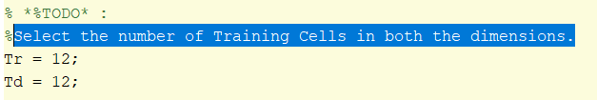

* Select the number of Guard Cells in both dimensions around the Cell under

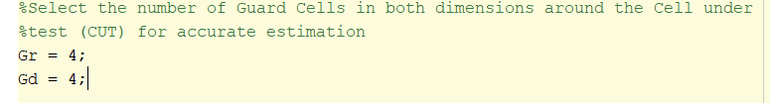

* Select offset the threshold by SNR value in dB

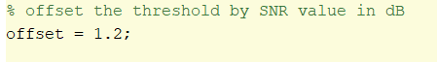

* Create a vector to store noise level for each iteration on training cells



design a loop such that it slides the CUT across range doppler map by giving margins at the edges for Training and Guard Cells. For every iteration sum the signal level within all the training cells. To sum convert the value from logarithmic to linear using db2pow function. Average the summed values for all of the training

cells used. After averaging convert it back to logarithimic using pow2db. Further add the offset to it to determine the threshold. Next, compare the signal under CUT with this threshold. If the CUT level > threshold assign it a value of 1, else equate it to 0.

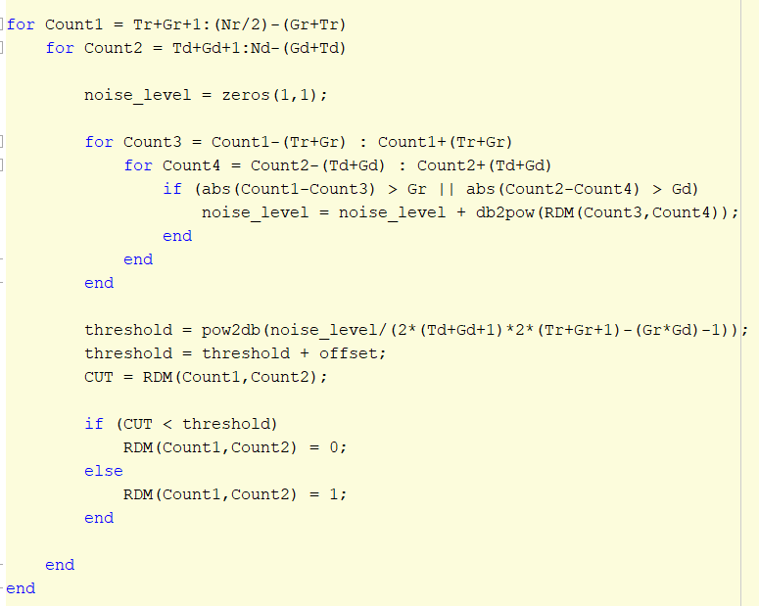

1. Steps taken to suppress the non-thresholded cells at the edges.

