



CSE411

Real-Time and Embedded Systems Design

|  |  |
| --- | --- |
| Name | ID |
| Abdelrahman Khaled Sallam | 20P8307 |
| Ahmed Taha Abdelrahman | 20P5437 |
| Anas Ahmed Hussein | 20P5726 |
| Donia Ahmed Nasr | 20P9451 |
| Mariam Wahdan Allam | 20P5500 |
| Yahia Ahmed Zaki | 20P6091 |

Power window control system

Contents

• Project description 3

• Contributions 3

• List of Components 4

• Circuit Wiring 4

• System Layout 5

• System Flowchart 6

• Tasks Code 7

➢ **vDriverDirections** 7

➢ **Driver Clockwise Direction (Manual Control)** 7

➢ **Driver Clockwise Direction (Automatic Control)** 8

➢ **Driver Anti-Clockwise Direction (Manual Control)** 9

➢ **Driver Anti-Clockwise Direction (Automatic Control)** 10

➢ **vClockWise** 11

➢ **vClockWise (Manual Control)** 11

➢ **vClockWise (Automatic Control)** 12

➢ **vAntiClockWise** 13

➢ **vAntiClockWise (Manual Control)** 13

➢ **vAntiClockWise (Automatic Control)** 14

• Problem Faced 15

List of figures

Figure 1:Project Circuit 4

Figure 2:Breadboard Components 5

Figure 3: Main Components 5

Figure 4:Manual control for driver clockwise 7

Figure 5:Automatic control for driver clockwise 8

Figure 6:Manual control for driver anti-clockwise 9

Figure 7:Automatic control for driver anti-clockwise 10

Figure 8:Manual control for passenger clockwise 11

Figure 9:Automatic control for passenger clockwise 12

Figure 10:Manual control for passenger anti-clockwise 13

Figure 11:Automatic control for passenger anti-clockwise 14

# Project description

The Integrated Power Window Control System project aims to develop a sophisticated solution for the front passenger door window, enabling seamless operation through both passenger and driver control panels. Leveraging FreeRTOS for real-time functionality, the system will incorporate essential features such as manual open/close, one-touch auto open/close, window lock, and jam protection. Implementation will include one limit switch to lock window when limit is reached and 4 push buttons to constrain the window motor's movement for passenger and driver and 2 push buttons for the stop and start of the passenger windows, while obstacle detection will be facilitated by a push button. Through meticulous hardware and software integration, this project seeks to enhance vehicle occupants' convenience and safety by delivering an intuitive, reliable, and comprehensive power window control system.

# Contributions

1. **Abdelrahman Khaled**

* Develop drivers for hardware components and connect them to appropriate ports on the Tiva C microcontroller and the L298N motor driver.

1. **Ahmed Taha**

* Work on designing the logic flow of the project and independently test components to ensure their proper functionality.

1. **Donia Ahmed**

* Study how the L298N motor driver works and connect the DC motor to it, ensuring proper understanding and functionality.

1. **Mariam Wahdan**

* Work on integrating interrupts with the system and understand how they synchronize tasks to ensure smooth operation.

1. **Anas Ahmed Hussein**

* Study the functionality of the limit switch and understand how to implement it to lock the window when the limit is reached.

1. **Yahia Ahmed Zaki**

* Learn about Pulse Width Modulation (PWM) and assist in wiring its configuration, ensuring proper control of motor speed and direction

# List of Components

|  |  |  |
| --- | --- | --- |
| Name | Quantity | Price(EGP) |
| TivaC123GH6PM Microcontroller | 1 | 1700 |
| 220 Ohm Resistors | 4 | 1 |
| Pushbuttons | 6 | 6 |
| Limit Switch | 2 | 50 |
| DC Motor | 1 | 40 |
| L298n Motor Driver | 1 | 100 |
|  | Total | 1,897 |

# Circuit Wiring

Figure :Project Circuit

# System Layout

**220-ohm Resistor**

**Push button**

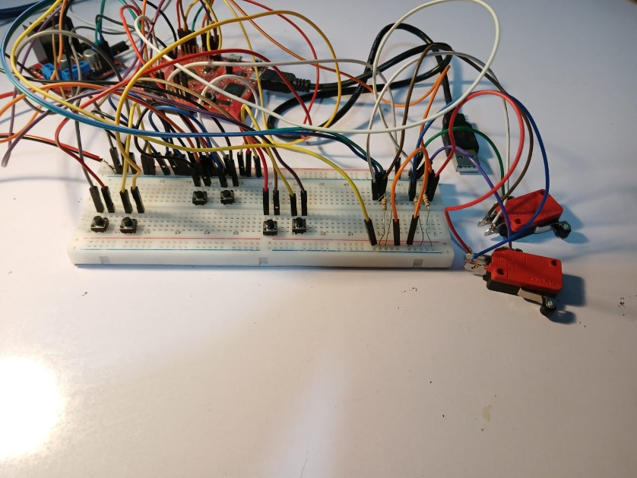

**Common GND**

Figure :Breadboard Components

**3.3V from Tiva**

**Limit Switch**

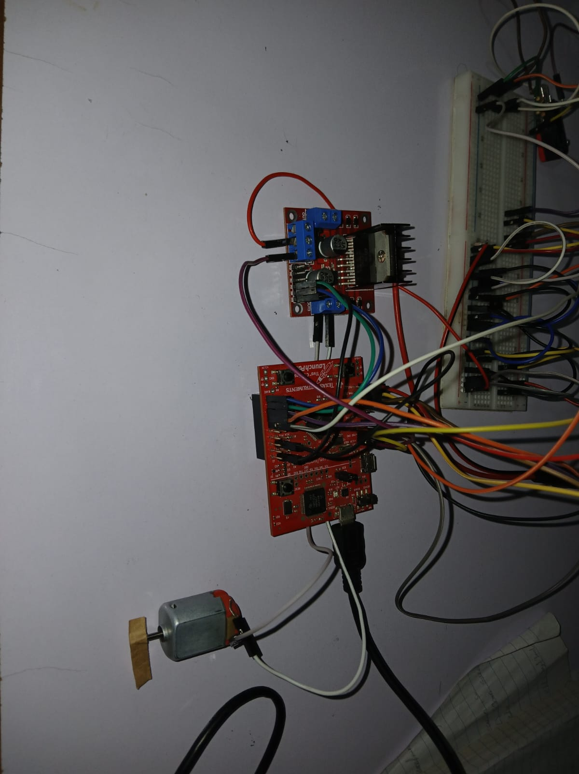

**1. 12V 2. GND 3. 5V**

**L298n motor driver**

Figure : Main Components

**Motor 2**

**TivaC123GH6PM**

**123**

**DC motor**

# System Flowchart

Start

Semaphore Creation

Peripherals Initialization

Creation of tasks and starting schedular

Nov

Automatic Control

Yes

If button still pressed

if(Button3B) 

No

Yes

Manual Control

vDriverDirections Task blocked

No

Automatic Control

Yes

If button still pressed

if(Button7) 

No

Yes

Manual Control

vClockWise Task blocked

No

Automatic Control

No

Yes

If button still pressed

vAnitClockWise Task blocked

if(Button6) 

Yes

Manual Control

# Tasks Code

## **vDriverDirections**

### **Driver Clockwise Direction (Manual Control)**

Figure :Manual control for driver clockwise

The "vDriverDirections" task holds the utmost priority among all other tasks. Its primary function is to manage the driver's control buttons, specifically Button 6 (connected to pin 6 on port B for clockwise rotation) and Button 3 (linked to pin 3 on port B for counterclockwise rotation).

Upon execution, this task first checks the status of a semaphore. If the semaphore is empty, it waits until it's signaled by the Interrupt Service Routine (ISR) triggered by Button 6.

Once the semaphore is given, the task assesses if the button has been pressed for an extended duration, indicating manual window control. In such cases, the motor rotates until either the button is released or the limit switch is activated. If the limit switch is triggered, rotation halts, and the task is blocked. Conversely, if the limit is not reached but the button is released, motor rotation ceases.

While the DC motor is in motion, a flag is toggled to "false" to ensure that when the passenger accesses the same resource after the driver, the driver must initiate control by pressing the start button

### **Driver Clockwise Direction (Automatic Control)**

Figure :Automatic control for driver clockwise

Alternatively, if Button 6 is pressed only once, it signifies the driver's preference for automatic control. This mode initiates motor rotation until either the limit is reached or Button 3 (anti-clockwise button) is pressed. If the limit switch is triggered, rotation halts, and the task is blocked. Conversely, if Button 3 is pressed, the motor reverses its direction of rotation.

### **Driver Anti-Clockwise Direction (Manual Control)**

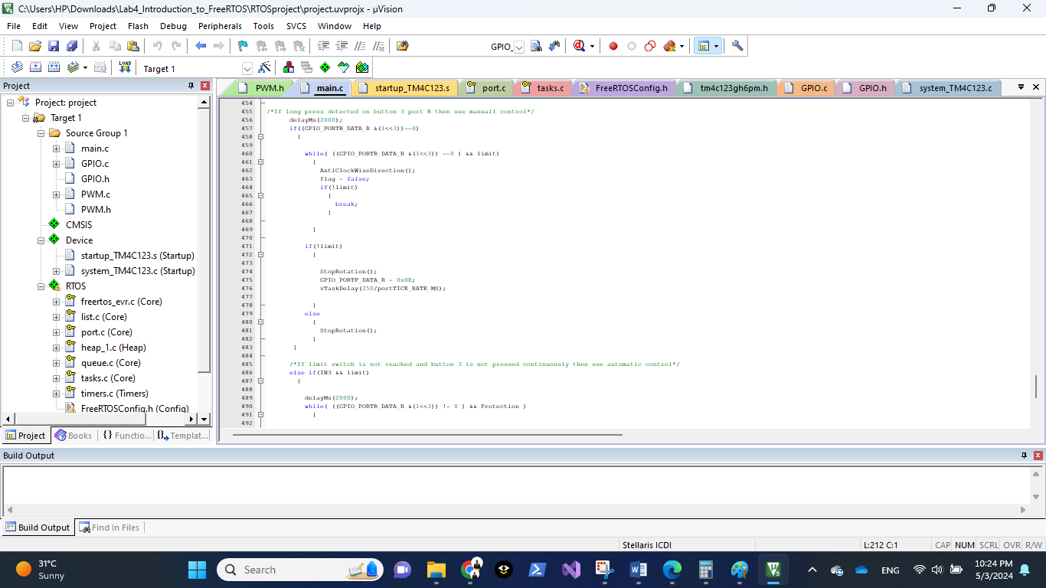

Figure :Manual control for driver anti-clockwise

If the triggered ISR was due to Button 3, we check if the button has been pressed for an extended duration, indicating manual window control. In such cases, the motor rotates until either the button is released or the limit switch is activated. If the limit switch is triggered, rotation halts, and the task is blocked. Conversely, if the limit is not reached but the button is released, motor rotation ceases and task is blocked on the semaphore.

While the DC motor is in motion, a flag is toggled to "false" to ensure that when the passenger accesses the same resource after the driver, the driver must initiate control for the passenger by pressing the start button

### **Driver Anti-Clockwise Direction (Automatic Control)**

Figure :Automatic control for driver anti-clockwise

Alternatively, if Button 3 is pressed only once, it signifies the driver's preference for automatic control. This mode initiates motor rotation until either the limit is reached or Button 6 (clockwise button) is pressed. If the limit switch is triggered, rotation halts, and the task is blocked. Conversely, if Button 6 is pressed, the motor reverses its direction of rotation, additionally if the protection button is pressed the rotation stops to prevent problems and the task is blocked on the semaphore

## **vClockWise**

* **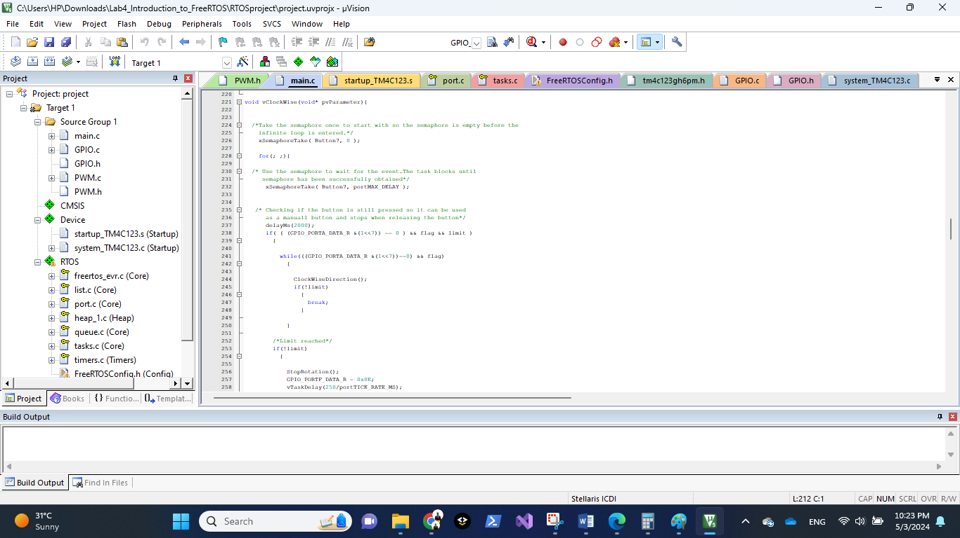****vClockWise (Manual Control)**

Figure :Manual control for passenger clockwise

The "vClockWise" task holds a priority lower than that of the driver task, yet it is initialized prior to the "vAntiClockWise" task, ensuring its execution precedence. Upon initialization, "vClockWise" waits for a semaphore to be signaled from the ISR triggered by pressing Button 7 (connected to pin 7 on port B for clockwise rotation). Upon receiving the semaphore, the task begins execution.

Initially, it checks if Button 7 is still pressed and if the flag is set to true (indicating that the passenger has control over the window), and verifies that the limit switch is not activated. If these conditions are met, it indicates the passenger's intent to utilize manual control. In such cases, the motor rotates until the button is released, the limit switch is triggered, or control is taken by the driver due to their higher priority.

If the limit switch is triggered, rotation halts, and the task is blocked. Conversely, if the flag is false, indicating that the driver has assumed control, rotation ceases, and the task is once again blocked on the semaphore, awaiting further task execution.

### **vClockWise (Automatic Control)**

Figure :Automatic control for passenger clockwise

Alternatively, if Button 7 is pressed only once, it signifies the passenger's preference for automatic control. This mode initiates motor rotation until either the limit is reached or driver wanted to take control. If the limit switch is triggered, rotation halts, and the task is blocked. Conversely, if driver took control, the motor stops rotation, and the task is blocked on the semaphore again waiting for other tasks

## **vAntiClockWise**

### **vAntiClockWise (Manual Control)**

Figure :Manual control for passenger anti-clockwise

The "vAntiClockWise" task is executed when the semaphore is taken from the ISR due to the interrupt triggered due to pressing on button 6 (pin 6 port B for anti-clockwise direction)

Initially, the task checks if Button 6 is still pressed and if the flag is set to true (indicating that the passenger has control over the window), and verifies that the limit switch is not activated. If these conditions are met, it indicates the passenger's intent to utilize manual control. In such cases, the motor rotates until the button is released, the limit switch is triggered, or control is taken by the driver due to their higher priority.

If the limit switch is triggered, rotation halts, and the task is blocked. Conversely, if the flag is false, indicating that the driver has assumed control, rotation ceases, and the task is once again blocked on the semaphore, awaiting further task execution.

### **vAntiClockWise (Automatic Control)**

Figure :Automatic control for passenger anti-clockwise

Alternatively, if Button 6 is pressed only once, it signifies the passenger's preference for automatic control. This mode initiates motor rotation until either the limit is reached or driver wanted to take control. If the limit switch is triggered, rotation halts, and the task is blocked. Conversely, if driver took control, the motor stops rotation, additionally if the protection button is pressed the rotation stops to prevent problems and the task is blocked on the semaphore

# Problem Faced

* **Synchronizing Tasks with Interrupts:**

One significant challenge we faced was synchronizing tasks with interrupts effectively. Integrating interrupt-driven events seamlessly into the task flow while ensuring critical tasks were not interrupted inappropriately required careful planning and synchronization strategies.

* **Learning PWM Configuration:**

Learning how to configure Pulse Width Modulation (PWM) posed a notable challenge. PWM is critical for controlling the speed and direction of motors, but understanding its principles and configuring it correctly required dedicated effort and experimentation.

* **Connecting 12V to the H-Bridge Safely:**

We encountered apprehension when learning how to connect the 12V power source to the H-bridge without damaging components. Fear of damaging components due to incorrect wiring or voltage fluctuations prompted thorough research and cautious implementation strategies to ensure the system's safety and integrity.

Top of Form