電通二乙微處理器實驗 實驗結報

實驗名稱 | Lab01
組別 |  | 組員 | 黃湐文

- 實驗目的
使用Thinkcad 模擬Ardunio 及電路 讓led閃爍及發出SOS求救訊號
- 實驗步驟
先使用Thinkcad將模擬的Ardunio及電路接上並聯電源,修改程式碼到對應的角位後,確認led有正常閃爍,再次更改程式碼使其可以發出sos求救訊號並將結果及程式碼上傳至Github
- 程式碼
void setup()
{
pinMode(9, OUTPUT);
}

void loop()
{
digitalWrite(9, HIGH);
delay(100); // Wait for 1000 millisecond(s)
digitalWrite(9, LOW);
delay(100); // Wait for 1000 millisecond(s)
digitalWrite(9, HIGH);
delay(100); // Wait for 1000 millisecond(s)
digitalWrite(9, LOW);
delay(100); // Wait for 1000 millisecond(s)
digitalWrite(9, HIGH);
delay(100); // Wait for 1000 millisecond(s)
digitalWrite(9, LOW);
delay(100); // Wait for 1000 millisecond(s)

digitalWrite(9, HIGH);
delay(300); // Wait for 1000 millisecond(s)
digitalWrite(9, LOW);
delay(100); // Wait for 1000 millisecond(s)
digitalWrite(9, HIGH);
delay(300); // Wait for 1000 millisecond(s)
digitalWrite(9, LOW);
delay(100); // Wait for 1000 millisecond(s)digitalWrite(9, HIGH);
digitalWrite(9, HIGH);
delay(300); // Wait for 1000 millisecond(s)
digitalWrite(9, LOW);
delay(100); // Wait for 1000 millisecond(s)digitalWrite(9, HIGH);

digitalWrite(9, HIGH);
delay(100); // Wait for 1000 millisecond(s)
digitalWrite(9, LOW);
delay(100); // Wait for 1000 millisecond(s)
digitalWrite(9, HIGH);
delay(100); // Wait for 1000 millisecond(s)
digitalWrite(9, LOW);
delay(100); // Wait for 1000 millisecond(s)
digitalWrite(9, HIGH);
delay(100); // Wait for 1000 millisecond(s)
digitalWrite(9, LOW);
delay(300); // Wait for 1000 millisecond(s)

}
- 實驗結果及分析
Led可以正常閃爍並發出SOS訊號
- 心得討論
這次Ardunio得初體驗可說是相當震撼,終於有種學到新東西的感覺,
唯一碰到的障礙為很多網站和軟體都是全英文操作的,這讓英文白癡得我用得有些吃力,不過整體來說然扔然是相當有趣的一次體驗,我的電路也有點生疏了,看來要找時間好好複習了,希望下次上課我可以少一點障礙
- 修正電路圖
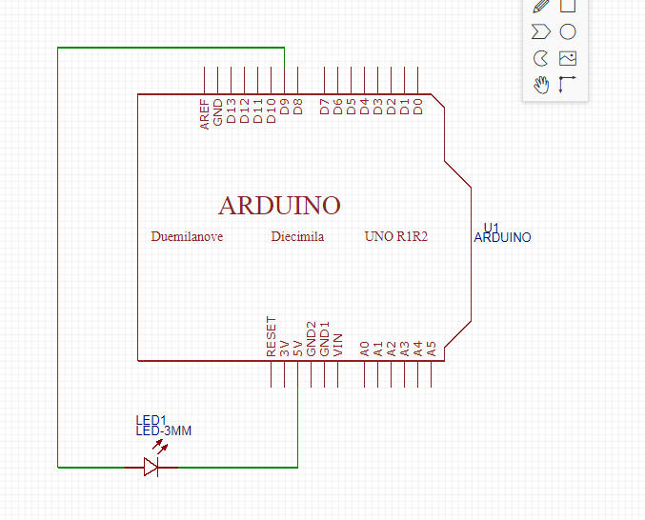
- 修正程式碼

