電通二乙微處理器實驗 實驗結報

實驗名稱 | Lab11
組別 | 電通二甲 | 組員 | 黃湐文

- 實驗目的
使用MCS與Arduino連線並將測量到的電阻值顯示在上面
- 實驗步驟
- 修改 MCS_GET code, 加入 MCS Remote
- 將A0電阻值上傳
- 程式碼
Check 1
#include <LWiFi.h>
#include <WiFiClient.h>
#include "MCS.h"

// Assign AP ssid / password here
#define _SSID "Yahii"
#define _KEY "0910152839"

// Assign device id / key of your test device
MCSDevice mcs("DB6jht54", "VlIy7We0QjT61RBX");

// Assign channel id
// The test device should have 2 channel
// the first channel should be "Controller" - "On/Off"
// the secord channel should be "Display" - "On/Off"
MCSControllerOnOff led("wen");
MCSDisplayOnOff remote("wen1");

#define LED_PIN 7

void setup() {
// setup Serial output at 9600
Serial.begin(9600);

// setup LED/Button pin
pinMode(LED_PIN, OUTPUT);

// setup Wifi connection
while(WL_CONNECTED != WiFi.status())
{
Serial.print("WiFi.begin(");
Serial.print(_SSID);
Serial.print(",");
Serial.print(_KEY);
Serial.println(")...");
WiFi.begin(_SSID, _KEY);
}
Serial.println("WiFi connected !!");

// setup MCS connection
mcs.addChannel(led);
mcs.addChannel(remote);
while(!mcs.connected())
{
Serial.println("MCS.connect()...");
mcs.connect();
}
Serial.println("MCS connected !!");

// read LED value from MCS server
while(!led.valid())
{
Serial.println("read LED value from MCS...");
led.value();
}
Serial.print("done, LED value = ");
Serial.println(led.value());
digitalWrite(LED_PIN, led.value() ? HIGH : LOW);
}

void loop() {
// call process() to allow background processing, add timeout to avoid high cpu usage
Serial.print("process(");
Serial.print(millis());
Serial.println(")");
mcs.process(100);

// updated flag will be cleared in process(), user must check it after process() call.
if(led.updated())
{
Serial.print("LED updated, new value = ");
Serial.println(led.value());
digitalWrite(LED_PIN, led.value() ? HIGH : LOW);
if(!remote.set(led.value()))
{
Serial.print("Failed to update remote");
Serial.println(remote.value());
}
}

// check if need to re-connect
while(!mcs.connected())
{
Serial.println("re-connect to MCS...");
mcs.connect();
if(mcs.connected())
Serial.println("MCS connected !!");
}
}

Check 2
#include <LWiFi.h>
#include <WiFiClient.h>
#include "MCS.h"

// Assign AP ssid / password here
#define _SSID "Yahii"
#define _KEY "0910152839"

// Assign device id / key of your test device
MCSDevice mcs("DB6jht54", "VlIy7We0QjT61RBX");

// Assign channel id
// The test device should have 2 channel
// the first channel should be "Controller" - "On/Off"
// the secord channel should be "Display" - "On/Off"
MCSControllerOnOff led("wen");
MCSDisplayOnOff remote("wen1");
MCSDisplayInteger Temp("wen2");

#define LED_PIN 7

void setup() {
// setup Serial output at 9600
Serial.begin(9600);

// setup LED/Button pin
pinMode(LED_PIN, OUTPUT);
pinMode(A0, OUTPUT);

// setup Wifi connection
while (WL_CONNECTED != WiFi.status())
{
Serial.print("WiFi.begin(");
Serial.print(_SSID);
Serial.print(",");
Serial.print(_KEY);
Serial.println(")...");
WiFi.begin(_SSID, _KEY);
}
Serial.println("WiFi connected !!");

// setup MCS connection
mcs.addChannel(led);
mcs.addChannel(remote);
mcs.addChannel(Temp);
while (!mcs.connected())
{
Serial.println("MCS.connect()...");
mcs.connect();
}
Serial.println("MCS connected !!");

// read LED value from MCS server
while (!led.valid())
{
Serial.println("read LED value from MCS...");
led.value();
}
Serial.print("done, LED value = ");
Serial.println(led.value());
digitalWrite(LED_PIN, led.value() ? HIGH : LOW);
}

void loop() {
// call process() to allow background processing, add timeout to avoid high cpu usage
Serial.print("process(");
Serial.print(millis());
Serial.println(")");
mcs.process(100);

// updated flag will be cleared in process(), user must check it after process() call.
if (led.updated())
{
Serial.print("LED updated, new value = ");
Serial.println(led.value());
digitalWrite(LED_PIN, led.value() ? HIGH : LOW);
if (!remote.set(led.value()))
{
Serial.print("Failed to update remote");
Serial.println(remote.value());
}
}
if (!Temp.set(analogRead(A0)))
{
Serial.print("Temp");
Serial.println("Temp.value(A0)");
}
// check if need to re-connect
while (!mcs.connected())
{
Serial.println("re-connect to MCS...");
mcs.connect();
if (mcs.connected())
Serial.println("MCS connected !!");
}
Temp.set(analogRead(A0));
}
- 實驗結果及分析
成功將電阻值上傳至MCS並顯示
- 心得討論
這是第一次將自己的板子與網路做連線,感覺還蠻酷的,沒有想到7697除了配有藍芽以外連Wi-Fi都有,比較麻煩的就是MCS的設定部分,不過照者講義做也是很快地就解決了,剩下一次實驗了,好險期末進度都有趕上沒有跟之前一樣還要補上個禮拜的進度
- 修正電路圖

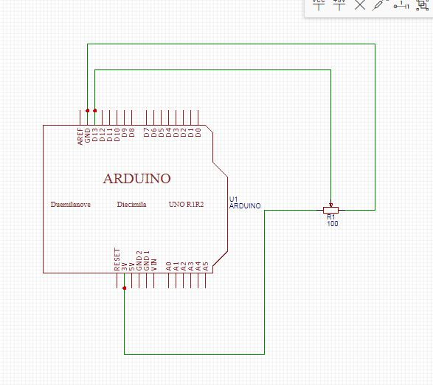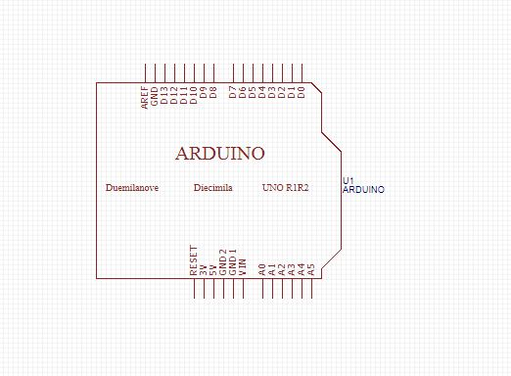
- 修正程式碼

