**Medical Store Management Project**

This Project is used to manage the small medical store made this project using the core java concepts.

Swing technology it’s used in the project. I learned this project during the core java course.

Project carries the multiple frame like login frame, bill generator frame, print frame, stock entry, filter stock check frame, stock check frame.

This is the small project nut it’s helps a lot in developing and improving my core java concepts.

In Project we add the medicines records and manage the bill etc. it’s all things done by the JDBC.

This is the small Desktop Application, using the IDE netbean.

**Technology:**

**Frontend and Backend**-Swing technology.

For the frontend design we used the different swing components like JFrame, JPanel,JLabel,JButton,JComboBox,JTextField,etc.

**DataBase: MySQL.**

In database there are the two important table.

Login table.

Medicines record table.

For the connectivity from database to java it’s done by the **maven technology**.

Flow of the Project:

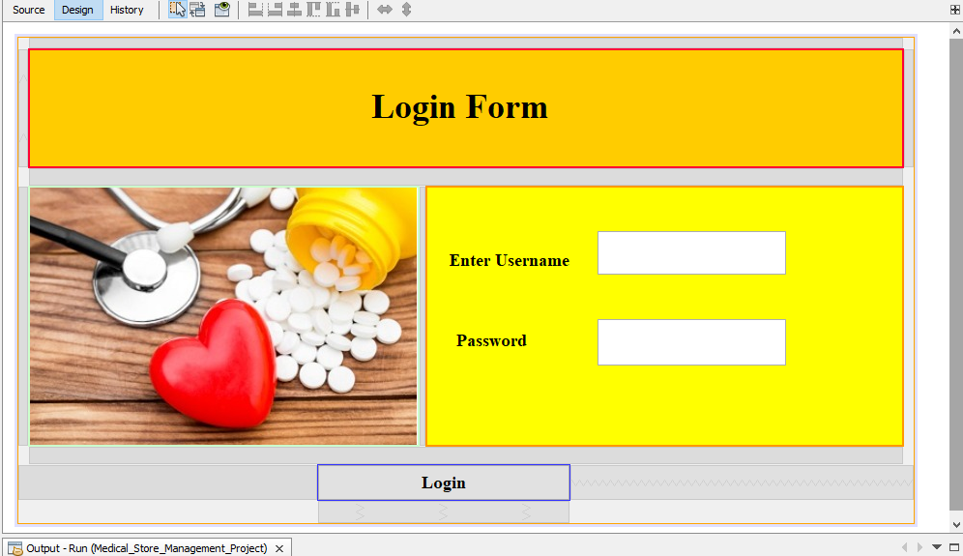

This is the first frame appears. This is basically the login frame its for admin of the medical store or who manage the store. Its must have to provide the correct username and password for login.

The login table it’s a static table in the database.

After Providing the correct username and password.

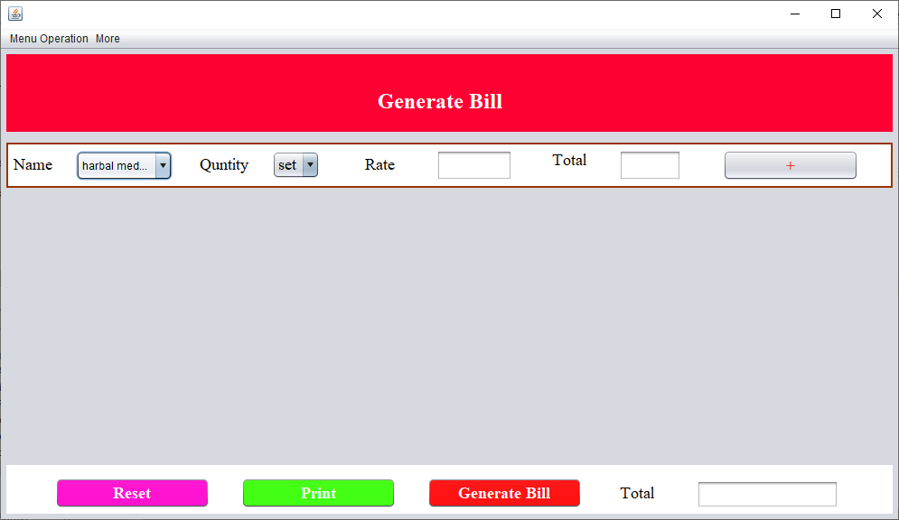

The bill generator frame its appears. This is the main frame of the project. And its carry out the whole process of the project.

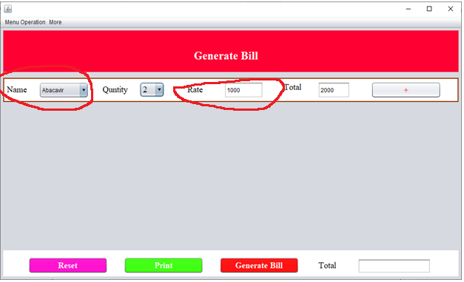

* When the medicine name it selected its starts showing the rate of the medicine.

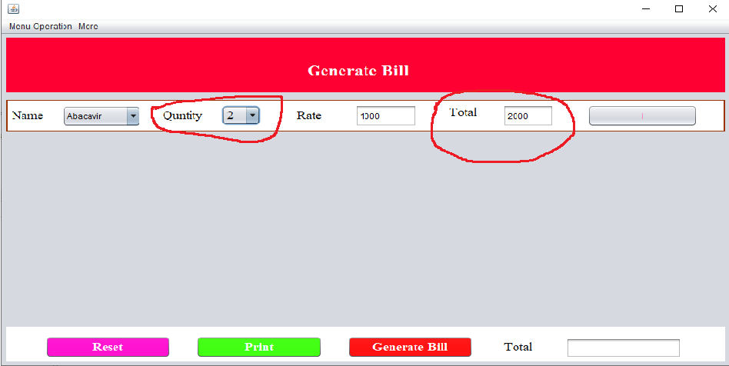

* Quantity selects its shows the total price of the selected medicine.

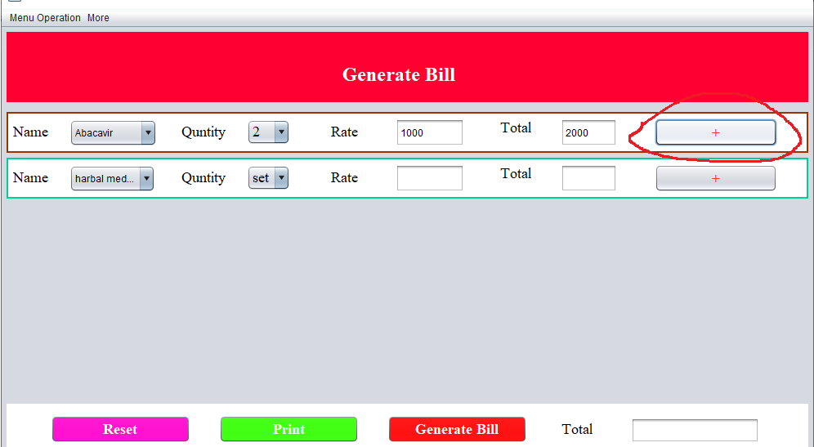

* When the Plus button it’s clicks the new Panel open.
* This frame contains this type of six panels.

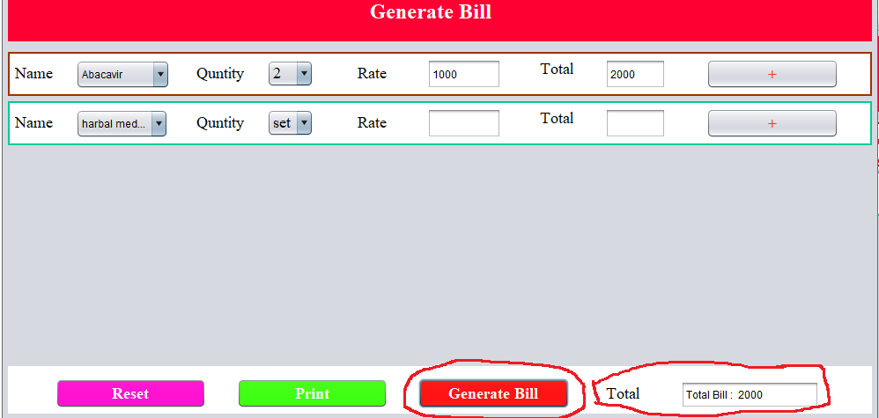

* Clicks on the generate button its show the total amount of the current bill.
* This feature of the project achieve through using the concept of exception handling.

**Code:**

private void bill_btnActionPerformed(java.awt.event.ActionEvent evt) {

flag=1;

int sum=0;

JTextField []jarr=new JTextField[6];

JComboBox[] name=new JComboBox[6];

JComboBox []quantity=new JComboBox[6];

ArrayList medicinename=new ArrayList();

ArrayList total=new ArrayList();

jarr[0]=tt1;

jarr[1]=tt2;

jarr[2]=tt3;

jarr[3]=tt4;

jarr[4]=tt5;

jarr[5]=tt6;

name[0]=c1;

name[1]=c2;

name[2]=c3;

name[3]=c4;

name[4]=c5;

name[5]=c6;

quantity[0]=s1;

quantity[1]=s2;

quantity[2]=s3;

quantity[3]=s4;

quantity[4]=s5;

quantity[5]=s6;

for(int i=0;i<=5;i++)

{

try

{

sum=sum+Integer.parseInt(jarr[i].getText());

medicinename.add(name[i].getSelectedItem());

total.add(jarr[i].getText());

updateDataBase(name[i],quantity[i]);

}

catch(Exception e)

{

System.out.println(e);

}

}

Final_Total.setText("Total Bill : "+sum);

printframe=new PrintFrame();

printframe.setText(medicinename,total,sum);

}

Exception:

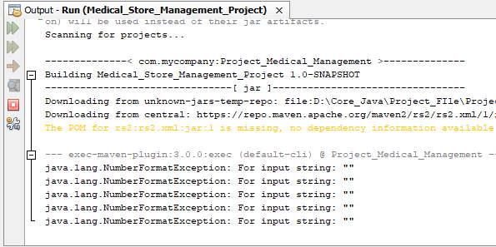

* When we generate the bill the selected medicines quantity get subtracted from the current Quantity of the medicines.
* For that we used the update database query.
* The current quantity of the medicines..

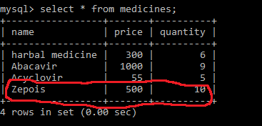

After selecting this particular medicine, and generating the bill the particular medicine quantity subtract from the current quantity.

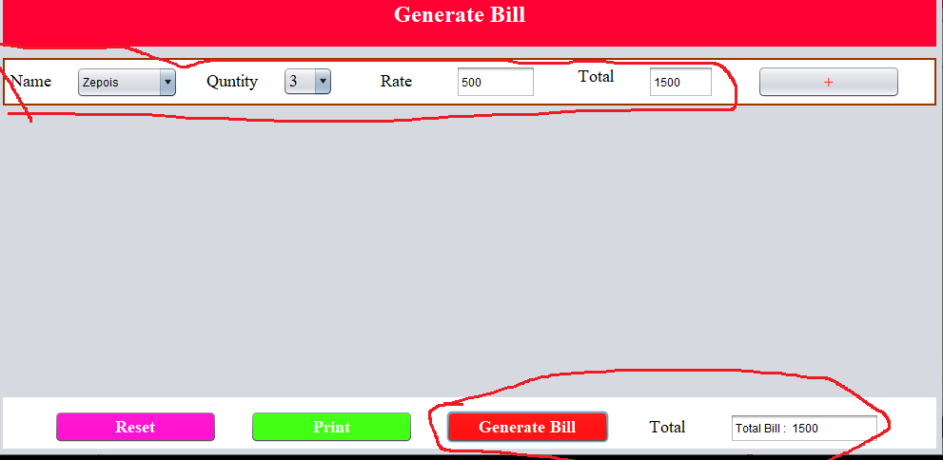

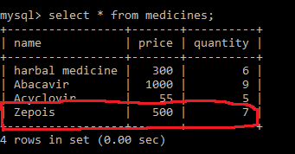

On this frame menu bar is there the menu bar contains the two options.

Stock Check and Filter Stock check options.

This both are also the frame.

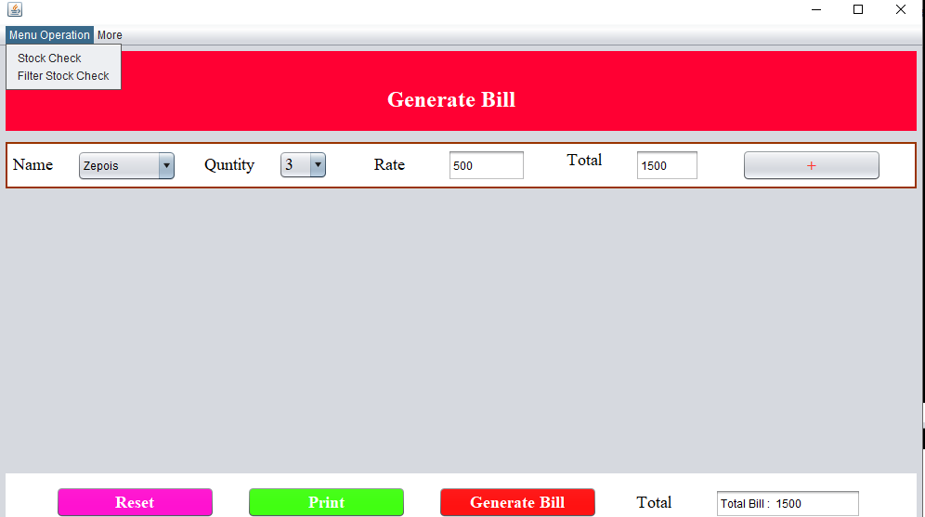

**Stock Check Frame**

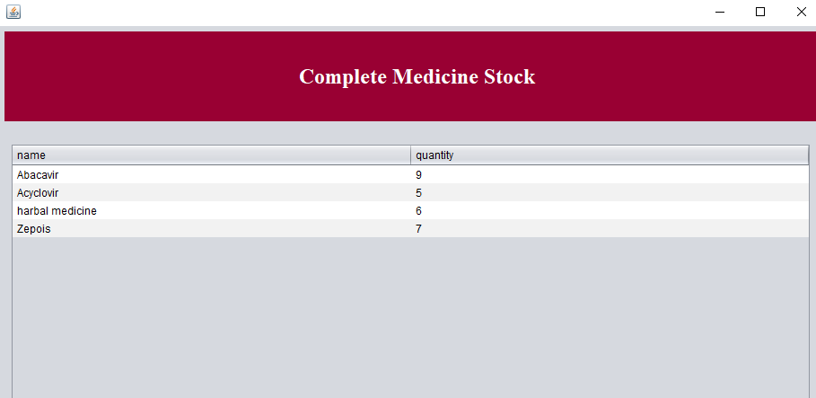

**Filter Stock Check Frame**

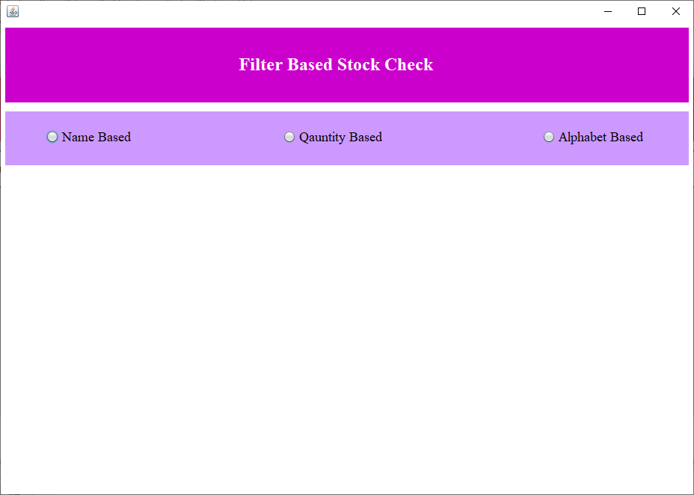

This is the frame used for check according to name based Quantity based and Alphabetical based.

This three button are the radio button and they are in the same button group. So when we press the one other are not available.

**i)Name Based:**

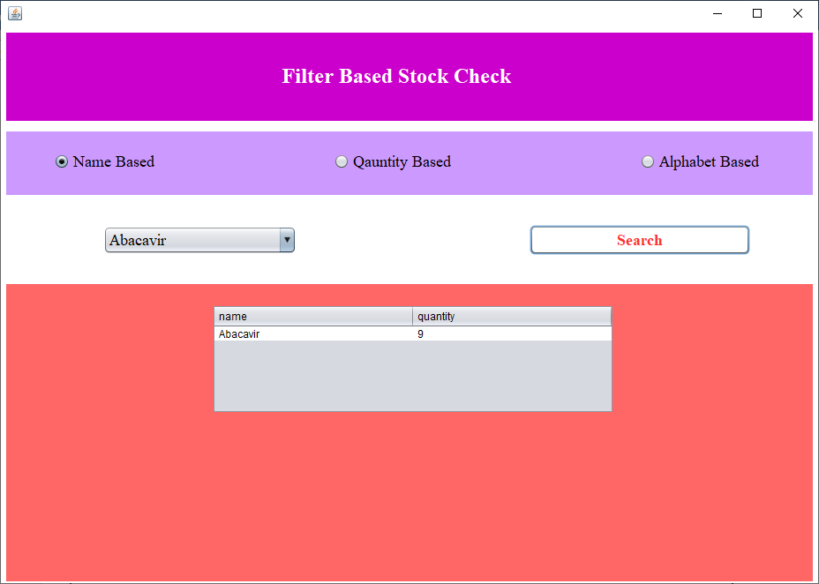

And the selected data show in the table. This table is manage by the rs.jar file. This file basically downloaded over the internet and attached with the netbean.

**ii)Quantity based**

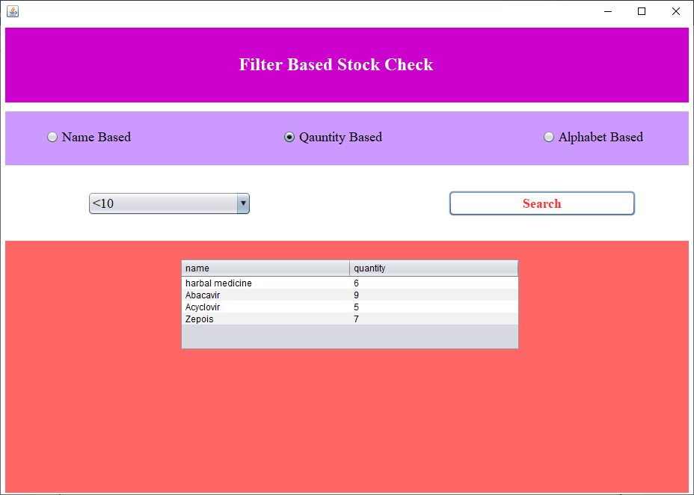

**iii) Alphabetical Based**

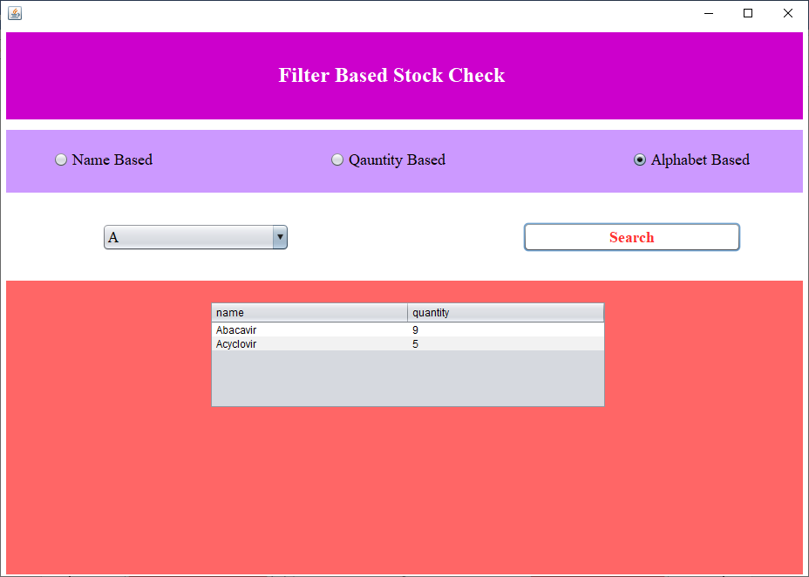

Other important frame id stock entry frame.

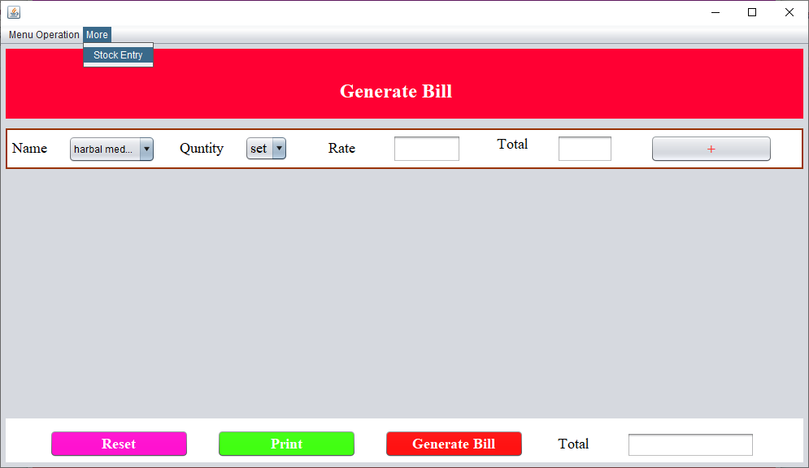

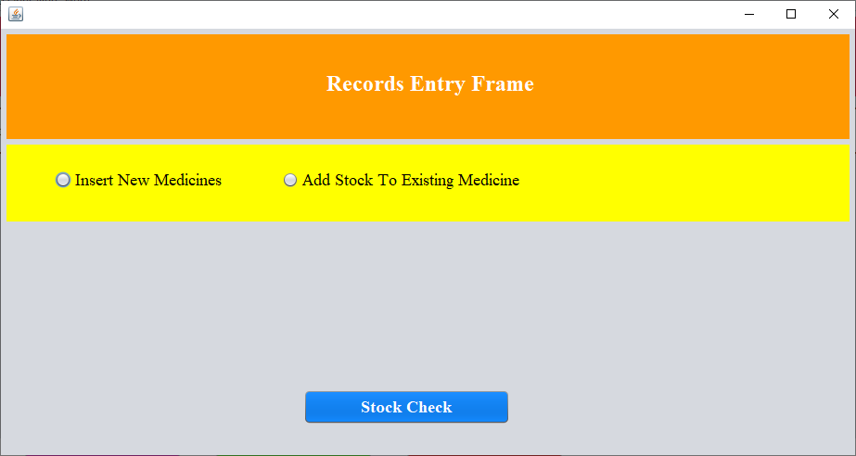

This frame used to add the new or existing medicines in the database.

i)For new medicines.

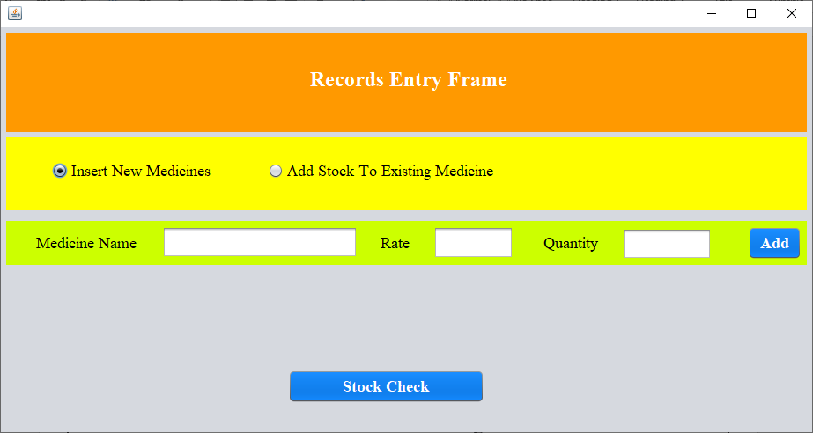

ii) for existing medicines.

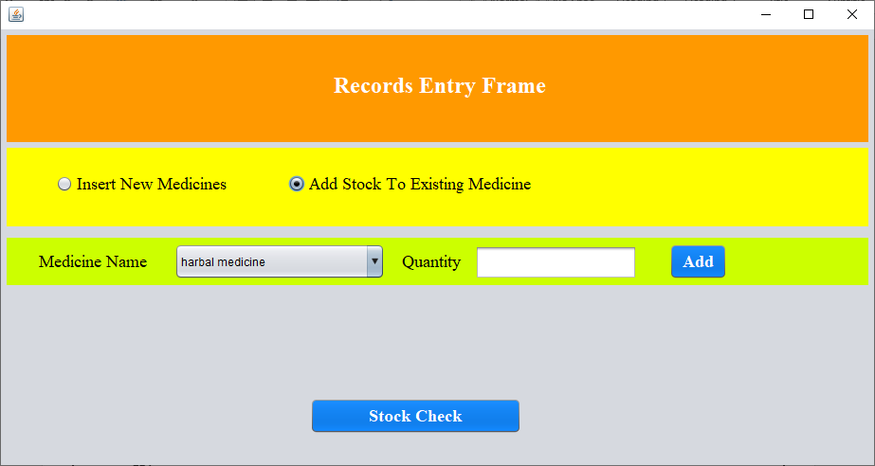

**Print Frame:**

When we click on the print it print the bill of the selected medicines.

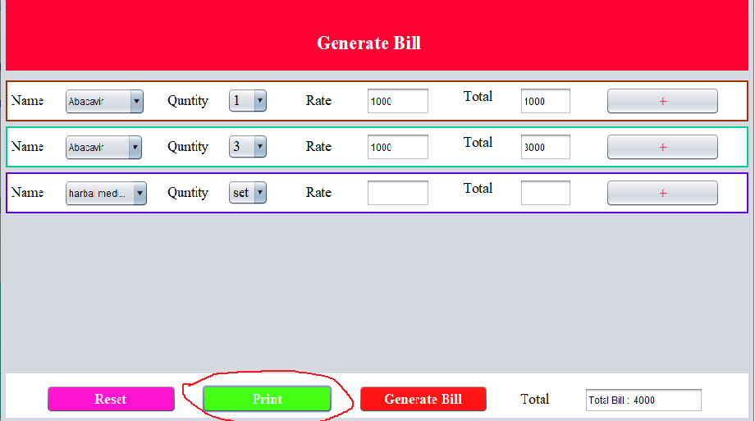

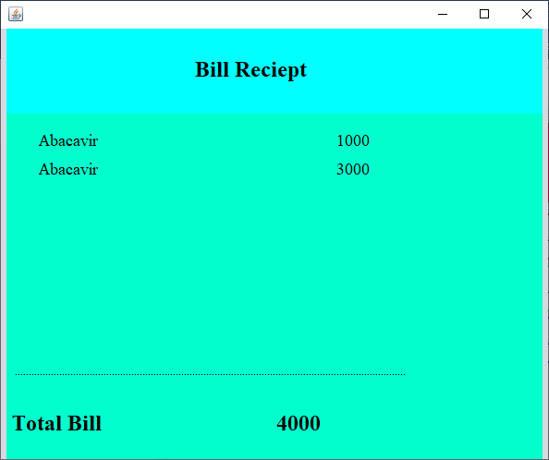

**Reset Button its used for reset the current bill and able to generate new bill.**

**Advantage:**

1. **The project is basically very useful for manage the medical store.**
2. **It’s make it easy to manage all the available medicines record in the medical store.**
3. **Helps to check the stock of the store.**
4. **Add the new medicines in the store.**
5. **Easy to create the bill and print the bill.**

**Disadvantage:**

1. **The project contains the only six bill panel at a time so if we want to add more medicines for bill so this feature its not available in the project.**
2. **GUI not attractive. And if this project its deliver to any newbie those are not know the technology they are feel difficultly to manage.**
3. **In the project very few features are available. So it’s good to modified it with some extra features like order the medicines, and add the medicines using the medicines bar code.**

**Modification:**

1. **In the Current project if I add same name of the medicines its allows me not gives any message for this.**

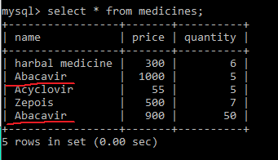

1. **And medicines goes in the negative no. but it is the fall of the project medicines quantity never should be negative no.**

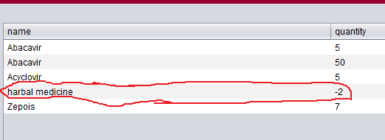

**Improvement:**

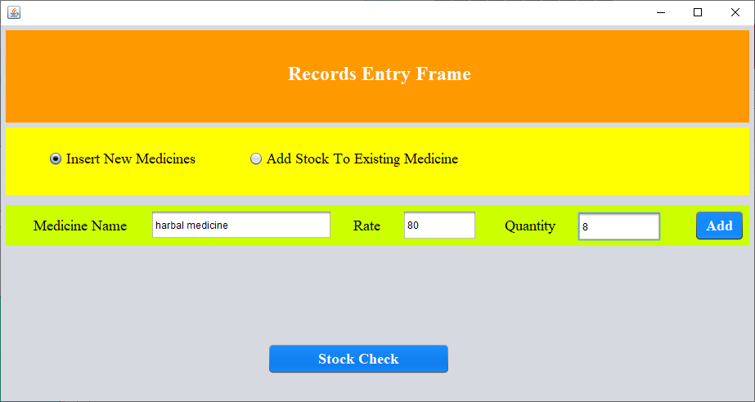

After make the name column as the primary key, its works fine

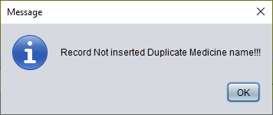

After modification in the updateDataBase()

Its working fine now medicines quantity not contains the negative values.

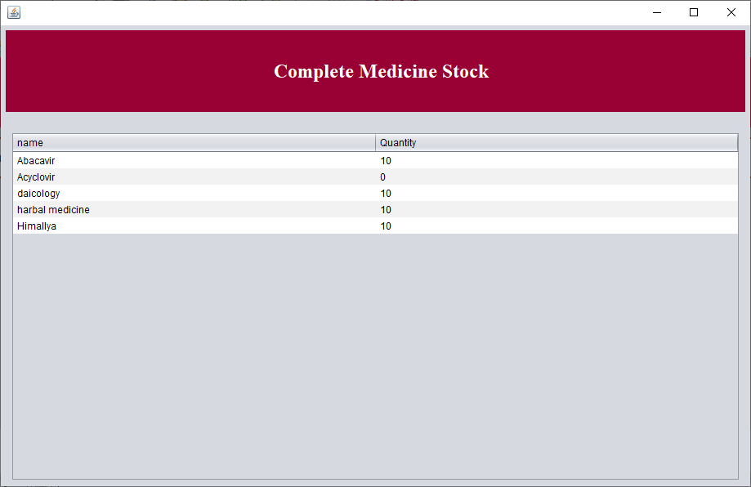

Now after selecting the medicines its check the current quantity of the selected medicine name and if quantity its 0 its gives the message.

