CE-4951 Experiment 1 – Laboratory Introduction and Digital Signal Line Coding including Manchester Coding

Performed Date: Sep 11, 2018

Submission Date: Sep 17, 2018

Instructor: Dr. Rothe

Performed by: Yahui Liang

Introduction:

In this lab, a pseudorandom binary sequence (PRBS) in various formats were measured by using the oscilloscope. By using Telecommunications Instructional Modeling System (TIMS), NRZ-L, NRZ-M, BIP-RZ, RZ-AMI, and Manchester PRBS were generated and measured to observe their characteristics. This report focuses on analyzing NRZ-L, BIP-RZ, and Manchester encoding format trade-offs in the later section.

Theoretical Solution:

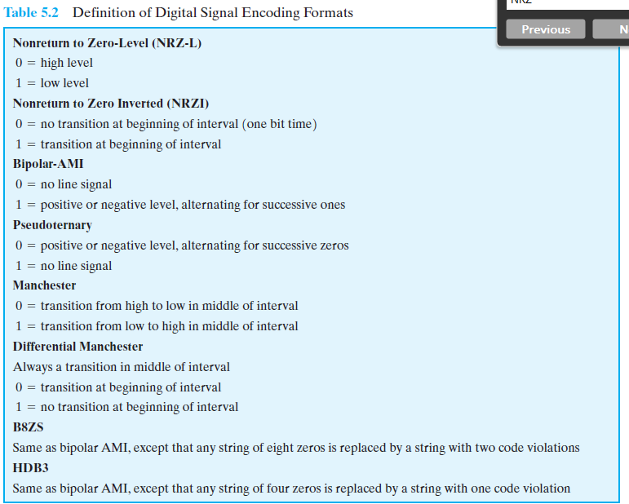

Figure 1: Definition of Digital Signal Encoding Formats. Cited from Stallings, W., Data and Computer Communications -Eighth Edition

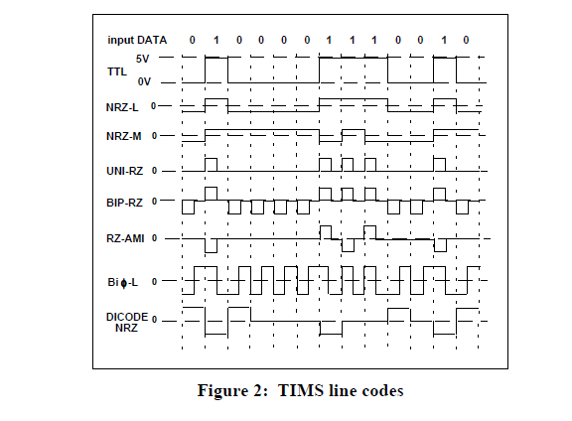

Figure 2: Digital Signal Encoding Formats. Cited from https://www.fiberoptics4sale.com/blogs/archive-posts/95040326-line-coding.

All laboratory results shown below should match with rules displayed here.

Laboratory Results and Analysis:

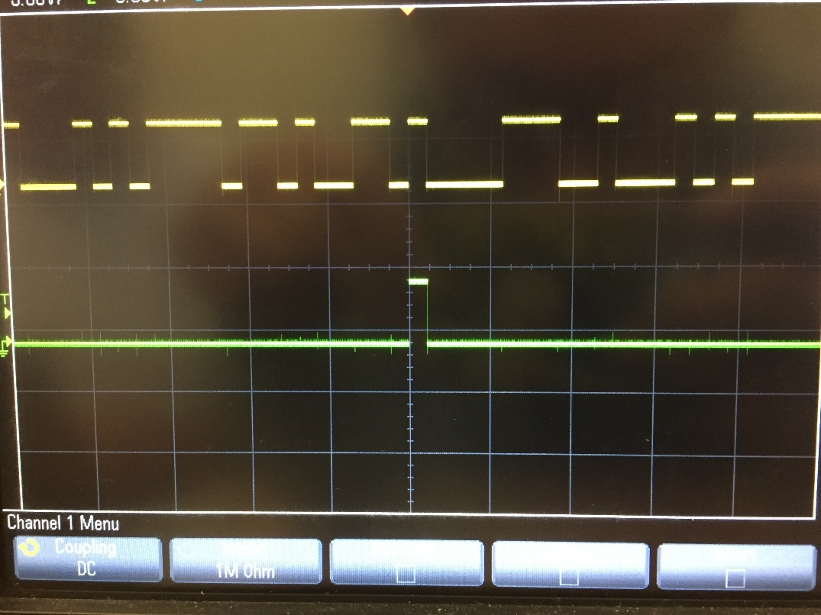



Figure 3: 32-bit data sequence. Data was retrieved from station #6, S312.

From sections circled by red pen shown above, it can be observed that 32-bit data sequence repeated over time.

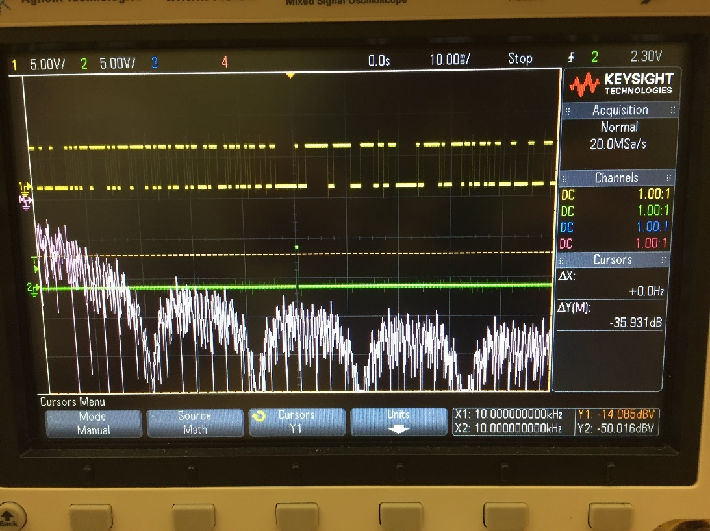

Figure 4: 2048-bit data sequence. Data was retrieved from station #6, S312.

The peak spectrum value in this case was estimated to be -14.085dBV.

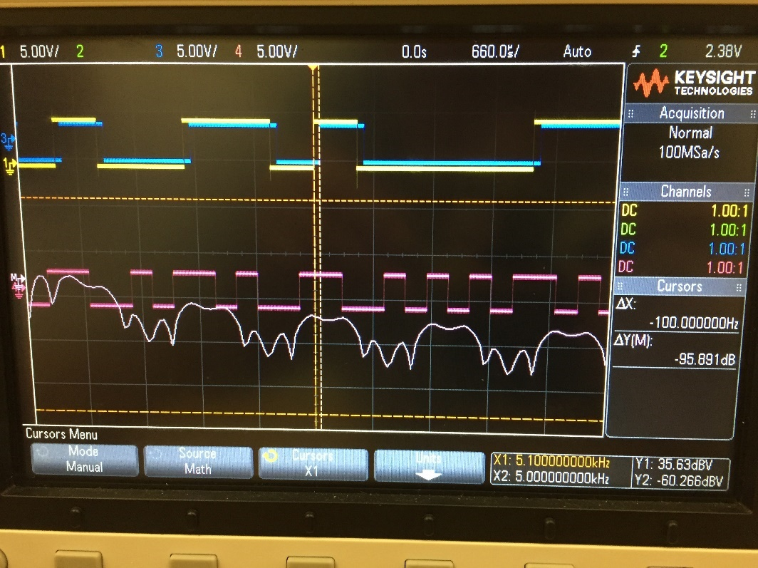

Figure 5: The comparison between the PRBS data signal and the NRZ-L line coder output. Data was retrieved from station #6, S312.

The output of PRBS data’s encoding format is NRZ-L. There is a tiny delay since some time was spent on transferring data between multiple devices.

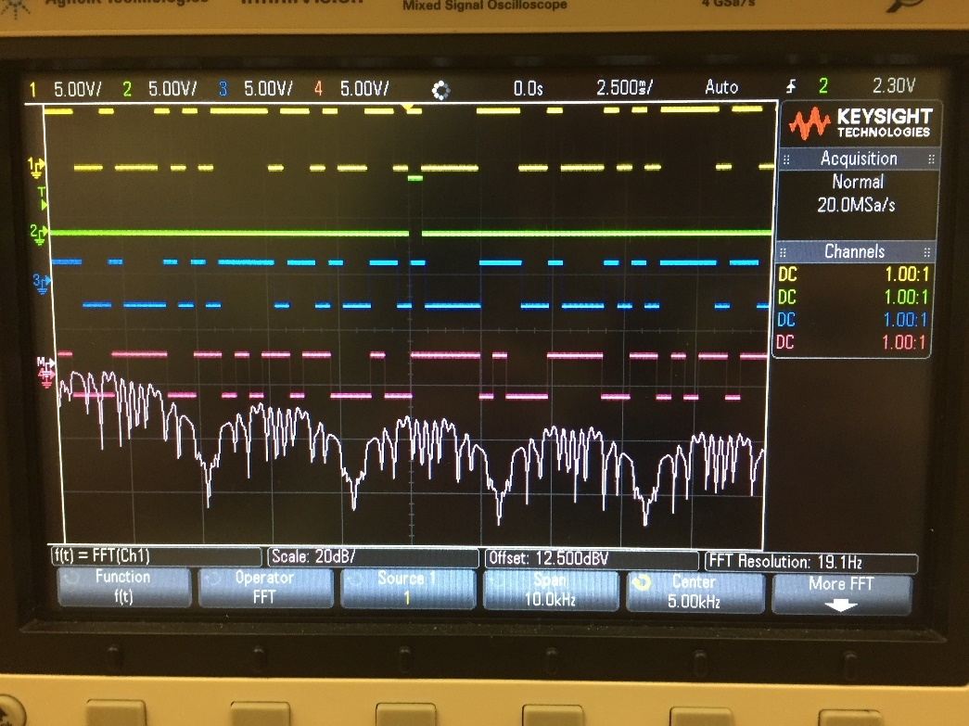

Figure 6: The comparison between the NRZ-L signal and the NRZ-M signal. Data was retrieved from station #6, S312.

The NRZ-M output matches well with the expected format shown in Figure 1. When NRZ-L switches from zero to one, the NRZ-M signal transited from zero to one or from one to zero at the beginning of the interval.

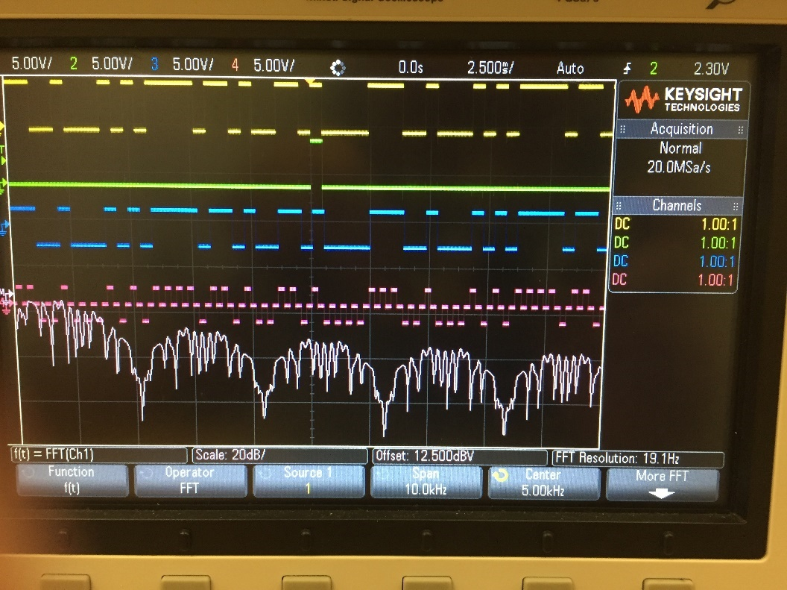

Figure 7: The comparison between the NRZ-L signal and the BIP-RZ signal. Data was retrieved from station #6, S312.

This graph also makes sense. The BIP-RZ first half of the interval is same as the NRZ-L signal (+1 means 1 and -1 means 0), and the last half of the interval is zero.

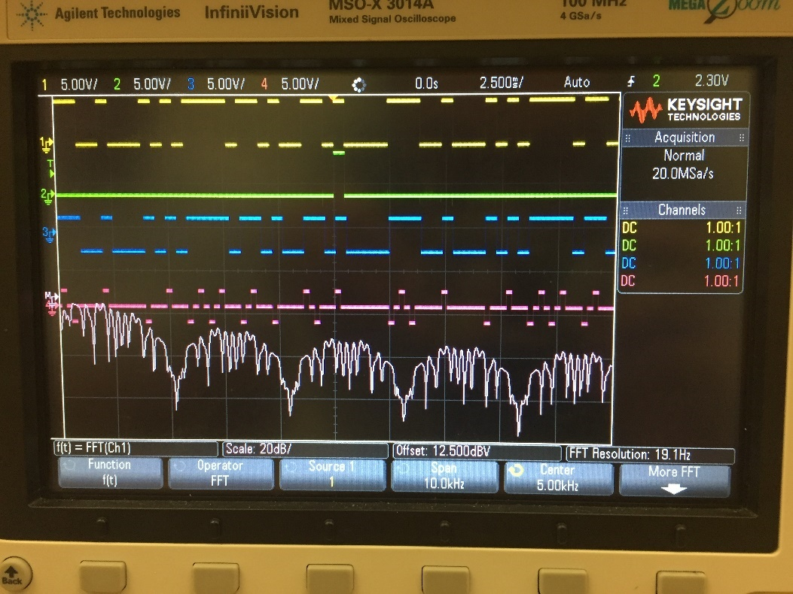

Figure 8: The comparison between the NRZ-L signal and the RZ-AMI signal. Data was retrieved from station #6, S312.

The RZ-AMI only transits when the bit is 1. The graph matches with this well.

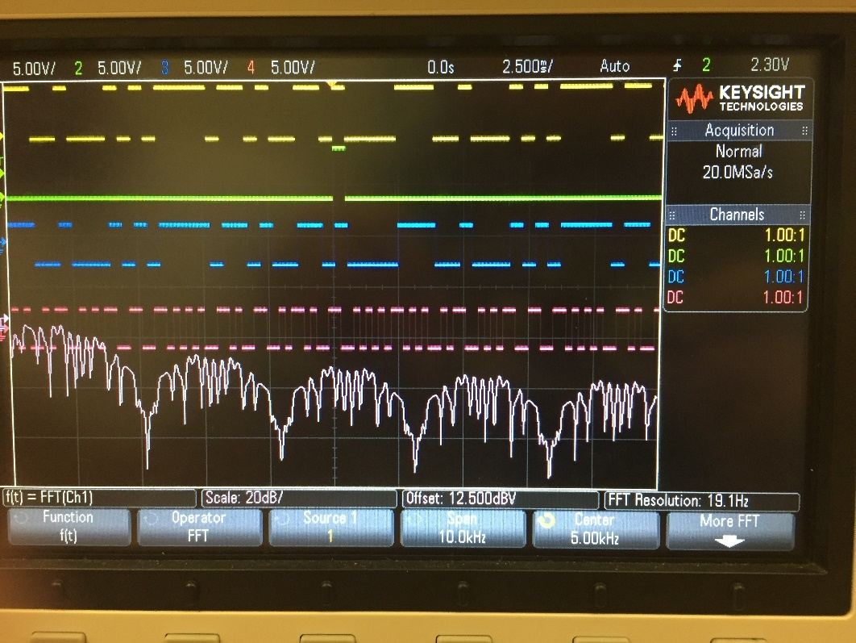

Figure 9: The comparison between the NRZ-L signal and the Manchester signal. Data was retrieved from station #6, S312.

In the screenshot, when the NRZ-L signal output logic 1, the Manchester signal had the falling edge in the middle of the interval; also, when the NRZ-L signal output logic 0, the Manchester signal had the rising edge in the middle of the interval. This is exactly same as the expectation.

Figure 10: Theoretical Frequency Spectrum



Figure 11: The actual frequency spectrum. Data was retrieved from station #6, S312.

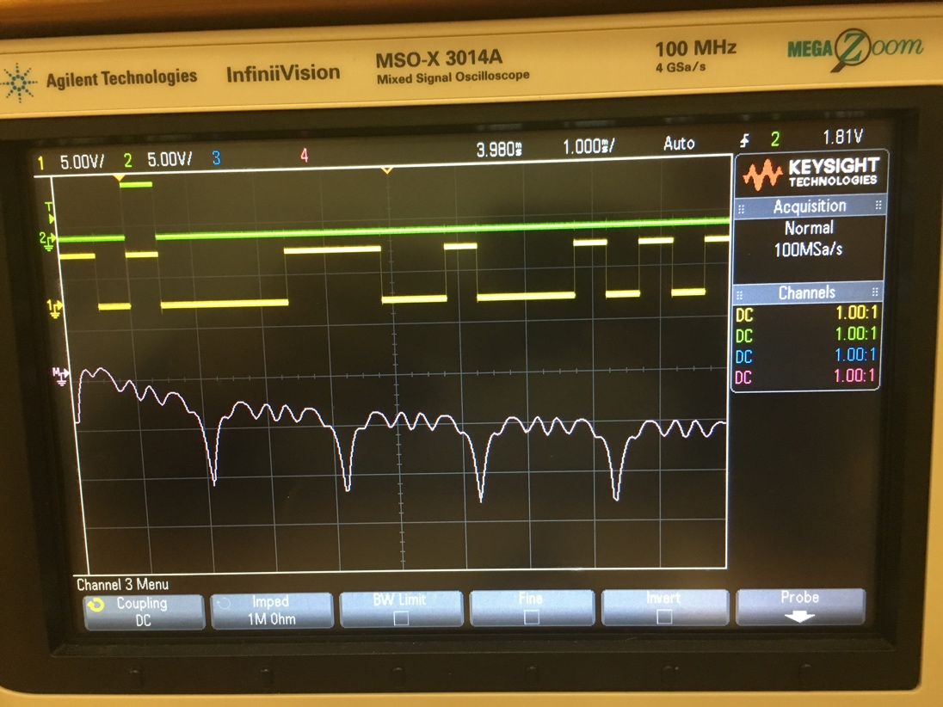

Figure 12: The actual frequency spectrum with less data. Data was retrieved from station #6, S312.

From comparing three figures shown above, main trends of spikes are similar with each other. However, there are much noise in the actual measurement. The reason which caused this was that the spectrum frequency for each data bit (or different sequences) can varies all the time in the reality (it is impossible to have multiple sequences to have the same spectrum frequency, and it is only in the ideal situation), and more variance will be included if there are more data added into the measurement.

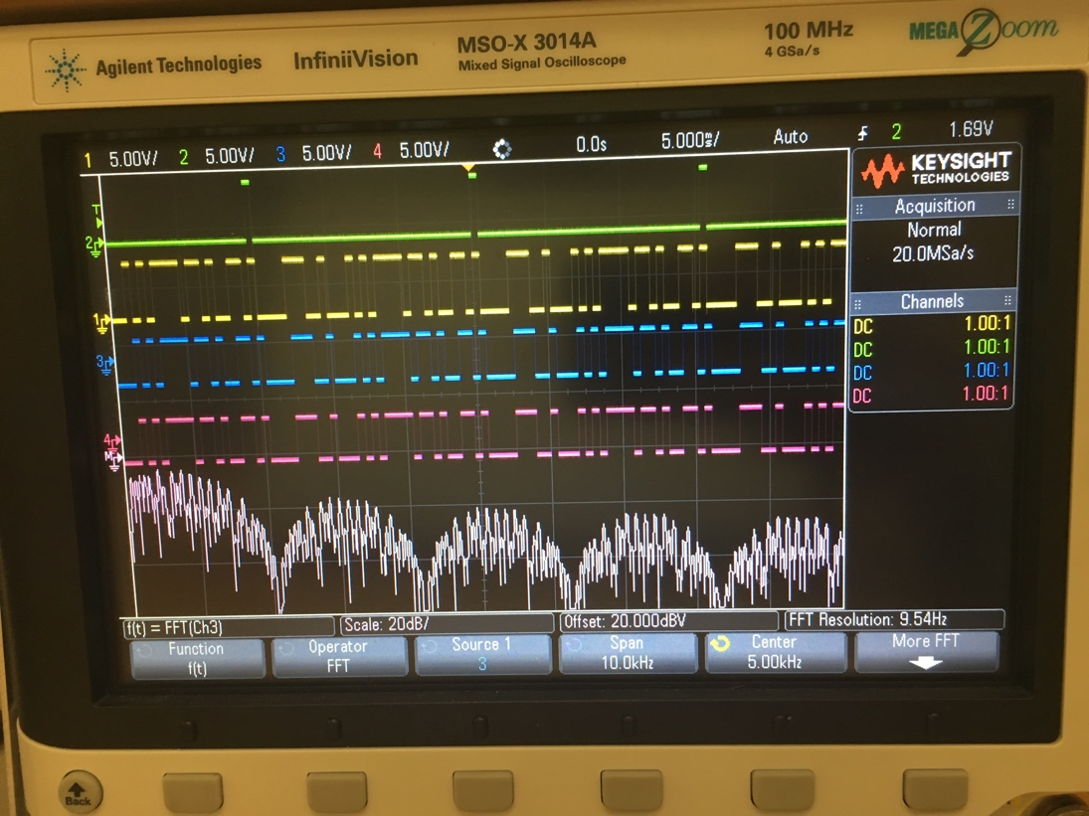

Figure 13: The NRZ-L signal frequency spectrum. Data was retrieved from station #6, S312.

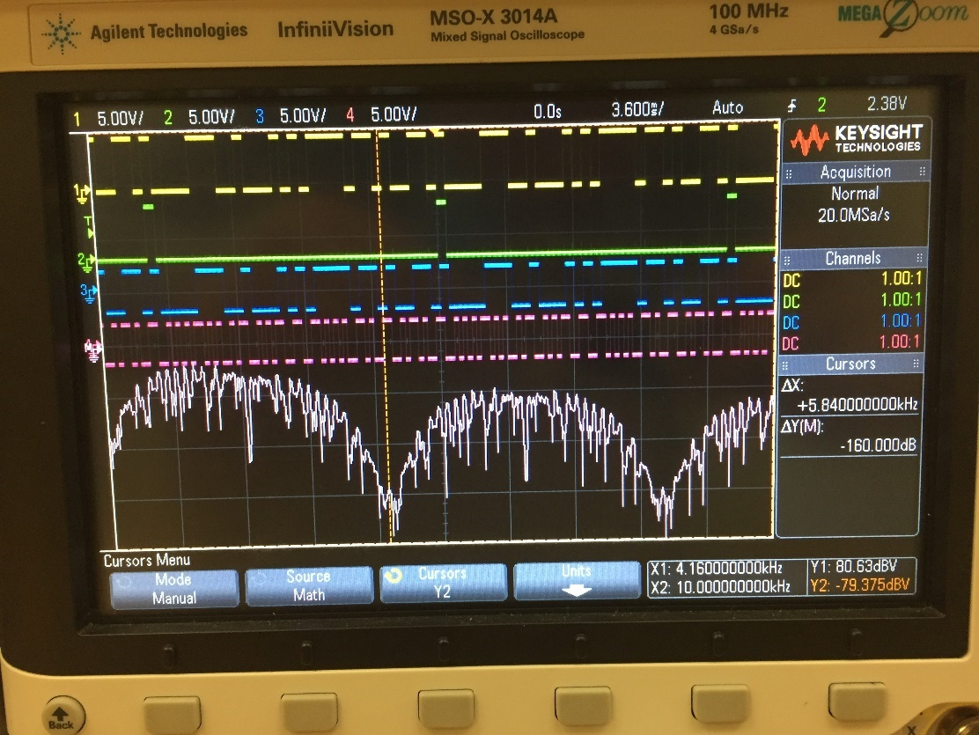

Figure 14: The Manchester frequency spectrum. Data was retrieved from station #6, S312.

The bandwidth of the Manchester encoding is two times larger than the NRZ-L encoding. The reason that the Manchester has the larger bandwidth is because its encoding condition gets triggered every half of the interval. For example, if 1 needs to be encoded, the signal should be transited at the beginning of the interval to make sure the signal can have a rising edge or a falling edge in the middle of the interval. Therefore, the Manchester’s bandwidth is two times higher than the clock frequency. In contrast, the NRZ-L signal only triggers the encoding condition at the beginning of the interval or once per clock period (0 is high level, and 1 is low level), so it’s bandwidth is between zero and the clock frequency.

The NRZ-L signal has the DC component since the decibel voltage is not zero (and it is just at the peak) when the frequency is zero. Manchester has the small DC component based on the figure shown above, but it should have no DC component based on the Wikipedia explanation. The reason can be the unstable connection to the ground, and this brings bias into the measurement.

Since the bandwidth of the Manchester signal is two times higher than the normal clock frequency, it is able to transfer extra things besides data. The Manchester encoding does not remain high or low more than one period, so this makes transferring clock and data in one transmission to be possible. By having the clock encoded in the transmission, the size of the wire can be reduced. This encoding format is commonly used in Ethernet, like video transferring, chat room, etc.

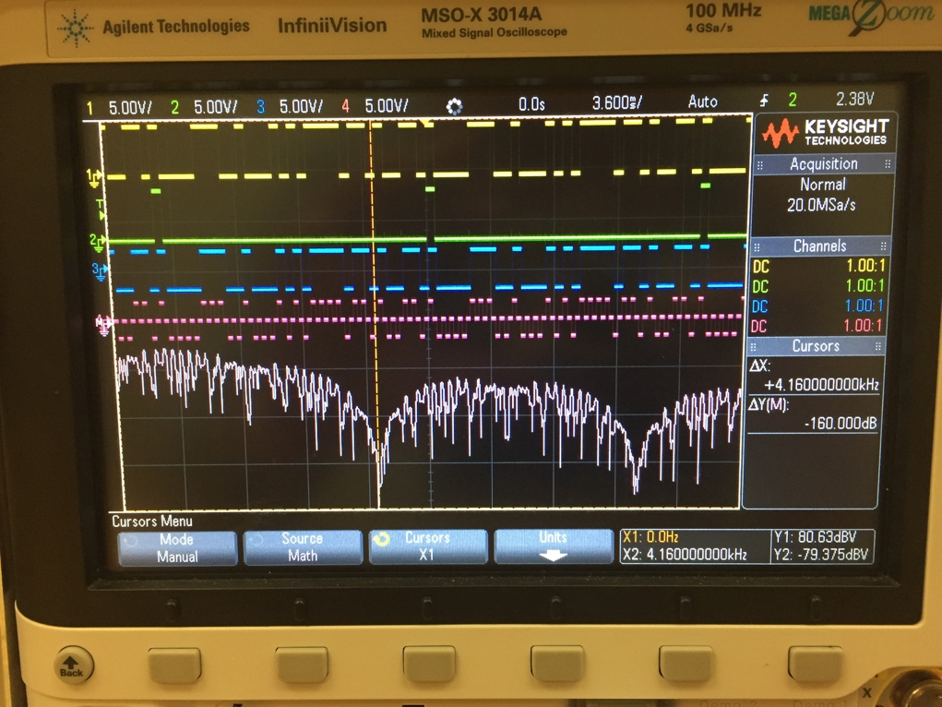

Figure : The frequency spectrum of the BIP-RZ signal. Data was retrieved from station #6, S312.

The BIP-RZ signal is similar with the Manchester signal that it does not have the DC component. Also, it only takes half of the interval to encode the data bit, and the other half will be left as zero. There are no consecutive 0s or 1s occur in the signal, so it is self-clocking. Similar with Manchester, it can be used for the high speed internet transferring.

However, both BIP-RZ and Manchester have the higher band width, this means more noise signals under unexpected frequencies are transferred.

Conclusion:

From this lab, different encoding formats were observed and their frequency spectrums were analyzed. It can be concluded that frequency spectrum significantly reveals bandwidths of encodings: signals with clocks encoded both have the wider bandwidth (two times greater) than signals without clocks encoded. None of signals are ideal, so frequency spectrums always have much noises in measurements.