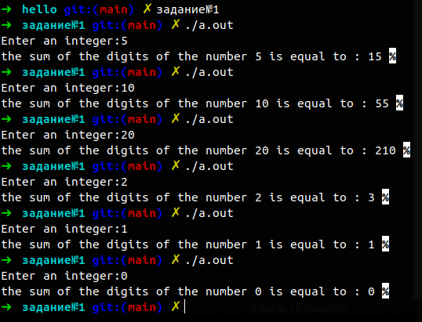
start
Set : a ; sum = 0;
Input : a ;
I < =a
I = 0 ; i<=a i++
Sum + = I ;
The end
Output = sum
no
yes

