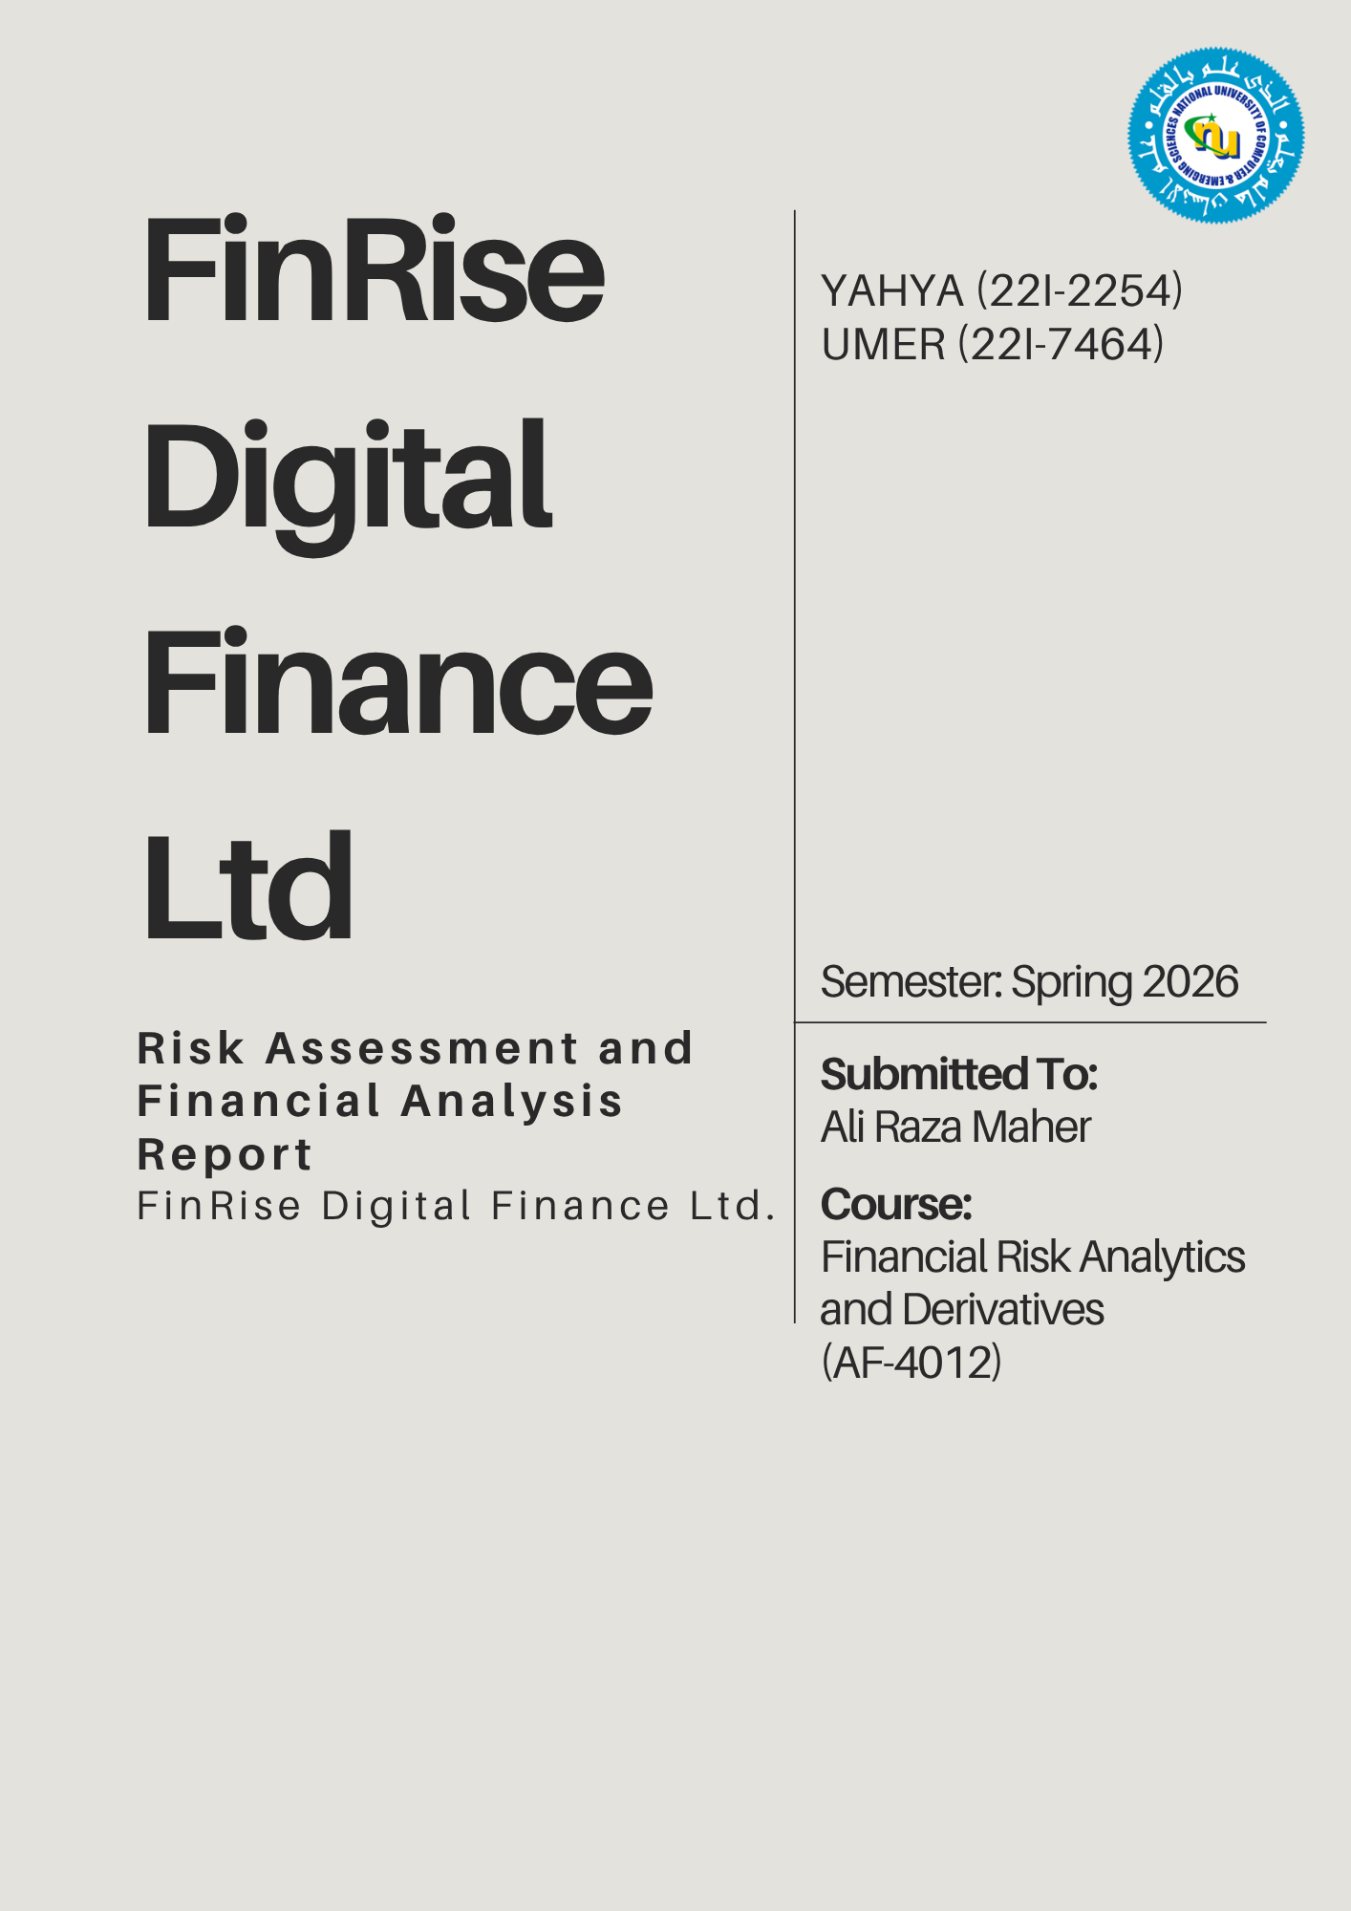

Table of Contents
Part 1: Risk Management Report 1
Introduction 1
Key Risks Faced by FinRise 1
1. Credit Risk 1
2. Market (Investment) Risk 1
3. Liquidity Risk 1
4. Operational Risk 1
5. Model Risk 2
6. Information Asymmetry 2
7. Legal & Compliance Risk 2
Part 2: Investment Portfolio Report 3
Part 3: Credit Risk Modelling 5

Part 1: Risk Management Report
To The Chief Risk Officer,

Introduction
FinRise Digital Finance Ltd is a fintech firm that provides nano-lending services through a digital platform and invests in the PSX. While the model enables fast and accessible services, it also exposes the company to multiple risks which are addressed below. Identifying said risks and managing them is essential for ensuring long-term sustainability and regulatory compliance.

Key Risks Faced by FinRise
- Credit Risk
Credit Risk is one of the most significant risks for FinRise, as it arises from the possibility that borrowers may fail to repay their loans. The company primarily targets freelancers, gig workers and small merchants (as addressed in the background of the company) who often have unstable or irregular income streams. This increases the likelihood of default, which supports the emerging concern raised that the default rate is increasing. Additionally, the absence of collateral in nano-lending further amplifies the firm’s exposure to potential losses.
During analysis of the dataset, it was shown that there’s variation in borrower credit scores and employment history, which indicates inconsistent repayment capacity, supporting the presence of higher default risk within the loan portfolio.
- Market (Investment) Risk
FinRise also invests its surplus liquidity in financial assets, with a significant portion (55%) allocated to equities listed on the Pakistan Stock Exchange (PSX). Since equities are inherently volatile, fluctuations in the market prices can lead to substantial losses in the investment portfolio. This exposes the firm to market risk, particularly during periods of economic instability.
The firm has a relatively high-risk concentration in volatile assets, as 55% of investment is exposed to equities on PSX.
- Liquidity Risk
Liquidity risk arises when the company is unable to meet its short-term financial obligations. Rapid growth in loan demand may lead to large cash outflows, potentially creating funding shortages. If FinRise does not maintain sufficient liquid reserves, it may struggle to continue lending operations or meet withdrawal and operational requirements.
- Operational Risk
This risk basically stems from failures in systems, processes, or external events. As a fully digital platform, FinRise relies heavily on technology, making it very vulnerable to system failures, cyberattacks, and technical disruptions. Any breakdown in the platform can interrupt lending services and negatively impact customer experience and trust.

- Model Risk
FinRise uses AI-driven credit scoring models to evaluate borrowers. While these models improve efficiency, they introduce model risk. Errors such as biased data, incorrect assumptions or overfitting can result in inaccurate credit decisions. Since these decisions are automated and applied at scale, even small errors can lead to significant losses.
Since the model relies on limited variables such as credit score and employment data, any inaccuracies or missing information in the dataset can lead to flawed predictions at scale
- Information Asymmetry
This occurs when borrowers’ possess more information about their financial condition than the lender. In the case of FinRise, many users have limited or unreliable financial histories, and variables such as credit scores or employment data may not fully capture their true repayment capacity. This will create some hidden risk and making credit risk assessment more difficult.
Looking at the dataset, although variables such as credit score and employment duration are available, they may not capture the borrower’s true financial behavior, reinforcing the problem of information asymmetry.
- Legal & Compliance Risk
FinRise operates under the regulatory frameworks of SECP & SBP, so they must comply with strict rules related to lending practices, consumer protection and data usage. Failure to comply with these regulations can result in penalties or restrictions, making compliance risk a critical concern.
Answers to CRO’s Questions
- Why is risk management particularly important for fintech firms?
Fintech firms rely on automated systems and scale rapidly, so even small errors can lead to major losses. Risk management ensures stability, compliance and customer trust.
- How does information asymmetry affect digital lending?
Borrowers may have better knowledge of their financial conditions, leading to higher-risk individuals getting loans and increasing default rates.
- What risks arise from automated credit scoring systems?
Biased or incomplete data can lead to incorrect lending decisions, and errors can scale quickly, causing significant losses.

These risks are interconnected, and failure to manage one may amplify others, highlighting the need for a comprehensive risk management framework.

Regards,
Risk Management Team
FinRise Digital Finance Ltd.

Part 2: Investment Portfolio Report

Part 3: Credit Risk Modelling

