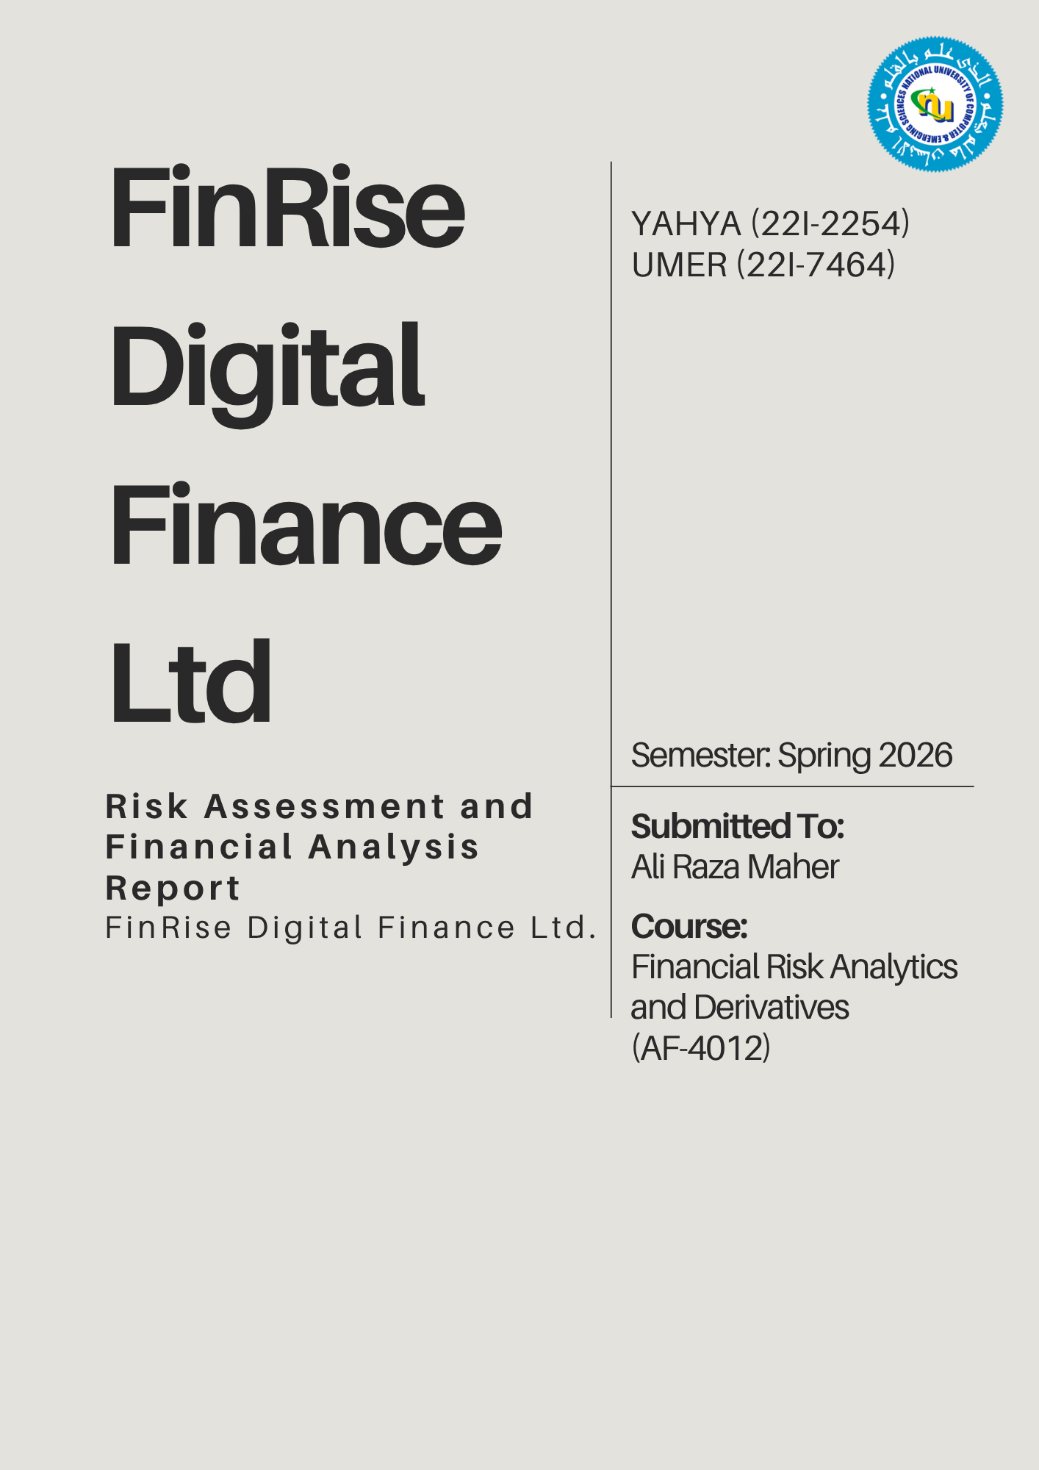

Table of Contents
Part 1: Risk Management Report 1
Introduction 1
Key Risks Faced by FinRise 1
1. Credit Risk 1
2. Market (Investment) Risk 1
3. Liquidity Risk 1
4. Operational Risk 1
5. Model Risk 2
6. Information Asymmetry 2
7. Legal & Compliance Risk 2
Answers to CRO’s Questions 2
Part 2: Investment Portfolio Report 3
1. Executive Summary 3
2. Portfolio Composition 3
3. Portfolio Risk Analysis 4
4. Recommendation to Management 4
Part 3: Credit Risk Modelling 5
1. Introduction 5
2. Data Exploration & Cleaning 5
3. Model Development 5
4. Model Evaluation 5
5. PD and Threshold Optimization (+ Optimal Portfolio) 6
6. Key Insights 6
7. Recommendations & Conclusion 6

Part 1: Risk Management Report
To The Chief Risk Officer,

Introduction
FinRise Digital Finance Ltd is a fintech firm that provides nano-lending services through a digital platform and invests in the PSX. While the model enables fast and accessible services, it also exposes the company to multiple risks which are addressed below. Identifying said risks and managing them is essential for ensuring long-term sustainability and regulatory compliance.

Key Risks Faced by FinRise
- Credit Risk
Credit Risk is one of the most significant risks for FinRise, as it arises from the possibility that borrowers may fail to repay their loans. The company primarily targets freelancers, gig workers and small merchants (as addressed in the background of the company) who often have unstable or irregular income streams. This increases the likelihood of default, which supports the emerging concern raised that the default rate is increasing. Additionally, the absence of collateral in nano-lending further amplifies the firm’s exposure to potential losses.
During analysis of the dataset, it was shown that there’s variation in borrower credit scores and employment history, which indicates inconsistent repayment capacity, supporting the presence of higher default risk within the loan portfolio.
- Market (Investment) Risk
FinRise also invests its surplus liquidity in financial assets, with a significant portion (55%) allocated to equities listed on the Pakistan Stock Exchange (PSX). Since equities are inherently volatile, fluctuations in the market prices can lead to substantial losses in the investment portfolio. This exposes the firm to market risk, particularly during periods of economic instability.
The firm has a relatively high-risk concentration in volatile assets, as 55% of investment is exposed to equities on PSX.
- Liquidity Risk
Liquidity risk arises when the company is unable to meet its short-term financial obligations. Rapid growth in loan demand may lead to large cash outflows, potentially creating funding shortages. If FinRise does not maintain sufficient liquid reserves, it may struggle to continue lending operations or meet withdrawal and operational requirements.
- Operational Risk
This risk basically stems from failures in systems, processes, or external events. As a fully digital platform, FinRise relies heavily on technology, making it very vulnerable to system failures, cyberattacks, and technical disruptions. Any breakdown in the platform can interrupt lending services and negatively impact customer experience and trust.

- Model Risk
FinRise uses AI-driven credit scoring models to evaluate borrowers. While these models improve efficiency, they introduce model risk. Errors such as biased data, incorrect assumptions or overfitting can result in inaccurate credit decisions. Since these decisions are automated and applied at scale, even small errors can lead to significant losses.
Since the model relies on limited variables such as credit score and employment data, any inaccuracies or missing information in the dataset can lead to flawed predictions at scale
- Information Asymmetry
This occurs when borrowers’ possess more information about their financial condition than the lender. In the case of FinRise, many users have limited or unreliable financial histories, and variables such as credit scores or employment data may not fully capture their true repayment capacity. This will create some hidden risk and making credit risk assessment more difficult.
Looking at the dataset, although variables such as credit score and employment duration are available, they may not capture the borrower’s true financial behavior, reinforcing the problem of information asymmetry.
- Legal & Compliance Risk
FinRise operates under the regulatory frameworks of SECP & SBP, so they must comply with strict rules related to lending practices, consumer protection and data usage. Failure to comply with these regulations can result in penalties or restrictions, making compliance risk a critical concern.

Answers to CRO’s Questions
- Why is risk management particularly important for fintech firms?
Fintech firms rely on automated systems and scale rapidly, so even small errors can lead to major losses. Risk management ensures stability, compliance and customer trust.
- How does information asymmetry affect digital lending?
Borrowers may have better knowledge of their financial conditions, leading to higher-risk individuals getting loans and increasing default rates.
- What risks arise from automated credit scoring systems?
Biased or incomplete data can lead to incorrect lending decisions, and errors can scale quickly, causing significant losses.

These risks are interconnected, and failure to manage one may amplify others, highlighting the need for a comprehensive risk management framework.

Regards,
Risk Management Team
FinRise Digital Finance Ltd.

Part 2: Investment Portfolio Report
FinRise Digital Finance Ltd.
Investment Portfolio Report Format
To: Chief Risk Officer (CRO) and Chief Financial Officer (CFO)
From: Risk Analytics Team (Syed Yahya Tariq, Muhammad Umer Raza)
Subject: Investment Portfolio Construction and Risk Assessment
Date: 11th April 2026
- Executive Summary
Following the concerns raised by the senior management regarding the inefficient use of surplus liquidity, a portfolio has been constructed to better utilize the idle funds while maintaining controlled risk levels.
The total investment portfolio value as given is PKR 2 billion, which has been allocated across equities (55%), treasury bills (30%) and bank deposits (15%) as per the guidelines in Annexure-A.
The equity portion consist of five PSX-listed stocks: FFC, SAZEW, OGDC, MEBL and LUCK, selected while ensuring that sector exposure limits are not violated.






After performing optimization, the final portfolio achieved:
- Expected Return: 43.21%
- Portfolio Risk (Standard Deviation): 14.27%
- Sharpe Ratio: 1.98
This shows that the portfolio is generating strong returns relative to the level of risk taken. A key observation is that while equities contribute to higher returns, the presence of treasury bills and bank deposits helps in stabilizing overall portfolio performance.
- Portfolio Composition
Asset | Sector | Allocation
FFC | Fertilizer | 10.33%
SAZEW | Other | 12.32%
OGDC | Oil & Gas | 9.23%
MEBL | Banking & Finance | 21.93%
LUCK | Other | 1.18%
Treasury Bills | Government | 30.00%
Bank Deposits | Banking | 15.00%
Table 1 Optimized Portfolio Allocation
The portfolio strictly follows all constraints defined in Annexure-A:
- Equity allocation is maintained at 55%
- Treasury bills and deposits meet the required minimum allocations
- No individual stock exceeds 25% of total portfolio
- Sector exposure limits are maintained within the defined thresholds
Special care was taken in managing exposure to the “Other” sector, ensuring that the combined weight of SAZEW and LUCK remains within the allowed limit.
- Portfolio Risk Analysis
The risk of the portfolio was calculated using the covariance matrix of stock returns along with the assigned weights.
- Portfolio Standard Deviation: 14.27%
This level of risk reflects the volatility coming from equity investments. However, diversification across multiple sectors helps reduce overall risk, since different sectors react differently to market conditions, the overall volatility is reducedmove exactly together.
Additionally, the inclusion of treasury bills and bank deposits plays an important role in stabilizing the portfolio, as these instruments provide relatively fixed and predictable returns.
The Sharpe ratio of 1.98 indicates that the portfolio is performing well on a risk-adjusted basis. It shows that the return generated is significantly higher than the risk-free rate, making the portfolio efficient.
- Recommendation to Management
Based on the analysis, the proposed portfolio is suitable for FinRise Digital Finance Ltd.
The portfolio:
- Complies with all SBP and SECP exposure limits
- Maintains a balance between risk and return
- Efficiently utilizes surplus liquidity
It is recommended that management adopt this portfolio structure for investing idle funds.
However, the following points should be considered going forward:
- Equity markets are volatile, so periodic review and rebalancing of the portfolio is necessary
- Sector exposure should be monitored regularly to ensure continued compliance
- Risk management practices should be updated as market conditions change
Overall, the portfolio improves the utilization of surplus liquidity while maintaining prudent risk levels, aligning well with the firm’s objectives.

Regards,
Risk Management Team
FinRise Digital Finance Ltd.

Part 3: Credit Risk Modelling
To: Chief Risk Officer (CRO) and Chief Financial Officer (CFO)
From: Risk Analytics Team (Syed Yahya Tariq, Muhammad Umer Raza)
Subject: Credit Risk Modeling for Nano-Lending Platform
Date: 11th April 2026

1.Introduction
As highlighted in the case study, the primary risk faced by FinRise lies in its nano-lending operations, particularly due to rising default rates among borrowers. This report develops a data-driven credit risk model to estimate the Probability of Default (PD) and optimize lending decisions. The objective is to support risk-adjusted lending while maintaining profitability.

2. Data Exploration & Cleaning
The dataset was imported into Python and the target variable “defaulted” (1 = default, 0 = repaid) was identified. Initial exploration involved checking data types, missing values, and summary statistics. Missing numerical values were handled using median imputation, while categorical variables such as employment type were converted into numerical form using one-hot encoding. Outliers were treated using the IQR method, and features were standardized to improve model performance.

3. Model Development
A logistic regression model was used to estimate PD due to its suitability for binary classification and interpretability. The dataset was split into training and testing sets using stratified sampling to preserve class distribution. Feature scaling and class weighting were applied to address differences in scale and class imbalance.
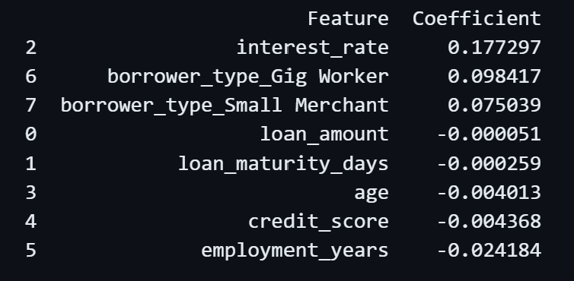
The model coefficients indicate the direction of impact of each variable on default probability. Variables associated with unstable income profiles tend to increase default risk, while more stable financial indicators reduce it. This aligns with FinRise’s observed exposure to higher-risk borrower segments.
Figure 1: Impact of Model Coefficients on Default Probability

4. Model Evaluation
The model was evaluated using the test dataset. The confusion matrix and accuracy provide an overview of prediction performance, while the ROC curve and AUC score assess the model’s ability to distinguish between defaulters and non-defaulters.
- The model gave an AUC score of “0.7189” which means that the model has good discriminatory power in distinguishing between defaulting and non-defaulting borrowers.
- As for the ROC curve, it is clearly above the diagonal line and rises steadily (shown in ipynb file). This means that the model is not perfect, but its meaningfully better than random guessing.

5. PD and Threshold Optimization (+ Optimal Portfolio)
Different PD thresholds were tested (e.g., 1% to 20%) due to relatively low predicted probabilities. For each threshold, the following metrics were computed; Expected Loss (EL), Saved Loss (from rejecting high-risk borrowers), Interest Income (from approved loans), Opportunity Cost (from rejecting good borrowers), Net Financial Impact.
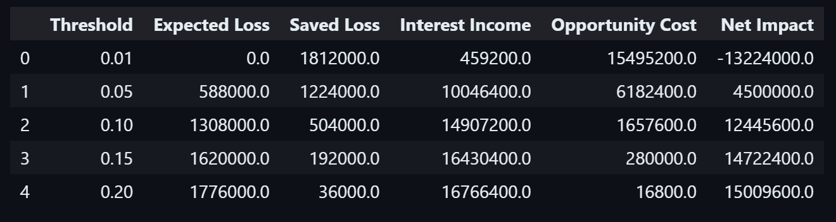
Figure 2: Financial Impact Across Different PD Thresholds
The optimal threshold is identified at PD = 0.20, where the net financial impact is maximized at approximately PKR 15.01 million. At this level, the model allows a higher number of loan approvals, resulting in the highest interest income, while the incremental increase in expected loss remains manageable. This indicates that a relatively less conservative lending strategy is more suitable for FinRise, given the model’s predictive capability.

6. Key Insights
The analysis shows that the nano-lending portfolio is highly imbalanced, with relatively few defaults but significant financial impact when they occur. The logistic regression model provides useful and interpretable risk signals. A clear trade-off exists between risk and profitability, where stricter thresholds reduce losses but limit revenue, while relaxed thresholds improve income at the cost of higher default exposure.

7. Recommendations & Conclusion
FinRise should adopt a PD-based lending strategy using the optimized threshold to improve credit decisions and portfolio quality. The model should be regularly updated and enhanced with additional behavioral data to improve accuracy. Continuous monitoring of borrower segments, especially higher-risk groups like gig workers, is essential. Overall, a data-driven approach enables FinRise to better balance profitability and risk while supporting sustainable growth.
Regards,
Risk Management Team
FinRise Digital Finance Ltd.

