**Table creation**

create database project;

use project;

create database project;

use project;

-- Table: Airlines

CREATE TABLE Airlines (

airline_code VARCHAR(10) PRIMARY KEY,

airline_name VARCHAR(100) NOT NULL

);

-- Table: Aircraft

CREATE TABLE Aircraft (

registration_number VARCHAR(20) PRIMARY KEY,

airline_code VARCHAR(10),

model_type VARCHAR(50),

capacity INT,

max_speed INT,

current_altitude INT,

speed INT,

location VARCHAR(100),

FOREIGN KEY (airline_code) REFERENCES Airlines(airline_code)

);

-- Table: Airports

CREATE TABLE Airports (

airport_code VARCHAR(10) PRIMARY KEY,

airport_name VARCHAR(100),

city VARCHAR(50),

country VARCHAR(50)

);

-- Table: Runways

CREATE TABLE Runways (

runway_id VARCHAR(10) PRIMARY KEY,

airport_code VARCHAR(10),

length INT,

width INT,

status VARCHAR(20), -- e.g., 'Available' or 'In Use'

FOREIGN KEY (airport_code) REFERENCES Airports(airport_code)

);

-- Table: Flights

CREATE TABLE Flights (

flight_number VARCHAR(20) PRIMARY KEY,

aircraft_id VARCHAR(20),

departure_time DATETIME,

arrival_time DATETIME,

origin VARCHAR(10),

destination VARCHAR(10),

status VARCHAR(20), -- e.g., 'On Time', 'Delayed'

FOREIGN KEY (aircraft_id) REFERENCES Aircraft(registration_number),

FOREIGN KEY (origin) REFERENCES Airports(airport_code),

FOREIGN KEY (destination) REFERENCES Airports(airport_code)

);

-- Table: Airspace

CREATE TABLE Airspace (

sector_id VARCHAR(10) PRIMARY KEY,

boundary_description TEXT

);

-- Table: AirTrafficControllers

CREATE TABLE AirTrafficControllers (

employee_id VARCHAR(20) PRIMARY KEY,

name VARCHAR(100),

contact_info VARCHAR(100),

sector_id VARCHAR(10),

FOREIGN KEY (sector_id) REFERENCES Airspace(sector_id)

);

-- Table: Weather

CREATE TABLE Weather (

weather_id INT PRIMARY KEY AUTO_INCREMENT,

location VARCHAR(100),

date_time DATETIME,

condition_description VARCHAR(200)

);

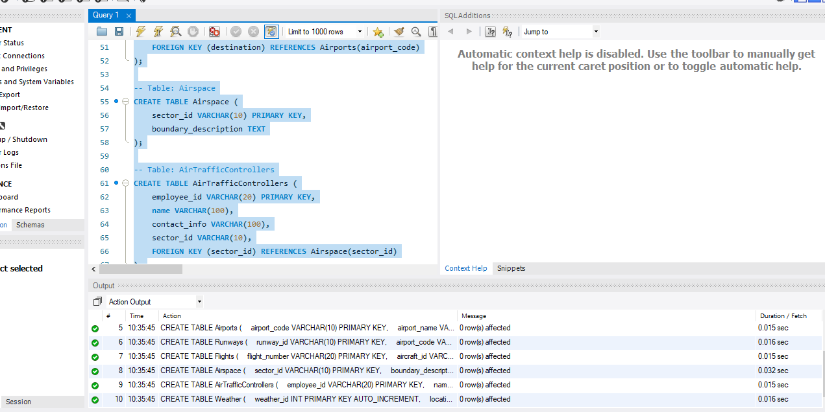

**Values insertion in each tables**

**-- Airlines**

INSERT INTO Airlines VALUES

('PK', 'Pakistan International Airlines'),

('EK', 'Emirates'),

('BA', 'British Airways'),

('QR', 'Qatar Airways'),

('AA', 'American Airlines'),

('SQ', 'Singapore Airlines'),

('LH', 'Lufthansa');

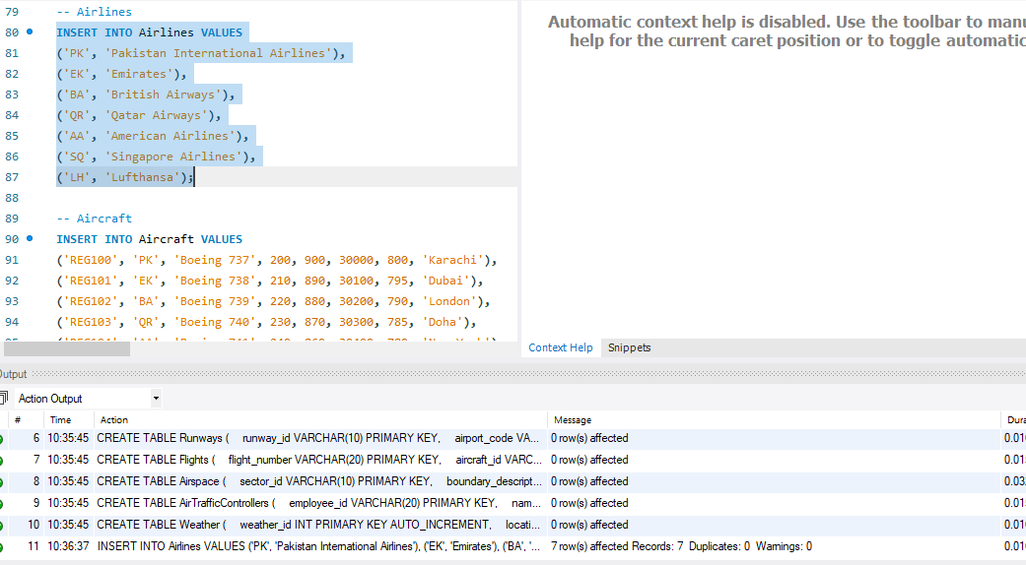

**-- Aircraft**

INSERT INTO Aircraft VALUES

('REG100', 'PK', 'Boeing 737', 200, 900, 30000, 800, 'Karachi'),

('REG101', 'EK', 'Boeing 738', 210, 890, 30100, 795, 'Dubai'),

('REG102', 'BA', 'Boeing 739', 220, 880, 30200, 790, 'London'),

('REG103', 'QR', 'Boeing 740', 230, 870, 30300, 785, 'Doha'),

('REG104', 'AA', 'Boeing 741', 240, 860, 30400, 780, 'New York'),

('REG105', 'SQ', 'Boeing 742', 250, 850, 30500, 775, 'Singapore'),

('REG106', 'LH', 'Boeing 743', 260, 840, 30600, 770, 'Berlin');

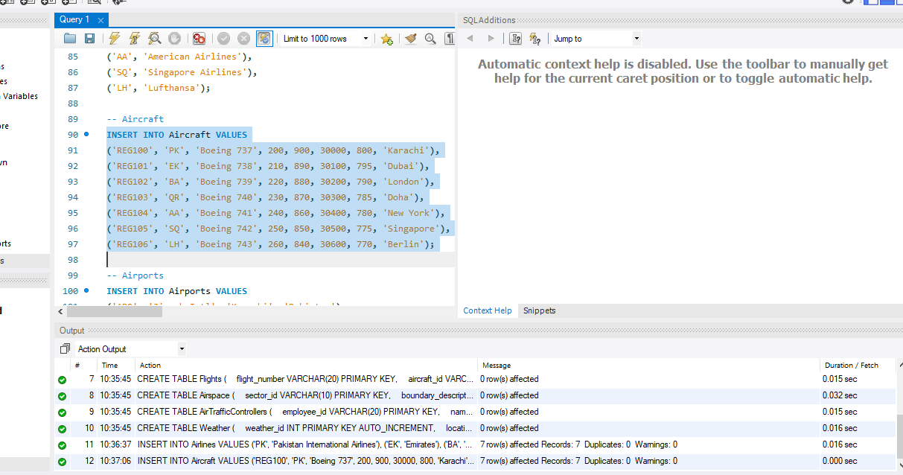

**-- Airports**

INSERT INTO Airports VALUES

('AP0', 'Jinnah Intl', 'Karachi', 'Pakistan'),

('AP1', 'Dubai Intl', 'Dubai', 'UAE'),

('AP2', 'Heathrow', 'London', 'UK'),

('AP3', 'Hamad Intl', 'Doha', 'Qatar'),

('AP4', 'JFK', 'New York', 'USA'),

('AP5', 'Changi', 'Singapore', 'Singapore'),

('AP6', 'Berlin Intl', 'Berlin', 'Germany');

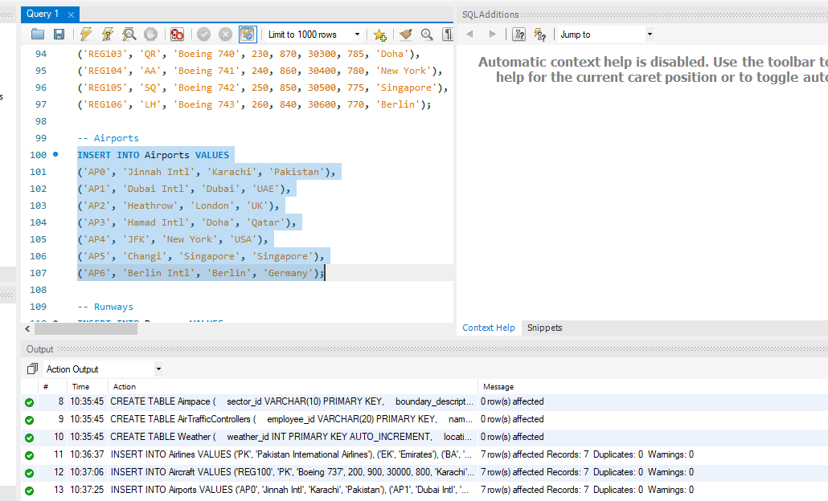

**-- Runways**

INSERT INTO Runways VALUES

('RWY0', 'AP0', 3000, 45, 'Available'),

('RWY1', 'AP1', 3100, 46, 'In Use'),

('RWY2', 'AP2', 3200, 47, 'Available'),

('RWY3', 'AP3', 3300, 48, 'In Use'),

('RWY4', 'AP4', 3400, 49, 'Available'),

('RWY5', 'AP5', 3500, 50, 'In Use'),

('RWY6', 'AP6', 3600, 51, 'Available');

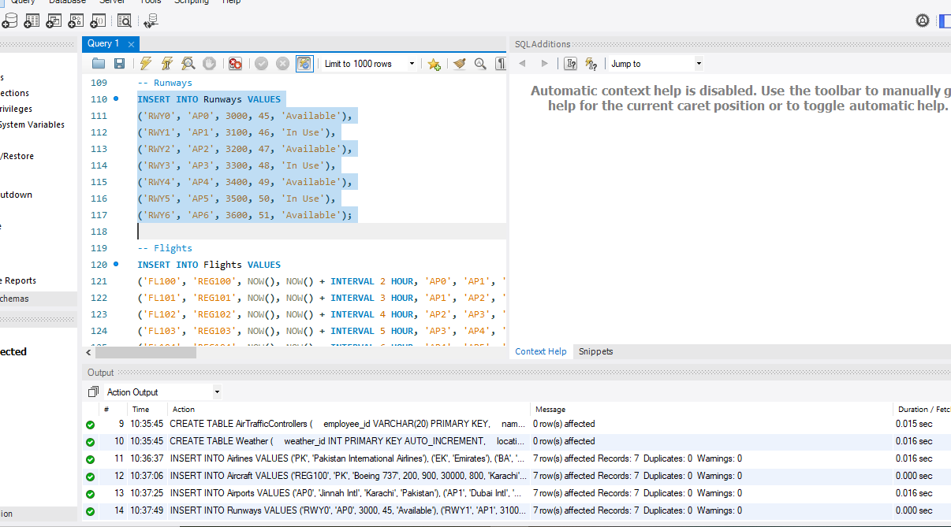

**-- Flights**

INSERT INTO Flights VALUES

('FL100', 'REG100', NOW(), NOW() + INTERVAL 2 HOUR, 'AP0', 'AP1', 'On Time'),

('FL101', 'REG101', NOW(), NOW() + INTERVAL 3 HOUR, 'AP1', 'AP2', 'Delayed'),

('FL102', 'REG102', NOW(), NOW() + INTERVAL 4 HOUR, 'AP2', 'AP3', 'On Time'),

('FL103', 'REG103', NOW(), NOW() + INTERVAL 5 HOUR, 'AP3', 'AP4', 'Delayed'),

('FL104', 'REG104', NOW(), NOW() + INTERVAL 6 HOUR, 'AP4', 'AP5', 'On Time'),

('FL105', 'REG105', NOW(), NOW() + INTERVAL 7 HOUR, 'AP5', 'AP6', 'Delayed'),

('FL106', 'REG106', NOW(), NOW() + INTERVAL 8 HOUR, 'AP6', 'AP0', 'On Time');

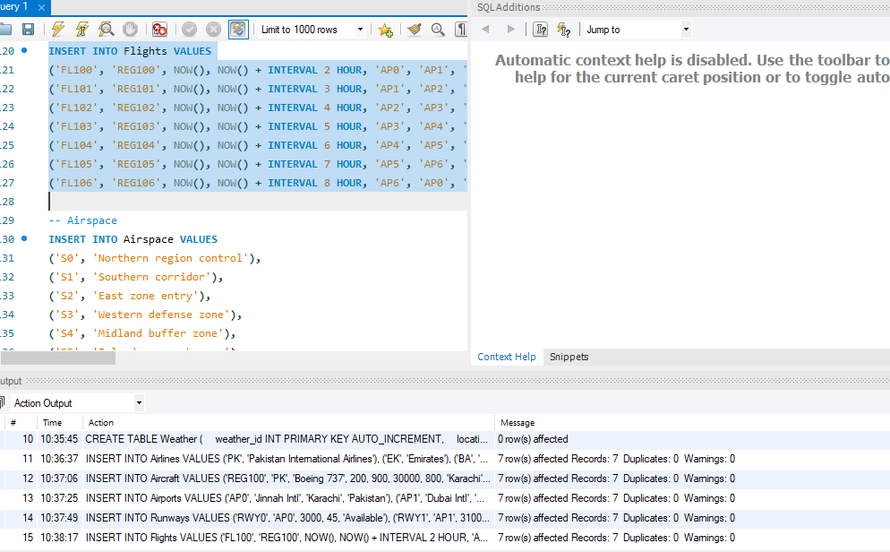

**-- Airspace**

INSERT INTO Airspace VALUES

('S0', 'Northern region control'),

('S1', 'Southern corridor'),

('S2', 'East zone entry'),

('S3', 'Western defense zone'),

('S4', 'Midland buffer zone'),

('S5', 'Island approach area'),

('S6', 'Mountainous airspace');

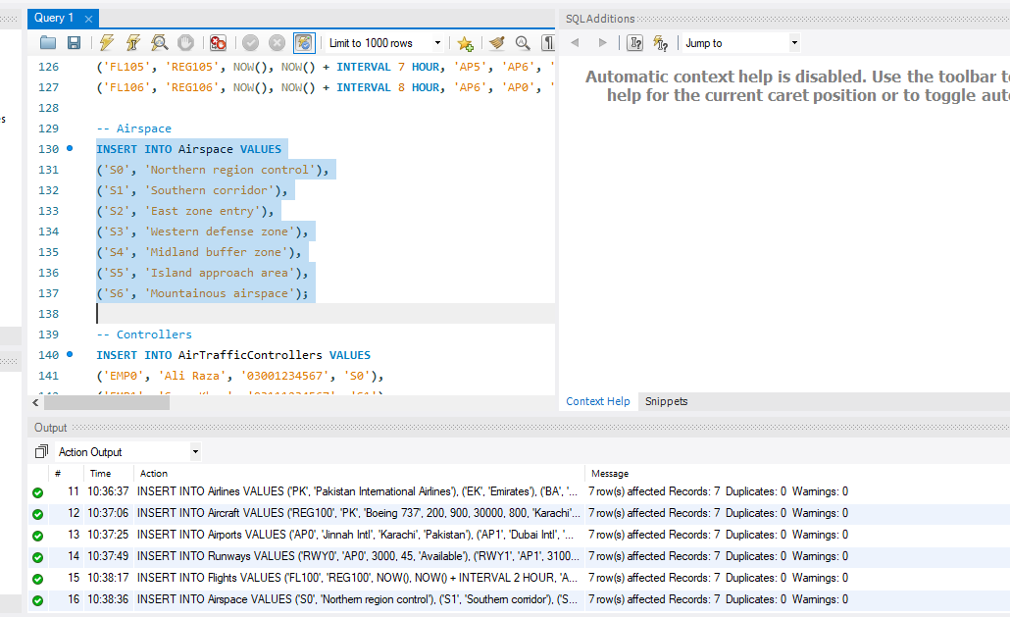

**-- Controllers**

INSERT INTO AirTrafficControllers VALUES

('EMP0', 'Ali Raza', '03001234567', 'S0'),

('EMP1', 'Sara Khan', '03111234567', 'S1'),

('EMP2', 'John Smith', '03221234567', 'S2'),

('EMP3', 'Maria Iqbal', '03331234567', 'S3'),

('EMP4', 'David Lee', '03441234567', 'S4'),

('EMP5', 'Hina Yousaf', '03551234567', 'S5'),

('EMP6', 'Ahmad Nadeem', '03661234567', 'S6');

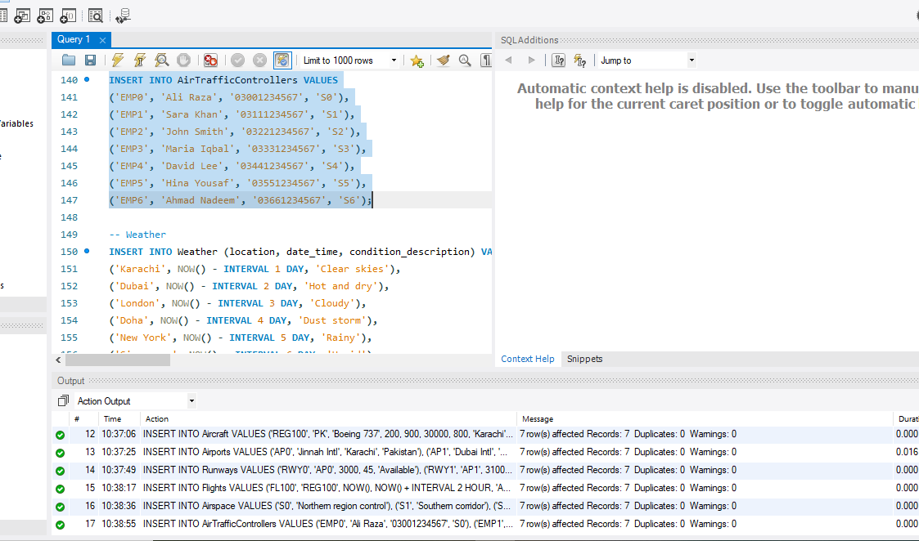

**-- Weather**

INSERT INTO Weather (location, date_time, condition_description) VALUES

('Karachi', NOW() - INTERVAL 1 DAY, 'Clear skies'),

('Dubai', NOW() - INTERVAL 2 DAY, 'Hot and dry'),

('London', NOW() - INTERVAL 3 DAY, 'Cloudy'),

('Doha', NOW() - INTERVAL 4 DAY, 'Dust storm'),

('New York', NOW() - INTERVAL 5 DAY, 'Rainy'),

('Singapore', NOW() - INTERVAL 6 DAY, 'Humid'),

('Berlin', NOW() - INTERVAL 7 DAY, 'Snowfall');

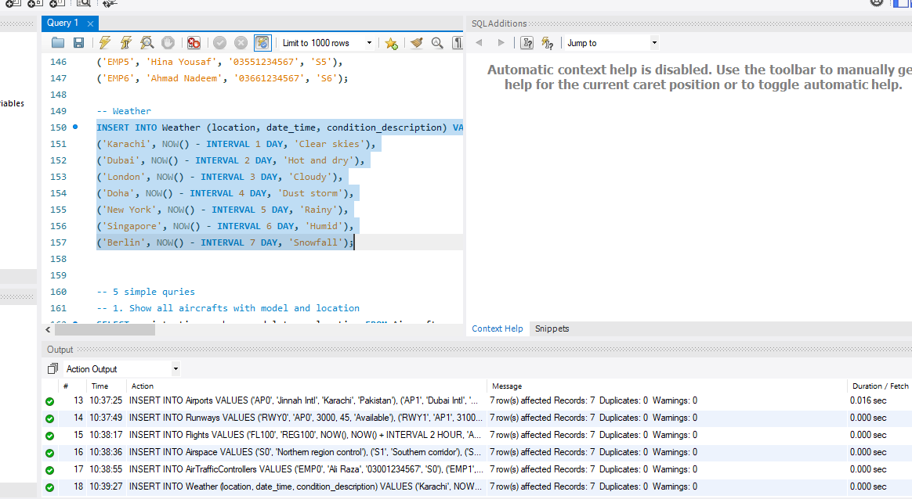

**-- 5 simple quries**

**-- 1. Show all aircrafts with model and location**

SELECT registration_number, model_type, location FROM Aircraft;

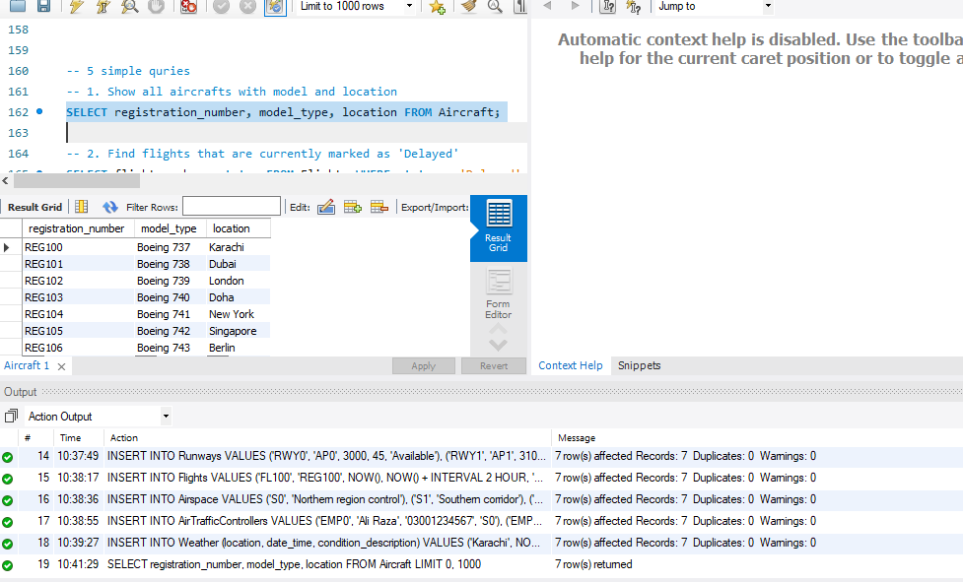

**-- 2. Find flights that are currently marked as 'Delayed'**

SELECT flight_number, status FROM Flights WHERE status = 'Delayed';

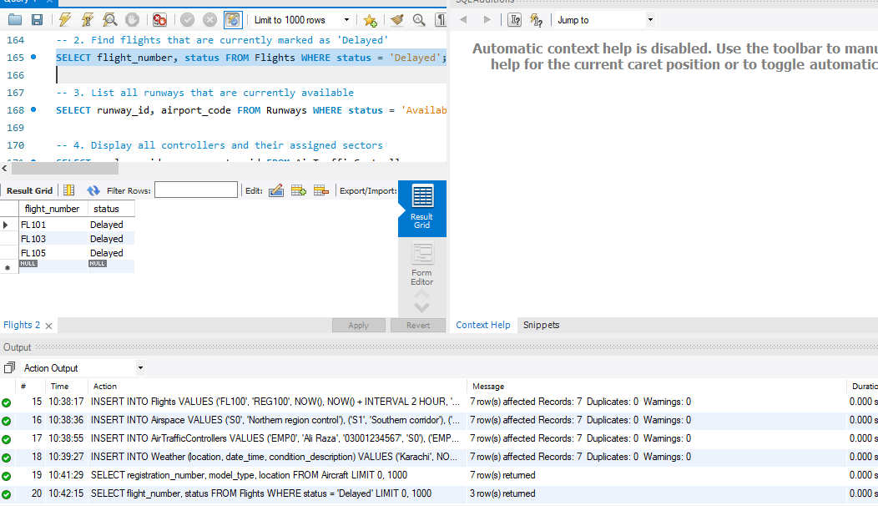

**-- 3. List all runways that are currently available**

SELECT runway_id, airport_code FROM Runways WHERE status = 'Available';

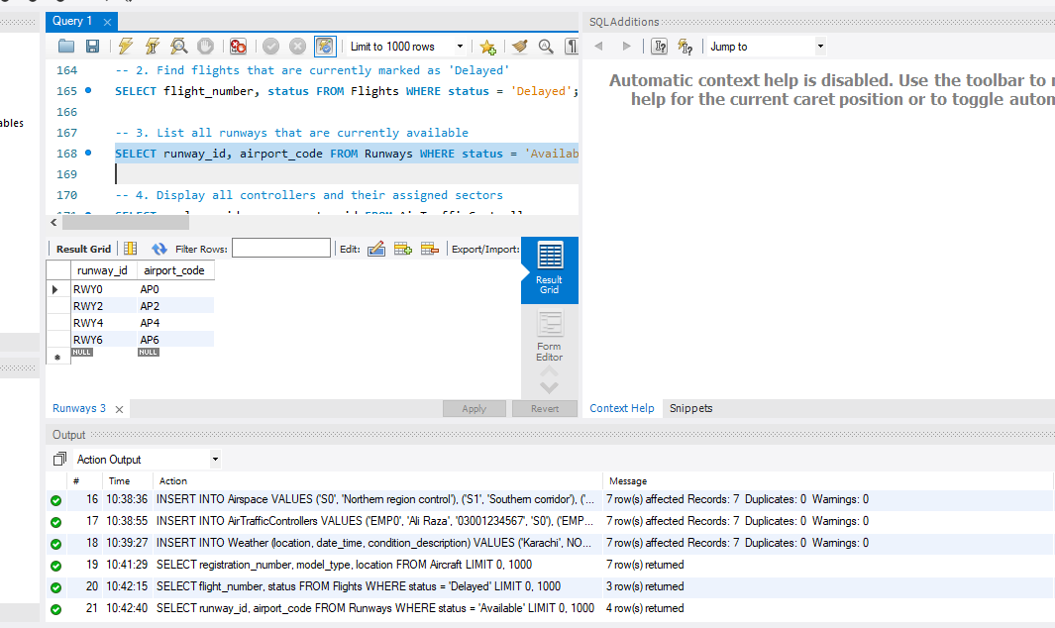

**-- 4. Display all controllers and their assigned sectors**

SELECT employee_id, name, sector_id FROM AirTrafficControllers;

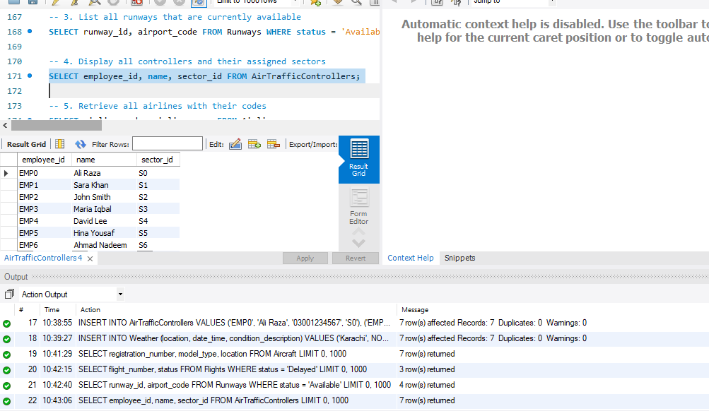

**-- 5. Retrieve all airlines with their codes**

SELECT airline_code, airline_name FROM Airlines;

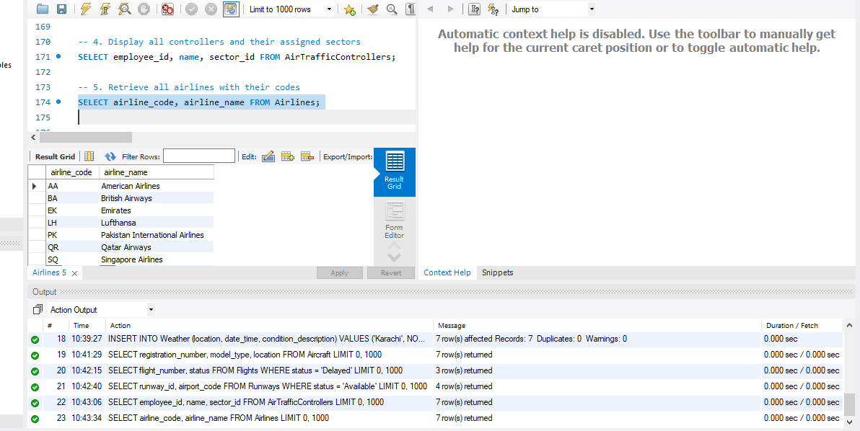

**-- 5 join quries**

**-- 1. List all flights with model type and airline name**

SELECT F.flight_number, A.model_type, L.airline_name

FROM Flights F

JOIN Aircraft A ON F.aircraft_id = A.registration_number

JOIN Airlines L ON A.airline_code = L.airline_code;

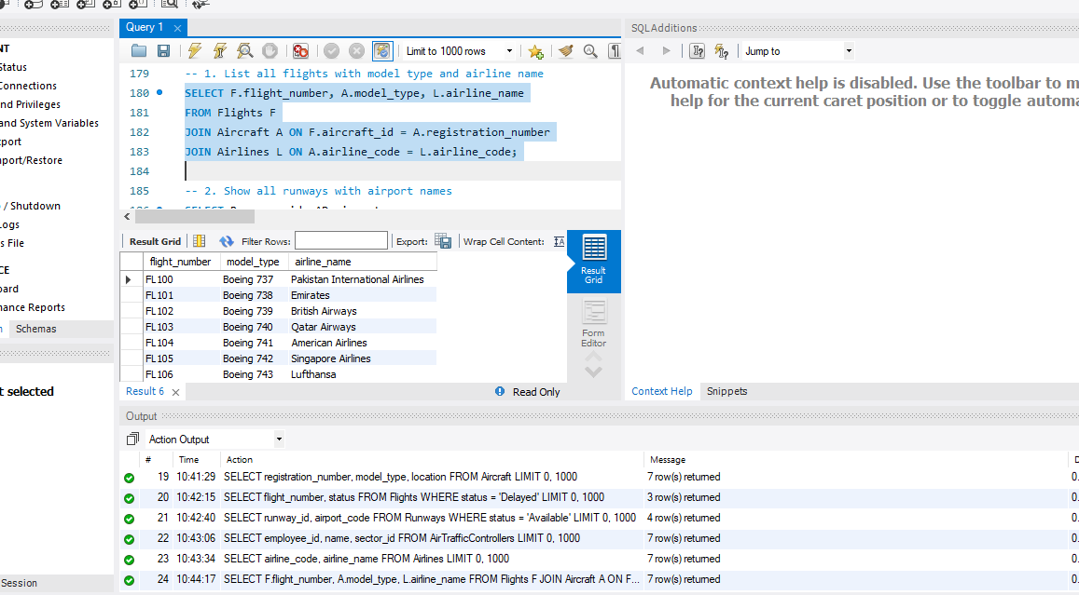

**-- 2. Show all runways with airport names**

SELECT R.runway_id, AP.airport_name

FROM Runways R

JOIN Airports AP ON R.airport_code = AP.airport_code;

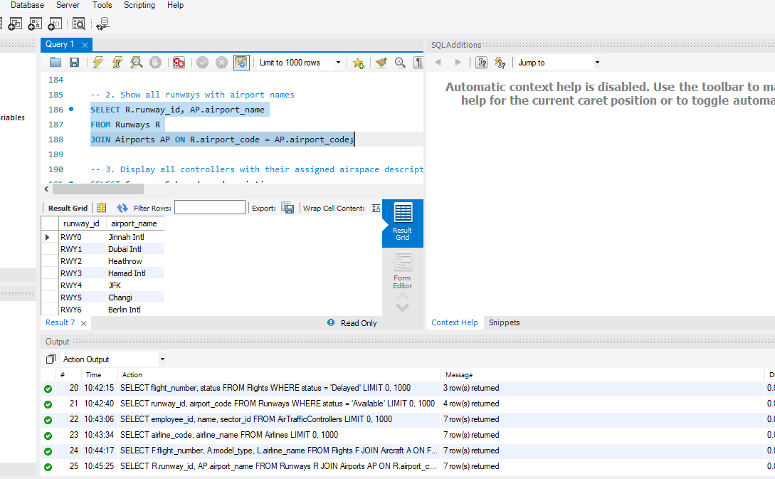

**-- 3. Display all controllers with their assigned airspace description**

SELECT C.name, S.boundary_description

FROM AirTrafficControllers C

JOIN Airspace S ON C.sector_id = S.sector_id;

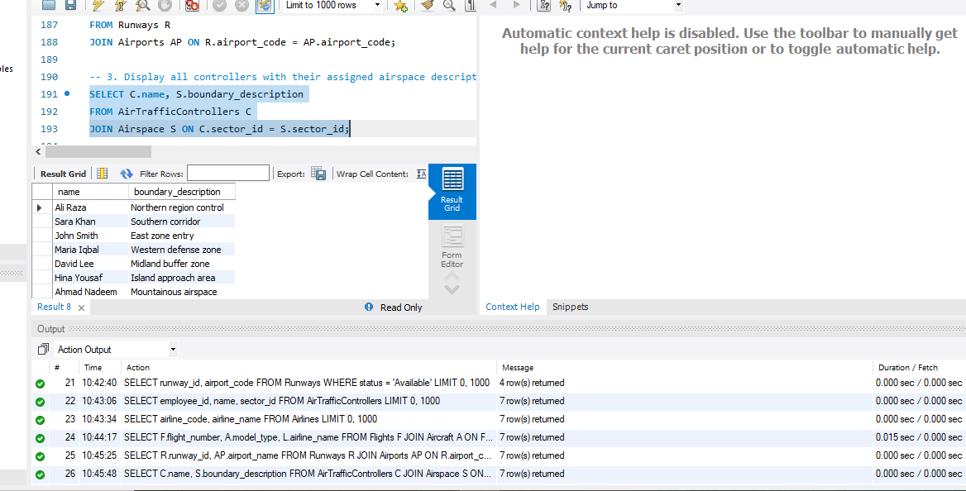

**-- 4. List each flight with origin and destination airport names**

SELECT F.flight_number, O.airport_name AS Origin, D.airport_name AS Destination

FROM Flights F

JOIN Airports O ON F.origin = O.airport_code

JOIN Airports D ON F.destination = D.airport_code;

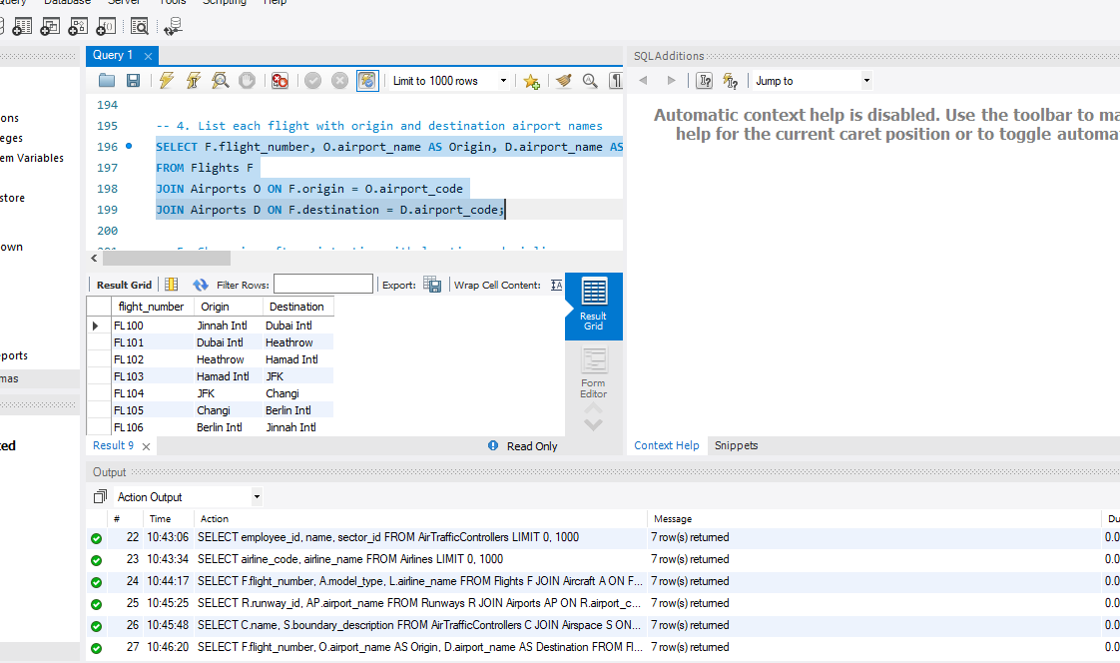

**-- 5. Show aircraft registration with location and airline name**

SELECT A.registration_number, A.location, L.airline_name

FROM Aircraft A

JOIN Airlines L ON A.airline_code = L.airline_code;

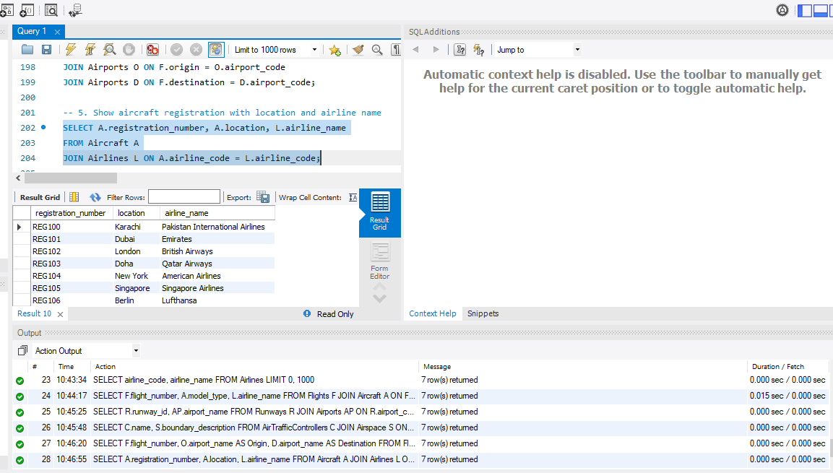

**-- 5 nested quries**

**-- 1. Flights using aircrafts with capacity more than 230**

SELECT flight_number

FROM Flights

WHERE aircraft_id IN (

SELECT registration_number FROM Aircraft WHERE capacity > 230

);

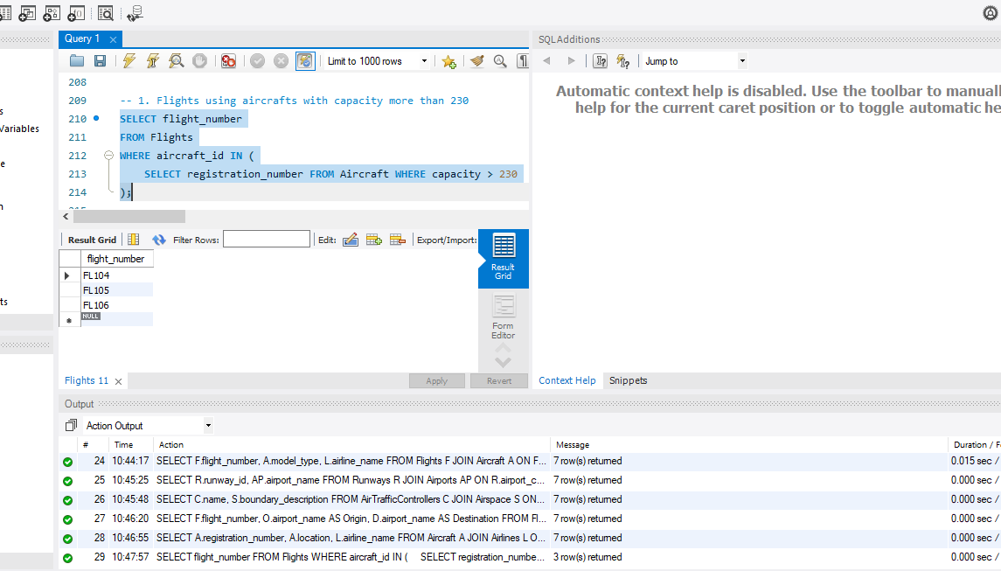

**-- 2. Airports where at least one runway is available**

SELECT airport_name

FROM Airports

WHERE airport_code IN (

SELECT airport_code FROM Runways WHERE status = 'Available'

);

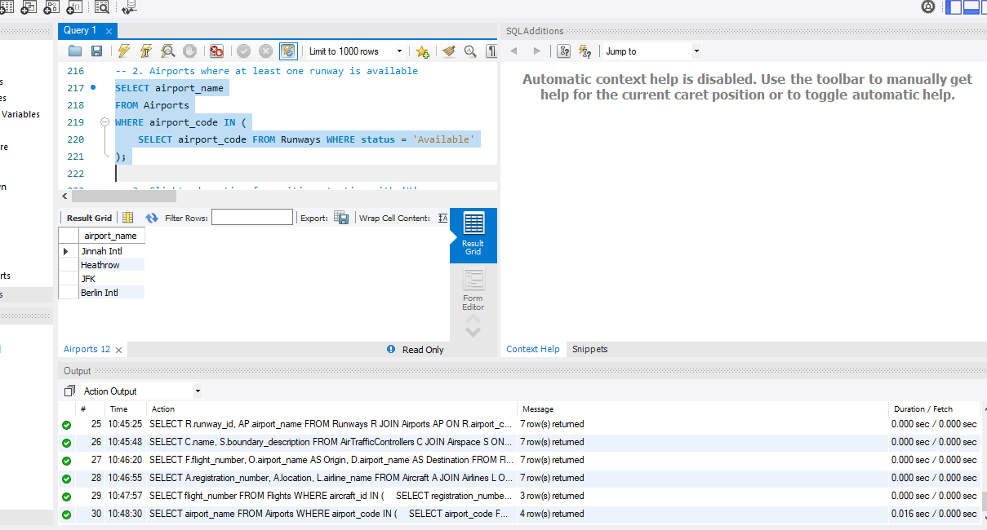

**-- 3. Flights departing from cities starting with 'K'**

SELECT flight_number

FROM Flights

WHERE origin IN (

SELECT airport_code FROM Airports WHERE city LIKE 'K%'

);

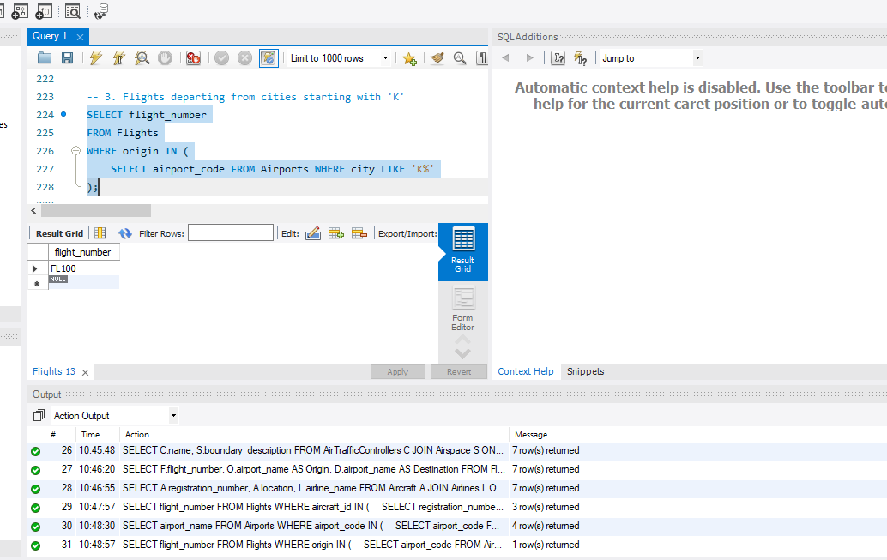

**-- 4. Controller(s) from the sector with the most controllers (should return all since one per sector)**

SELECT name

FROM AirTrafficControllers

WHERE sector_id = (

SELECT sector_id FROM (

SELECT sector_id, COUNT(*) AS total

FROM AirTrafficControllers

GROUP BY sector_id

ORDER BY total DESC

LIMIT 1

) AS TopSector

);

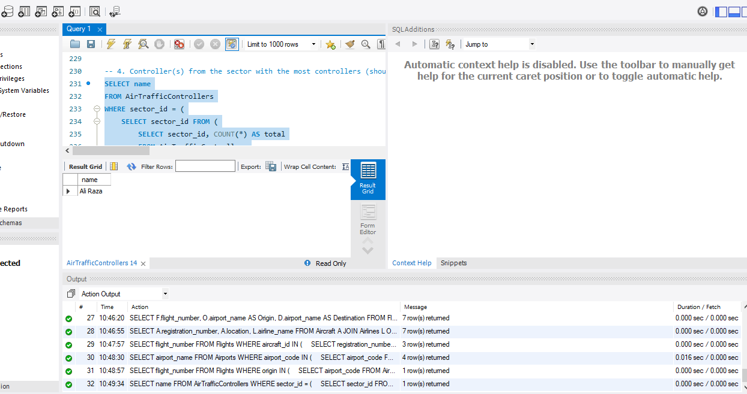

**-- 5. Airlines operating more than 1 aircraft**

SELECT airline_name

FROM Airlines

WHERE airline_code IN (

SELECT airline_code

FROM Aircraft

GROUP BY airline_code

HAVING COUNT(*) > 1

);

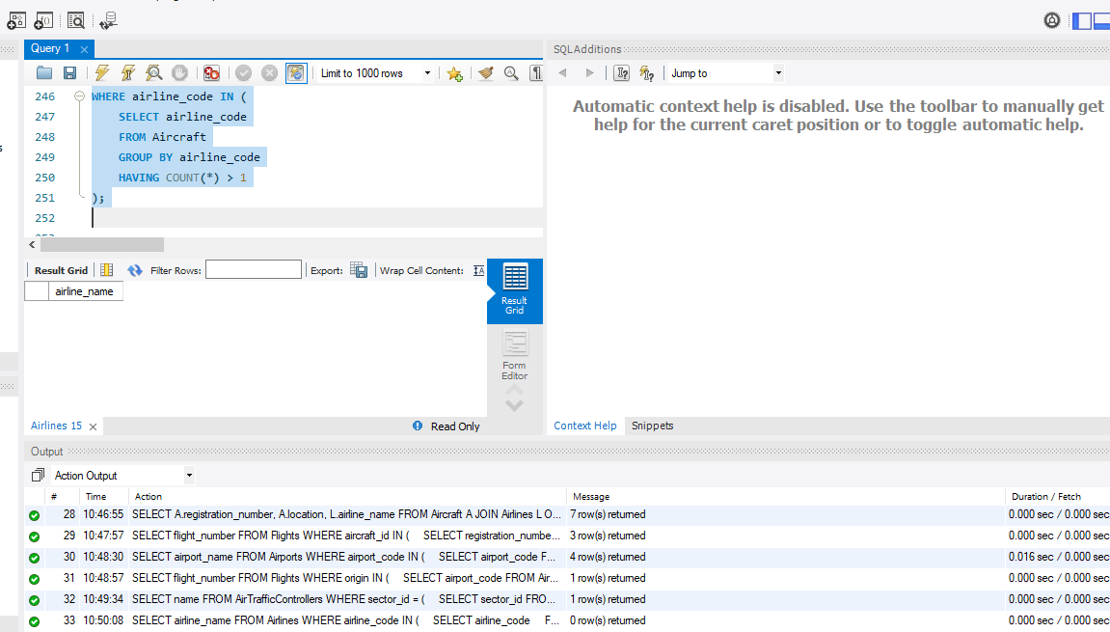

**-- 5 aggrigate fx quries**

**-- 1. Total number of flights in the system**

SELECT COUNT(*) AS total_flights FROM Flights;

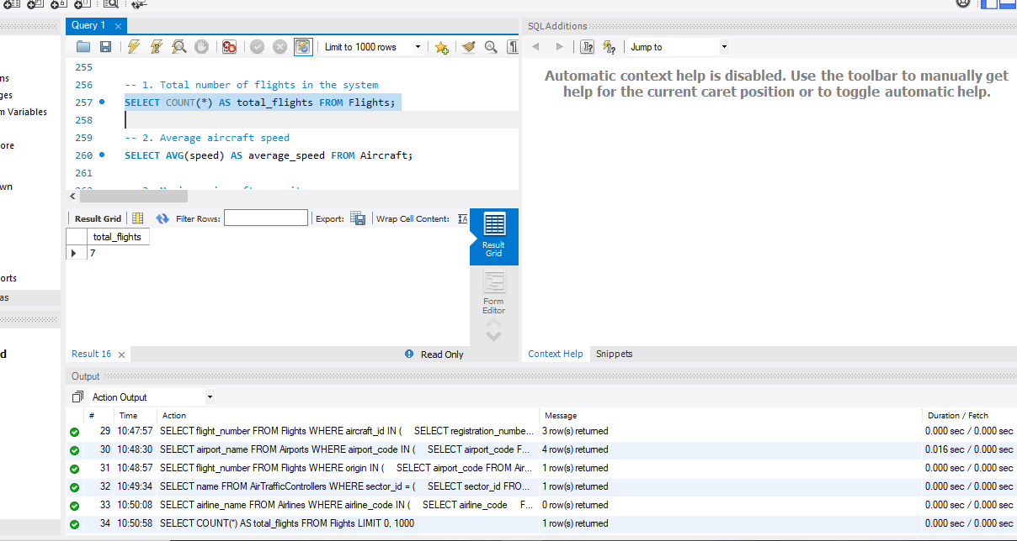

**-- 2. Average aircraft speed**

SELECT AVG(speed) AS average_speed FROM Aircraft;

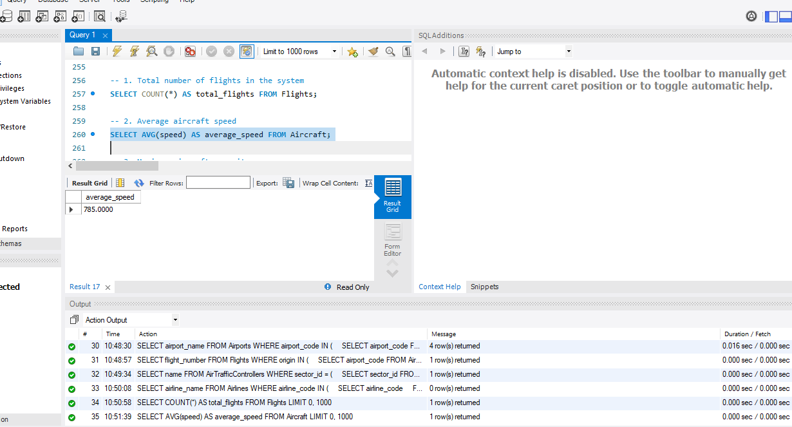

**-- 3. Maximum aircraft capacity**

SELECT MAX(capacity) AS max_capacity FROM Aircraft;

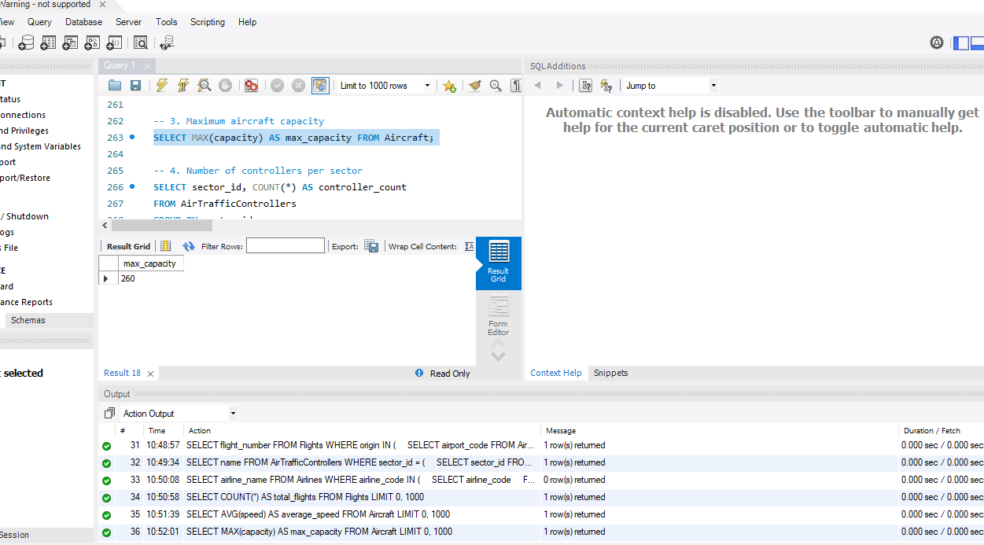

**-- 4. Number of controllers per sector**

SELECT sector_id, COUNT(*) AS controller_count

FROM AirTrafficControllers

GROUP BY sector_id;

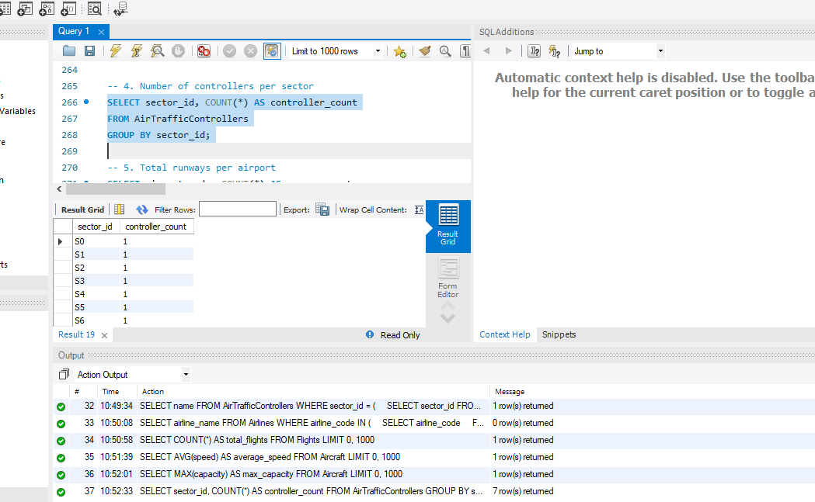

**-- 5. Total runways per airport**

SELECT airport_code, COUNT(*) AS runway_count

FROM Runways

GROUP BY airport_code;

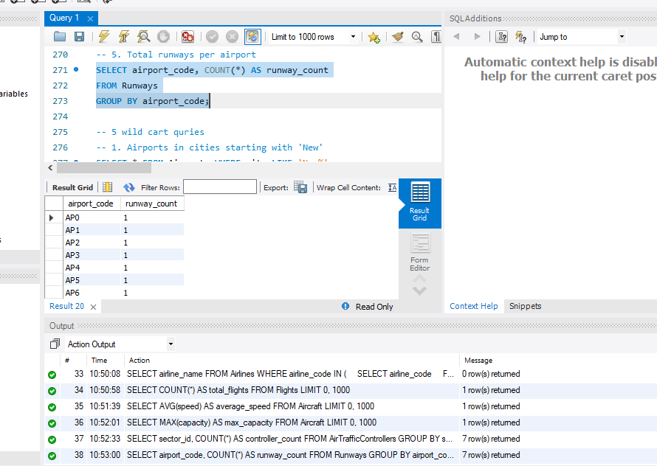

**-- 5 wild cart quries**

**-- 1. Airports in cities starting with 'New'**

SELECT * FROM Airports WHERE city LIKE 'New%';

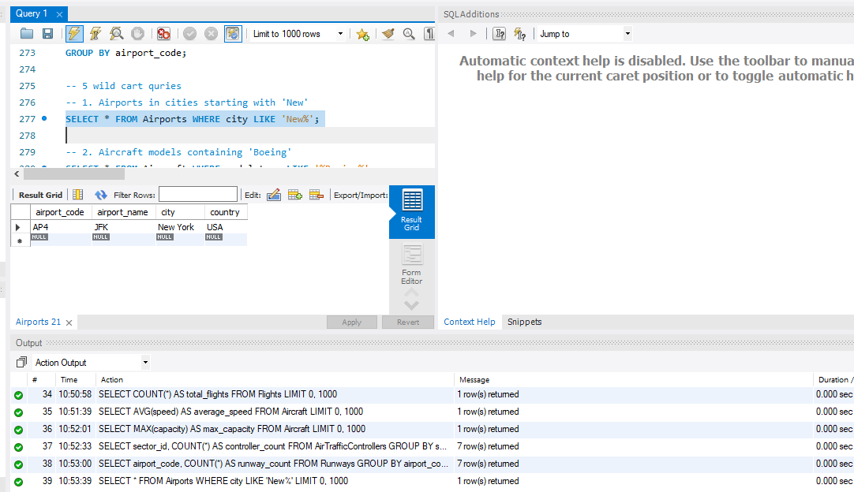

**-- 2. Aircraft models containing 'Boeing'**

SELECT * FROM Aircraft WHERE model_type LIKE '%Boeing%';

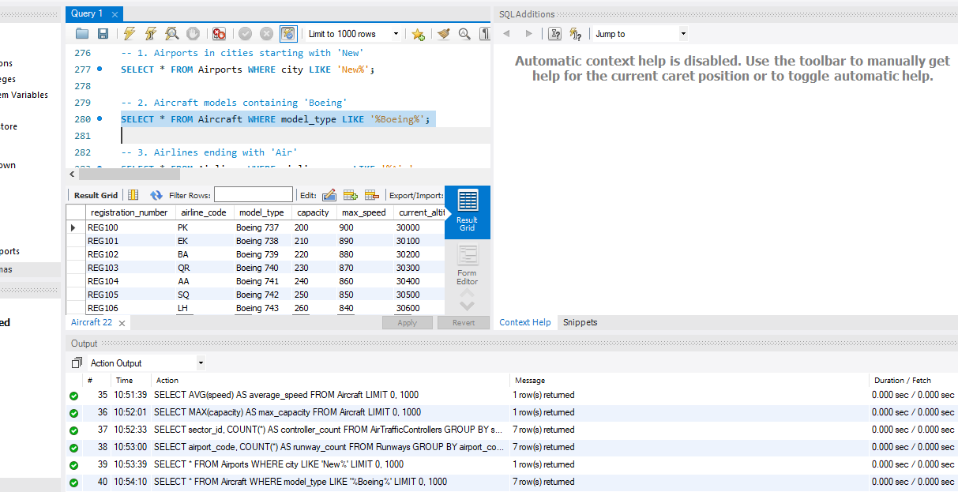

**-- 3. Airlines ending with 'Air'**

SELECT * FROM Airlines WHERE airline_name LIKE '%Air';

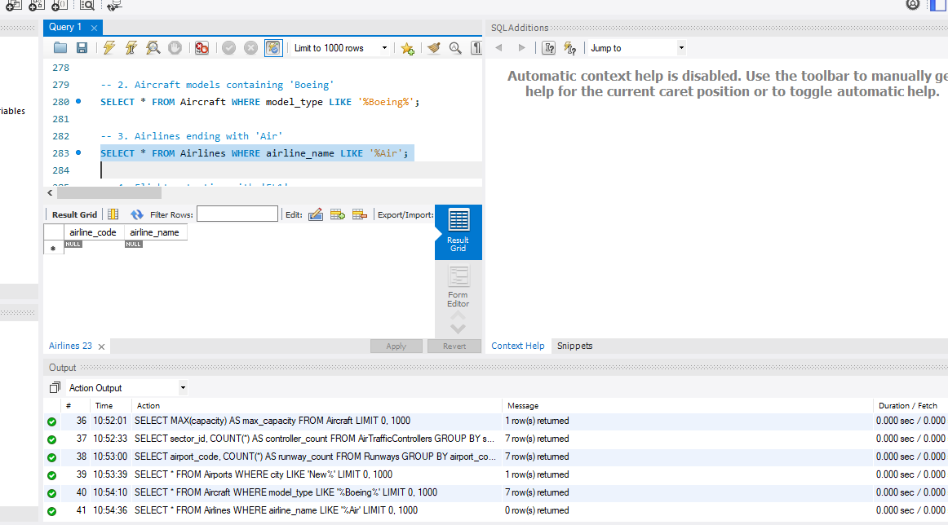

**-- 4. Flights starting with 'FL1'**

SELECT * FROM Flights WHERE flight_number LIKE 'FL1%';

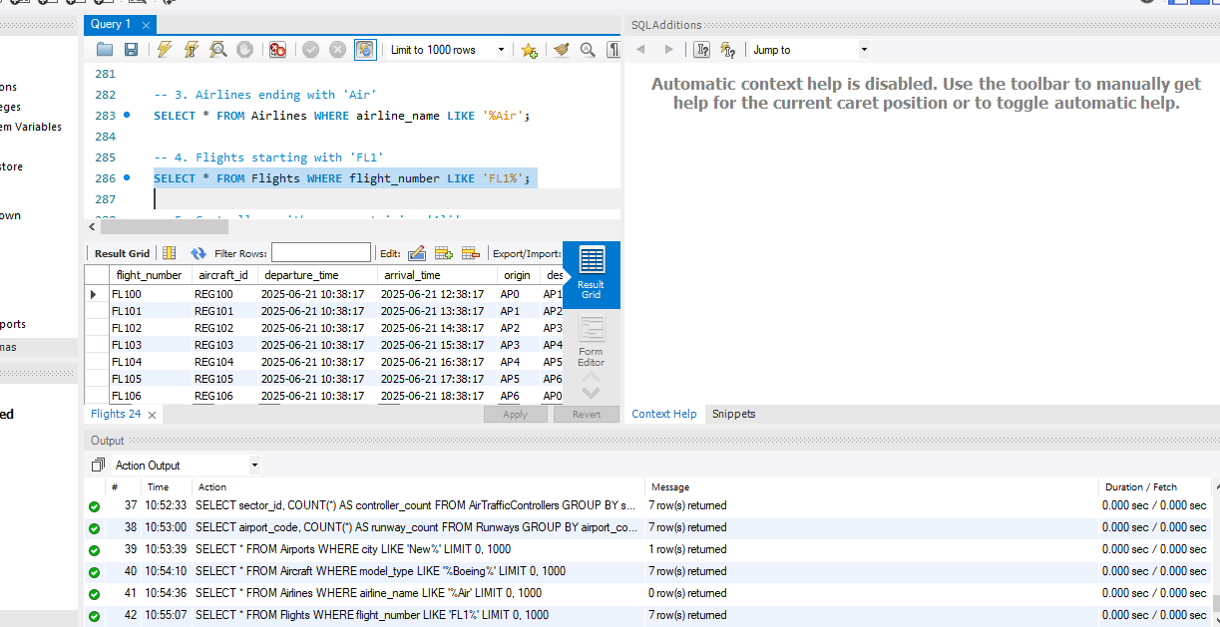

**-- 5. Controllers with name containing 'Ali'**

SELECT * FROM AirTrafficControllers WHERE name LIKE '%Ali%';

);

