***Chapter I:*Software Project Management Plan**

1. **Introduction**

Since football has become the world’s most popular sport; the numbers of its fans has increased too. From all around the globe fans are crazy about this game and also their support for their local and national teams. Therefor it’s normal to see the crowds and the unmanageable number of fans at the tickets offices and the mess we witness at the stadiums. Especially here in Jordan. The process of issuing tickets becomes out of control when it comes to organize the local matches at the arenas.

Some of the problems that we've noticed; is that the crowds at the gates of stadiums is so annoying for the fans while purchasing tickets. A very huge number at the window of purchasing the tickets for the matches which it causes some injuries for some fans before the match starts, or some of them messes the chance to buy a ticket. Also, another problem arises from there, some tickets are fraud and sold at the black market which causes another critical problem; which is the overflow of the fans out of the stadium capacity. According to this observations, our team decided to take a part in solving this problem by building an online ticketing and booking system for the Jordanian Football Association (JFA) to help organize the Jordanian football matches.

In this documentation we will walk you through the process of building this system and demonstrate its functionality and its impact on the problem field.

**1.1 Project overview**

“Tickety” is a website that provides online ticket booking service to the football fans in a way that organizes the process of issuing and the distribution of JFA matches tickets, in addition to that “Tickety” is meant to reduce the crowding at the stadium gates and prevent fraud tickets.

**1.3 Process model (methodology)**

We used the agile model since we walked in the process of analysis and design of the system and the development process in parallel; which allowed us to move in a flexible way back and forth at each process of the life cycle.

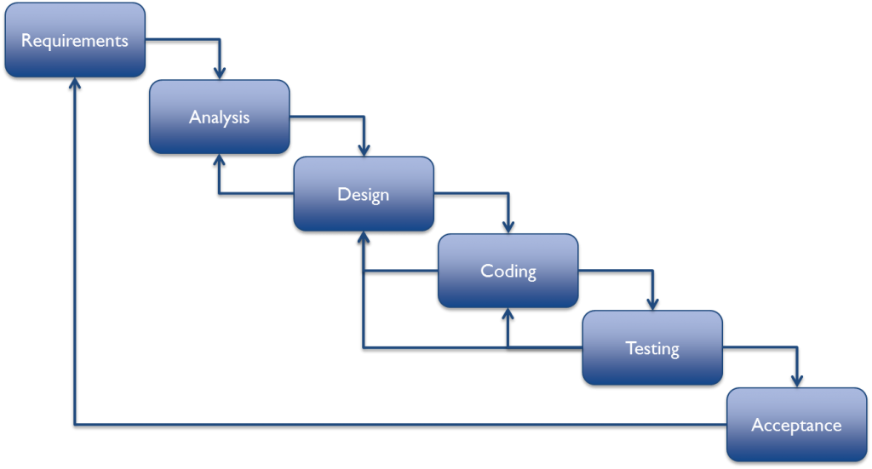

***Figure 1.2: Project process Model.***

Down below; we show the Gantt chart that shows the schedule of the activities of the development.

**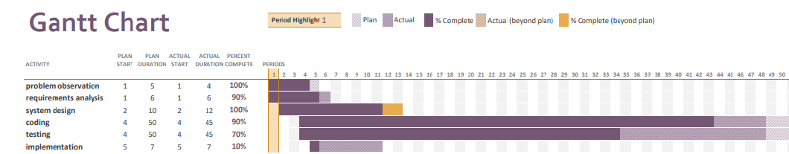 *Figure 1.3: Gantt chart***

**1.3 Project responsibilities**

The responsibilities we have in this project are:

* Each member of the team will be responsible about a specific part.
* Fulfil the project requirement as expected.
* Ensure that the project is applicable.
* Deliver the product to the customers in timely manner.
* Guarantee quality performance as high as possible.

**1.4 Managerial process**

In this section we define project objectives, risk management and controller.

* **Management objectives and priorities**
* Save the time for the users instead of standing in queues in front of the box offices and arriving several hours before the game.
* Reducing traffic jams which appears before matches.
* Reducing the phenomenon of black market for tickets.
* Decrease the number of fraud tickets.
* Increase the security in the stadiums by linking the site with the Department of Public Security to allow them to get the personal data of the Attendance inside the stadium.
* Reducing financial cost of printing the tickets.
* **Risk management**
* Costs for building this website are in mid-range, a string and will designed financial feasibility study is required to measure the budget available.
* Making sure that the system interface is user friendly and the naïve users are also able to interact with it with no ambiguity to be noticed.
* Securing the payment services and keep up to date with the used APIs for payments transactions.
* **Monitoring and controlling mechanisms**

Monitoring and controlling mechanisms in several levels including:

* The team leader measures progress towards the goals of the project.
* Team leader monitors the deviation of the plan.
* Team leader modifies and updates the plan when necessary.
* **Technical process**

This section describes the tools we used to crate /written this documentation and designed the diagrams & interfaces.

## **Methods, tools, and techniques**

Microsoft-Visio: Diagrams creation and design.

## **Software documentation**

Microsoft-word & Microsoft-excel: Creation of this documentation and some diagrams.

## **Project support functions**

* Django framework with python and Bootstrap to create the interfaces.
* Integrating Postgres 9.4 database and Paypal payments API.
* Widget tweaks django package for the interface of django forms.
* pyBarcode package for barcodes generation.

***Chapter II:  
 Requirements Analysis Document***

1. **Introduction:**

In this chapter, the documentation will describe the purpose that the system is built for, and the scope of the system. Also it will discuss the success scenarios of the system and the comparison between the current system and the proposed system. We will go more in depth of the system to list what is this system supposed to perform and how it should operate at the section of the functional and non-functional requirements.

Some diagrams are provided to demonstrate more details of the development and the processes involved in the scope of the system.

* 1. **Purpose of the system**

The main purpose of the system is to eliminate the Limitations of the current system by using online payment and booking which leads to reduce the crowds jamming in the front of the stadiums, and the fraud tickets.

* 1. **Scope of the system**

In this section we will identify the actors, events and the information that will flow through the system. The system will be made specifically for the Jordanian Football Association (JFA) and the Jordanian football fans. Users are able to view the matches sorted by its occurrence; whether it is coming, today or finished. Also users are able to see matches details such as the teams and the stadium that is hosting the match, weather condition at match day and matches results if it is finished. The most important part for the football fans is that to purchase a ticket in two methods: online or by reserving a ticket and purchase is in person 3 days before match day. The administration of the system will be able to add, update and delete records for the following:

1. Teams
2. Matches
3. Users
4. Stadiums
5. Tickets

* **Objectives and success criteria of the project**

**Project objectives:**

1- Organize the entry of crowed to the stadium, in quick and easy way which saves time.

2- Saving money by reducing the printed tickets.

3- Reduce the phenomenon of black market and fraud tickets.

**Success standards:**

1- The ratio of using the application through the public.

2- The dependency of Jordanian Football Association on the Website.

3- Attract sponsors whom may find an interest in the system.

* 1. **Current system**

The current system have many problems such as:

* Crowd Jamming in front of the stadium.
* Acquires the presence in person for the football fan at the stadium’s box office a while before the kickoff.
* Difficulty of organizing the ticket distribution on the box offices.
* Black markets can take a place in the situation of crowd jamming.
* Fake tickets can be easily printed and distributed in the front of the stadium.
* An important part is that booking and purchasing tickets is done manually.
  1. **Proposed system**

Tickety provides the option of online payment in advance which has the following advantages:

* Reduces crowd jamming
* reduce the black market tickets fraud
* Tickety will save the customer’s Time by 90 %
* Lowering the JFA printed tickets cost.
* Possibility of booking without the need to be present in person
  1. **Functional requirements :**

1. **user (football fan) requirements:**

* **view matches details such as :**
* matches competition
* matches home and away teams
* matches date and time
* match stadium
* match extra details if available
* **purchase tickets:**
* Provide user credentials including: username, phone number and email address.
* Select match, seat class and payment method whether it's online or in person pay.
* **Search** :
  + - Text search in teams name or competition name. The results are filtered based on the search query.
    - Filter results based on match status whether the match is coming, today or finished.
* View finished matches results**.**

1. **Admin requirements:**

* the admin is able to perform actions as shown following:
  + - **create**
    - **retrieve**
    - **update**
    - **delete**

These actions are applied on the following entities:

* + - teams
    - matches
    - stadiums
    - users
    - tickets

### **Non-functional requirements:**

#### **Usability:** system interface will be managed to support ease of access and user-friendly to be readable and understandable.

#### **Reliability:** the reliability that the system will provide is by the accuracy of the results and in case of failure; the recovery will be as quick as possible, make sure payments are secured and provide the best possible online tickets booking experience.

### **Performance:** guarantee as high as possible a quick and will managed tickets issuing.

#### **Scalability:** the system will provide a functionality of expanding the search areas or shrinking them.

#### **Implementation:** the system will be designed, built and produced to meet quality standards

* 1. **System models**

In this section describes the scenarios, Use cases, Activity diagram, Sequence Diagram, Entity relationship Diagram and object model. This section contains the complete functional specification, including illustrating the user interface of the system and navigational paths representing the sequence of screens.

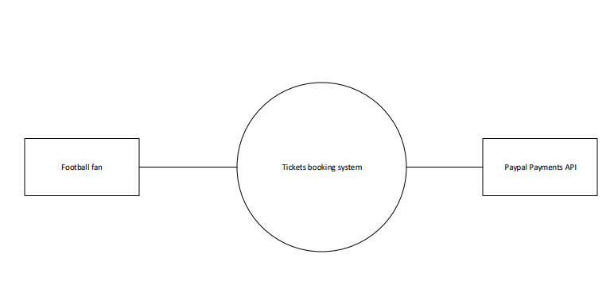

***Figure 2.1: Context Diagram***

* + 1. **use case**

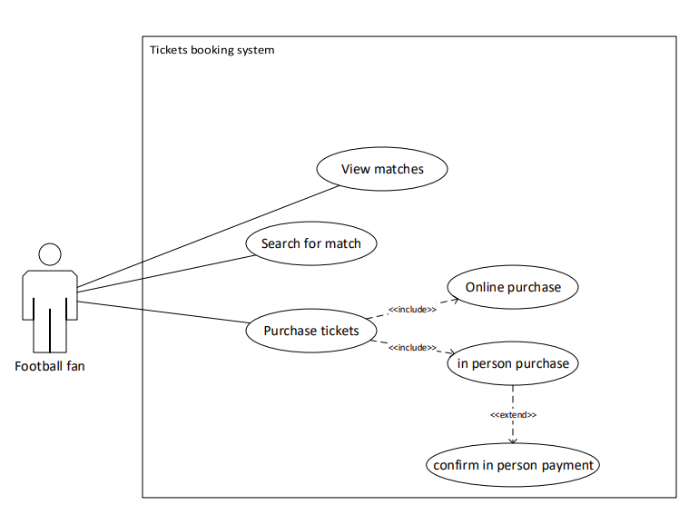

***Figure 2.2: football fan usecase diagram***

|  |  |
| --- | --- |
| Case | description |
| View match | Football fan is able to view the matches and it’s details that are listed in the system. |
| Search for match | The ability to search for a specific match through text search or filtered search queries. |
| Purchase tickets | A functionality that provides two choices of payment methods whether an online or in person |
| Online purchase | A payment method allows to purchase tickets online |
| In person purchase | A payment method allows the football fan to purchase tickets for a match in person at the stadium. |

**Table 2.1: football fan Use Case**

* + 1. **use case**

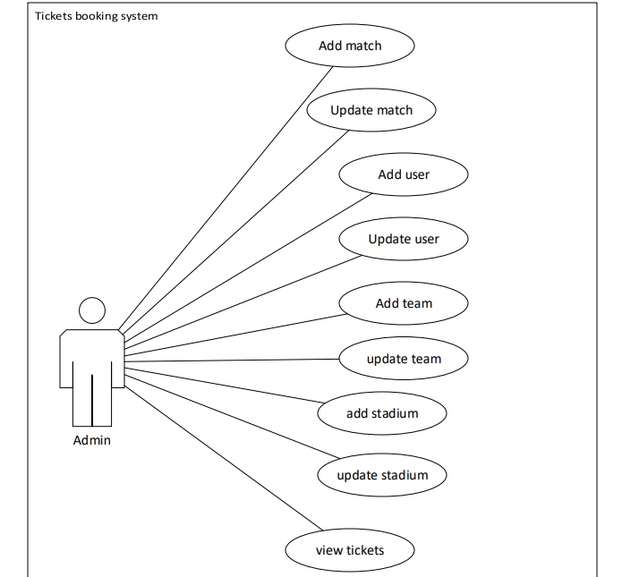

***Figure 2.3:Admin use case diagram***

|  |  |
| --- | --- |
| Case | description |
| Add match | Ability to create matches on the system via dashboard |
| Update match | Update matches details if there is any |
| Add user | Create profiles to users and determine their role on the system |
| Update user | Update information of a user |
| Add team | Ability to create teams on the system via dashboard |
| Update team | Update matches details if there is any |
| Add stadium | Ability to create stadiums on the system via dashboard |
| Update stadium | Update stadiums details if there is any |
| View tickets | View booked tickets for the matches |

**Table 2.2: Admin Use Case**

* 1. **Class Model**

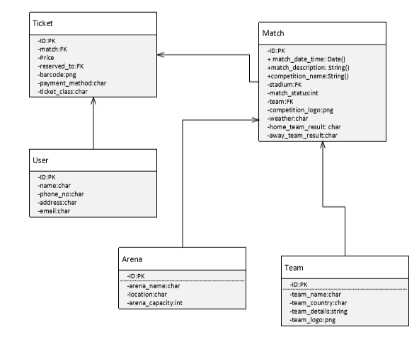

***Figure 2.5: class diagram***

**2.8 Sequence Model**

Figure 2.4: Class model

* 1. 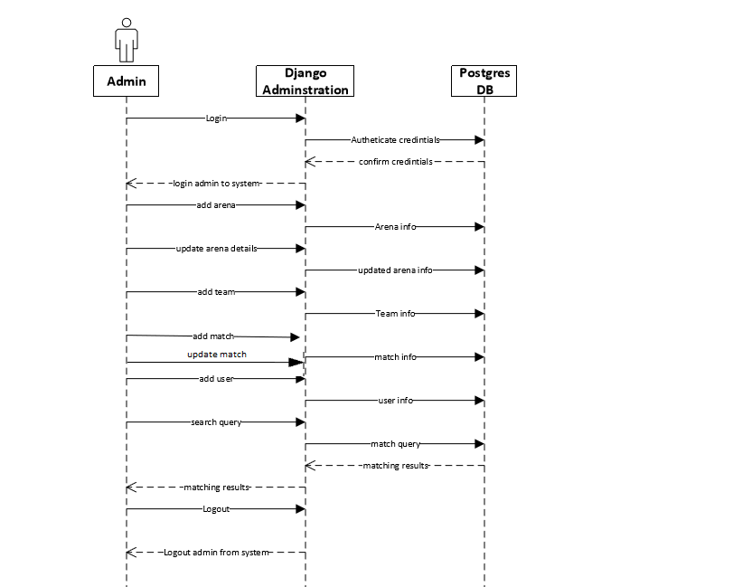**Sequence diagram**

***Figure 2.5: Admin Sequence Diagram***

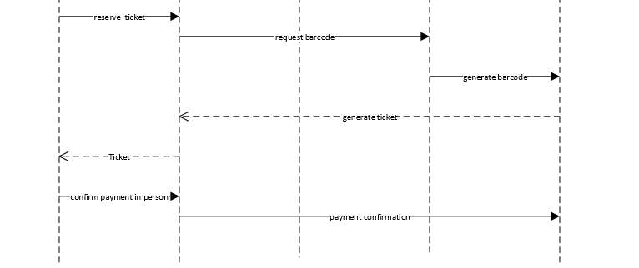

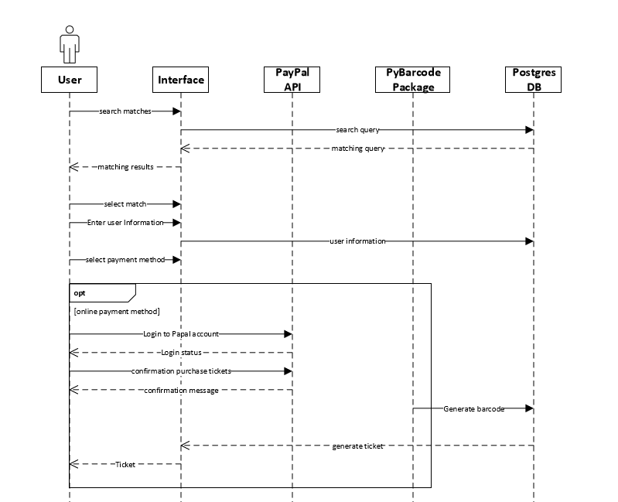

***Figure 2.6: football fan (user) Use case.***

**2.9 Entity Relationship Model**

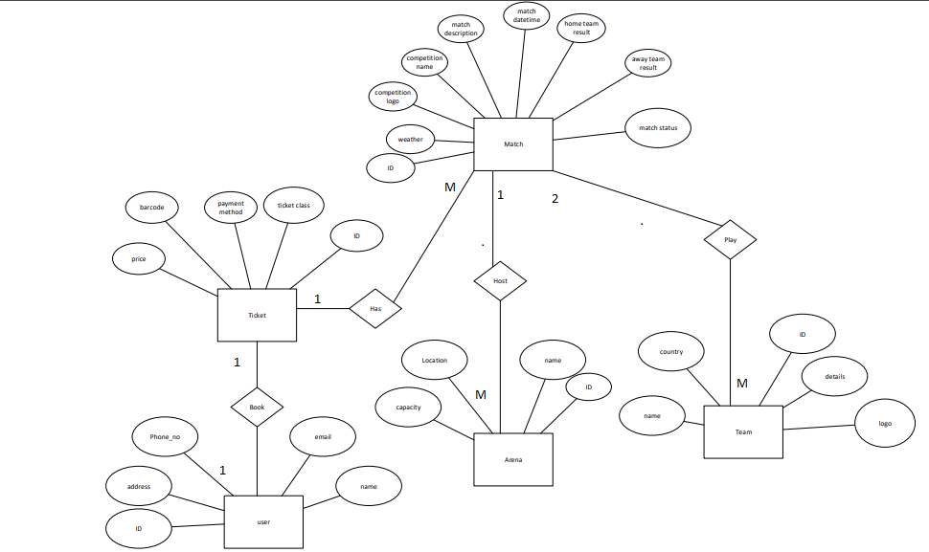

***Figure 2.7: Entity Relationship Diagram***

**Activity diagram**

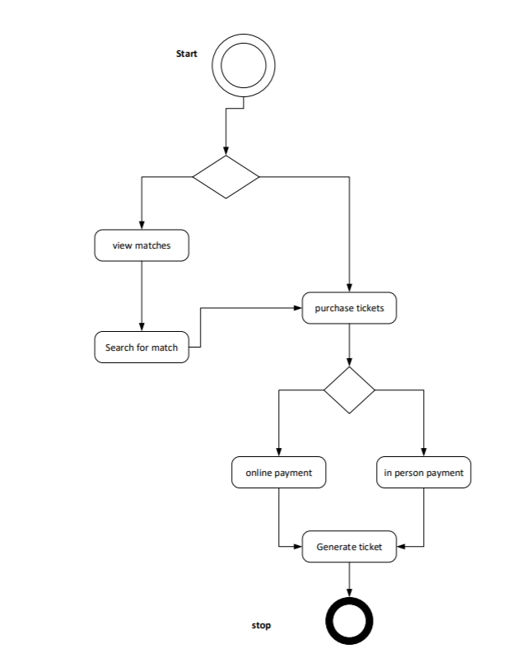

Chapter 3

Test plan

# **Introduction**

Test plans are very sensitive aspect in software development. Especially when the system provides payments transactions. Therefore; maintaining security of these transactions is a key element to make sure that the system is behaving correctly and is producing logical results.

In this chapter we will discuss how we tested the parts of the system which include testing materials the approach of the test plan, personnel’s responsible for each test has been performed.

# **Approach**

The objective of the test is to verify that the functionality of online tickets booking system works according to the specifications, also the team has considered the following criteria:

The main approach of the system is to make sure that all the requirements are satisfied correctly and the outputs are showing correct and logical results. Following a criteria to ensure system behavior is as expected:

* Test focus is on the speed, security, quality and response handling.
* Test activities will be assigned and described clearly for each member of the testing team. Also tests are broken down into smaller pieces in order to have a clear understanding of each part.
* The aim of testing is to identify bugs, non-logical results and request/response failures if found to be fixed and to corrected. To maintain the flow of the usage of the system.

# **Testing materials (hardware/software requirements)**

Software materials:

* Windows 10 professional
* Sublime text. Or any text editor
* Python pip installer latest build.
* Django web framework 1.10.
* Pgadmin 3 for postgresql 9.4 engine.
* Google chrome browser.
* Paypal test account for online payments.

Test cases:

|  |  |  |  |
| --- | --- | --- | --- |
| **#** | **Description** | **Error message** | **Action** |
| 1 | Unregistered user on the system login | Please enter a correct username and password. Note that both fields are case-sensitive | Make sure of the credentials or make sure it is a registered user |
| 2 | User attempts to access unauthorized functionality | You need to have a permission access denied. | Check user permissions |
| 3 | Typing undefined URL | Raise 404 error code and redirect to page not found | Check URL’s |
| 4 | search for a not existed objects | No matching results | N/A |
| 5 | Missed required fields | This field is required | Check highlighted field |

Tests scheduling:

|  |  |  |  |
| --- | --- | --- | --- |
| **Test type** | **Tested portion** | **Date** | **Tester** |
| Unit test | 1) login  2) logout  3) search  4)purchase tickets  5)URL mapping |  |  |
| Integration test | Walkthrough a full scenario for searching, booking a ticket online and in person, perform create, retrieve, update and delete methods on the admin site. |  |  |
| Functionalities testing | Confirm if the system is meeting the requirements or not |  |  |

Chapter 4:

Future work and conclusion

Future work:

There are many functionalities may be developed and added on to the system in order to make improve its performance and functionality; to provide the best experience to the user and the JFA. The following are the planed updates for the future work:

1. Provide a 3D seat view of the stadium for the user; to give the ability of choosing where to set.
2. Provide an area where team’s history and information are available; so that the website becomes a terminal for the Jordanian sports.
3. Expand the use of the system for all Jordanian sports in a way to organize the Jordanian sports community and modernize it.

Conclusion:

This documentation is intended to give an overview about the online tickets booking system for the football fans that supports JFA teams. The goal of this system is to reduce time and effort of booking tickets for the matches held by the JFA, manage and organize match day events of a football game in Jordan, reduce costs and crowding at the stadiums and guarantee no black market and fraud tickets as much as possible. This can benefit in finding opportunities to improve the performance of the JFA and manage the football sport in a modern way in jordan.