**Compte rendu**

**brief N1N2**

TABLE CLIENTS

**Create table clients ( id_clients int PRIMARY KEY NOT NULL , first_name , last_name , gender , phone);**

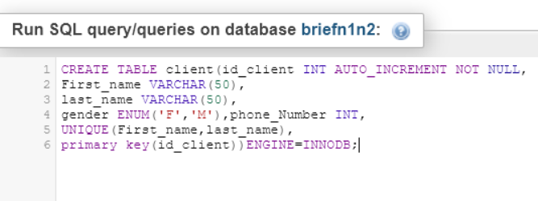

TABLE ORDERS

**CREATE TABLE Orders(  
    id_order int AUTO_INCREMENT PRIMARY KEY NOT NULL  ,  
    order_time DATETIME,  
    Quantity int,  
    id_client int Not null,  
    CONSTRAINT fkId_client FOREIGN KEY (id_client) REFERENCES clients(id_client)  
  )**

TABLE PROD

**CREATE TABLE prod (id_prod int PRIMARY KEY NOT NULL  , name_prod , price, prod_origine);**

TABLE COMMAND

**CREAT TABLE command ( id_commande int primary key , id_orders , id_prod,),**

**id_corders int Not null,  
    CONSTRAINT fkId_orders FOREIGN KEY (id_orders) REFERENCES orders(id_orders),**

**id_prod int Not null,  
    CONSTRAINT fkId_prod FOREIGN KEY (id_prod) REFERENCES prod(id_prod);**

*QUESTIONS :*

*# Step 1 :*

*#1 In the table ‘products’ add a new column called with this description :*

***Product_origin varchar(50)* .**

**Alter table products**

**Add Product_origin varchar(50)**

#2 what’s the SQL query that allow us to delete a column in a table

**drop**

#3 Pour aller plus loin dans la définition des donnée (LDD) ; on utilise un mot clé commun appelé **‘Truncat’** ? expliquez en quelques ligne le fonctionnement de cette commande et donner un exemple explicatif ?

**La commande TRUNCATE permet de supprimer toutes les données d’une table sans supprimer la table en elle-même**

#4 Add a unique constraint to the ‘first_name’ and ‘last_name’ column in clients table ? what’s UNIQUE constraint ?

**ALTER TABLE client**

**ADD CONSTRAINT U_name UNIQUE (first_name,last_name);**

#5 change the column name ‘order_tim’e to ’Date_order’ in the table ‘command’ and change the type to ‘DATETIME’

**ALTER TABLE orders CHANGE time date_orders DATETIME;**

#6 delete the column ‘quantity’ from the table ‘command’

**ALTER TABLE orders DROP quantity;**

#Establish the foreign key Constraints in order to tie all the tables

(Products, clients, command)

*# Step 2 :*

*Insert those Data in the table Clients:*

**INSERT INTO client (first_name, last_name,gender,phone_number)**

**VALUES** ('Chris','Martin','M','01123147789'),

('Emma','Law','F','01123439899'),

('Mark','Watkins','M','01174592013'),

('Daniel','Williams','M',NULL),

('Sarah','Taylor','F','01176348290'),

('Katie','Armstrong','F','01145787353'),

('Michael','Bluth','M','01980289282'),

('Kat','Nash','F','01176987789'),

('Buster','Bluth','M','01173456782'),

('Charlie',NULL,'F','01139287883'),

('Lindsay','Bluth','F','01176923804'),

('Harry','Johnson','M',NULL),

('John','Smith','M','01174987221'),

*Insert those Data in the table command:*

***INSERT INTO command (id_command,id_clients,datecommand)***

***value***

(1,1,'2017-01-01 08-02-11'),

(1,2,'2017-01-01 08-05-16'),

(5,12,'2017-01-01 08-44-34'),

(3,4,'2017-01-01 09-20-02'),

(1,9,'2017-01-01 11-51-56'),

(6,22,'2017-01-01 13-07-10'),

(1,1,'2017-01-02 08-03-41'),

(3,10,'2017-01-02 09-15-22'),

(2,2,'2017-01-02 10-10-10'),

(3,13,'2017-01-02 12-07-23'),

(1,1,'2017-01-03 08-13-50'),

(7,16,'2017-01-03 08-47-09'),

(6,21,'2017-01-03 09-12-11'),

(5,22,'2017-01-03 11-05-33'),

(4,3,'2017-01-03 11-08-55'),

(3,11,'2017-01-03 12-02-14'),

(2,23,'2017-01-03 13-41-22'),

(1,1,'2017-01-04 08-08-56'),

(3,10,'2017-01-04 11-23-43'),

(4,12,'2017-01-05 08-30-09'),

(7,1,'2017-01-06 09-02-47'),

(3,18,'2017-01-06 13-23-34'),

(2,16,'2017-01-07 09-12-39'),

(2,14,'2017-01-07 11-24-15'),

(4,5,'2017-01-08 08-54-11'),

(1,1,'2017-01-09 08-03-11'),

(6,20,'2017-01-10 10-34-12'),

(3,3,'2017-01-10 11-02-11'),

(4,24,'2017-01-11 08-39-11'),

(4,8,'2017-01-12 13-20-13'),

(1,1,'2017-01-14 08-27-10'),

(4,15,'2017-01-15 08-30-56'),

(1,7,'2017-01-16 10-02-11')

*Insert those Data in the table Products:*

***INSERT INTO products (ID_products, name, price,products_origin)***

***VALUES***

(1,’special coffee’, 7.5,’Brazil’)

(2,’coffee family’, 8,’Cuba’)

(13,’coffee 2.0’, 8.5,’Ethopia’)

(3, ‘animal coffee’,25,’Indonesia’)

(22,’coffe plus’, 15.5,’Italy’)

(14,’coffee ++’,30.00,’Maroc’)

*#Step 3:*

#1 update in the table products the following statement :

* Price * 5 condition (product_name = special coffee):

**UPDATE produit  
SET prix_produit = 37.5  
WHERE name_produit = "special coffee";**

* Coffee_orgin = EST Europe where id_product = 22

**UPDATE produit  
SET produit_origin = "EST Europe"  
WHERE id_produit = 22;**

#2 in the table command, Print the recent command ordered

**SELECT * FROM commande WHERE commande_temps IN (SELECT MAX(commande_temps) FROM commande)**

#3 the customer who made the maximum of command

**SELECT id_client, COUNT(*) as max_client_commande from commande  
GROUP BY id_client  
ORDER by max_client_commande desc LIMIT 1;  
SELECT * from clients;**

#4 in the table clients print how many man and woman we have

**SELECT genre , count(*) as man_woman from clients  
GROUP by genre  
order by man_woman desc limit 2;  
SELECT * from clients;**

*#Step 4:*

*Selecting:*

#1 Select from the products Table the following:

* All the products which have the price above 15

**SELECT id_prod  
FROM prod  
WHERE prix_prod > 15;**

* The product name and the price which contains the sentence ‘special’

**SELECT name_prod, prix_prod  
FROM prod  
WHERE name_prod LIKE 'special%**'

* Product name which price != 8.5

**SELECT id_prod**

**FROM prod**

**WHERE prix_prod != 8.5**

* the name and price of all products with a coffee origin

Equal to Cuba or Indonesia. Ordered by name from A-Z.

**SELECT name_prod, prix_prod , product_origin  
FROM prod**

**WHERE product_origin LIKE 'indonesia%' OR product_origin like 'cuba%'**

**ORDER by product_origin ASC**

* the name, price and coffee origin but rename the price to

retail_price in the results set.

**SELECT price as retail_price**

**FROM prod**

#2 Select from the table clients the following:

* the first name and phone number of all the females who have a last name of Bluth.

**SELECT nom, phone**

**from clients**

**WHERE nom = 'bluth'**

* How many male customers don’t have a phone number entered into the customers table?

**SELECT \***

**FROM clients**

**WHERE phone IS NULL AND genre = 'H'**

* the first name and phone number of all customers

who’s last name contains the pattern ‘ar’.

**SELECT \***

**FROM clients**

**WHERE nom LIKE 'ar%'**

* select distinct last names and order alphabetically from A-Z.

**SELECT DISTINCT nom FROM clients**

**ORDER by nom ASC**

#2 Select from the table command the following :

* all the orders from February 2017 for customers with id’s of 2, 4, 6 or 8.

**SELECT \***

**FROM commande**

**WHERE commande_temps BETWEEN '2017-01-01' and '2017-01-29' and (id_client =24 or id_client =34 or id_client =26 or id_client =28)**

* the first 3 orders placed by customer with id 1, in january 2017.

**SELECT commande_temps**

**FROM commande**

**WHERE commande_temps BETWEEN '2017-01-01' and '2017-01-30' and (id_client =22)**

*#Step 5:*

*Multiple Selection using Joins:*

* Select the order id and clients phone number for all orders of product id 4.

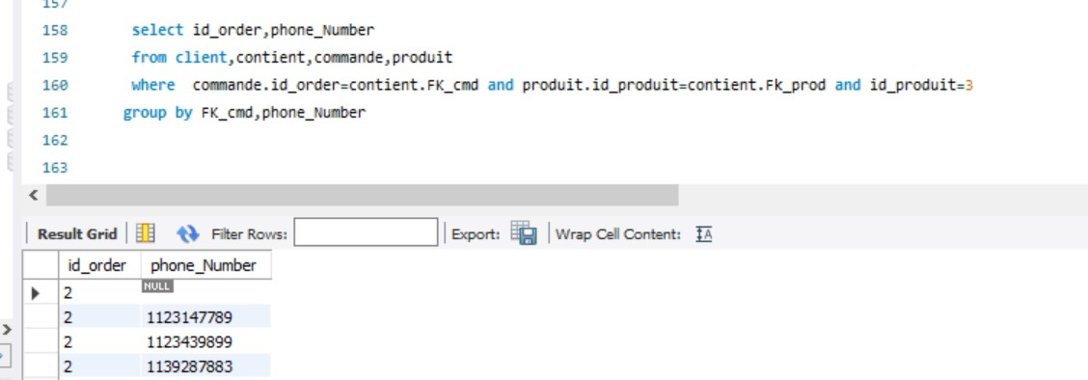

* Select the product name and order time for filter coffees sold between January 15th 2017 and February 14th 2017.

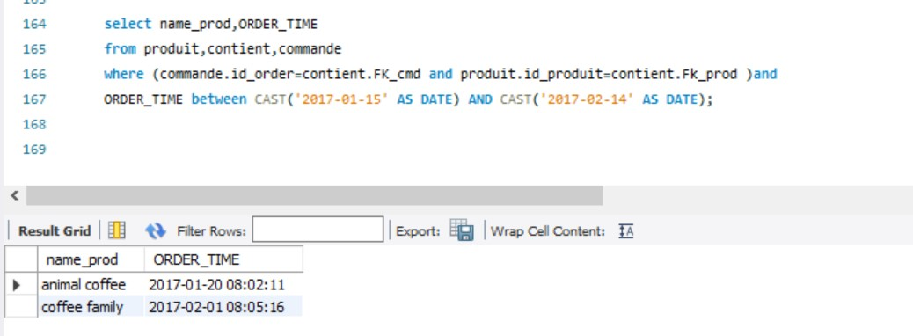

* Select the product name and price and order time for all orders from females in January 2017.

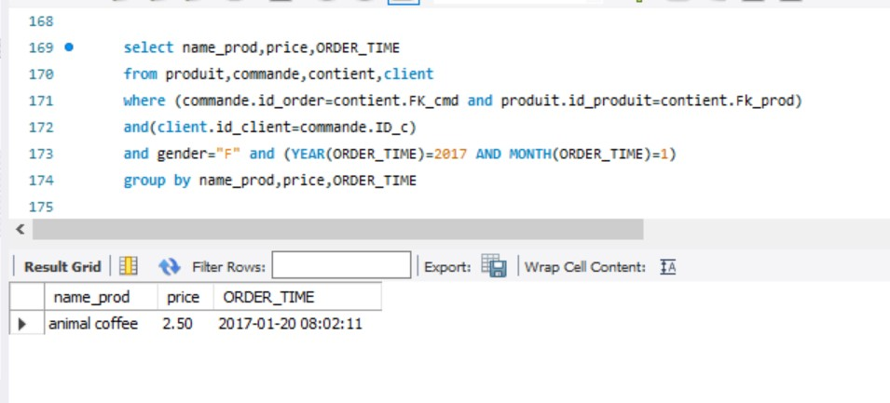

*FIN*