DATA MINING MINI-PROJECT
Automatic Detection of Absence Seizures from EEG Signals
From raw recordings to reconstructed seizure intervals
Prepared by
Yahya Houimdi
Brahim Elmi
Class 3A Info 1
Data Mining applied to biomedical data
October 2026

Contents
Summary 4
1. Introduction 5
1.1 Context 5
1.2 Problem statement 5
1.3 Objectives 5
1.4 Three difficulties that shaped the work 5
2. Data 6
2.1 Files provided 6
2.2 Which annotations can be trusted 6
2.3 Recordings kept and excluded 6
2.4 Data-quality observations 7
3. Methodology 8
3.1 Pipeline 8
3.2 Tools 8
3.3 The interactive application 8
3.4 Train, validation and test split 9
3.5 Handling class imbalance 10
3.6 Safeguards against data leakage 10
4. Results: exploration and dataset construction 11
4.1 Part I: understanding and exploring the data 11
4.2 Part II: using the annotations 12
4.3 Part III: building the target variable 14
4.4 Part IV: segmenting the signal 15
4.5 Part V: temporal features 15
5. Results: frequency and exploratory analysis 17
5.1 Part VI: frequency analysis 17
5.2 Part VII: exploratory analysis 18
6. Results: models and evaluation 21
6.1 Part VIII: building the models 21
6.2 Part IX: evaluation 21
6.3 Which metric should be preferred? 23
7. Results: temporal detection and error analysis 25
7.1 Part X: reconstructing the seizures 25
7.2 Part XI: error analysis 26
8. Improvements 28
8.1 Improvements already implemented 28
8.2 Proposed improvements 28
9. Discussion 29
9.1 What the results show 29
9.2 Limits 29
10. Conclusion 30
Appendix: reproducing the results 31

Summary
This project builds a complete Data Mining chain that starts from raw electroencephalogram (EEG) recordings and ends with a model that detects absence seizures and gives the start and end time of each one.
The work covers the twelve parts of the assignment: exploration, annotation processing, target construction, segmentation, temporal and frequency features, exploratory analysis, four classical classifiers, evaluation, choice of metric, temporal reconstruction, error analysis, and improvements. Two deep-learning models were added as an improvement.

Main results
- Data. 18 recordings with validated annotations were used: 7.2 hours of signal at 256 Hz and 71 seizures. Seizures occupy 3.7% of the recorded time.
- Features. Each window is described by 8 temporal features and 4 frequency-band powers per EEG channel. The band powers are the most discriminant features by a wide margin.
- Models. Six models were trained on six balanced training sets. The model selected on validation data is an LSTM; on four recordings never seen in training it reaches a recall of 0.84, a precision of 0.64 and an F1-score of 0.73 on the seizure class. The Random Forest is the best classical model (recall 0.94, F1 0.72).
- Seizure reconstruction. After merging predicted windows into intervals, all 12 seizures of the test recordings are detected, with a mean start error of 0.4 s. The model also produces 21 false alarms in 1.45 hours.
- Reliability. The test set contains only 12 seizures. Cross-validation shows that scores change strongly from one group of recordings to another, so the ranking of the models is indicative.

Deliverables
- An interactive Streamlit application for Parts I to V.
- A reproducible Python pipeline (scripts and notebooks) for Parts VI to XII, with 40 automated tests.
- This report and the accompanying presentation.

1. Introduction

1.1 Context
An electroencephalogram records the electrical activity of the brain through electrodes placed on the scalp. Absence seizures are short epileptic episodes, typically a few seconds long, during which the patient loses awareness. On the EEG they appear as a rhythmic discharge of spikes and waves at about 3 Hz, visible on all channels at once.
Reviewing a recording by eye to find these episodes is slow. One recording lasts 20 to 60 minutes and may contain a dozen seizures of a few seconds each. An automatic detector that proposes the seizure periods would save the clinician time.

1.2 Problem statement
The task is a binary classification problem on time series. For every moment of a recording, the system must decide between two classes:
- Class 0: no seizure.
- Class 1: seizure.
The final output is not the class of each window but a list of seizures, each with a start time, an end time and a duration.

1.3 Objectives
- Load, explore and visualise EEG recordings and their annotations.
- Build the target variable and segment the signal into windows.
- Extract temporal and frequency features and analyse them.
- Train and compare Decision Tree, Random Forest, KNN and SVM classifiers.
- Choose appropriate metrics for an imbalanced medical problem.
- Reconstruct seizure intervals from the predictions and analyse the errors.
- Propose and test improvements.

1.4 Three difficulties that shaped the work
- Class imbalance. Fewer than 4% of windows belong to a seizure, so accuracy is misleading and the training data must be rebalanced.
- Data leakage. Windows overlap by 50%. If windows of one recording are placed in both the training and the test set, the model is tested on near-copies of what it learned. The split is therefore made on whole recordings.
- Little data. 71 seizures in 18 recordings. Results depend on which recordings are in the test set, and this uncertainty is measured and reported.

2. Data

2.1 Files provided
Table 1. Description of the dataset
Item | Value
Recordings | 22, each with a signal file (*_0000d) and an annotation log (*_0000h)
Original format | MATLAB .mat, converted to CSV with data/converter.py
Sampling frequency | 256 Hz
Total size | 8.5 million samples, about 9.2 hours
Channels | 12 to 23 per recording: 19 EEG channels in most files, plus ECG, EMG and SLI (photic stimulation)
Seizure annotations | Annotations.xlsx: start of trace and start/end clock time of each seizure

2.2 Which annotations can be trusted
Two sources of annotation exist, and only one is usable. The h files list events such as "absence", "ARTEFACT" or "YO", but their time column is only the row number divided by 256; it does not say when the event happened. They cannot place a seizure in the signal.
Annotations.xlsx is therefore the only source of labels. It stores clock times as fractions of a day. Each time is converted to seconds from the beginning of the trace:
t (s) = (event time − start of trace) × 86 400
For recording 190304A-E, the trace starts at 10:13:35 and the seizure runs from 10:35:06 to 10:35:13, which gives the interval 1291 s to 1298 s. Each interval is then checked against the real duration of the signal.

2.3 Recordings kept and excluded
18 of the 22 recordings have fully valid intervals. Four are excluded from machine learning:
Table 2. Recordings excluded from the supervised dataset
Recording | Reason for exclusion
200625A_F, 210204B_C, 210208B_G | Not listed in Annotations.xlsx
210504B_C | Its first seizure is entered as lasting six hours (12:50:58 to 18:51:06) in a 52-minute recording

Recording 210504B_C has 11 other valid seizures. It was still excluded: the true position of the first seizure is unknown, so its windows would have been labelled "no seizure" and would have taught the model something false.

2.4 Data-quality observations
- Mains interference. A 50 Hz component dominates the raw signal. On the first minute of channel Fp1 of recording 211104B_D it carries 98% of the signal variance.
- Offset and drift. Channels have a large constant offset (several hundred units) and drift slowly during the recording.
- Different layouts. Four channel layouts exist; channel names are read from each file instead of being fixed in the code.
- Different scales. Amplitudes differ between recordings by more than a factor of ten.
- Encoding. Accented characters in the annotation labels are corrupted ("Début" is stored with unreadable characters); they are repaired on loading.

3. Methodology

3.1 Pipeline
The pipeline follows the one given in the assignment, with two additions: a validation set and a balancing step.
- Exploration. Load a recording, measure its sampling frequency and duration, count missing values, plot the signal.
- Annotations. Convert the Excel clock times to seconds and validate each seizure interval.
- Target. Give each sample the class 1 inside a seizure interval and 0 elsewhere.
- Segmentation. Cut the signal into windows of 1 s or 2 s with 50% overlap; a window is class 1 when at least 50% of its samples are in a seizure.
- Features. Compute 8 temporal features and 4 frequency-band powers per EEG channel.
- Split. Assign whole recordings to train, validation and test.
- Balancing. Rebalance the training rows only.
- Training. Fit six models; choose hyperparameters and decision threshold on the validation set.
- Evaluation. Score the test set once.
- Reconstruction. Merge predicted windows into seizure intervals and compare them with the annotations.

3.2 Tools
Table 3. Software used
Purpose | Tool
Language | Python 3.10
Data handling | pandas, NumPy, PyArrow (Parquet cache)
Signal processing | NumPy FFT, SciPy
Classical models | scikit-learn
Deep learning | PyTorch
Application and plots | Streamlit, Plotly, Matplotlib
Tests | pytest (40 tests)

3.3 The interactive application
Parts I to V are implemented in a Streamlit application, EEG Seizure Explorer, started with streamlit run app.py. It has one tab per part of the assignment. The user chooses a recording and channels in the sidebar; every figure and table of Questions 1 to 8 is then computed for that recording.
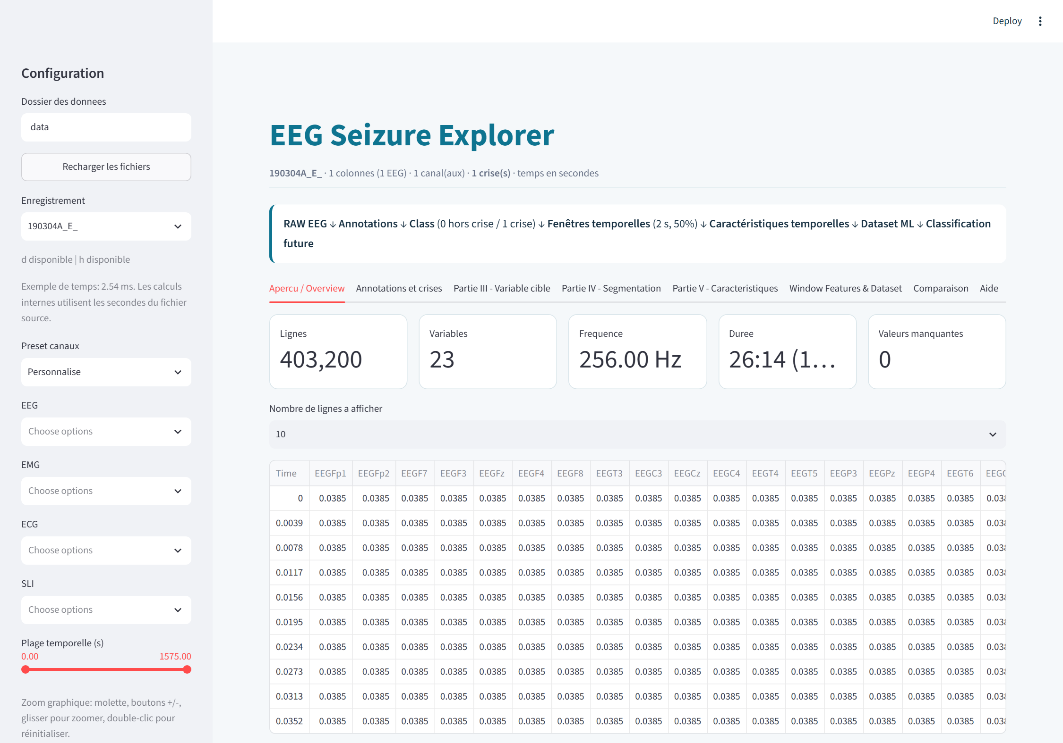
Figure 1. Application, overview tab: number of rows, variables, sampling frequency, duration, missing values and first rows of the selected recording

3.4 Train, validation and test split
The assignment suggests a stratified split of 80% for training and 20% for testing. Applied directly to windows, this split would be flawed here: consecutive windows share half of their samples, so a random split places near-copies of training windows in the test set and inflates every score.
The split was therefore made on whole recordings, keeping the spirit of the assignment:
- About 20% of the recordings (4 of 18) form the test set.
- The remaining 80% is divided again into training (11 recordings) and validation (3 recordings). The validation set is used to choose hyperparameters and thresholds, so that the test set is used only once.
- The split is stratified on the proportion of seizure windows, and fixed by a random seed. It was chosen from the labels only, never from model results.
Table 4. Composition of the three partitions (1-second windows)
Partition | Recordings | 1 s windows | Seizure windows | Seizures
Train | 11 | 32,819 | 1,162 (3.5%) | 46
Validation | 3 | 8,499 | 384 (4.5%) | 13
Test | 4 | 10,448 | 420 (4.0%) | 12
Total | 18 | 51,766 | 1,966 (3.8%) | 71

The test recordings are 210406A_F, 210928B_B, 211027B_C and 230210B_D.

3.5 Handling class imbalance
Three balancing strategies were applied to the training rows only. Validation and test data keep their real proportion of seizures.
Table 5. The three balancing strategies
Method | Class 0 (no seizure) | Class 1 (seizure) | Rows per class (1 s)
Undersampling | Randomly reduced to the size of class 1 | All rows kept | 1,162
Oversampling | All rows kept | Sampled with replacement up to the size of class 0 | 31,657
Hybrid | Reduced to the midpoint | Sampled with replacement up to the midpoint | 16,409

With two window durations (1 s and 2 s) and three strategies, six training sets were produced. Each model was trained on all six.

3.6 Safeguards against data leakage
- No recording appears in more than one partition.
- Missing-value imputation and scaling are fitted on training rows only.
- Balancing is done after the split.
- Recording identifiers, window numbers and times are never used as model inputs.
- An automatic check verifies every exported dataset before a model is trained.

4. Results: exploration and dataset construction
Questions 1 to 6 are illustrated with recording 211104B_D, a 20-minute recording with five seizures.

4.1 Part I: understanding and exploring the data
Question 1. Load an EEG file. Identify the number of rows, the number of variables, the sampling frequency, the total duration and the number of missing values. Display the first rows.
Table 6. Question 1 for recording 211104B_D
Property | Value
Number of rows | 309,760
Number of variables | 22 (Time, 19 EEG channels, SLI, ECG)
Sampling frequency | 256 Hz (median time step of 3.906 ms)
Total duration | 1,210 s (20 min 10 s)
Missing values | 0

The sampling frequency is computed from the Time column as the inverse of the median time step, rather than assumed.
Table 7. First rows of the file (first five columns; the full table is shown in the application)
Time | EEGFp1 | EEGFp2 | EEGF7 | EEGF3
0.0000 | −706.735 | −771.887 | −720.160 | 94.237
0.0039 | … | … | … | …
0.0156 | −744.860 | −849.926 | −803.031 | 14.409

Question 2. Plot the EEG signal against time, with axes, title and units. What do you notice visually during the seizures?
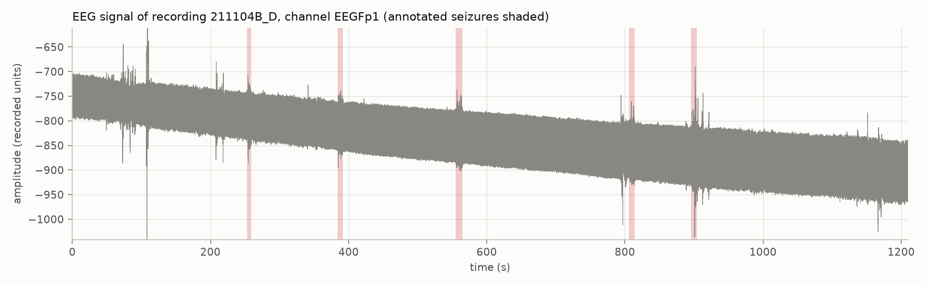
Figure 2. EEG signal of recording 211104B_D, channel Fp1. The five annotated seizures are shaded. The file gives no unit; amplitudes are in recorded units
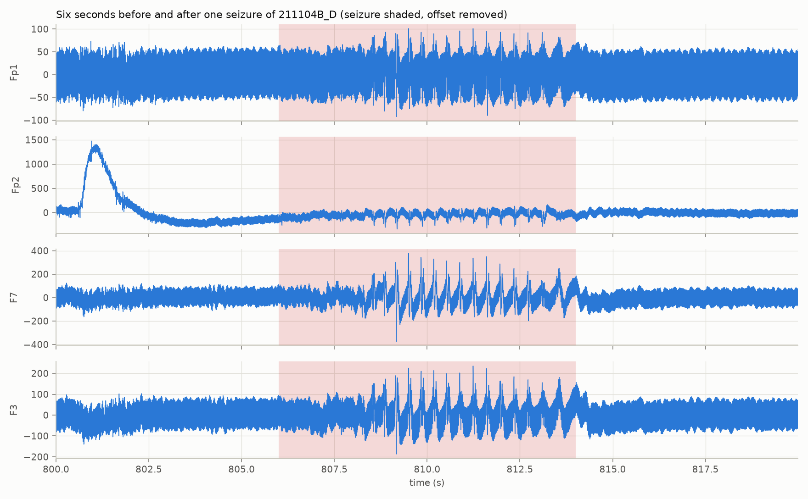
Figure 3. Four channels around the seizure at 806 s to 814 s, with the offset removed
Observation. Seen over the whole recording, the seizures are hardly visible: the trace is dominated by a thick band of 50 Hz interference and by a slow drift. Zooming on one seizure shows the characteristic pattern:
- A rhythmic series of large spikes followed by slow waves, about three per second.
- The pattern appears on all channels at the same moment.
- It starts and stops abruptly, and its amplitude is clearly larger than the background on most channels.
The annotated start (806 s) is about two seconds earlier than the first clear spike (about 808 s). Annotations are given to the second and are not exact at the edges.

4.2 Part II: using the annotations
Question 3. Identify automatically the start and end of each seizure and the total number of seizures.
Table 8. Seizures of recording 211104B_D: 5 seizures
Seizure | Start (s) | End (s) | Duration (s)
1 | 253 | 259 | 6
2 | 384 | 392 | 8
3 | 555 | 565 | 10
4 | 806 | 814 | 8
5 | 896 | 904 | 8

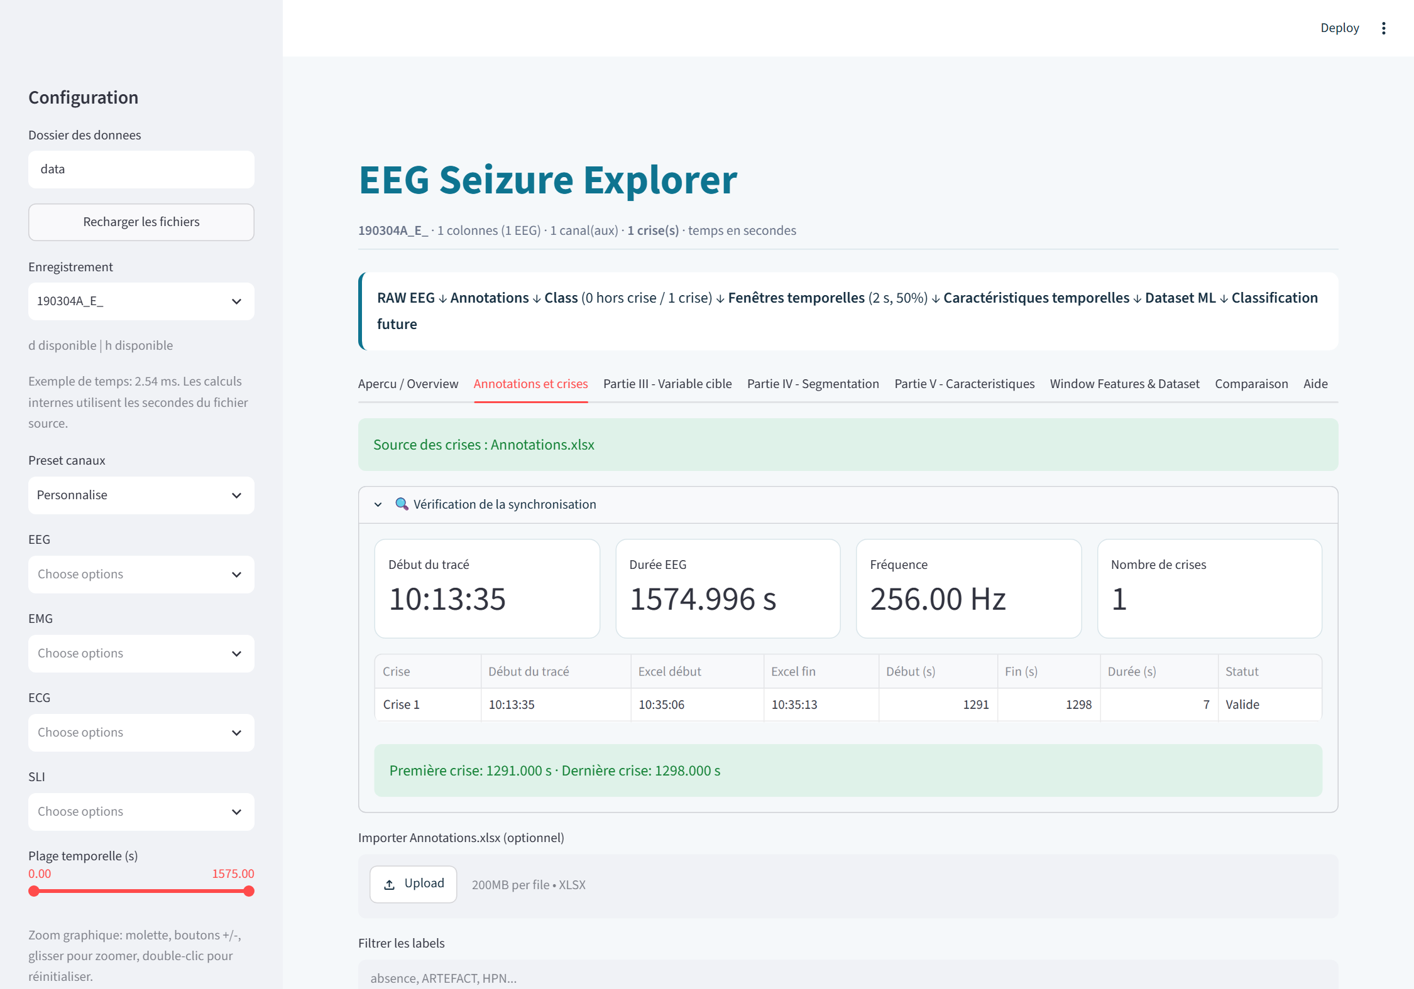
Figure 4. Application, annotation tab: conversion of the Excel clock times to seconds and validation of each interval (recording 190304A_E)
Question 4. Compute the mean, minimum and maximum duration and the mean interval between two seizures. Do all seizures have a similar duration?
Table 9. Duration statistics
Statistic | Recording 211104B_D | All 18 recordings
Number of seizures | 5 | 71
Mean duration | 8.0 s | 13.6 s
Minimum duration | 6 s | 3 s
Maximum duration | 10 s | 49 s
Mean interval between seizures | 152.8 s | —
Coefficient of variation | 0.16 | 0.68

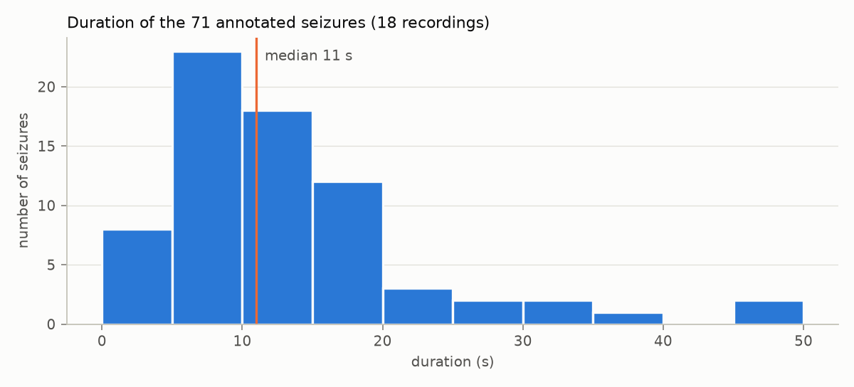
Figure 5. Distribution of the duration of the 71 annotated seizures
Answer. Within this recording the seizures are similar: 6 to 10 s, with a coefficient of variation of 0.16. Across all recordings they are not: durations range from 3 s to 49 s, the median is 11 s and the coefficient of variation is 0.68. Most seizures last 5 to 15 s, with a few much longer ones. Duration is a property of the patient more than of the seizure type.

4.3 Part III: building the target variable
Question 5. Create a column Class: 0 outside seizures, 1 during a seizure.
For each sample, Class = 1 when its time lies in one of the intervals [start, end], and 0 otherwise. Overlapping intervals are merged first. The computation uses a sorted search on the time column and is not a loop over samples, so it runs in a fraction of a second on 300,000 rows.
Question 6. Display the signal distinguishing the periods outside and during seizures. Is the class imbalance important?
Figure 2 shows the signal with the seizure periods shaded. The application shows the same view interactively, with the Class curve under the signal.
Table 10. Class distribution of the samples of recording 211104B_D
Class | Samples | Percentage
0, no seizure | 299,520 | 96.7%
1, seizure | 10,240 | 3.3%

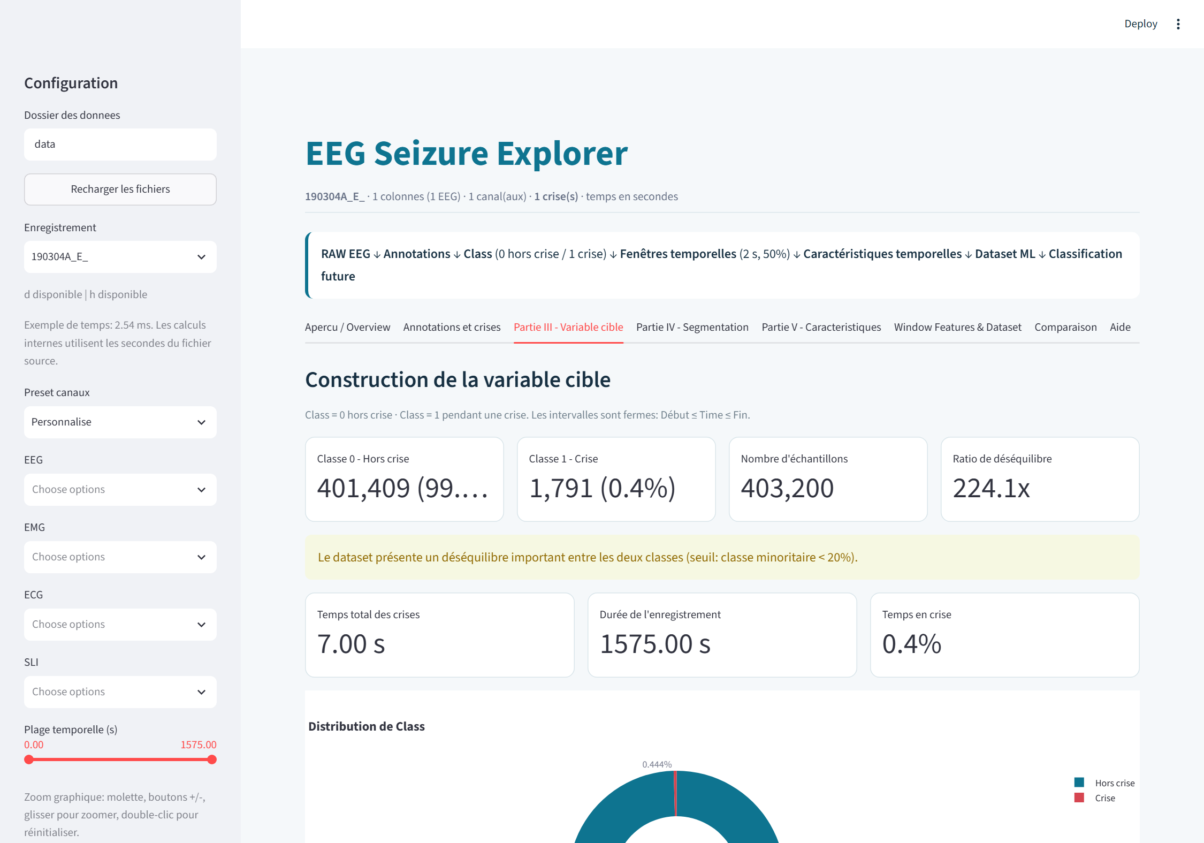
Figure 6. Application, target tab: class counts, imbalance ratio and warning (recording 190304A_E, one seizure of 7 s)
Answer. Yes, the imbalance is strong. In this recording, 29 samples out of 30 are outside a seizure. Over the 18 recordings, seizures occupy 965 s of 25,892 s, that is 3.7% of the time; for a recording with a single short seizure the proportion falls to 0.4%. Two consequences follow: accuracy cannot be used alone (Question 13), and the training data must be rebalanced (Section 3.5).

4.4 Part IV: segmenting the signal
Question 7. Cut the signal into windows and give each window a class: 1 if at least 50% of its samples belong to a seizure. Create a dataset with one row per window.
At 256 Hz, a 2-second window contains 512 samples. With 50% overlap, a new window starts every 256 samples (1 s). The number of samples is computed from the measured sampling frequency:
samples per window = round(duration × fs) step = round(samples per window × (1 − overlap))
Recording 211104B_D gives 1,209 windows of 2 s: 1,164 of class 0 and 45 of class 1. Windows of 1 s were also produced to compare the two durations.

4.5 Part V: temporal features
Question 8. Produce the dataset of features. Check the total number of windows and the number in each class.
Eight temporal features are computed on the raw samples of each window, for each EEG channel:
Table 11. Temporal features
Feature | Definition
Mean | Arithmetic mean of the samples
Std, Variance | Standard deviation and its square
Min, Max | Smallest and largest sample
Amplitude | Max − Min
RMS | Square root of the mean of the squared samples
Energy | Sum of the squared samples

Feature names carry the channel name (for example EEGFp1_RMS), so the 19 channels give 152 temporal columns. The dataset covers all 18 recordings:
Table 12. Question 8: size of the window datasets
Window duration | Total windows | Class 0 | Class 1 | Class 1 share
2 s | 25,874 | 24,873 | 1,001 | 3.9%
1 s | 51,766 | 49,800 | 1,966 | 3.8%

The dataset has no missing value and no duplicated window.

5. Results: frequency and exploratory analysis

5.1 Part VI: frequency analysis
Question 9. For each window compute the FFT, show the signal in the time and frequency domains, and compute the power in the Delta, Theta, Alpha and Beta bands.
Each window is mean-centred and transformed with the FFT. The one-sided power spectral density is 2·|X(f)|² / (fs·N), and the power of a band is the integral of this density between the band limits.
Table 13. Frequency bands
Band | Frequencies
Delta | 0.5–4 Hz
Theta | 4–8 Hz
Alpha | 8–13 Hz
Beta | 13–30 Hz

This adds 4 features per channel, 76 columns for 19 channels. Each window is now described by 228 features. A unit test checks the computation: a sine wave of amplitude 1 at 3, 6, 10 or 20 Hz has all of its power (0.5) in its own band.
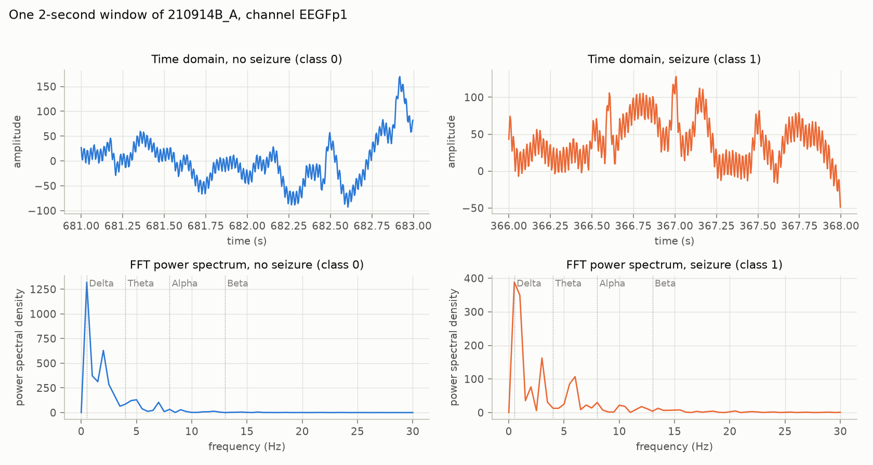
Figure 7. A non-seizure window and a seizure window of the same recording, in the time domain (top) and in the frequency domain (bottom)
Observation. The seizure window has peaks near 3 Hz and 6 Hz. This is the spike-and-wave discharge at 3 Hz and its first harmonic. The non-seizure window has its power below 3 Hz, which corresponds to slow drift. Since all four bands end at 30 Hz, the band powers also ignore the 50 Hz interference that pollutes the temporal features.

5.2 Part VII: exploratory analysis
Question 10. Compare the features between the two classes and represent the differences.
Features are averaged over the EEG channels of each window. Only training windows are used (15,811 of class 0 and 593 of class 1, 2-second windows), so that nothing is learned from the test recordings.
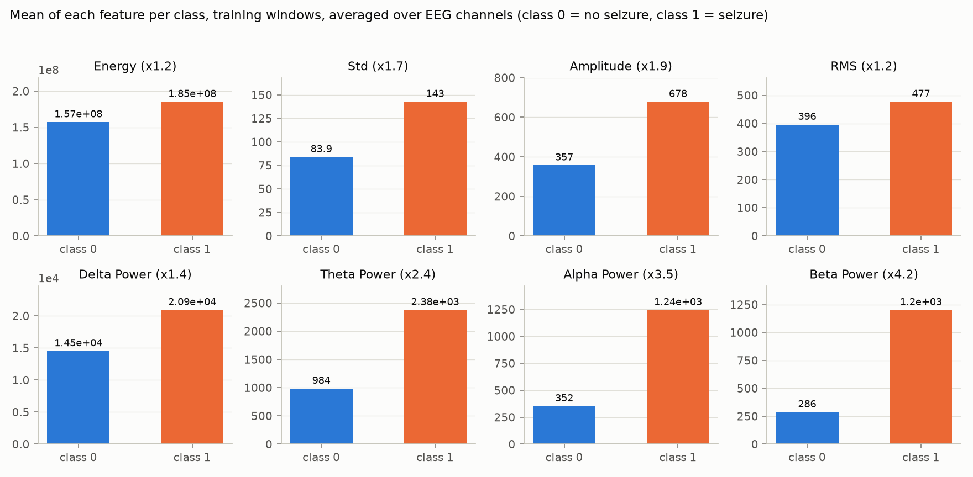
Figure 8. Mean of each feature in the two classes. The factor in each title is the ratio class 1 / class 0
Table 14. Question 10: features in the two classes
Feature | Mean, class 0 | Mean, class 1 | Ratio | Std, class 0 | Std, class 1 | AUC alone
Energy | 1.57e8 | 1.85e8 | 1.2 | 1.98e8 | 1.38e8 | 0.59
Std | 83.9 | 142.6 | 1.7 | 112.1 | 94.0 | 0.83
Amplitude | 357 | 678 | 1.9 | 477 | 387 | 0.89
Delta power | 14,516 | 20,921 | 1.4 | 165,470 | 113,891 | 0.92
Theta power | 984 | 2,376 | 2.4 | 10,039 | 2,591 | 0.95
Alpha power | 352 | 1,245 | 3.5 | 3,699 | 1,234 | 0.94
Beta power | 286 | 1,201 | 4.2 | 3,478 | 1,684 | 0.95

"AUC alone" is the area under the ROC curve obtained when the feature is used by itself as a seizure score: 0.5 means no information, 1 means perfect separation.
- Seizure windows have more power in every band: 1.4 to 4.2 times more on average.
- Amplitude and standard deviation roughly double during a seizure.
- Energy and RMS hardly change (ratio 1.2). They are dominated by the constant offset of the signal, not by its oscillation.
- Standard deviations are as large as the means: a few windows with artefacts take extreme values, and the two classes overlap. No single threshold on one feature is enough.
Question 11. Compute the correlation matrix. Which features are strongly correlated? Are some redundant? Which are the most discriminant?
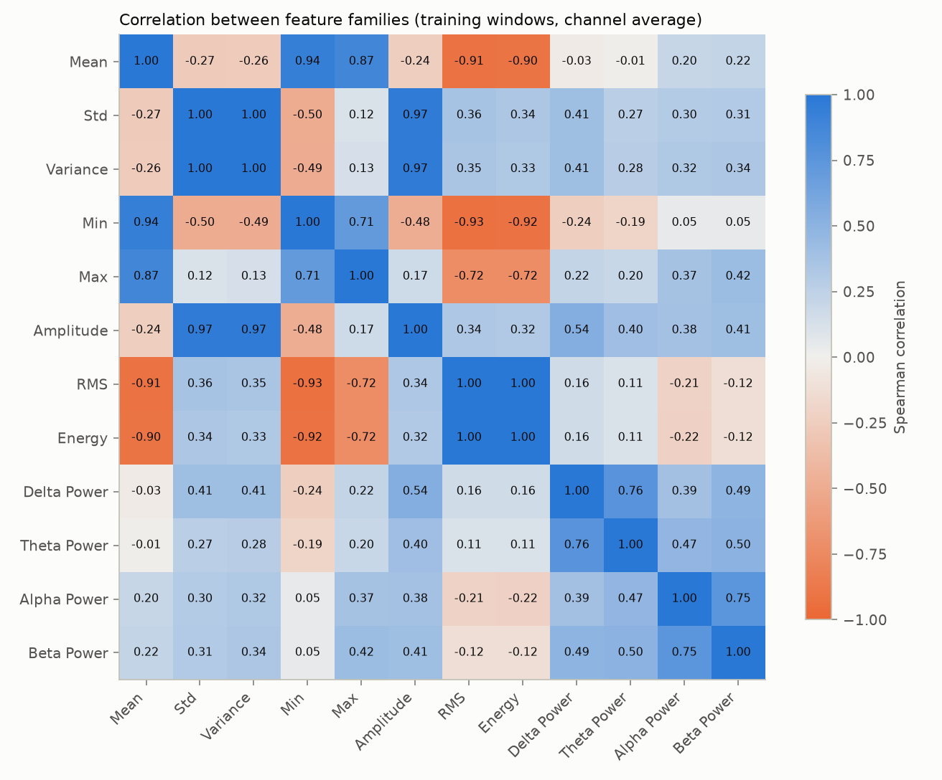
Figure 9. Spearman correlation between the twelve feature families
Table 15. Most strongly correlated pairs
Pair | Correlation
RMS and Energy | 1.00
Std and Variance | 1.00
Std (or Variance) and Amplitude | 0.97
Mean and Min | 0.94
Min and RMS | −0.93
Mean and RMS | −0.91
Delta and Theta power | 0.76
Alpha and Beta power | 0.75

Strongly correlated features. RMS and Energy, Std and Variance, and Std and Amplitude are almost perfectly correlated. Mean, Min, RMS and Energy all follow the offset of the signal.
Redundancy. Yes. Variance is the square of Std, and Energy is the square of RMS multiplied by the window length; each pair orders the windows in exactly the same way. The twelve features reduce to about four groups: offset (Mean, Min, Max, RMS, Energy), spread (Std, Variance, Amplitude), slow activity (Delta, Theta) and fast activity (Alpha, Beta). All features were kept, since tree-based models are not affected by redundancy; KNN and SVM are the models it can hurt.
Most discriminant features. The band powers: Beta (0.95), Theta (0.95), Alpha (0.94) and Delta (0.92), followed by Amplitude (0.89), and Std and Variance (0.83). Mean, Max, RMS and Energy carry almost no information (0.57 to 0.60).

6. Results: models and evaluation

6.1 Part VIII: building the models
Question 12. Build at least a Decision Tree, a Random Forest, a KNN and an SVM.
The four requested models were trained, and two neural networks were added as the deep-learning improvement suggested in Part XII.
Table 16. Models and hyperparameters
Model | Settings searched or used
Decision Tree | Maximum depth 5, 10 or unlimited; minimum leaf size 5 or 20
Random Forest | 300 trees; maximum depth 12 or unlimited; minimum leaf size 1 or 5
KNN | Standardised features; 5, 11 or 21 neighbours; uniform or distance weights
SVM | Standardised features; RBF kernel; C = 0.1, 1 or 10
1D-CNN | Input: 5 consecutive windows. Two convolution layers (32 and 16 filters) and global average pooling
LSTM | Input: 5 consecutive windows. One recurrent layer of 32 units, dropout 0.2

Training procedure
- Missing values are replaced by the training median; for KNN, SVM and the networks, features are standardised with training statistics.
- Each candidate is trained on a balanced training set.
- The decision threshold on the model's seizure score is the one that maximises the F1-score on the validation set.
- The candidate with the best validation F1-score is kept; recall decides ties.
- The test set is scored once with this model and this threshold.
The neural networks are trained with the Adam optimiser and stopped when the validation F1-score has not improved for five epochs. Their input is a sequence of five consecutive windows of the same recording; because resampled rows are no longer consecutive, sequences are built first and the training sequences are balanced afterwards.
In total 36 runs were made: 6 models on 6 training sets.

6.2 Part IX: evaluation
The table below gives, for each model, the result on the test set with the training set that had the best validation F1-score. Precision, recall and F1-score are those of the seizure class.
Table 17. Results on the test set (4 recordings, 12 seizures)
Model | Training set | Accuracy | Precision | Recall | F1-score
Decision Tree | 2 s, undersampling | 0.951 | 0.449 | 0.896 | 0.598
Random Forest | 2 s, undersampling | 0.970 | 0.582 | 0.939 | 0.718
KNN | 2 s, undersampling | 0.960 | 0.504 | 0.925 | 0.652
SVM | 2 s, oversampling | 0.973 | 0.712 | 0.571 | 0.634
1D-CNN | 2 s, oversampling | 0.956 | 0.481 | 0.887 | 0.624
LSTM | 1 s, undersampling | 0.975 | 0.644 | 0.838 | 0.728

Confusion matrices
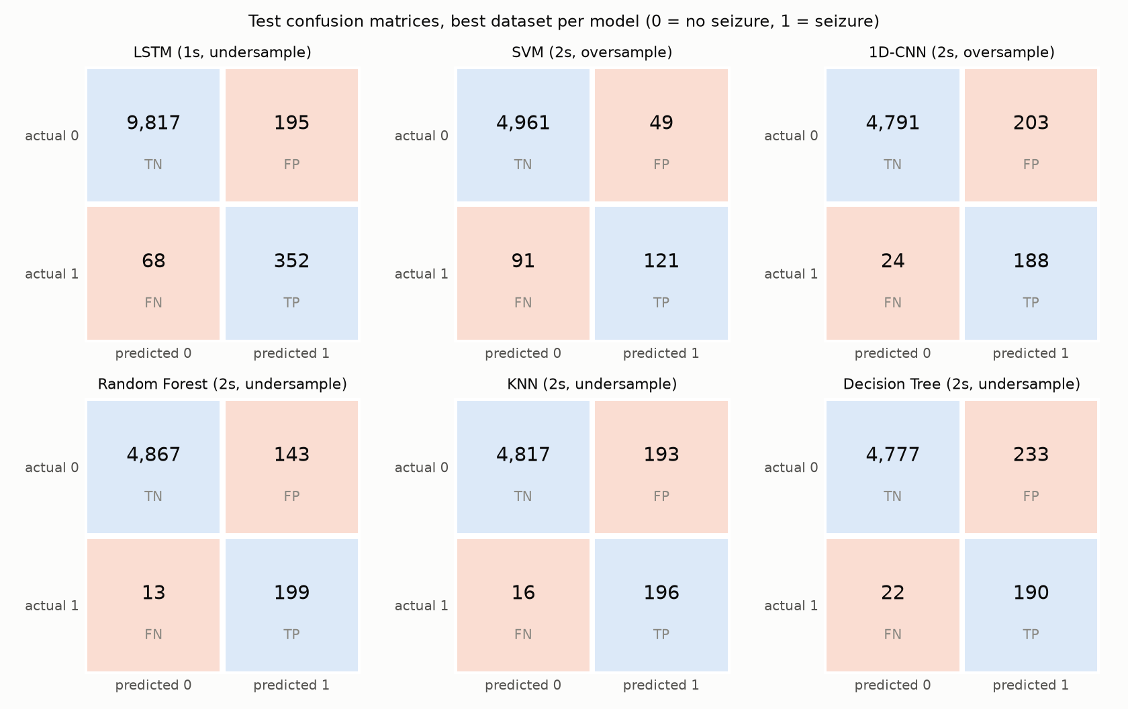
Figure 10. Confusion matrices on the test set. TN: true negatives, FP: false positives, FN: false negatives, TP: true positives
Interpretation. A confusion matrix separates the two kinds of error. The bottom-left cell (FN) counts seizure windows that the model missed; the top-right cell (FP) counts normal windows flagged as seizure.
- The Random Forest misses the fewest seizure windows: 13 of 212. It pays for this with 143 false alarms.
- The SVM is the opposite: only 49 false alarms, but 91 missed seizure windows, 43% of them.
- The Decision Tree and KNN find about as many seizure windows as the Random Forest but with more false alarms (233 and 193).
- The LSTM counts are on 1-second windows, hence about twice as many windows.

Effect of the training set
Table 18. Test F1-score of every model on every training set
Model | 1 s hybrid | 1 s over | 1 s under | 2 s hybrid | 2 s over | 2 s under
Decision Tree | 0.664 | 0.696 | 0.299 | 0.540 | 0.540 | 0.598
Random Forest | 0.660 | 0.635 | 0.689 | 0.682 | 0.664 | 0.718
KNN | 0.294 | 0.537 | 0.442 | 0.373 | 0.333 | 0.652
SVM | 0.524 | 0.663 | 0.696 | 0.587 | 0.634 | 0.565
1D-CNN | 0.625 | 0.675 | 0.687 | 0.634 | 0.624 | 0.485
LSTM | 0.715 | 0.722 | 0.728 | 0.689 | 0.617 | 0.638

- The Random Forest and the LSTM are the most stable: their F1-score stays between 0.62 and 0.73 on all six training sets.
- The Decision Tree and KNN are unstable, from 0.29 to 0.70. A single tree overfits; KNN suffers from 228 correlated features.
- No balancing strategy and no window duration is best for every model. Undersampling gives the best test F1-score for five of the six models although it keeps only 1,162 or 593 windows per class: the quantity of non-seizure data is not what limits performance.

How reliable is the ranking?
With 13 seizures in validation and 12 in test, one split is a thin basis for comparing models. The four classical models were therefore re-evaluated by a grouped 5-fold cross-validation on the 14 training and validation recordings (59 seizures). The test recordings were not used.
Table 19. Grouped 5-fold cross-validation: mean ± standard deviation over the folds
Model | F1-score | Recall | Precision
Random Forest | 0.61 ± 0.08 | 0.60 ± 0.20 | 0.71 ± 0.17
KNN | 0.54 ± 0.10 | 0.58 ± 0.21 | 0.61 ± 0.23
Decision Tree | 0.39 ± 0.22 | 0.56 ± 0.23 | 0.41 ± 0.25
SVM | 0.30 ± 0.24 | 0.66 ± 0.37 | 0.21 ± 0.18

- The Random Forest is the most robust classical model: best mean and smallest spread.
- The SVM does not confirm its good validation score: its F1-score falls below 0.1 in two folds, because its decision threshold does not transfer from one group of recordings to another.
- The spread between folds (0.08 to 0.24) is as large as the differences between models.
The neural networks were not cross-validated because of training time. The advantage of the LSTM over the Random Forest on the test set (0.728 against 0.718) is therefore within the uncertainty.

6.3 Which metric should be preferred?
Question 13. Explain why accuracy alone can be misleading. Among accuracy, precision, recall and F1-score, which are the most relevant for detecting seizures?
Why accuracy is misleading. About 4% of the test windows are seizures. A model that always answers "no seizure" obtains 96.0% accuracy on the test set (10,028 windows of 10,448) while detecting nothing. The six models have accuracies of 0.951 to 0.975, all within three points of this useless model. Accuracy even ranks the models wrongly: the SVM has the second-best accuracy (0.973) and by far the worst recall (0.571). Accuracy is dominated by the true negatives, which are numerous and easy.
The relevant metrics.
- Recall comes first. A missed seizure is the costly error for a medical detector: the event is not recorded and the patient's number of seizures is underestimated.
- Precision comes second. Each false alarm costs the clinician time, and a detector that raises alarms constantly is no longer trusted.
- F1-score combines the two and cannot be maximised by predicting a single class. It is the selection criterion used in this project, with recall to decide ties.
The trade-off is visible in the results table of Section 6.2. The Random Forest (recall 0.94, precision 0.58) and the SVM (recall 0.57, precision 0.71) have close F1-scores but would behave very differently in use. For screening, the profile of the Random Forest is preferable.
Window-level metrics are not the final answer either. What matters in practice is the number of seizures found and the number of false alarms per hour; this is the subject of the next section.

7. Results: temporal detection and error analysis

7.1 Part X: reconstructing the seizures
Question 14. From the predictions of the best model, reconstruct the time intervals of the detected seizures and compare them with the real annotations.
Best model. The LSTM trained on 1-second windows with undersampling has the highest validation F1-score (0.836) of the 36 runs. The choice did not use the test set.
Method.
- A window is predicted "seizure" when the score of the model is at least 0.96, the threshold chosen on validation.
- Consecutive positive windows of the same recording are merged into one interval.
- Two intervals separated by one second or less are joined.
- A real seizure is counted as detected when a predicted interval overlaps it. A predicted interval that overlaps no real seizure is a false alarm.
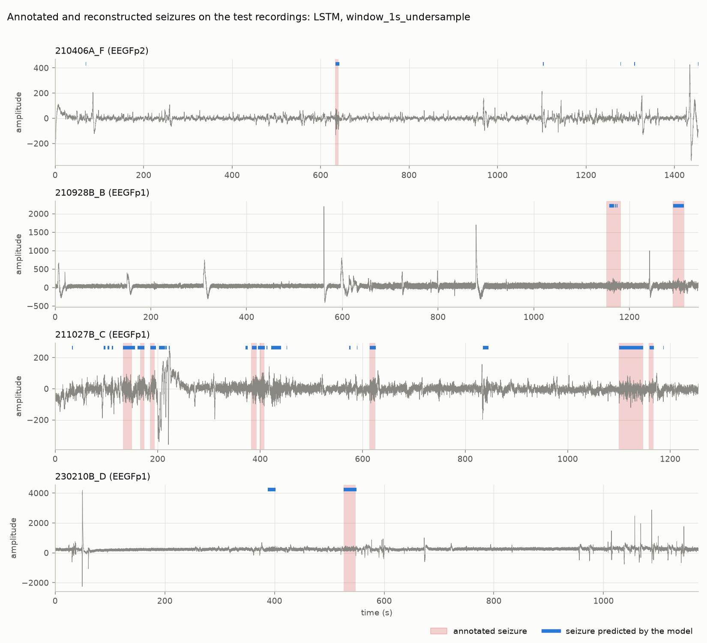
Figure 11. Signal, annotated seizures (shaded) and seizures predicted by the model (blue bars) on the four test recordings
Table 20. Question 14: detected seizures compared with the annotations
Recording | Real seizure (s) | Detected seizure (s) | Start error (s)
210406A_F | 633.0 → 641.0 | 633.5 → 642.5 | +0.5
210928B_B | 1152.0 → 1182.0 | 1157.5 → 1167.5 (plus two fragments) | +5.5
210928B_B | 1290.0 → 1315.0 | 1291.5 → 1313.5 | +1.5
211027B_C | 132.0 → 150.0 | 132.0 → 156.0 | 0.0
211027B_C | 166.0 → 174.0 | 160.5 → 174.0 | −5.5
211027B_C | 185.0 → 194.0 | 185.5 → 196.5 | +0.5
211027B_C | 382.0 → 393.0 | 384.0 → 393.0 | +2.0
211027B_C | 399.0 → 408.0 | 396.0 → 409.5 | −3.0
211027B_C | 613.0 → 625.0 | 613.5 → 626.0 | +0.5
211027B_C | 1100.0 → 1147.0 | 1100.5 → 1147.5 | +0.5
211027B_C | 1158.0 → 1167.0 | 1159.5 → 1168.0 | +1.5
230210B_D | 526.0 → 548.0 | 526.5 → 549.5 | +0.5

Table 21. Summary of the reconstruction (1.45 hours of recording)
Result at the level of seizures | Value
Real seizures in the test recordings | 12
Seizures detected | 12 (100%)
Seizures missed | 0
Mean start error | +0.4 s
Starts within 2 s of the annotation | 9 of 12
Predicted intervals | 35
False alarms | 21, that is 14.5 per hour

Comparison. All 12 seizures are found and 9 of the 12 starts are within two seconds of the annotation. The first seizure of recording 210928B_B is found 5.5 s late and only half of it is covered, in three fragments. Detected intervals end on average slightly after the annotated end.

7.2 Part XI: error analysis
Table 22. Outcome of each 1-second window of the test set, selected model
Recording | True positives | False positives | False negatives | True negatives
210406A_F | 15 | 11 | 2 | 2,875
210928B_B | 63 | 0 | 47 | 2,573
211027B_C | 231 | 154 | 17 | 2,103
230210B_D | 43 | 30 | 2 | 2,266
Total | 352 | 195 | 68 | 9,817

True positives and true negatives
352 of the 420 seizure windows (84%) and 9,817 of the 10,012 normal windows (98%) are classified correctly.

False negatives: 68 windows
- 47 of the 68 are in recording 210928B_B. Both of its seizures are found, but only about half of the first one is covered.
- These are seizure windows that score below the high threshold (0.96). They shorten the detected seizure; they do not hide it.
- The other 21 are spread over the remaining ten seizures, about two windows each.

False positives: 195 windows, 21 intervals
- 154 of the 195 windows and 15 of the 21 intervals are in a single recording, 211027B_C. Many are just before or after one of its eight seizures, for example between 94 s and 114 s, before the seizure at 132 s. They may be short discharges that were not annotated, or a reaction of the model to this patient's background rhythm; the data cannot tell which.
- 12 of the 21 false alarms last two seconds or less. The median false alarm lasts 2 s, against 11 s for a real seizure.
- Four false alarms last more than 10 s. They were not investigated further.

Assessment
The selected model is a sensitive detector with too many short false alarms. It misses no seizure of the test set but would interrupt a clinician about 14 times per hour. It is usable as an aid that proposes candidates for review, not as an autonomous detector.

8. Improvements

8.1 Improvements already implemented
Several of the directions suggested in Part XII were implemented and measured during the project.
Table 23. Improvements implemented
Improvement | What was done | Effect
New features | Four frequency-band powers per channel | Best classical test F1-score went from 0.49 to 0.72
Class imbalance | Three balancing strategies on the training set | Recall of 0.84 to 0.94 for five of the six models
Window size | 1 s and 2 s windows compared | No duration is best for all models
Hyperparameters | Grid search on the validation set | Different settings selected per training set
Decision threshold | Chosen on validation to maximise F1 | Adapts each model to the 4% seizure rate
Normalisation | Standardisation for KNN, SVM and the networks | Required for distance-based models
Deep learning | 1D-CNN and LSTM on sequences of five windows | LSTM has the best test F1-score (0.73)

The comparison in the first row uses the same four classical models before and after the frequency features were added; the earlier run also had a different test set, so the gain is indicative.

8.2 Proposed improvements
- Remove very short detections. Real seizures last at least 3 s, while 12 of the 21 false alarms last 2 s or less. Rejecting predicted intervals shorter than a minimum duration, chosen on validation data, should remove more than half of the false alarms without losing a seizure. This was observed on the test set and deliberately not applied, since tuning it there would bias the result.
- Filter and normalise each recording. A 50 Hz notch filter and a high-pass filter would remove the interference and the drift that make the temporal features nearly useless. Scaling each channel by its own recording, or using relative band powers, would make recordings comparable. The large differences between recordings suggest this is the main source of error.
- Target the 3 Hz discharge directly. Add the power in a narrow 2.5–4 Hz band, its ratio to total power, and the dominant frequency. The Delta band used here (0.5–4 Hz) mixes the discharge with slow drift.
- Select features. Remove exact duplicates (Variance, Energy) and the features driven by the offset. KNN and SVM should benefit the most.
- More data and patient identifiers. With a patient identifier, the evaluation could be made across patients. Recording 210504B_C and its 11 seizures could be recovered by correcting one cell of the annotation file.

9. Discussion

9.1 What the results show
- Frequency features are decisive. This agrees with the physiology: an absence seizure is defined by a discharge at 3 Hz. The temporal features asked for in Part V are weak on this dataset because of the offset, the drift and the 50 Hz interference.
- Context helps. The LSTM looks at five consecutive windows. A seizure lasts several seconds while most artefacts are brief, so a model that sees the neighbouring windows is harder to mislead.
- Ensembles are robust. The Random Forest is nearly as good as the LSTM, trains in seconds and is the most stable model in cross-validation. A single Decision Tree is unreliable.
- Balancing matters less than expected. All three strategies give similar results; even 1,162 windows per class are enough.

9.2 Limits
- Few seizures. The test set holds 12 seizures in 4 recordings. One more or one fewer detection changes the seizure-level recall by 8 points.
- No patient identifier. The annotation file gives only age and sex. Two recordings of the same patient may be in different partitions, so the evaluation is independent of the recording but not proven independent of the patient.
- Optimistic validation scores. Validation F1-scores (0.76 to 0.84) are higher than test F1-scores (0.60 to 0.73) for every model, because thresholds and hyperparameters were tuned on the three validation recordings.
- Limited search. Small hyperparameter grids, one architecture per neural network, one random seed, and no cross-validation of the networks.
- Imprecise annotations. Times are given to the second, and the 50% rule makes the windows at the edges of a seizure ambiguous.
- Split different from the assignment. The split is by recording, not a stratified 80/20 split of windows. This lowers the scores but makes them honest.

10. Conclusion
The project delivers the complete chain requested: from the raw EEG signal to the list of seizures with their start and end times, with an interactive application for the exploration and a reproducible pipeline for the modelling.
Three lessons stand out:
- The evaluation protocol matters as much as the model. Splitting by recording, balancing only the training data and choosing models on a validation set give lower but trustworthy numbers.
- Domain knowledge beats model complexity. Adding four frequency-band powers improved every model more than any change of algorithm.
- Accuracy says nothing here. All models exceed 95% accuracy; they differ by their recall and precision on the seizure class, and above all by the number of seizures found and the number of false alarms.
On recordings never seen in training, the selected model finds all 12 seizures and places most starts within two seconds, at the price of 14 false alarms per hour. It can assist a clinician by proposing candidate seizures; it is not ready to work alone.
The next steps are clear: filter the 50 Hz interference and normalise each recording, reject very short detections, and above all obtain more annotated recordings with patient identifiers.

Appendix: reproducing the results
All results are produced by the code of the repository. From the project root:
Table 24. Commands
Step | Command
Install | python -m pip install -r requirements.txt
Application | streamlit run app.py
Build datasets | prepare_balanced_exports() in eeg_app/src/experiments.py
Train classical models | python scripts/train_classical_models.py
Train neural networks | python scripts/train_neural_models.py
Cross-validation | python scripts/cross_validate_models.py
Comparison and reconstruction | python scripts/compare_models.py
Figures | python scripts/build_exploration_figures.py, python scripts/build_eda_figures.py
Tests | python -m pytest -q (40 tests)

Numerical results are stored in the results/ folder (model_comparison.csv, best_per_model.csv, selected_model_report.json), and the datasets in extracted_data/. The README describes the structure of the repository in detail.

