Project Architecture & Workflow Guide

1. Purpose of This Document
You are both building on the same project: a small system that watches a patient's vital signs at home, decides whether something needs attention, and — when it does — figures out what kind of network support that situation would need. This guide explains the architecture and the end-to-end workflow so you both start from the same picture. It does not go into the underlying research design choices behind why the project is built this way — those are out of scope for this onboarding, by design.

2. The Big Picture
The system is organised into four layers, from the sensor on the patient's wrist to the network resources that might eventually be reconfigured. Figure 1 shows the four layers and how data flows between them.
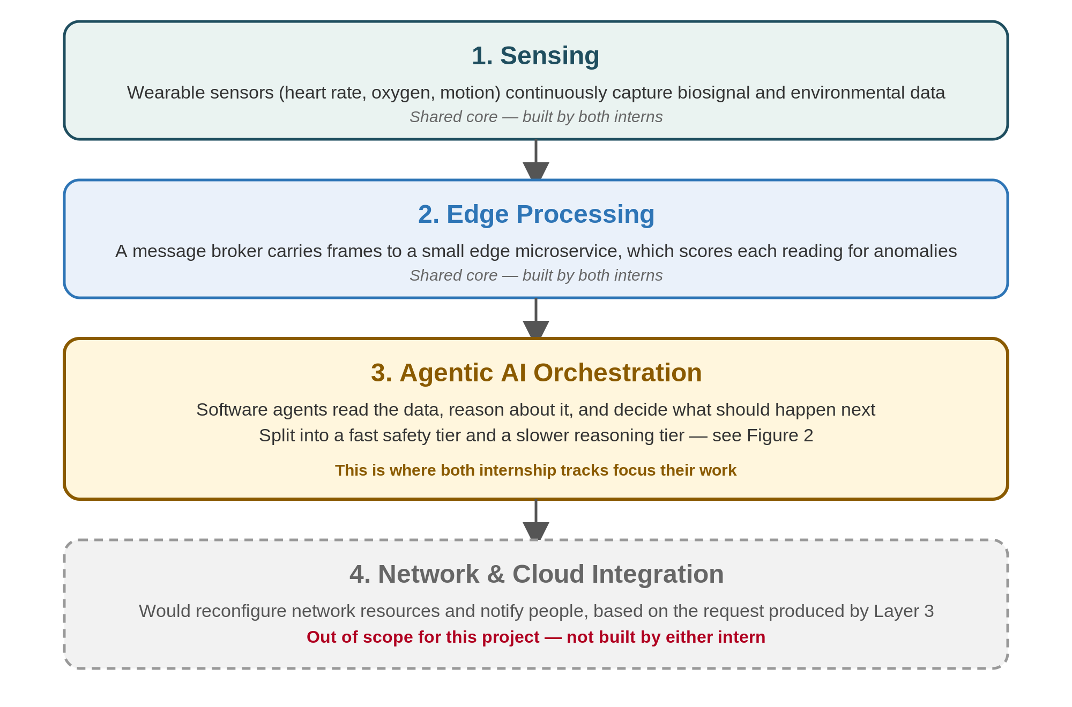
Figure 1 — The four layers of the system, from sensing to network integration.
Both of you work inside Layer 3, the Agentic AI Orchestration layer. Layers 1 and 2 are shared infrastructure you will set up together at the start; Layer 4 is explicitly out of scope — your systems produce a request describing what the network should do, but neither of you builds the part that would actually act on it.

3. Why Two Speeds?
A cardiac event needs a response fast enough to matter medically — a fraction of a second. Understanding what is actually going on — is this really dangerous, is the patient alone, does their history change how to react — benefits from the kind of reasoning modern AI language models are good at, but that reasoning takes noticeably longer to run: anywhere from a tenth of a second to a couple of seconds. Wait for that reasoning before every alarm decision, and the system misses the medical deadline. Skip the reasoning entirely, and the system loses the ability to adapt to context. The project's answer is to split the decision into two tiers that run at the same time, connected only by a message queue — never by a direct call that could make one wait on the other.

4. The Two Tiers, in Detail
Figure 2 zooms into Layer 3. Tier 1 is small, deterministic, and fast: it applies fixed rules and never calls an AI model. Tier 2 is where the reasoning happens: it builds a fuller picture of the situation, looks up relevant background information, and drafts a response.
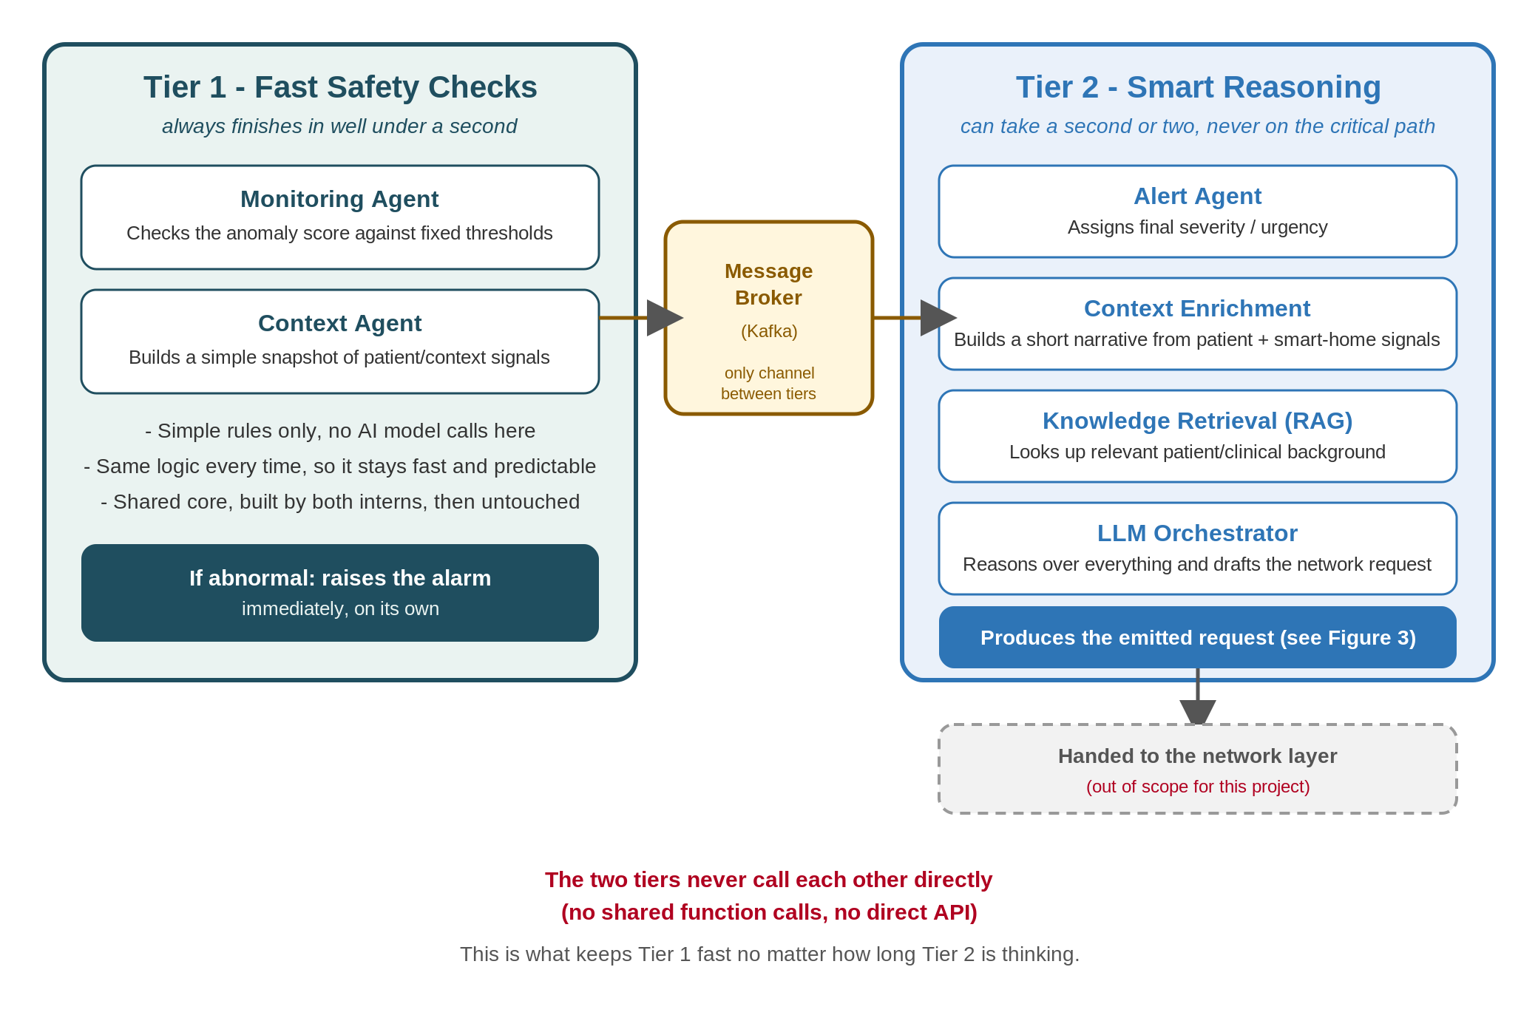
Figure 2 — Tier 1 (fast, rule-based) and Tier 2 (slower, reasoning-based), connected only through a message broker.
The important design rule, visible in the figure: the two tiers never call each other directly. They only exchange messages through a broker (this project uses Kafka). That is what guarantees Tier 1 stays fast no matter how long Tier 2 is thinking — there is no code path by which Tier 2 can block Tier 1.

5. From a Sensor Reading to a Network Request
Figure 3 walks through the full sequence for a single reading, from the moment it arrives to the moment the system has produced (but not sent) a network request.
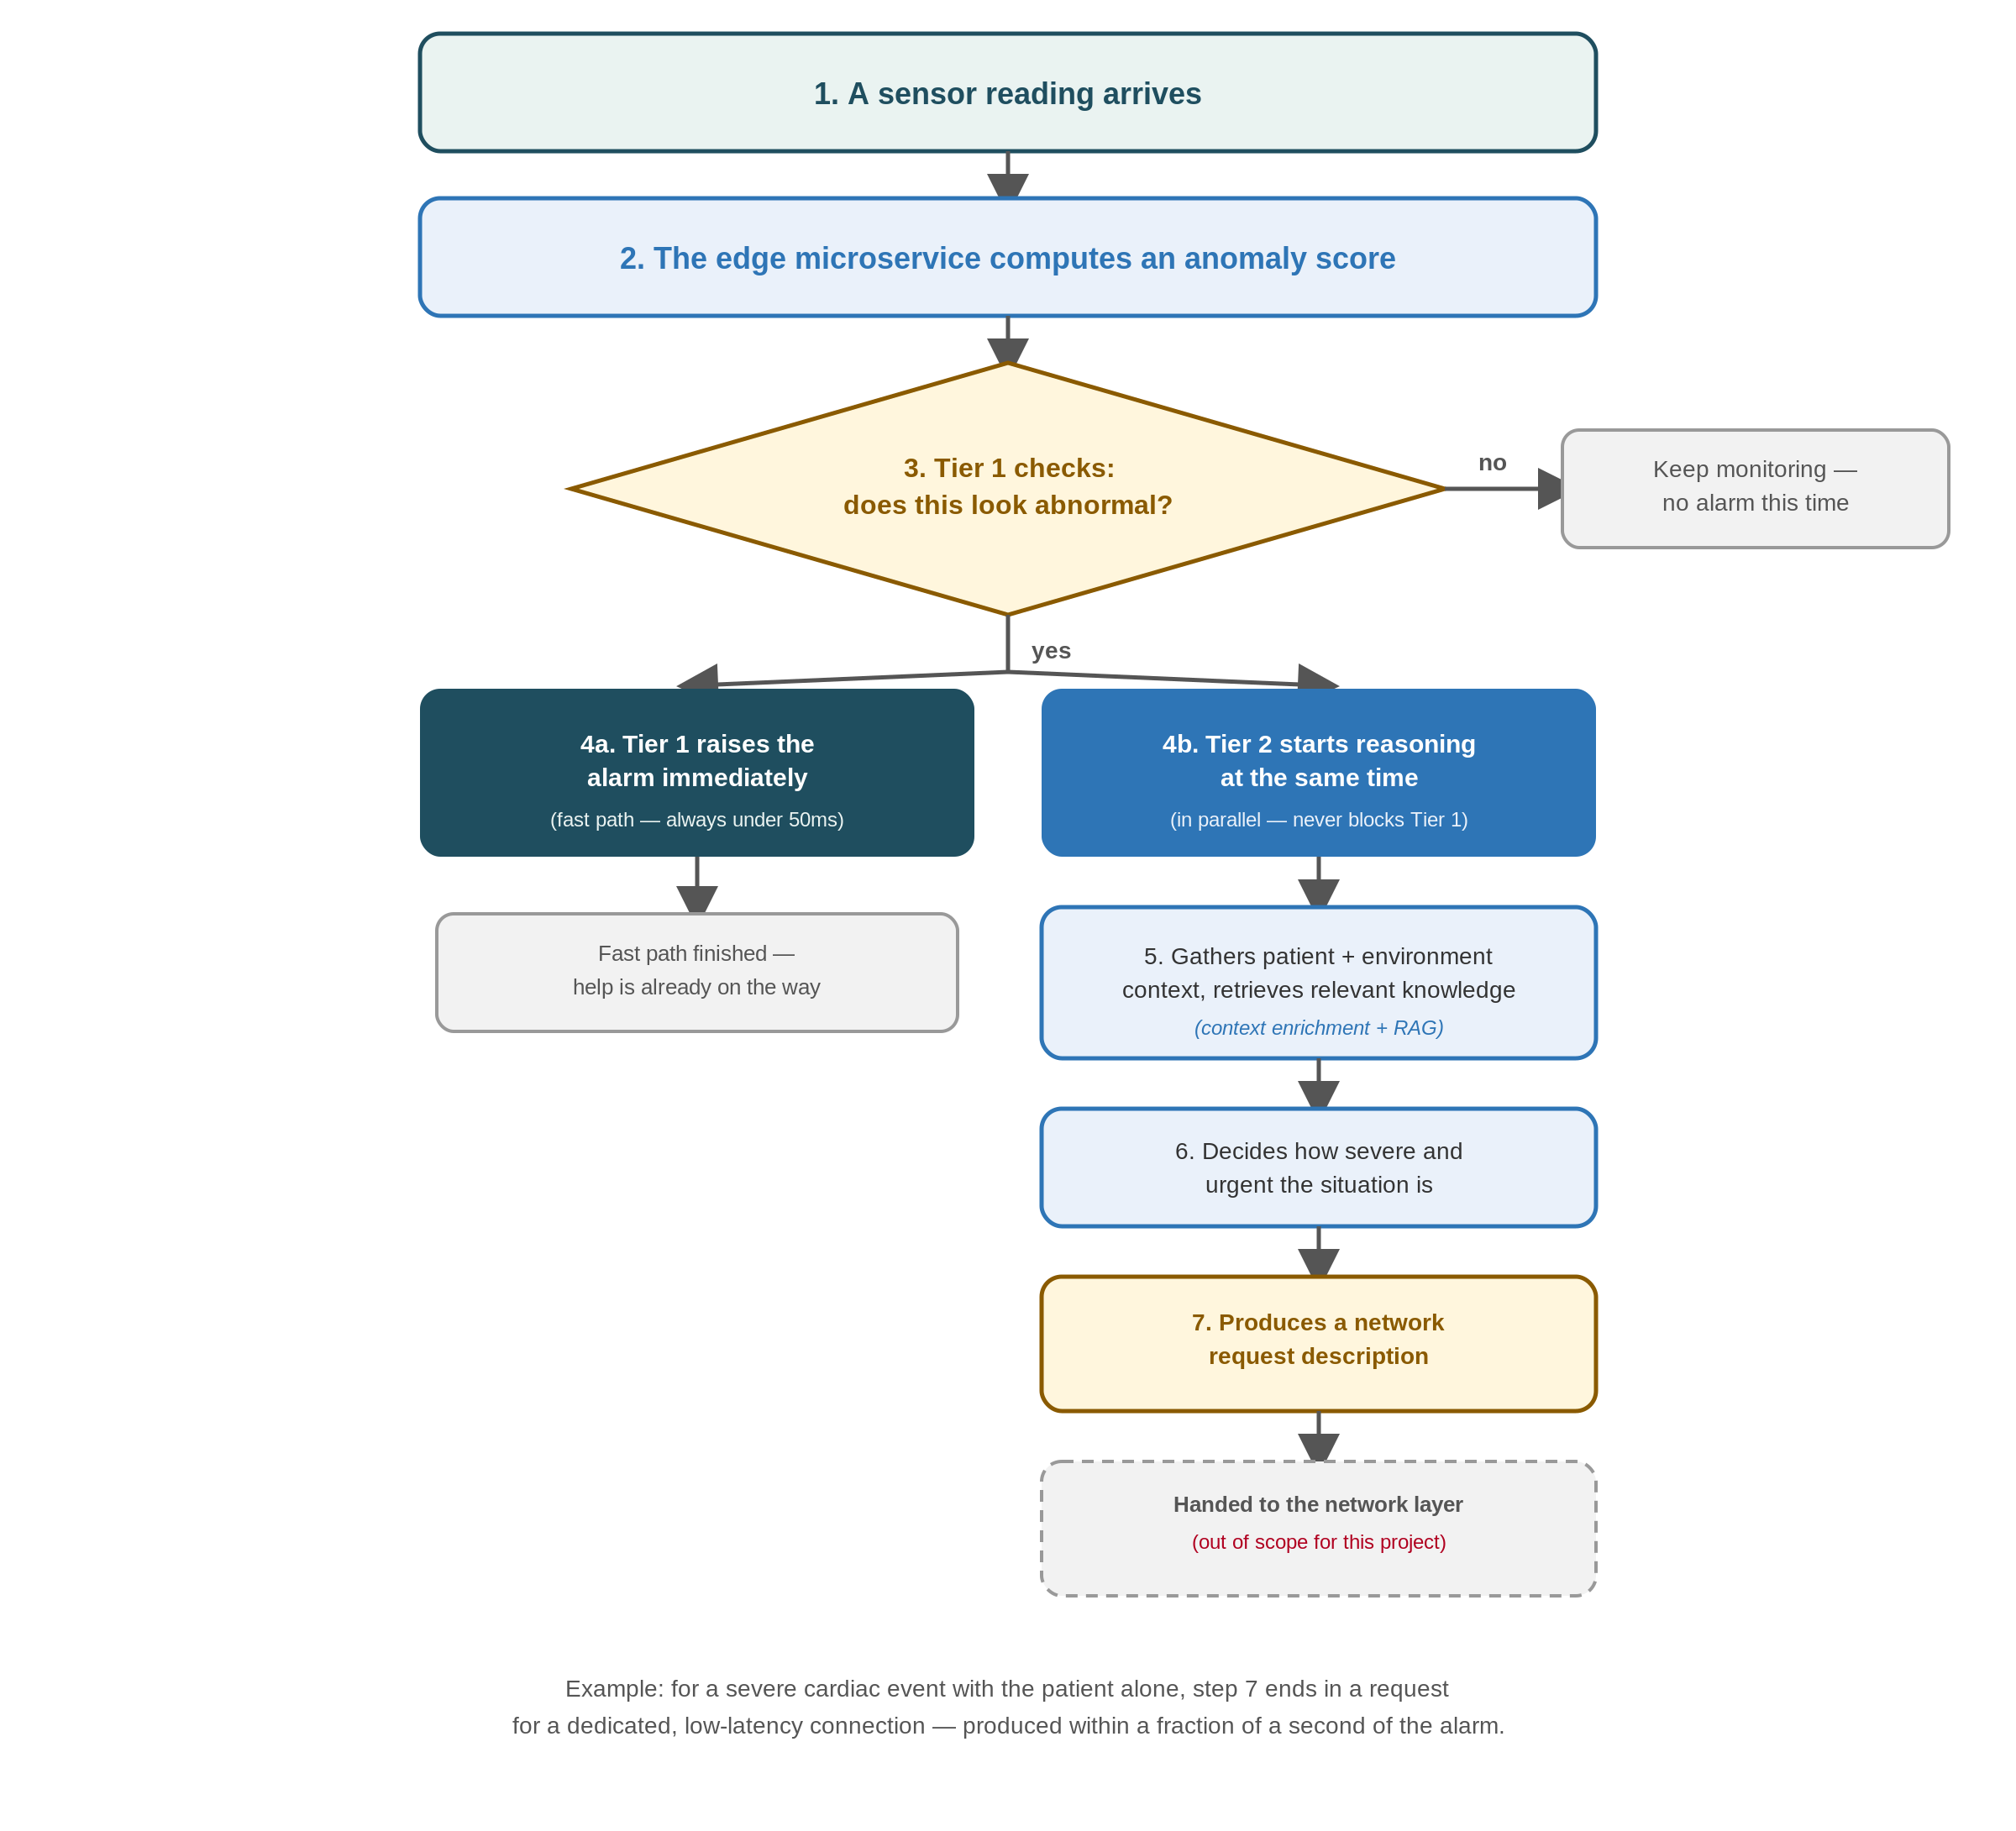
Figure 3 — The end-to-end workflow, from sensor reading to emitted network request.
Two things are worth noticing in this diagram. First, steps 4a and 4b happen in parallel: Tier 1 does not wait for Tier 2 to finish reasoning before raising the alarm. Second, the system's output (step 7) is a description of what the network should do — it is not itself a network change. What happens after that description is produced is outside this project.

6. What Do We Mean by “Context”?
Context comes in two broad kinds, and the interesting cases usually come from combining them rather than looking at either alone:
- Patient state — what the person is doing right now, whether they respond when checked on, whether they have taken their medication, how their readings have been trending.
- Environment / smart home — whether anyone else is home, the ambient temperature, whether a door opened, whether a smart speaker picked up an unusual sound.
A single elevated reading might mean nothing on its own. The same reading combined with “alone, hot room, missed medication” might be worth watching closely, even though no individual signal crossed an alarm threshold. Recognising that kind of combination is exactly the sort of judgment call that benefits from Tier 2's reasoning rather than a fixed table of rules — and it is the main reason this project uses AI reasoning at all, rather than a purely rule-based system.

7. How the System Decides What Matters
Once Tier 2 has reasoned about a situation, it translates that judgment into two things: how severe/urgent the situation is, and what kind of network support that would call for. The mapping is intentionally simple and illustrative — you will define the exact version you need for your own scenarios:
Severity level | What it generally means | What we ask the network for
Critical / Life-threatening | Requires an immediate professional response | A dedicated, guaranteed low-latency connection
High | Requires prompt attention | A dedicated but less strict connection
Moderate | Worth a closer look, not an emergency | A good-quality shared connection
Normal | Nothing abnormal detected | No special request

8. The Scenarios You Will Use
Both tracks work from the same fixed, small set of scenarios — three straightforward ones and three deliberately trickier ones, described here in plain terms.

8.1 Core scenarios
ID | Situation | What should happen
S1 | Irregular heartbeat + a fall detected + low oxygen reading + patient elderly and alone | Classified as very severe; the system should request a dedicated, low-latency connection
S2 | All readings within normal range, nothing unusual | No alarm; no network request produced
S3 | Unusually slow heart rate, no other risk factors present | Classified as moderate; a good-quality but non-emergency connection is requested

8.2 Context-enriched, deliberately ambiguous scenarios
ID | Situation | What should happen
S4 | No single reading crosses an alarm threshold, but three weak signals combine: mild heart-rate elevation, a hot room, and a missed medication dose, patient alone | Should raise a “watch closely” flag — a case a simple rule table would likely miss entirely
S5 | Heart-rate spike, an unanswered check-in, and a loud noise picked up by a smart speaker — but the fall sensor itself did not trigger | Should still be treated as a likely fall, by combining evidence the fall sensor alone would have missed
S6 | An alarm-level reading arrives at the same moment the wearable's connection briefly drops | The alarm still goes out immediately and unmodified — but the system can attach a note asking for a quick confirmation, since the drop makes the reading slightly less certain
The first three exist to prove the basic pipeline works end to end. The last three exist to show why a reasoning tier is useful in the first place: each is a case where a fixed table of thresholds either misses something a human would catch, or reacts more bluntly than the situation calls for.

9. What Is In Scope, and What Is Not
- In scope for both tracks: the sensor-replay setup, the message broker, Tier 1, Tier 2, the severity/urgency mapping, and producing the network-request description.
- Out of scope for both tracks: anything that would actually act on that request — network reconfiguration, real hardware slicing, or notifying real emergency services. The project stops at producing a well-formed request.
- Also out of scope: real smart-home hardware. Context signals such as presence, temperature, or audio events are scripted/synthetic for this project, not collected from real devices.

10. Shared Vocabulary
- Agent — a software component that perceives data, reasons (often via an AI model), and can take or request actions.
- Tier — one of the two speeds described in §3–4: Tier 1 (fast, rule-based) or Tier 2 (slower, reasoning-based).
- Orchestration framework — a library/platform used to define and run multiple agents and the flow of control between them.
- RAG (Retrieval-Augmented Generation) — retrieving relevant background information before an AI model responds, so its output is grounded in real, specific knowledge rather than relying only on what the model already “knows.”
- Context enrichment — combining several weak or partial signals (patient state, environment) into a short description a reasoning model can use, instead of a single fixed-shape snapshot.
- Severity / urgency mapping — the decision layer described in §7 that turns “what happened” plus “in what context” into “how serious is this and what should we ask the network for.”
- Network request / intent — the plain description of what the network should provide (e.g. a low-latency connection), produced as this project's final output.
- Ablation — comparing two versions of a system (e.g. with and without a capability) on the same cases, to see where and why they differ.
- Benchmark — a standardised task/dataset/metric set used to measure and compare the performance of a tool or system in a reproducible way.

