Internship Proposal B
RAG Engineering, Interoperability Services, and a Coordination-Layer Systems Experiment
Companion track: Proposal A — Context-Aware Agentic Reasoning. Please read the Project Architecture & Workflow Guide before this document — it defines the shared architecture, workflow, and scenarios (S1–S6) this proposal builds on.

1. Overview
Both interns extend the same small home-monitoring system, described in the Project Architecture & Workflow Guide: sensor data flows through an edge microservice into a fast, rule-based safety tier (Tier 1) and a slower, reasoning-based tier (Tier 2, owned by the companion Track A), which together decide whether to raise an alarm and what kind of network support that situation would call for. This track — Track B — makes two things possible: that Tier 2 can look up relevant background knowledge at all, and that the system's outputs are consumable outside the testbed. It also runs its own small systems experiment on the shared architecture's central coordination rule.

2. Shared Core (recap)
Built together with the Track A intern in the first two weeks; full detail is in the Project Architecture & Workflow Guide, §2 and Figure 1.
- Sensor replay, message broker, and edge microservice (anomaly scoring).
- Tier 1 — Monitoring Agent and Context Agent, exactly as specified in the guide; neither track modifies this once built.
- The three core scenarios, S1–S3, and the base severity/urgency mapping.
- The emitted network-request artifact concept (a description, not an action) — the interface both tracks build toward.

3. Track B — Objective
Select an open-source knowledge-retrieval stack for the project, then turn it — and the shared core's emitted network-request artifact — into two small, documented services (a retrieval service and a network-request emission service), and run a self-contained systems experiment that measures what happens if the shared architecture's central coordination rule is deliberately broken.

4. Phase 1 — Comparing Knowledge-Retrieval Tools
Tier 2 needs to look up relevant background information — patient history, general guidance — before reasoning about an ambiguous case. This phase picks the tooling for that, grounded in evidence rather than habit.

4.1 Candidate tools
- Vector stores: Chroma, Qdrant, FAISS.
- Evaluation frameworks: RAGAS, DeepEval.
- Optional, time permitting: a system-level profiling tool reporting latency/resource usage alongside quality metrics.
- Any additional candidate you identify as relevant, with justification.

4.2 Tasks
- Compare 2–3 open-source vector stores on self-hosting effort, indexing workflow, and query latency at small scale.
- Compare 2–3 evaluation frameworks on metric coverage (faithfulness, context precision/recall, answer relevance), whether they require reference answers or are reference-free, and setup effort.
- Build a small knowledge base sized to the project's own scenarios: general background material plus the synthetic patient-profile snippets Track A's S1–S6 scenarios need, with a matching set of test queries.
- Document findings in the comparison matrix (Appendix A) and flag any tool that proved difficult to install or unstable, with a recommended fallback.
- Synthesise into a short written recommendation for which combination to carry forward.

5. Phase 2 — From Comparison to Service

5.1 Retrieval service
Wrap the chosen vector store and retrieval pipeline behind a small, documented endpoint — POST /search {query, k} — rather than leaving it as an importable library. Track A calls this endpoint as a client; you own and host the service. This is the concrete implementation of the interface both tracks agree on in Week 2 (§7).

5.2 Network-request emission service
Track A's Tier-2 pipeline writes emitted network requests (a plain description of what the network should provide, plus its severity/urgency tag) to the message broker and a log file. This service exposes that artifact through a small read-only endpoint — GET /requests/latest, GET /requests/{scenario} — so a demo dashboard, or anything built later on top of this project, can consume results without being a broker consumer itself. Document both services with a short OpenAPI specification.

6. Phase 3 — The Coordination-Layer Systems Experiment
This is your own original empirical contribution, mirroring Track A's ablation but at the systems-coordination layer rather than the reasoning layer. The shared architecture's central design rule (Project Architecture & Workflow Guide, Figure 2) is that Tier 1 and Tier 2 never call each other directly — only through the message broker, precisely so Tier 1 stays fast no matter how long Tier 2 takes. This phase turns that rule from an assumption into a measurement on your own build:
- Build an alternate Tier-1↔Tier-2 hookup over a synchronous request/response call — explicitly as a deliberate anti-pattern, never as a replacement for the shared core's broker-based path.
- Run the same delayed-response sanity check from Phase 2 of the shared core against both this alternate hookup and the untouched broker-based path, and log Tier-1 latency for each.
- Report the comparison: does breaking the “never call directly” rule visibly degrade Tier-1 latency, and by how much, as the injected delay grows?
This deliberately does not modify the shared core's real coordination path — the alternate hookup is a separate, disposable measurement harness, built and torn down for this experiment only.

7. Interface With Track A
Interface | Track A provides / consumes | Track B provides / consumes
Retrieval service — search(query, k) | Consumes: calls this service from the context-assembly step to fetch patient-profile snippets | Provides: builds and hosts this service on top of the tool chosen in Phase 1
Evaluation tooling | Consumes: uses it to score retrieval accuracy/grounding in their ablation | Provides: sets it up as part of Phase 1, exposes it for reuse
Shared knowledge base | Consumes: uses a small, task-relevant subset for S1–S6 | Provides: builds and owns the full corpus and test-query set
Network-request emission service | Provides: their Tier-2 pipeline is the source of the requests this service exposes | Provides: builds and hosts the service itself, over Track A's emitted artifacts

8. Why This Engineering Work Matters
Comparing retrieval tools against the project's own scenarios, rather than picking one by reputation, means the choice is grounded in evidence a reviewer can check. Turning the shared core's outputs into two small services is what makes them consumable by anything outside the testbed — a demo, a dashboard, a future extension — rather than only readable from a log file. And the systems experiment in Phase 3 is the most direct test of this whole project's central design claim: that keeping Tier 1 and Tier 2 on separate, broker-only channels is not just tidy engineering, but the specific thing that protects Tier 1's speed. Showing that on your own build, with your own measurements, is a stronger result than citing that it should be true.

9. Deliverables
- The comparison matrix and recommendation for the retrieval stack (Appendix A).
- The shared knowledge base and test-query set (used by both tracks).
- The retrieval service and network-request emission service, documented with an OpenAPI spec, running against the recommended stack.
- The coordination-layer systems experiment report.
- A short final report (5–8 pages) covering the comparison, the two services, and the systems experiment — this is what you defend.

10. Success Criteria
Criterion | How it is checked
Comparison matrix completed for 2–3 vector stores and 2–3 evaluation frameworks | Appendix A review
Retrieval service returns the correct patient-profile snippet for Track A's S1–S6 test queries | End-to-end query test against the shared knowledge base
Network-request emission service correctly reflects Track A's logged output artifacts | Cross-check service responses against the broker topic / log file
Systems experiment shows the predicted direction (alternate hookup degrades under injected delay, broker-based path stays flat) | Comparison of measured latency curves for both paths
Both services documented with a runnable OpenAPI spec | Spec review plus a working request against each endpoint

11. Risks and Mitigations
Risk | Impact | Mitigation
Vector store / evaluation-tool setup takes longer than planned | Retrieval service slips past Week 5 | Track A works against a stub endpoint from Week 4, so a late service does not block Track A's harness
The systems experiment shows a weaker effect than expected at small scale | Less dramatic result | Still a valid, reportable outcome — report the direction and magnitude honestly; a small but consistent effect still supports the shared design rule
Scope creep toward a full production-grade service layer | Timeline balloons | Both services are deliberately minimal: one query endpoint, one read endpoint, no auth/versioning infrastructure beyond what's needed to demo

12. Joint Schedule (9 weeks)
Wk | Both (shared core) | Track A / Track B (diverge from Week 3) | Joint sync / shared artifact
1 | Docker stack, replay scripts, fix S1–S3 fixtures together | — | Kickoff: agree shared knowledge-base domain
2 | Build Tier-1 agents together; agree the retrieval / network-request service contract before diverging | — | Interface contract sign-off — both tracks depend on this being fixed early
3 | — | A: benchmark orchestration frameworks for Tier 2. B: start vector-store comparison (Phase 1) | —
4 | — | A: finish framework benchmarking. B: finish vector-store comparison; start evaluation-tooling comparison + retrieval-service skeleton | —
5 | — | A: begin context-enrichment design on the chosen framework. B: finish evaluation-tooling comparison; bring the real retrieval service online; start the network-request emission service (Phase 2) | Retrieval service goes live — A switches from stub to real endpoint
6 | — | A: narrative assembly + severity/urgency extension for S4–S6. B: run the coordination-layer systems experiment (Phase 3) | —
7 | — | A: build and run the ablation harness across S1–S6. B: finalize the systems-experiment report; document both services | —
8 | — | A: add quantitative scoring to the ablation using B's tooling; start write-up. B: finalize the RAG comparison write-up | —
9 | Joint demo of the shared core plus both tracks | Each finalizes their own report | Joint cross-presentation; each intern defends their own track individually

Appendix A — Knowledge-Retrieval Tool Comparison Template
Criterion | Tool A | Tool B | Tool C
Install effort (hours)
Runs on target env. (edge HW / cluster)?
Key metrics produced
Maps to project needs
Fit as-is / needs adaptation

Figures Referenced in This Proposal
Reproduced here from the Project Architecture & Workflow Guide for convenience; see that document for the full explanation.
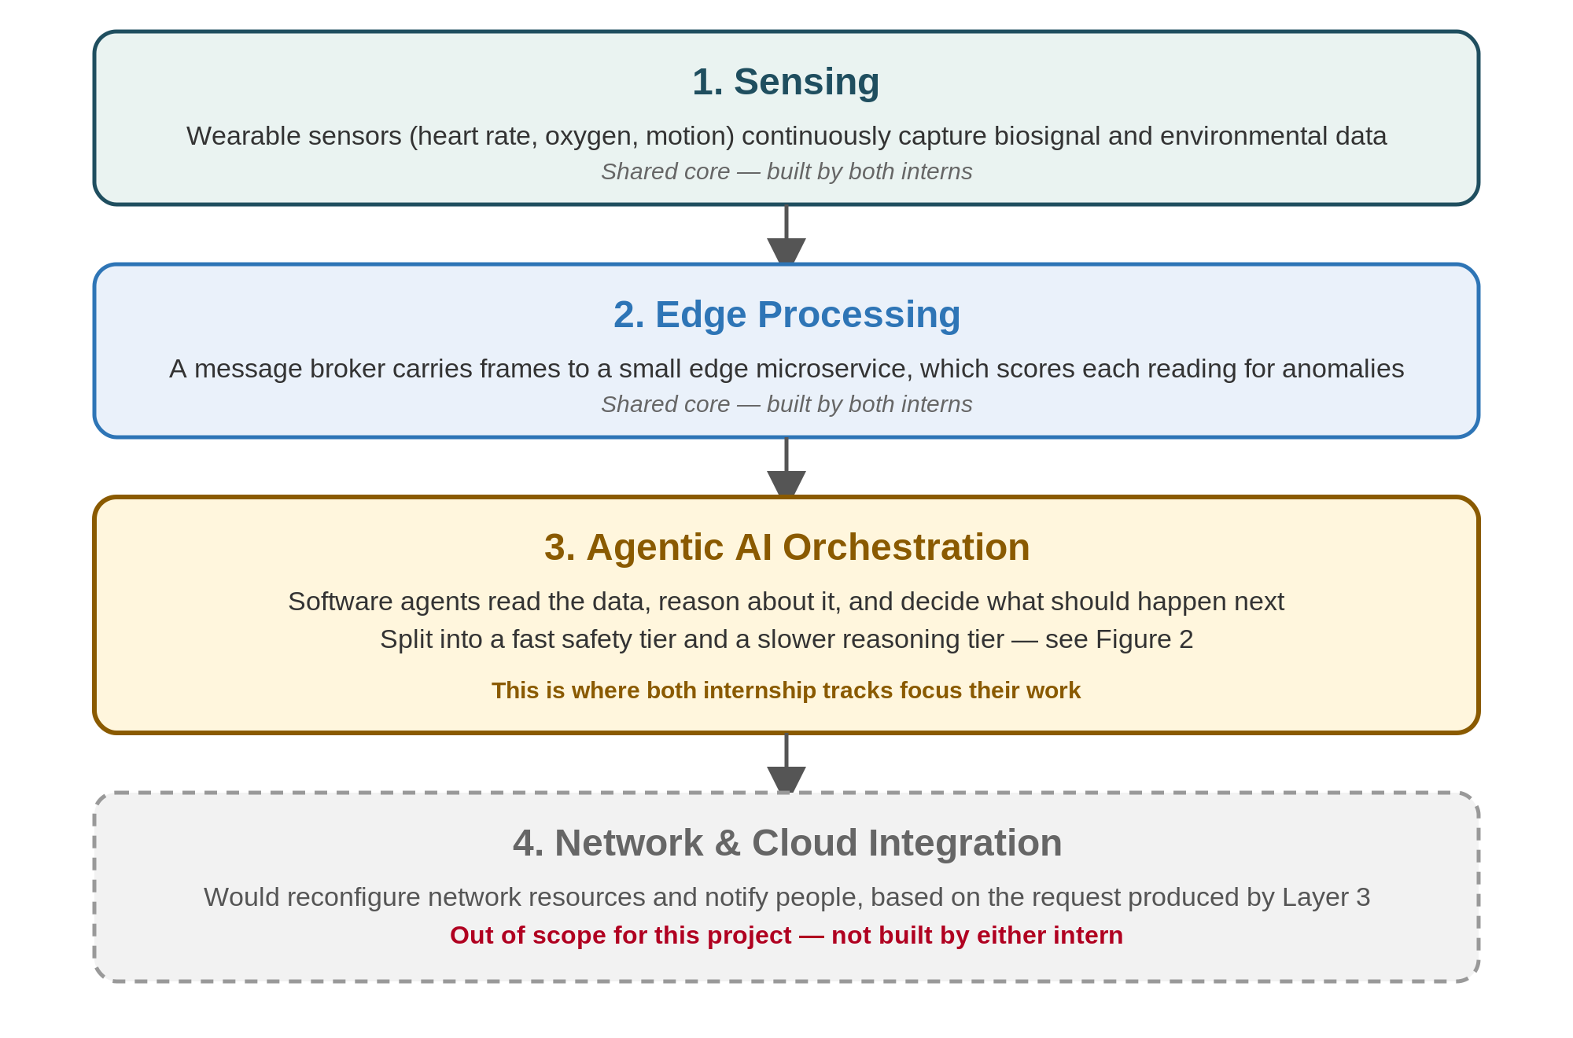
Figure 1 — The four layers of the system. The network-request emission service you build sits right at the boundary with Layer 4.
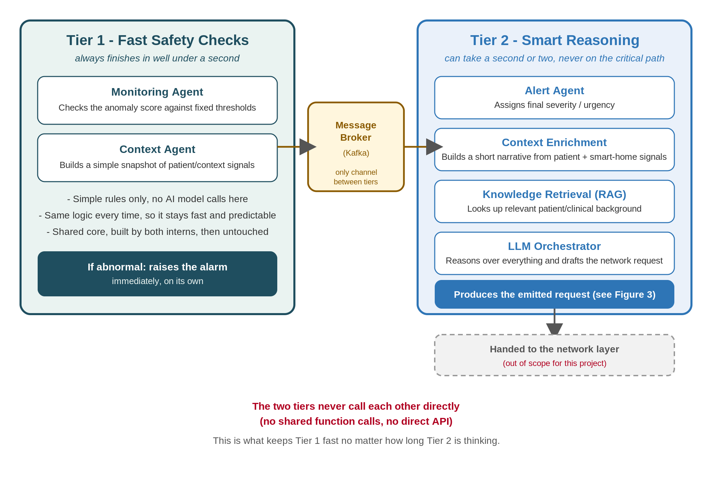
Figure 2 — Tier 1 and Tier 2, connected only through the message broker. The Phase 3 systems experiment tests what happens if that rule is broken.

